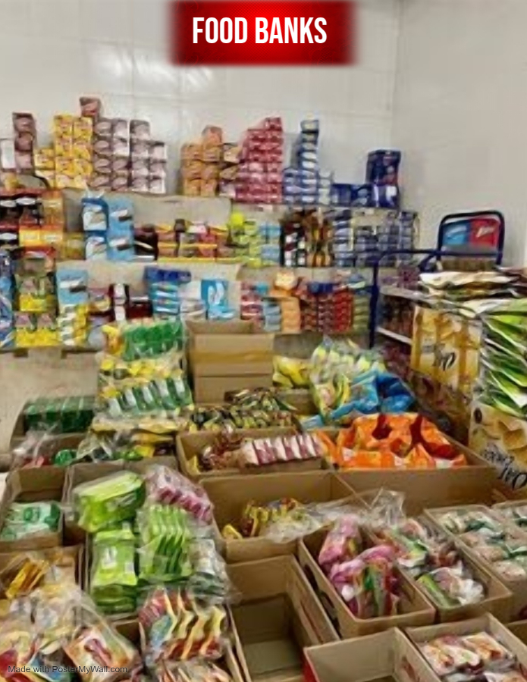
Sign of Dove Church
1189 Sunset Dr. Radcliff KY, 40160 (270)351-3550
- Food Pantry Call for Appointment
- Monday – Thursday from 10:00- 11:00
- Warm Blessings Community Kitchen
- E Dixie Ave. Elizabethtown KY, 42701 (270)763-9276
- Participants bring their own bag or a box
- Fridays Only 8:00 – 14:45
- Helping Hands of Hope
6796 South Wilson Rd. Elizabethtown KY, 42701 (270)796-3092
Must be residents of Hardin County
- Once a month 2nd Saturday of each month form 9:00-13:00 no documentation needed
- Monday – Thursday from 9:00 – 16:00, closed during lunch 12:00-1:00
- ID for every adult over 18 years old, SS for every household member, 30 days’ pay stub, Furlough letter, proof of income for every household member
- Closed Fridays
- James Catholic Church
307 W Dixie Ave. Elizabethtown, KY 42701 (270) 763-4249
- Must be Hardin County Residents
- Monday- Thursday 10:00-14:00
- Must show proof of ID and Mailing Address
- Dare to Care Food Bank
5803 Fern Valley Rd. Louisville, KY 40228 (502) 966-3821
1.Emergency Pantry once a month
2. No ID required but recommended
3. Monday- Thursday from 9:00-16:00 and Friday 09:00- 14:00
4. Closed during lunch 12:00-13:00
- Fern Creek Highview United Ministries Food Distribution Center
9300 Beulah Church Rd. Louisville, KY 40291 (502) 762-9611
- ID required
- Must live in our area; 40291, 40228, 40218
- Monday – Friday from 10:00- 13:00
- Can also be contacted @louisvilleministries.org
- Saint George Community Center
1205 S. 26th St Louisville, KY 40210 (502) 776-3200
- Tuesdays 10:00-12:00 Fresh produce, bread, sweets and drinks
- Thursday 10:00- 12:00 Pantry Staples like canned and boxed foods
- Second Tuesday of each month 10:00-12:00 Federal Commodities boxes are distributed to qualified senior citizens
- Missionary Baptist Church Food Distribution Center
- Shanks Ln. Louisville, KY 40216 (502) 447-0055
- ID only
- 4th Saturday of the Month 10:00-12:00

