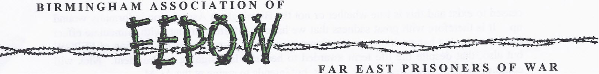

Chairman - Keith Andrews, Treasurer - Margaret Walton , Secretary - Barbara James
Committee Members - James Whiskens, Angela Lane, Annette Hughes, Rowford Bowditch

BAFEPOW NEWS SHEET FOR AUGUST 2025 - VJ80 COMMEMORATIONS BEGIN!
PLEASE COME AND JOIN US AT OUR VJ80 LUNCH
ON TUESDAY, 2ND OF SEPTEMBER!

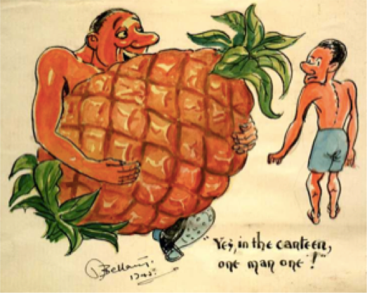
The BAFEPOW Committee has been busy arranging our commemoration for VJ80 and, as we in our association regard September 2nd 1945 as the final end of WWII when the official surrender was signed by the Japaneses in Tokyo Harbour, we are inviting you to join us for a VJ80 lunch at the Holiday Inn in Birmingham.
Do come and join us from 11.00 onwards and we will sit down to eat our lunch at one o’clock. The cost of the meal will be £10 per head and will also include a glass of wine for a toast to the memory of those who fought for our country and who sadly became POWs of the Japanese. They then endured the most appalling treatment from which many did not survive. Some of you have already let us know that you wish to attend and have paid but, those of you have not ,will need to let me, Barbara, know if you will be joining us and please let Margaret have your payment. Also, if you haven’t already done so, please confirm your choice of the main course - the menu is as follows:-

Starter
Soup of the day and Baker’s Basket Roll
Choice of Main meals
Pan Fried Chicken Supreme, or Sweet Potato Falafel,
Crushed New Potatoes, Seasonal Veg,
Seasonal Veg, Pan Jus Harissa Sauce.(GF ,V,VG)

Desert
Fruit salad and Cream
VE and VJ DAY 80th ANNIVERSARY COMMEMORATIVE SERVICE AT ELY CATHEDRAL ON JULY 13TH

Yet again we were fortunate to be represented by Tony and his sister, Annette, at this service that was held within the beautiful Ely Cathedral.
The service was planned by the cathedral to take place approximately half way datewise between VE Day and VJDay which was so much better than it centring on VE Day which has so often happened in the past. Tony commented that it was well attended and seemed to mention VE Day and then to spend more time in remembering the Far East, although the Burma Star veterans perhaps did not receive as much focus as they merited but we won’t complain.
Tony placed a BAFEPOW wreath in the Regimental Chapel there and chatted to various people he knows in the FEPOW community. It was a shame that only two hundred order of service handouts had been printed as these soon ran out which shows how many people showed an interest and showed up for this special commemoration.

A REMINDER OF OUR AGM ON 12/08/25
Just a quick reminder that our AGM will be held at the Holiday Inn on Tuesday, August 12th and it will commence at 12.00 although you are welcome to arrive from 11.00 onwards. If you haven’t already let me (Barbara) know that you are attending, please contact me by August 4th so that I can add you to the number for lunch. If you have any items to add to the agenda please let me know and also if you would like me to email you an advance copy of the minutes of the AGM in 2024 - printed copies will be available on the day.

MPS DEBATE VJ80 IN PARLIAMENT
I was contacted by my MP, Laurence Turner, who knows of my FEPOW Dad to say that he was speaking in a debate to be held in the Houses of Parliament on Monday, July 21st. He wondered if he could mention me and my role as secretary to BAFEPOW and could he visit me. I instantly agreed and got permission from my fellow committee members to give him and our neighbouring constituency MP, Al Carns - Minister for Veterans - one of our VJ80 badges to wear. The debate is now recorded in Hansard for posterity and, if you haven’t come across the various reports on Facebook about it, then here is the link to it and it really is worth reading all of it!

Victory over Japan: 80th Anniversary - Hansard - UK Parliament

APOLOGY FOR THIS NEWS SHEET BEING BRIEF
I am sorry that this news sheet might be a little short but I have been very busy preparing for our AGM, the VJ80 lunch and also sending out our VJ80 badges to our regular members. I also have to say that I have been even more busy than expected with the care of my mother who many of you may know as she has been a long time member of both BAFEPOW and COFEPOW and used to go to the NMA for many events over the years. Sadly my Mom, Iris, had a fall and has been in hospital for surgery and subsequent recovery for over a week. So far she has made a reasonable recovery and I do appreciate all the good wishes I have received from many of you but it has taken up a lot more of my time than usual and it is very worrying. Thank you for understanding that this has restricted my time but it has not detracted from my determination that on VJ Day 80 I will be ‘Remembering Them and Honouring Them!’

WELFARE GRANTS FOR FEPOW, WIVES AND WIDOWS
If you need help with a grant towards hospital stays, Nursing Home Costs, alterations to the home, mobility aids etc, then please get in touch with:-
Mr Stephen John, the Java Club by email:- stephen.su.47@gmail.com
Mrs Pauline Simpson, NFFWRA by email:- enquiries@nationalfepowfellowship.org.uk

The BAFEPOW news sheet is put together by the association secretary, Barbara James, and, hopefully, it contains items of interest to all members. You are very welcome to suggest future topics or to submit items for future inclusion. You can contact me via email:- bmjames142@yahoo.co.uk or by phone:- 07954104857
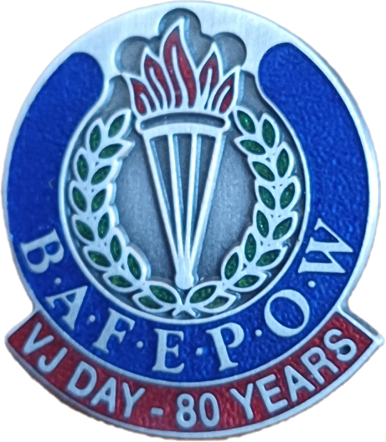

May the Spirit that kept them going, keep us going
and we shall always do our best to ensure that future generations learn of their history and by remembering them henceforth know that they have honoured them!

THE FEPOW PRAYER

And we that are left grow old with the years

Remembering their heartache, their pain and their tears.

We hope and we pray that never again, Man will sink to such sorrow and shame,

The price that they paid we must always remember

Every day, every month and not just in November!

We shall remember them!

