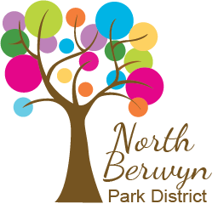

Public Notice

The Wednesday, July 9, 2025 Board Meeting

has been changed to

Thursday, July 10, 2025 at 5:00pm.

Joseph C Vallez Activity Center,
1529 S Harlem Avenue

Posted: 07/01/2025

