Special Guest speaker
Belah Rose


September 10, 2026 from 8:00 PM to 9:00 PM ET
Belah Rose is the founder of “Delight your Marriage” – a marriage transformation coaching ministry that has helped thousands of wives across the world move from disconnection, loneliness, and frustration into marriages full of warmth, intimacy, and joy.
Her podcast – one of the top Christian marriage podcasts with over 500 episodes – has reached more than 100 countries. Her coaching, courses, and community have produced story after story of God redeeming what seemed unredeemable: cold marriages made warm, distant husbands drawn close, and wives who once felt hopeless now radiating joy. It’s transformation – rooted in Scripture, tested in real marriages, and offered to you with a heart full of love.
Her website: delightyourmarrige.com

Get your Free Invitation Zoom link: Email burgi@aclaministry.com
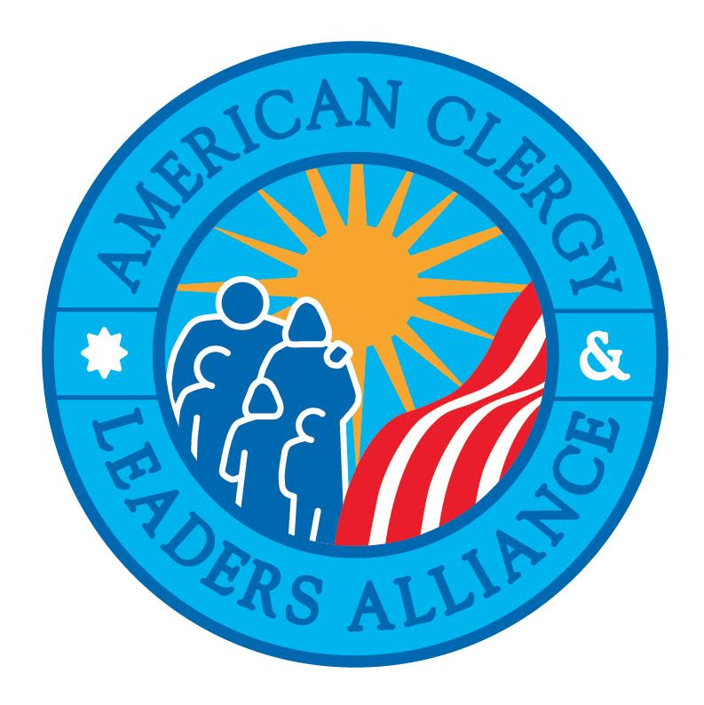

Sponsored by the American Clergy and Leaders Alliance, Inc.
www.ACLAministry.org

