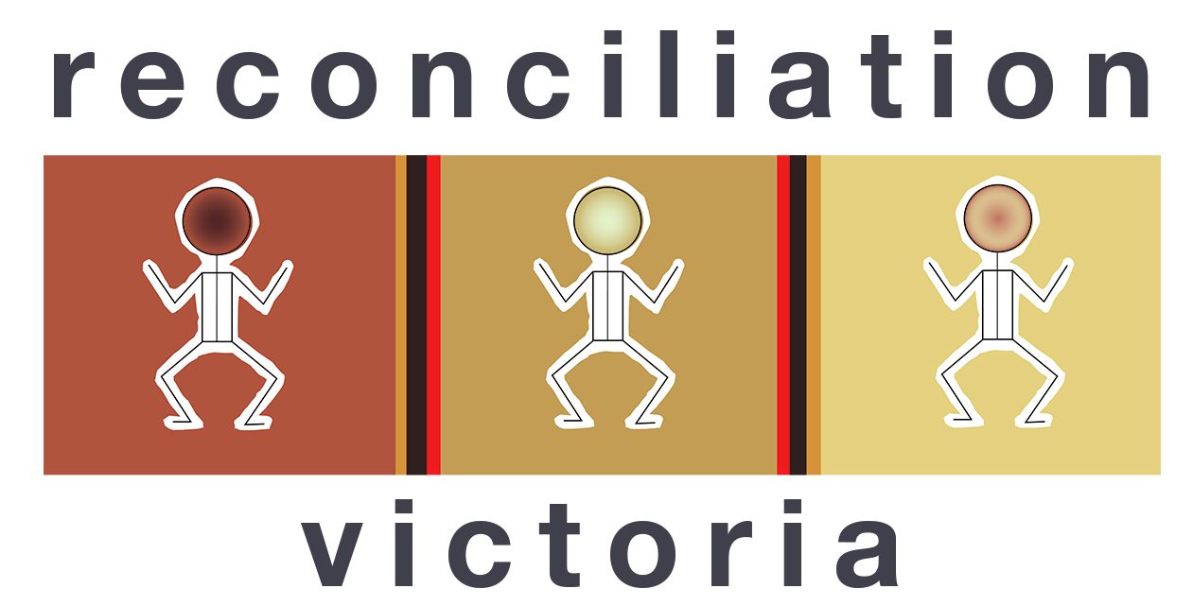

Reconciliation Victoria submission to the Inquiry into Racism, Hate and Violence Directed at Aboriginal and Torres Strait Islander People

Reconciliation Victoria acknowledges the Traditional Owners of Country throughout Victoria, and recognises First Peoples continuing connection to lands, waters, and community. We pay our respects to Elders past and present who carry the memories, traditions, cultures, and aspirations of First Peoples, and who forge the path ahead for emerging leaders. We dedicate ourselves to working respectfully with and guided by First Peoples, and to listen and amplify the voices of Aboriginal and Torres Strait Islander Peoples in all areas of our work.

Background

Reconciliation Victoria (RV) is the peak statewide body promoting reconciliation across Victoria.

RV’s purpose is to provide leadership in the movement to build support, understanding and action to achieve genuine and meaningful reconciliation in Victoria.

Meaningful reconciliation has many elements including raising awareness of the causes and realities of colonisation’s impact on Aboriginal and Torres Strait Islander peoples, addressing racism, supporting the processes of Treaty, and truth-telling, and working for fairness and social justice.

RV does this alongside other allies including other state bodies and the national body, Reconciliation Australia.

RV defines Reconciliation as consisting of five action areas:

- First Nations Rights Actions: We stand for social justice and First Nations rights to Country, cultural practices and self-determination - We commit to being brave allies and accomplices to advocate for change and walking together towards genuine reconciliation.
- Anti-Racism Actions: We stand against racism across our communities and reflect on our privilege - Overcoming racism and understanding white privilege and power relations and how this impacts all of us in our journey to reconciliation
- Collective Actions: Reconciliation is everyone’s business All levels of community, institutions, business, government and individuals have responsibility and accountability to achieving reconciliation.
- Cultural Actions: We recognise and celebrate Aboriginal and Torres Strait Islander cultures as part of our collective and shared history - We draw strength from and are inspired by the stories and voices of Aboriginal and Torres Strait Islander knowledge holders and communities.
- Truth Actions: We recognise historical injustices and their continued impacts on Aboriginal and Torres Strait Islander communities today Going beyond truth-telling, to truth-listening and truth-actions as collective communities to hold space for listening and reflecting upon past historical injustices, and to heal our country and communities.

While Anti-Racism is just one identified action area, it is apparent that many actions in the other four elements, for example, recognition and celebration of First Peoples culture, and recognition of historical injustices, are of crucial importance in countering racist narratives and helping create a respectful and inclusive nation.

RV’s work on anti-racism

RV works to counter racism in the education system, the corporate sector and the community generally.

Through liaison with teachers, RV has identified teacher skills and confidence in preventing and managing racist behaviour as a key area requiring effort. RV has obtained permission to run a training program developed by Reconciliation South Australia with support from the SA Department of Education and BHP. RV is in discussion with the Victorian Department of Education about implementing this program in Victoria.

RV has also engaged First Nations suppliers who will be providing anti-racism training to RV’s corporate members’ management and staff in 2026.

RV participates in anti-racism forums such as those at the recent Progress Conference in Naarm (Melbourne).

We also use our communication channels (enewsletter, website, socials) to raise awareness of events such as the International Day for the Elimination of Racial Discrimination, and to promote anti-racism training, the Call it Out website and ABC’s End Game program.

RV support for LRGs

The frontline in countering racism in the community is Victoria’s network of Local Reconciliation Groups (LRGs).

A key element of RV’s work is supporting and coordinating 35 LRGs across metropolitan and regional Victoria. We have worked to significantly expand this network since the 2023 Referendum.

LRGs play an important role in advancing and promoting reconciliation at the community level. LRGs come together to provide opportunities for learning and action, which can involve organising a range of events and activities such as local forums, film nights, concerts, cultural tours, and walks, talks at local schools, art exhibitions and information displays.

Many groups also work with local government and schools to promote reconciliation and greater awareness of Aboriginal history and culture.

RV supports the LRGs through:

- Convening an LRG Working Group to identify key issues, challenges and opportunities for LRGs and seek solutions.
- Convening forums to brief LRG representatives on upcoming events and opportunities to participate in Treaty, Truth-telling and anti-racism actions, and to give them a space to discuss approaches and to practice skills (for example, anti-racism conversations).
- growing the LRG base with particular focus on initiatives to engage young people and people from multicultural backgrounds.
- bringing LRGs into projects and conversations, for example, the Strengthening Councils’ Treaty Awareness and Information Pilot Project, and working with them to deliver on-country forums with Traditional Owners.

While some of these activities are explicitly anti-racist in focus, others are designed to raise community awareness and build respect for Aboriginal culture, community and contribution,

Our submission looks at several case studies of the transformational anti-racism and reconciliation work being done by some Victorian LRGs.

LRG anti-racism case studies

1. Bendigo Reconciliation and Allyship Committee

The Bendigo Reconciliation and Allyship Committee (BR&AC) has been involved in a range of initiatives to address racism towards First Nations people. These include the following.

Organisational Self-Assessment Tool

The BR&AC has developed and implemented an organisational self-assessment tool designed to help organisations gather a snapshot of organisational practices and policies as they relate to addressing racism both within the organisation and in the broader community. A particular focus of the self-assessment process is to enable organisations in the health and community sectors to reflect on covert racism that can be embedded within the practices and processes of organisations.

Feedback from First Nations people is that organisations can and do discriminate against and exclude First Nations people by the way they operate.

The BR&AC has worked with a number of organisations to complete the self-assessment tool and has conducted workshops with organisations to discuss the results and insights.

The feedback from the self-assessment mainly centred around the following points:

The self-assessment:
- helped organisations to reflect what was being done to address racism in the organisation.
- Helped organisations to reflect on policies regarding racism.
- Helped organisations to consider whether they were only non-racist or actively anti-racist.
- Helped organisations look at their reconciliation action plan (RAP) and identify whether addressing racism was embedded in it.

Often organisations would look first to policies and procedures and think that, if they had them right, that they were addressing racism. They needed encouragement to move to a space of self-reflection and to begin analysing how organisational processes, procedures and service design can have inbuilt covert racism.

Following the self-assessment there needs to be a workshop bringing together organisations to talk about their results. One workshop BR&AC did centred around First Nations people giving feedback - and this proved highly effective.

Anti-racism workshops

In partnership with First Nations people in Bendigo, the BR&AC has developed an anti-racism workshop designed to build understanding of the impact of racism on First Nations people and to promote action by allies and organisations to address racism.

The workshop has been conducted for organisations and as a workshop for the general community.

The workshop has three components. These include:

- The viewing a series of short films that highlight racism towards First Nations people.
- Reflection by a panel of First Nations people on the films and the nature and impact of racism towards them.
- Discussion with workshop participants on actions they can take to address racism.

The workshop has been very effective. For example, two local government departments and a local land management organisation combined to host a workshop for their local staff. The workshop promoted valuable discussion and planning of actions. Since the workshop there has been follow up meetings between the organisations involved to progress their actions.

Individual and Organisational Guide

The BR&AC is currently finalising a practical guide to support individuals and organisations in taking real, ongoing actions, not just symbolic steps, toward reconciliation.

Real reconciliation starts with individuals and organisations reflecting on culture and privilege, together with considering how individuals and organisations can actively address racism, prioritise truth-telling and support self-determination.

The Guide is intended to:

- Build understanding of key principles such as cultural humility, truth-telling, and allyship.
- Offer practical steps and strategies to embed reconciliation and anti-racism into workplace culture and policy.
- Shift responsibility for change from those experiencing racism to the broader workforce and leadership.

The aim of this guide is to serve as a practical tool that supports consistent action. It offers organisations clear, grounded strategies for embedding reconciliation and anti-racism into everyday practice.

The guide has been designed so it can be replicated and promoted by other reconciliation groups and community organisations.

2. Geelong One Fire Reconciliation Group

Geelong One Fire is a long term committed group of allies to First Nations People in its region on Wadawurrung Country. It is guided by and led in its actions by Wadawurrung and other First Nations people.

Reconciliation in the Park – celebrating First Nations culture

One Fire has partnered with Wadawurrung and other First Nations people for 17 years in creating this event for National Reconciliation Week. One Fire won the 2016 Community HART Award for genuine collaboration in bringing celebration and learning about First Nations culture, society and people to everyone in Djilang/Geelong. One Fire works to support this event through obtaining funds, organising equipment and co-ordinating ally volunteers each year.

This event is One Fire’s largest event which brings First Nations people and the broader community together. It has built strong relationships, centred truth telling, celebration of culture and has grown reconciliation across the region through education centres, community groups, workplaces, faith-based organisations and sports clubs. One Fire believes that it contributes to cultural safety for First Nations people locally, and is a supportive event in the face of ongoing racism.

26th January – Challenging the backlash of a new right wing dominated Council

During 2022–23, the Kilangitj Advisory Committee to Council undertook extensive community conversations and consultation to inform a renewed approach to 26 January. One Fire was a member of this Advisory Committee and drew on its broad networks to engage the community. This contributed to one of the largest participation rates in the Council’s “Our Say” process, including the highest level of input from First Nations people.

Feedback from the consultation showed strong support for centring First Nations perspectives on this day, creating opportunities for truth-telling, and fostering connection and learning across the Geelong community. At the time, the Mayor and Councillors unanimously endorsed the recommendations, including advocating to the Federal Government for a change to the date of “Australia Day” to one that is inclusive of all Australians.

In 2024, a newly elected Council, with a majority of more conservative councillors, revisited this position. They moved to reverse elements of the previous Council’s approach to January 26th. This shift was strongly contested by First Nations community members, Geelong One Fire, and other supporters, who raised concerns during Council meetings about the dismissal of the outcomes of the earlier consultation. One Fire subsequently asked questions at many Council meetings in relation to counsellors’ responsibilities, plans and commitment to improving relationships with the local Indigenous community

The need for Federal Government leadership and action to prevent local government swings undermining cultural safety and progress on reconciliation in relation to 26 January is very apparent at a local level.

3. Allies Supporting Treaty Seymour

Allies Supporting Treaty was formed by members of the BEAM Mitchell Environment Group around 2021 in the Lower Hume area, specifically based in Seymour, Victoria, but including surrounding towns from Kilmore to Euroa, the Strathbogie’s and beyond.

Over the last 5 to 6 years, BEAM’s weekly radio program, EarthChat, has become a regular vehicle for the North East members of the First People’s Assembly of Victoria to get the word out about Treaty in Victoria. These programs become podcasts on Spotify, Apple, Podbean and on BEAM’s website, beam.org.au thereby broadening the listener base. Over time Allies Supporting Treaty Seymour has tracked an increasing number of ‘hits’ from people listening to the Treaty podcasts.

Allies Supporting Treaty are aware that Treaty is not ‘done and dusted’ just because it’s been signed between the Victorian State Government and the First People’s Assembly of Victoria and is now legislated. It is certainly apparent in the Seymour region that many people do not understand the benefits, not only for the Aboriginal people living in the Lower Hume, but for all Victorians across the State.

Allies Supporting Treaty’s stall at the recent Seymour Expo clearly revealed a lack of awareness by the majority of people, many of whom were completely unaware or uninterested in knowing more. Those who had some awareness believed that Treaty was invalid, since Australia, and therefore Victoria, had voted NO in the 2023 Voice Referendum so they were frustrated and critical that the current State Government legislated Treaty at the end of 2025.

Allies Supporting Treaty will continue to explore meaningful ways for raising awareness about the benefits of Treaty in a respectful way using as many avenues as possible. Their aim is to support the creation of an environment of safety in which people can contemplate and embrace the opportunities Treaty offers and thereby create unity enabling the Victoria community to move forward. Modelling this in Victoria will hopefully encourage the whole country to follow suit.

Additional examples of such initiatives are:

- Active Voice and Treaty Email list of around 250 people - including Walk for Truth updates and other related events and projects.
- Gatherings inviting members of the above list to come together to share their experience of sharing messages about Treaty and related matters, and working together to utilise other opportunities.
- Stalls at local markets and streets, to invite passersby to talk about Treaty, and Aboriginal issues generally - for example, the need for closing the gap and First Nations self-determination.
- Ally support offered to NAIDOC and other indigenous events in the region when taken up and guided by Indigenous Community.
- Creating one-on-one and small group 'kitchen table' conversations to raise awareness about Treaty and related matters, and take advantage of opportunities that present themselves for respectful conversations.

4. Darebin Solidarity with First Peoples

Darebin Solidarity with First Peoples (DSFP) is an Allies group located in the northern suburbs of Naarm.

In early 2025 DSFP commenced a relationship with the Fitzroy Stars, an Aboriginal football/netball club based in Thornbury and affiliated with the Northern Football/Netball League.

Since then, DSFP has raised funds to support the Stars’ players, and DSFP volunteers attend matches where they provide help with goal umpiring, timekeeping, running water, and barracking.

Racist comments by supporters of other teams occur regularly at both football and netball matches.

The Club has suggested that DSFP volunteers could have a possible role in calling out racist remarks during matches, videoing incidents and reporting incidents.

From a preventive perspective, DSFP is also looking at ways it can support the Club by providing signage at urging supporters to behave respectfully at its ground. If successful, this approach could be a model other clubs in the League could adopt.

Issues have also been raised about the League’s process for handling complaints about racist remarks. A DSFP member with legal qualifications is working with the Club to explore ways to assist the League improve its processes.

The Fitzroy Stars are very supportive of involvement by Allies, as they see it as publicly demonstrating that non-Indigenous people are standing with them in opposing racism and dispelling any perception that racism a ‘black versus white’ issue.

While DSFP’s engagement with the Fitzroy Stars is little more than 12 months old, numerous avenues are already emerging showing ways in which Ally groups can support First Nations clubs and sportspeople in countering racism.

Summary

The case studies above demonstrate how LRGs are well positioned to play an effective role in working with First Peoples at a local level to raise awareness of racism among non-indigenous people, and to act to prevent and oppose racism.

State reconciliation bodies, in turn, have a key role to play in providing support, leadership and guidance to LRGs. RV has regularly assessed LRG project proposals and provided funding for them – for example, National Reconciliation Week grants. However discretionary funding of this kind is currently very limited.

Recommendations

- The Commonwealth Government implement the Uluru Statement from the Heart in full given the critical importance of each of its three key areas – Voice, Treaty and Truth – to addressing racism.

- Commonwealth, State, and Territory Governments fund state reconciliation bodies to enable them to support local community anti-racism, reconciliation and truth-telling initiatives.

- Commonwealth, State, and Territory Governments recognise anti-racism as an integral element of reconciliation.

- Commonwealth, State, and Territory Governments recognise the importance of Truth-telling in countering racist views of our shared history.

- Commonwealth, State, and Territory Governments work with and show leadership to local governments to ensure policy shifts do not undermine cultural safety and progress on reconciliation, particularly in relation to 26 January.

Aunty Gina Bundle OAM
Professor Andrew Gunstone
Co-Chairs Reconciliation Victoria

