A PUBLICATION OF THE ASSOCIATION OF LOCAL GOVERNMENT
AUTHORITIES OF JAMAICA January 2015

New Year’s Message from Mayor Scean Barnswell, President of ALGAJ

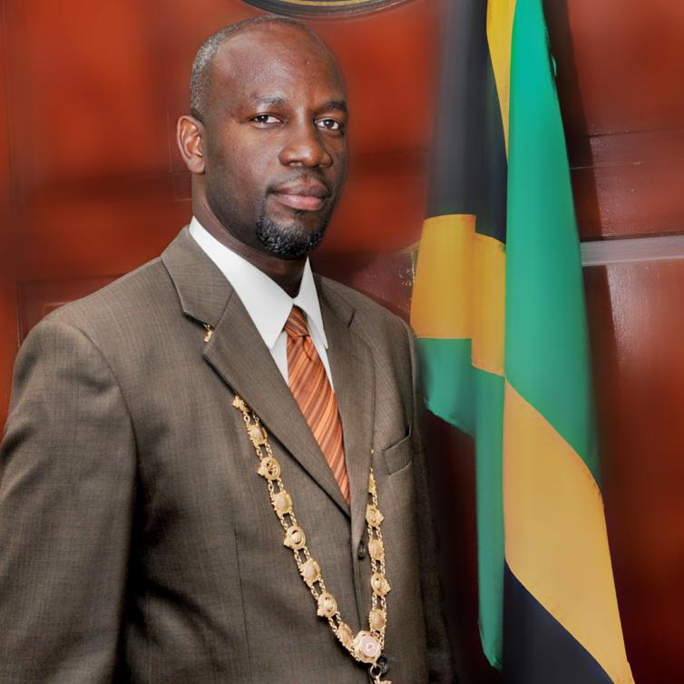
projects that should impact positively on the lives of citizens. But being a resilient nation, I am confident that we can overcome all adversities by means of utilizing shared resources, ideas and adopting best practices. We need to also maintain a work environment that encourages us to think about how our actions impact the local authorities as a whole and realize that TEAM (Together Each Achieves More) work is the way to be a top performer.
I wish you a happy New Year and God's richest blessings throughout this year and beyond.

Let it be the year that we rededicate ourselves to quality service delivery, engage citizens in the decision-making process and get our stakeholders more involved in the implementation process of our various projects.
Let us be optimistic that we will witness the three Strategic laws become a reality by the end of this Parliamentary year; that the local authorities will maintain a firm position at the decision-making table and continue the public education drive to sensitize the citizens of our roles, functions and responsibilities.
We are very well aware that the tight fiscal space in which we operate can pose a challenge to implement
My colleagues, as we commence the New Year, let us reflect on 2014 and what we've accomplished, the challenges we faced and the new goals to be attained.
Let 2015 be the year when it will happen. There is still more work to be done so let’s use our time wisely, double our efforts and go the extra mile to achieve our targets.


1Brooks Avenue May Pen P.O., Clarendon; Telephone #: 986-4656;
Email: algajamaica@yahoo.com

