BRANDING THE CITY OF KINGSTON – THE WATERFRONT
Kingston & St. Andrew Municipal Corporation

In recent times cities across the world have been looking at ways in which they can promote themselves. A clear, compelling and unique brand is what has been used in recent years as a foundation to promote cities as a desirable as a visitor destination, business location and a place to call home. Globalization has caused cities to become competitive at becoming an attractive tourist destination, workplace, culturally rich place and more.
Development of a brand strategy for a city influences the features of that place to provide a relevant and compelling promise to a target audience. It is not an ad campaign or a tagline. Rather, the branding strategy is a deeper, more emotionally shared vision that influences actions. There are many reasons why it is critical for a place to have a brand, but the most common is to stimulate economic growth.
A strong brand can: Shift the perception of a place that may be suffering from a poor image among external and internal constituents and create a common vision for the future of the community and its potential. Provide a consistent representation of the place. Enhance its local, regional and/or global awareness and position. Shed unfavorable stereotypes associated with a place and make it more appealing. These are all of which we would ideally like to achieve for Jamaica’s capital: Kingston. A strong and identifiable branding image would have a positive impact on the satisfaction of the visitors and residents of Kingston.
BACKGROUND
It is through this that the KSAMC has embarked upon branding Kingston. The branding process will consist of a series of events, products and infrastructure development which will have an effect on all the residents and visitors to Kingston.
The first of the branding projects to be implemented is the erection of a large double sided sign posted on the Waterfront, Downtown, Kingston so that the public will be able to come in contact with the sign, and in turn have the opportunity to interact with the branding theme “LoveMaKingston.”
The location being suggested for the sign is to be located along the Ocean Boulevard next to the Bank of Jamaica Building (see Figure 1 below). This position was selected as the area is open and would allow for viewing while approaching the Waterfront from Nethersole Place. Photographs could easily be taken with the sign and the waterfront in the back drop while the reverse of the sign could be seen from the Harbour and Palisadoes.
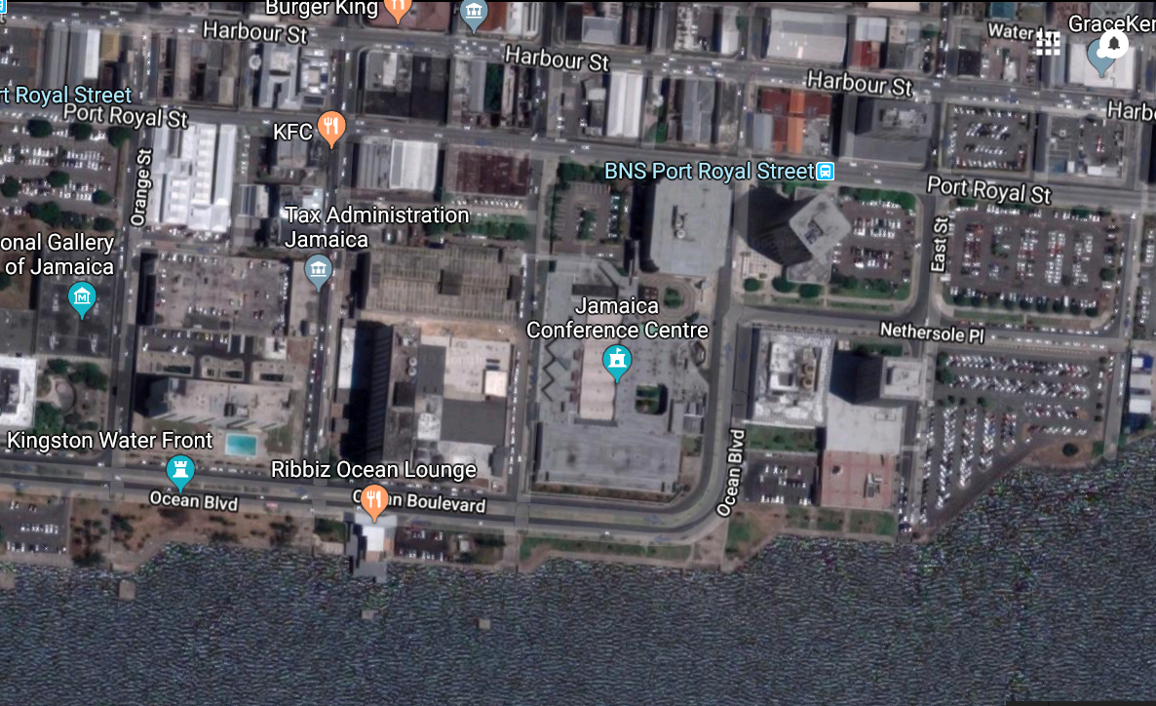
Proposed Sign Location
The reverse of the signs view from the Harbour and from Palisadoes would be appropriate. This would attract persons to view by doing boat tours and also from the Palisadoes which all passengers from the Norman Manley International Airport must use to acess the city.
“LoveMaKingston” would be the backdrop for many photos and selfies, local and international, branding the city’s image throughout the world through social media.
THE SIGN DETAILS
The signs letters should be able to moved and placed on its own so if there is damage each letter could be easily replaced. Each letter should be constructed with steel frame, aluminum cladding and a polycarbonate front and back. The colourful sides should be covered in a vinyl wrap so that the letters can be skinned with different wraps.
Each letter should be 10ft tall and each rest on a base.
Each letter should be equipped with L.E.D lights which can transition to a variety of colors.
MANAGEMENT OF SIGN
The sign would be able to change to themes for a variety of seasons (Easter, Christmas, and themes for a variety of festivals and events, local nonprofit charities).
The KSAMC would maintain a schedule for the themes to be displayed for the year. Individuals and Companies could apply to the KSAMC for lighting requests to be displayed (at a cost to be determined).
Each approved lighting display would be approved to be displayed for 24 hours (10am-10am). The approved lighting would be included in the signs original multicoloured display pattern. Multiple displays would be accommodated on the same day when multiple requests are scheduled together.
There will be no fee required to submit a lighting request but if approved a fee will be paid. Staff of the KSAMC will program the sign year-round with seasonal colour variations in addition to commemorative lighting requests received from the local community.
All requests will be considered on a first come, first served basis and the signs maintenance and cleaning would be carried out by the KSAMC.
The KSAMC is currently in the process of obtaining a design for the city brand with the input from tertiary institutions within Kingston and St. Andrew. The chosen design will then be used so that the project can be initiated and implemented.

