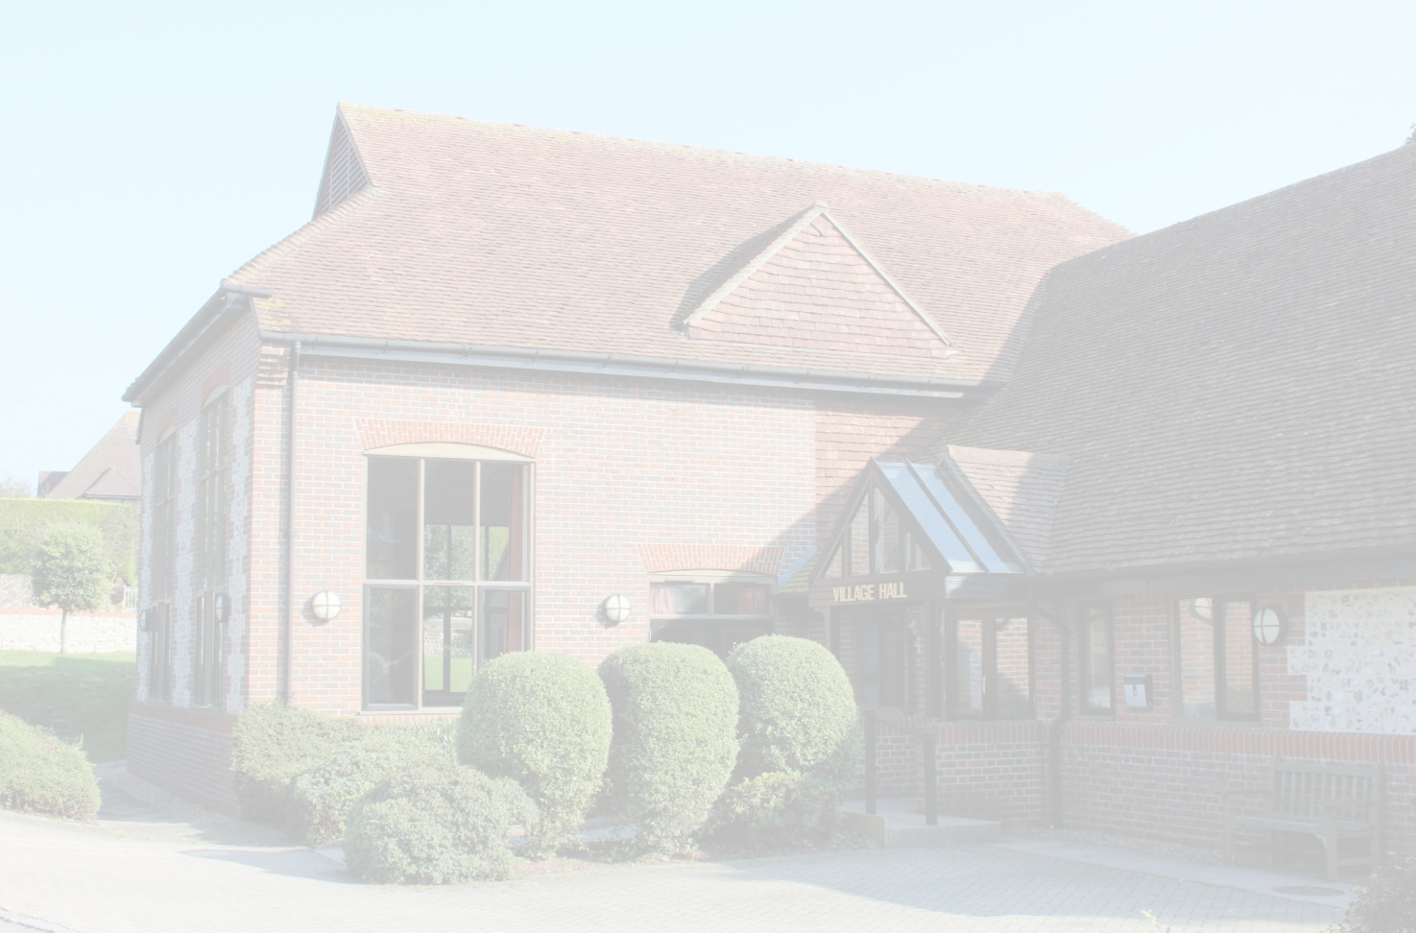

East Dean & Friston Village Hall

Risk Assessment

and Action Plan

Updated May 2026

Introduction
In 2016 the Trustee Officers decided to carry out a Risk Assessment of the village hall to control the risks to people who use the hall and are involved in its maintenance and upkeep. At the same time review the format of the historical assessments. The Trustee Officers did not have a legal requirement to record the findings of this risk assessment as less than five people work at the hall. Much of the repair and maintenance work at the hall was done by self---employed workers, who have responsibility for their own health and safety issues.
However, the Trustee Officers decided that there were sound legal, operating and business reasons to record the findings of the risk assessment, and to take steps to make sure that they were brought to the attention of those working or holding an event in the hall.
How was the risk assessment done?
The Assessment Team followed the HSE’s guidance in “Controlling the risks in the workplace”.

- To identify the hazards, the Assessment Team:

--- looked at HSE’s web pages for free health and safety advice and guidance for village halls;
--- walked around the hall, car park and other areas of the hall, noting things that might pose a risk; and
--- spoke to other users of the hall, and to people who had done jobs at the hall, to learn from their experience and to get their views on health and safety.

The Risk Assessment was carried out in November 2015 by the then Health & Safety liaison officer, Judith Morrison and the Hall Manager, Tina Woodley---Roberts. Their assessment was reviewed by the Vice Chairman of the Trustees, Stewart Fuller, and the Operations Officer, Bill Hallett.

The last updated has been carried out by the now Chairman of the Trustees, Paul Seeley in May 2026.
---

- The Assessment Team then wrote who could be harmed by the hazards and how.

- They recorded what controls were in place to manage these risks and then compared these to the guidance on HSE’s website.

- This Risk Assessment includes an action plan which notes what is needed to be completed and by whom and by when. The action plan is shaded in green within this document.

- The Trustees agreed to put in place all the additional risk controls noted in this Risk Assessment. They also decided that the Risk Assessment would be made available to Employees, Trustees, Contractors, Users and Visitors to the Hall. Reference would be included in the terms of hire. A copy will also kept in the Hall for reference purposes and a copy will be included on the Village Hall website. The Trustees decided to review the risk assessment every year or immediately if any changes occurred to the Hall or how the Hall was used

What are the hazards | Who might be harmed and how | What are we already doing | What further action is necessary | Action by who | Action by when | Date done
Slips trips and spills | Users of the village Hall may suffer injuries such as fractures or bruising if they slip eg spillages or trip over objects. | - Adequate lighting to all areas within the Village Hall.  - Hall floors checked daily and cleaned as necessary.  - Entrance barrier mats in place.  - No storage in corridors.  - No trailing electrical leads/ cables.  - Adequate Hall external lighting.  - Paths externally are cleared of fallen leaves, lichen, etc.*  - Paths externally are gritted when icy or snow covered. *  - Step in path from Car Park to Main Entrance; hi---viz paint applied to tread nosing; and reapplied* as necessary, cautionary signage provided and handrail fitted to both sides.  - *These actions are on the caretaker’s job list.

What are the hazards | Who might be harmed and how | What are we already doing | What further action is necessary | Action by who | Action by when | Date done
Use of Stage | Users would likely suffer injury in accessing or falling from stage. | - Moveable steps to front of Stage has a bracket to hold them in securely position.  - Permanent flight of steps to the back stage area have handrail to assist access/egress.  - Stage extension units are correctly assembled only by trained persons when used. | - Trustees have confirmed stage extensions to be removed from premises. | TWR | 30/09/26

What are the hazards | Who might be harmed and how | What are we already doing | What further action is necessary | Action by who | Action by when | Date done
Work at height | Anyone working at any height could suffer injuries should they fall. | - Appropriate commercial ladder and steps available for use.  - Hire tower when ladders and steps not appropriate.  - Hall staff and cleaners know how to use the stepladder safely  - Ladder used to access main loft space through bulkhead in Main Hall has facility to be secured at head.  - Kitchen loft ladder is secure.  - HSE guide on safe use of ladders downloaded and store in mail rack in Kitchen. Download information on the safe manual handling; and appended to this Risk Assessment.  - Download information on the safe manual handling; and appended to this Risk Assessment.  - Hall users to be made aware through hire agreement that they are responsible for using the stepladder safely and ladder to loft must be secured.  - Warning notices displayed in loft space on bulkhead doors. | None

What are the hazards | Who might be harmed and how | What are we already doing | What further action is necessary | Action by who | Action by when | Date done
Hazardous substances eg cleaning products | The cleaners and others cleaning risk skin problems, eye damage and breathing problems through direct contact with cleaning products. | - Mops buckets brushes are provided.  - Cleaning products monitored by users and any complaints acted upon immediately eg products replaced immediately.  - Cleaners are asked to use the products safely; ie follow instructions on labels.  - Cleaning products are stored securely.  - Gloves, masks and goggles are available for use by cleaners; they have been advised.  - Flammable paints, solvent, etc to be stored off site.
Electricity | All users risk electric shocks or burns from faulty equipment or installation or misuse of electrical appliances. | - Fixed installation inspected regularly.  - All repairs by qualified electrician.  - Portable appliance testing (PAT) is carried out regularly.  - Portable equipment inspected for visual signs of damage before use.  - Hall users know that they are responsible for any equipment used on site.  - Through the booking process, Users are asked what Hall equipment they will need; qualified technicians are available to set up the Hall’s specialised equipment for Users and show them how to use it.

What are the hazards | Who might be harmed and how | What are we already doing | What further action is necessary | Action by who | Action by when | Date done
Gas | All users could be injured by burns, asphyxiation, explosion, etc. | - Gas supply is turned off at gas valve set (adjacent to the kitchen fire escape door) when gas hob/oven not in used.  - Clear instructions are displayed in the Kitchen on how to turn off the supply.  - Instructions are given to first time Users on the safe operation of the gas hob/oven.  - The oven and hob unit is on castors; in normal circumstances these are kept in the lock position; a retaining cable is also fitted to protect the integrity of the gas supply hose when the unit is moved.  - The gas fired boilers are regularly inspected and serviced by appropriately qualified engineers. | - Review hire agreement. | TWR | 30/09/26
Specific issues arising from Kitchen operation | Potential injury to any kitchen user from countertop water boilers, use of kitchen implements including knifes and other sharp tools. Congestion in Kitchen when the Hall is particularly busy. | - Instructions on the use of the countertop water boilers are displayed.  - All implements are cleaned and returned to their allocated storage space when not in use.  - All fridge/freezers have a thermometer.  - Meat thermometer provided.  - Long and standard oven gloves provided.  - Extract duct from hob canopy cleaned internally annually.

What are the hazards | Who might be harmed and how | What are we already doing | What further action is necessary | Action by who | Action by when | Date done
Stored equipment | All as relevant. | - Users know to stack tables and chairs safely and their own equipment if stored at the hall in the space allocated.  - All items stored in the Loft Storage area to be stored safely and not impede access/egress routes. | - All unwanted equipment to be removed. | - All | Ongoing
Manual handling | All when handling and moving equipment/boxes which may be heavy or awkward. | - All to take care when handling and moving equipment /boxes which may be heavy or awkward.  - Trolleys are available to move objects/chairs.  - Users know where they are kept.  - ‘Manual Handling at Work’ guide  appended to this Risk Assessment.
Generally | Duty of care to other Users. | - ‘Job Requirement Book’ for any user to report maintenance issues.  - Accident book is provided.  - The above are reviewed daily/weekly/monthly/as appropriate.  - It is a condition of the hire agreement that hirers confirm that they have read, understood and will comply with the requirements of this Risk Assessment. | - Provide notice advising Users where Accident Book is located.
Fire | See separate Fire Risk Assessment.

Key to abbreviations:
TWR
Tina Woodley-Roberts; Hall Manger
---
Denotes Action Plan
“All” or “User(s)” shall mean any Hall user including all or any of (but not limited to) the following:
--- Employees
--- Hirers
--- Trustees
--- Contractors
--- Visitors

Appendices:

--- HSE Manual Handling at Work Guide
--- Safe Use of Ladders and Stepladders

Manual handling at work

A brief guide

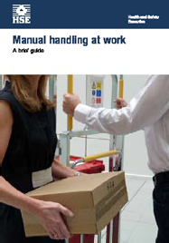
Introduction
This leaflet describes what you, as an employer, may need to do to protect your employees from the risk of injury through manual handling tasks in the workplace. It will also be useful to employees and their representatives.

This is a web-friendly version of leaflet INDG143(rev3), published 11/12
The Manual Handling Operations Regulations 1992, as amended in 2002 (‘the Regulations’) apply to a wide range of manual handling activities, including lifting, lowering, pushing, pulling or carrying. The load may be either animate, such as a person or an animal, or inanimate, such as a box or a trolley.

What’s the problem?
Incorrect manual handling is one of the most common causes of injury at work. It causes work-related musculoskeletal disorders (MSDs) which account for over a third of all workplace injuries. (For the latest statistics, visit the HSE web page, www.hse.gov.uk/statistics/causdis/musculoskeletal/index.htm.)

Manual handling injuries can happen anywhere people are at work – on farms and building sites, in factories, offices, warehouses, hospitals, banks, laboratories, and while making deliveries. Heavy manual labour, awkward postures, manual materials handling, and previous or existing injury are all risk factors in developing MSDs.
There is more information and advice on MSDs on the HSE website, including advice on managing back pain at work.

Taking the action described here will help prevent these injuries and is likely to be cost effective. But you can’t prevent all MSDs, so it is still essential to encourage early reporting of symptoms.

What should I do about it?
Consider the risks from manual handling to the health and safety of your employees – this guidance will help you to do this. If there are risks, the Regulations apply.

Consult and involve the workforce. Your employees and their representatives know first hand what the risks in the workplace are. They can probably offer practical solutions to controlling them.

The Regulations require employers to:





Health and Safety Executive
- avoid the need for hazardous manual handling, so far as is reasonably practicable;
- assess the risk of injury from any hazardous manual handling that can’t be avoided; and
- reduce the risk of injury from hazardous manual handling, so far as is reasonably practicable.
Page 1 of 10

These points are explained in detail under ‘Avoiding manual handling’ and ‘Assessing and reducing the risk of injury’.

Employees have duties too. They should:
- follow systems of work in place for their safety;
- use equipment provided for their safety properly;
- cooperate with their employer on health and safety matters;
- inform their employer if they identify hazardous handling activities;
- take care to make sure their activities do not put others at risk.

Avoiding manual handling

Check whether you need to move it at all
For example:

- Does a large workpiece really need to be moved, or can the activity (eg wrapping or machining) be done safely where the item already is?
- Can raw materials be delivered directly to their point of use?

Consider automation, particularly for new processes
Think about mechanisation and using handling aids. For example:
- a conveyor;
- a pallet truck;
- an electric or hand-powered hoist;
- a lift truck.
But beware of new hazards from automation or mechanisation. For example:
- automated plant still needs cleaning, maintenance etc;
- lift trucks must be suited to the work and have properly trained operators.

Controlling the risks
As part of managing the health and safety of your business, you must control the risks in your workplace. To do this you need to think about what might cause harm to people and decide whether you are doing enough to prevent harm. This process is known as a risk assessment and it is something you are required by law to carry out.

A risk assessment is about identifying and taking sensible and proportionate measures to control the risks in your workplace, not about creating huge amounts of paperwork. You are probably already taking steps to protect your employees, but your risk assessment will help you decide whether you should be doing more.

Think about how accidents and ill health could happen and concentrate on real risks – those that are most likely and which will cause the most harm. The following might help:

- Think about your workplace activities, processes and the substances used that could injure your employees or harm their health.

- Ask your employees what they think the hazards are, as they may notice things that are not obvious to you and may have some good ideas on how to control
the risks.
- Check manufacturers’ instructions or data sheets for chemicals and equipment, as they can be very helpful in spelling out the hazards.
- Some workers may have particular requirements, for example new and young workers, migrant workers, new or expectant mothers, people with disabilities,
temporary workers, contractors, homeworkers and lone workers may be at particular risk.

Having identified the hazards, you then have to decide how likely it is that harm will occur. Risk is a part of everyday life and you are not expected to eliminate all risks. What you must do is make sure you know about the main risks and the things you need to do to manage them responsibly. Generally, you need to do everything reasonably practicable to protect people from harm.

Make a record of your significant findings – the hazards, how people might be harmed by them and what you have in place to control the risks. Any record produced should be simple and focused on controls. If you have fewer than five employees you do not have to write anything down. But it is useful to do this so you can review it at a later date, for example if something changes. If you have five or more employees, you are required by law to write it down.

Few workplaces stay the same, so it makes sense to review what you are doing regularly.

Table 1 Making an assessment

Problems to look for when making an assessment | Ways of reducing the risk of injury
The tasks, do they involve:  - holding loads away from the body?  - twisting, stooping or reaching upwards?  - large vertical movement?  - long carrying distances?  - strenuous pushing or pulling?  - repetitive handling?  - insufficient rest or recovery time?  - a work rate imposed by a process? | Can you:  - use a lifting aid?  - improve workplace layout to improve efficiency?  - reduce the amount of twisting and stooping?  - avoid lifting from floor level or above shoulder height, especially heavy loads?  - reduce carrying distances?  - avoid repetitive handling?  - vary the work, allowing one set of muscles to rest while another is used?  - push rather than pull?
The loads, are they:  - heavy or bulky?  - difficult to grasp?  - unstable or likely to move unpredictably (like animals)?  - harmful, eg sharp or hot?  - awkwardly stacked?  - too large for the handler to see over? | Can you make the load:  - lighter or less bulky?  - easier to grasp?  - more stable?  - evenly stacked?  If the load comes in from elsewhere, have you asked the supplier to help, eg by providing handles or smaller packages?

Table 1 Making an assessment (continued)

Problems to look for when making an assessment | Ways of reducing the risk of injury
The working environment, are there:  - restrictions on posture?  - bumpy, obstructed or slippery floors?  - variations in floor levels?  - hot/cold/humid conditions?  - gusts of wind or other strong air movements?  - poor lighting conditions?  - restrictions on movements from clothes or personal protective equipment (PPE)? | Can you:  - remove obstructions to free movement?  - provide better flooring?  - avoid steps and steep ramps?  - prevent extremes of hot and cold?  - improve lighting?  - provide protective clothing or PPE that is less restrictive?  - ensure your employees’ clothing and footwear is suitable for their work?
Individual capacity, does the job:  - require unusual capability, eg above average strength or agility?  - endanger those with a health problem or learning/ physical disability?  - endanger pregnant women?  - call for special information or training? | Can you:  - pay particular attention to those who have a physical weakness?  - take extra care of pregnant workers?  - give your employees more information, eg about the range of tasks they are likely to face?  - provide more training (see ‘What about training?’)  - get advice from an occupational health advisor if you need to?
Handling aids and equipment:  - is the device the correct type for the job?  - is it well maintained?  - are the wheels on the device suited to the floor surface?  - do the wheels run freely?  - is the handle height between the waist and shoulders?  - are the handle grips in good condition and comfortable?  - are there any brakes? If so, do they work? | Can you:  - adjust the work rate?  - provide equipment that is more suitable for the task?  - carry out planned preventive maintenance to prevent problems?  - change the wheels, tyres and/or flooring so that equipment moves easily?  - provide better handles and handle grips?  - make the brakes easier to use, reliable and effective?
Work organisation factors:  - is the work repetitive or boring?  - is work machine or system-paced?  - do workers feel the demands of the work are excessive?  - have workers little control of the work and working methods?  - is there poor communication between managers and employees? | Can you:  - change tasks to reduce the monotony?  - make more use of workers’ skills?  - make workloads and deadlines more achievable?  - encourage good communication and teamwork?  - involve workers in decisions?  - provide better training and information?

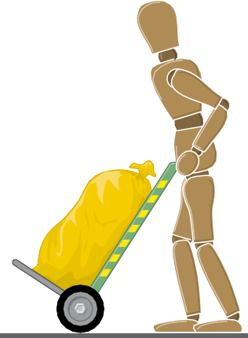
How far must I reduce the risk?
To the balancing the level ‘reasonably practicable’. This means balancing the level of risk against the measures needed to control the risk in terms of money, time and trouble.

Do I have to provide mechanical aids in every case?
You should definitely provide mechanical aids if it is reasonably practicable to do so and the risks identified in your risk assessment can be reduced or eliminated by this means. But you should consider mechanical aids in other situations as well – they can improve productivity as well as safety. Even something as simple as a sack truck can make a big improvement.

What about training?
Training is important but remember that, on its own, it can’t overcome:
- a lack of mechanical aids;
- unsuitable loads;
- bad working conditions.
Training should cover:
- manual handling risk factors and how injuries can occur;
- how to carry out safe manual handling, including good handling technique (see ‘Good handling technique for lifting’ and ‘Good handling technique for pushing
and pulling’);
- appropriate systems of work for the individual’s tasks and environment;
- use of mechanical aids;
- practical work to allow the trainer to identify and put right anything the trainee is not doing safely.

Good handling technique for lifting
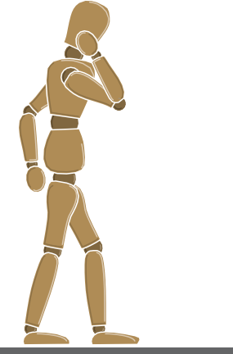
Here are some practical tips, suitable for use in training people in safe manual handling.

Think before lifting/handling. Plan the lift. Can handling aids be used? Where is the load going to be placed? Will help be needed with the load? Remove obstructions such as discarded wrapping materials. For a long lift, consider resting the load midway on a table or bench to change grip.
Adopt a stable position. The feet should be apart with one leg slightly forward to maintain balance (alongside the load, if it is on the ground). The worker should be prepared to move their feet during the
lift to maintain their stability. Avoid tight clothing or unsuitable footwear, which may make this difficult.

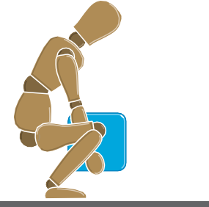

Get a good hold. Where possible, the load should be hugged as close as possible to the body. This may be better than gripping it tightly with hands only.

Start in a good posture. At the start of the lift, slight bending of the back, hips and knees is preferable to fully flexing the back (stooping) or fully flexing the hips and knees (squatting).

Don’t flex the back any further while lifting. This can happen if the legs begin to straighten before starting to raise the load.
Keep the load close to the waist. Keep the load close to the body for as long as possible while lifting. Keep the heaviest side of the load next to the body. If a close approach to the load is not possible, try to slide it towards the body before attempting to lift it.

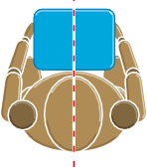
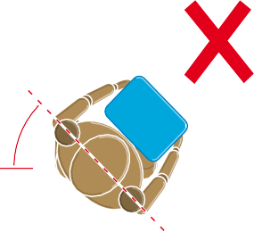
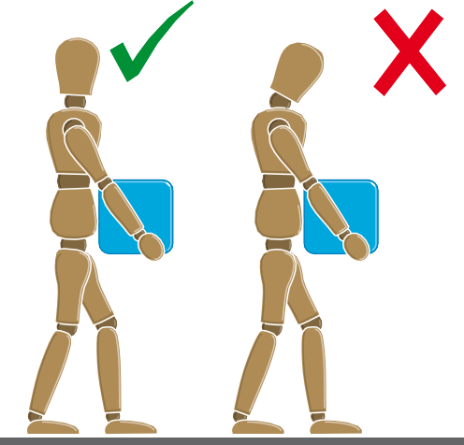
Avoid twisting the back or leaning sideways, especially while the back is bent. Shoulders should be kept level and facing in the same direction as the hips. Turning by moving the feet is better than twisting and lifting at the same time.
Keep the head up when handling. Look ahead, not down at the load, once it has been held securely.

Move smoothly. The load should not be jerked or snatched as this can make it harder to keep control and can increase the risk of injury.

Don’t lift or handle more than can be easily managed. There is a difference between what people can lift and what they can safely lift. If in doubt, seek advice or get help.


Put down, then adjust. If precise positioning of the load is necessary, put it down first, then slide it into the desired position.

Good handling technique for pushing and pulling
Here are some practical points to remember when loads are pushed or pulled.

Handling devices. Aids such as barrows and trolleys should have handle heights that are between the shoulder and waist. Devices should be well maintained with wheels that run smoothly. The law requires that equipment is maintained. When you buy new trolleys etc, make sure they are good quality with large diameter wheels made of suitable material and with castors, bearings etc which will last with minimum maintenance. Consulting your employees and safety representatives will help, as they know what works and what doesn’t.

Force. As a rough guide the amount of force that needs to be applied to move a load over a flat, level surface using a well-maintained handling aid is at least 2% of the load weight. For example, if the load weight is 400 kg, then the force needed to move the load is 8 kg. The force needed will be larger, perhaps a lot larger, if conditions are not perfect (eg wheels not in the right position or a device that is poorly maintained). The operator should try to push rather than pull when moving a load, provided they can see over it and control steering and stopping.

Slopes. Employees should get help from another worker whenever necessary, if they have to negotiate a slope or ramp, as pushing and pulling forces can be very high. For example, if a load of 400 kg is moved up a slope of 1 in 12 (about 5°), the required force is over 30 kg even in ideal conditions – good wheels and a smooth slope. This is above the guideline weight for men and well above the guideline weight for women.

Uneven surfaces. Moving an object over soft or uneven surfaces requires higher forces. On an uneven surface, the force needed to start the load moving could increase to 10% of the load weight, although this might be offset to some extent by using larger wheels. Soft ground may be even worse.

Stance and pace. To make it easier to push or pull, employees should keep their feet well away from the load and go no faster than walking speed. This will stop them becoming too tired too quickly.

How do I know if there’s a risk of injury?
It’s a matter of judgement in each case, but there are certain things to look out for, such as people puffing and sweating, excessive fatigue, bad posture, cramped work areas, awkward or heavy loads or people with a history of back trouble.
Operators can often highlight which activities are unpopular, difficult or hard work.

It is difficult to be precise – so many factors vary between jobs, workplaces and people. But the general risk assessment guidelines in the next section should help you identify when you need to do a more detailed risk assessment.

General risk assessment guidelines
There is no such thing as a completely ‘safe’ manual handling operation. But working within the following guidelines will cut the risk and reduce the need for a more detailed assessment.

- Use Figure 1 to make a quick and easy assessment. Each box contains a guideline weight for lifting and lowering in that zone. (As you can see, the
guideline weights are reduced if handling is done with arms extended, or at high or low levels, as that is where injuries are most likely to happen.)
- Observe the work activity you are assessing and compare it to the
diagram. First, decide which box or boxes the lifter’s hands pass through when
moving the load. Then, assess the maximum weight being handled. If it is less than the figure given in the box, the operation is within the guidelines.
- If the lifter’s hands enter more than one box during the operation, use the smallest weight. Use an in-between weight if the hands are close to a boundary
between boxes.
- The guideline weights assume that the load is readily grasped with both hands and that the operation takes place in reasonable working conditions, with the
lifter in a stable body position.

Women Men

Shoulder height Elbow height
Knuckle height

Mid lower leg height

3 kg

10 kg

7 kg

7 kg

16 kg
10 kg

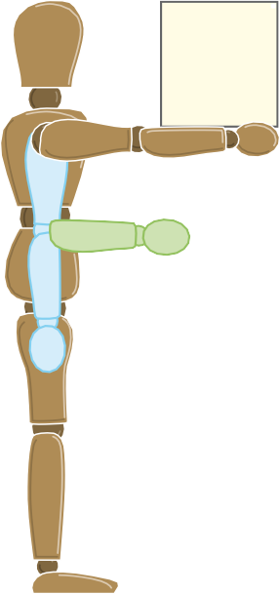
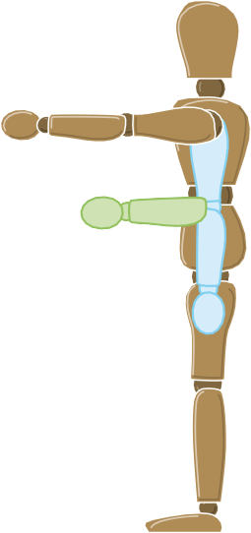
20 kg

13 kg

7 kg

25 kg

20 kg

13 kg
5 kg

Shoulder height Elbow height

15 kg

10 kg
Knuckle height

10 kg

Mid lower leg heig
5 kg

Figure 1 Lifting and lowering
7 kg
3 kg
10 kg

Twisting
Reduce the guideline weights if the handler twists to the side during the operation. As a rough guide, reduce them by 10% if the handler twists beyond 45°, and by 20% if the handler twists beyond 90°.

Frequent lifting and lowering
The guideline weights are for infrequent operations – up to about 30 operations per hour – where the pace of work is not forced, adequate pauses to rest or use different muscles are possible, and the load is not supported by the handler for any length of time. Reduce the weights if the operation is repeated more often. As a rough guide, reduce the weights by 30% if the operation is repeated once or twice a minute, by 50% if it is repeated 5–8 times a minute, and by 80% where it is repeated more than 12 times a minute.

Pushing and pulling
The task is within the guidelines if the figures in Table 2 are not exceeded:

Table 2 | Men | Women
Force to stop or start the load | 20 kg | 15 kg
Sustained force to keep the load in motion | 10 kg | 7 kg

See ‘Good handling technique for pushing and pulling’ for some examples of forces required to push or pull loads.

Using the results: Do I need to make a more detailed assessment?
Using Figure 1 is a first step. If it shows the manual handling is within the guideline figures (bearing in mind the reduced limits for twisting and frequent lifts) you do not need to do any more in most cases. But you will need to make a more detailed assessment if:

- the conditions given for using the guidelines (eg that the load can be readily grasped with both hands) are not met;
- the person doing the lifting has reduced capacity, eg through ill health or pregnancy;
- the handling operation must take place with the hands beyond the boxes in the diagram; or
- the guideline figures in the diagram are exceeded.
For pushing and pulling, you should make a more detailed assessment if:
- there are extra risk factors like uneven floors or constricted spaces;
- the worker can’t push or pull the load with their hands between knuckle and shoulder height;
- the load has to be moved for more than about 20 m without a break; or
- the guideline figures in Table 2 are likely to be exceeded.
See the HSE guidance Manual handling (see ‘Further reading’) for more advice on how to make a more detailed assessment.

HSE has also developed a tool called the Manual Handling Assessment Chart (MAC), to help you assess the most common risk factors in lifting, carrying and team handling. You may find the MAC useful to help identify high-risk manual handling operations and to help complete detailed risk assessments. It can be downloaded from www.hse.gov.uk/msd.

Does this mean I mustn’t exceed the guidelines?
No. The risk assessment guidelines are not ‘safe limits’ for lifting. But work outside the guidelines is likely to increase the risk of injury, so you should examine the task closely for possible improvements. You should remember that you must make the work less demanding, if it is reasonably practicable to do so.

Your main duty is to avoid lifting operations that have a risk of injury. Where it is not practicable to do this, assess each lifting operation and reduce the risk of injury to the lowest level reasonably practicable. Look carefully at higher risk operations to make sure they have been properly assessed.

Further reading
HSE’s website on musculoskeletal disorders: www.hse.gov.uk/msd

Manual handling. Manual Handling Operations Regulations 1992 (as amended). Guidance on Regulations L23 (Third edition) HSE Books 2004
ISBN 978 0 7176 2823 0 www.hse.gov.uk/pubns/books/l23.htm This book gives comprehensive guidance, including:
- the full text of the Manual Handling Operations Regulations 1992 (as amended in 2002) with detailed advice on each regulation;
- guidelines for assessing risk while lifting, carrying, pushing and pulling, and handling while seated;
- practical advice on measures to reduce the risk of injury; and
- an example of an assessment checklist.
Manual handling: Solutions you can handle HSG115 HSE Books 1994 ISBN 978 0 7176 0693 1 www.hse.gov.uk/pubns/books/hsg115.htm

Getting to grips with hoisting people Health Services Information Sheet HSIS3 HSE Books 2011 www.hse.gov.uk/pubns/hsis3.pdf

More guidance on risk assessment can be found at www.hse.gov.uk/risk.

Further information
For information about health and safety, or to report inconsistencies or inaccuracies in this guidance, visit www.hse.gov.uk/. You can view HSE guidance online and order priced publications from the website. HSE priced publications are also available from bookshops.

This guidance is issued by the Health and Safety Executive. Following the guidance is not compulsory, unless specifically stated, and you are free to take other action. But if you do follow the guidance you will normally be doing enough to comply with the law. Health and safety inspectors seek to secure compliance with the law and may refer to this guidance.

This leaflet can be found at www.hse.gov.uk/pubns/indg143.htm.

© Crown copyright If you wish to reuse this information visit www.hse.gov.uk/copyright.htm for details. First published 11/12.

Safe use of ladders and stepladders

A brief guide

Ladders and stepladders are not banned under health and safety law.
In fact they can be a sensible and practical option for low-risk, short-duration tasks.

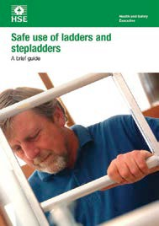
Introduction
This guidance is for employers on the simple, sensible precautions they should take to keep people safe when using ladders and stepladders in the workplace. This will also be useful for employees and their representatives.

Health and Safety Executive
This is a web-friendly version of leaflet INDG455, published 01/14
Following this guidance is normally enough to comply with the Work at Height Regulations 2005 (WAHR). You are free to take other action, except where the guidance says you must do something specific.

Ladders and stepladders are not banned under health and safety law.

In fact they can be a sensible and practical option for low-risk, short-duration tasks, although they may not automatically be your first choice. Make sure you use the right type of ladder and you know how to use it safely.

The law calls for a sensible, proportionate approach to managing risk, and further guidance on what you should do before deciding if a ladder is the right type of equipment for a particular task is provided in Working at height: A brief guide (see ‘Further reading’).

References to ladders in this leaflet, unless otherwise indicated, refer to leaning ladders (sometimes known as extension ladders) and stepladders and the guidance applies similarly to both. More specific requirements that only apply to a leaning ladder or a stepladder are covered in detail under the relevant headings.

When is a ladder the most suitable equipment?
The law says that ladders can be used for work at height when a risk assessment has shown that using equipment offering a higher level of fall protection is not justified because of the low risk and short duration of use; or there are existing workplace features which cannot be altered.

Short duration is not the deciding factor in establishing whether use of a ladder is acceptable or not – you should have first considered the risk. As a guide, if your task would require staying up a leaning ladder or stepladder for more than 30 minutes at a time, it is recommended that you consider alternative equipment.

You should only use ladders in situations where they can be used safely, eg where the ladder will be level and stable, and where it is reasonably practicable to do so, the ladder can be secured.

Who can use a ladder at work?
To use a ladder you need to be competent, ie have had instruction and understand how to use the equipment safely.

Appropriate training can help. If you are being trained, you should work under the supervision of somebody who can perform the task competently. Training can often take place on the job.

Check your ladder before you use it
Before starting a task, you should always carry out a ‘pre-use’ check to spot any obvious visual defects to make sure the ladder is safe to use.

A pre-use check should be carried out:

- by the user;
- at the beginning of the working day;
- after something has changed, eg a ladder has been dropped or moved from a dirty area to a clean area (check the state or condition of the feet).

Check the stiles – make sure they are not bent or damaged, as the ladder could buckle or collapse.

Check the feet – if they are missing, worn or damaged the ladder could slip. Also check ladder feet when moving from soft/dirty ground (eg dug soil, loose sand/ stone, a dirty workshop) to a smooth, solid surface (eg paving slabs), to make sure the foot material and not the dirt (eg soil, chippings or embedded stones) is making contact with the ground.

Check the rungs – if they are bent, worn, missing or loose the ladder could fail.

Check any locking mechanisms – if they are bent or the fixings are worn or damaged the ladder could collapse. Ensure any locking bars are engaged.

Check the stepladder platform – if it is split or buckled the ladder could become unstable or collapse.

Check the steps or treads on stepladders – if they are contaminated they could be slippery; if the fixings are loose on steps, they could collapse.

If you spot any of the above defects, don’t use the ladder and notify your employer.

Use your ladder safely
Once you have done your ‘pre-use’ check, there are simple precautions that can minimise the risk of a fall.

Leaning ladders
When using a leaning ladder to carry out a task:

- only carry light materials and tools – read the manufacturers’ labels on the ladder and assess the risks;
- don’t overreach – make sure your belt buckle (navel) stays within the stiles;
- make sure it is long enough or high enough for the task;

  - don’t overload it – consider workers’ weight and the equipment or materials they are carrying before working at height. Check the pictogram or label on the ladder for information;
  - make sure the ladder angle is at 75° – you should use the 1 in 4 rule (ie 1 unit out for every 4 units up) – see Figure 1;
  - always grip the ladder and face the ladder rungs while climbing or descending – don’t slide down the stiles;
  - don’t try to move or extend ladders while standing on the rungs;
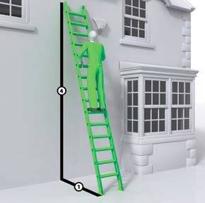
  - don’t work off the top three rungs, and try to make sure the ladder extends at least 1 m (three rungs) above where you are working;
  - don’t stand ladders on moveable objects, such as pallets, bricks, lift trucks, tower scaffolds, excavator buckets, vans, or mobile elevating work platforms;
  - avoid holding items when climbing (consider using a tool belt);
  - don’t work within 6 m horizontally of any overhead power line, unless it has been made dead or it is protected with insulation. Use a non-conductive ladder (eg fibreglass or timber) for any electrical work;
  - maintain three points of contact when climbing (this means a hand and two feet) and wherever possible at the work position – see Figures 2 and 3;
  - where you cannot maintain a handhold, other than for a brief period (eg to hold a nail while starting to knock it in, starting a screw etc), you will need to take other measures to prevent a fall or reduce the consequences if one happened;
  - for a leaning ladder, you should secure it (eg by tying the ladder to prevent it from slipping either outwards or sideways) and have a strong upper resting point, ie do not rest a ladder against weak upper surfaces (eg glazing or plastic gutters – see Figure 4);
II
Figure 1 Ladder showing the correct 1 in 4 angle (means of
securing omitted for clarity)
  - you could also use an effective stability device.

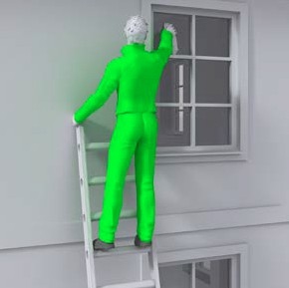
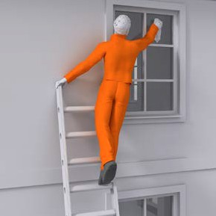
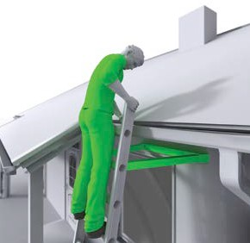
Figure 2 Correct – user
II maintaining three points of contact (means of securing
omitted for clarity)
Figure 3 Incorrect – overreaching
X and not maintaining three points of contact (means of securing
omitted for clarity)
II
Figure 4 Correct – use of a stand-off device to ensure a strong resting point. Do not rest a ladder against weak upper surfaces such as glazing or plastic gutters. Follow the manufacturer’s instructions

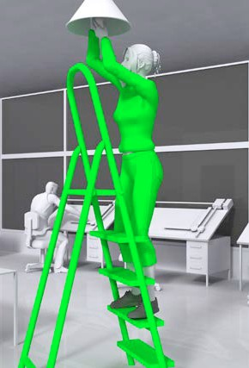
Stepladders
When using a stepladder to carry out a task:

    - check all four stepladder feet are in contact with the ground and the steps are level;
    - only carry light materials and tools;
    - don’t overreach;
    - don’t stand and work on the top three steps (including a step forming the very top of the stepladder) unless there is a suitable handhold;
    - ensure any locking devices are engaged;
    - try to position the stepladder to face the work activity and not side on. However, there are occasions when a risk assessment may show it is safer to work side on, eg in a retail stock room when you can’t engage the stepladder locks to work face on because of space restraints in narrow aisles, but you can fully lock it to work side on;
    - try to avoid work that imposes a side loading, such as side-on drilling through solid materials (eg bricks or concrete);
    - where side-on loadings cannot be avoided, you should prevent the steps from tipping over, eg by tying the steps. Otherwise, use a more suitable type of access equipment;
    - maintain three points of contact at the working position. This means two feet and one hand, or when both hands need to be free for a brief period, two feet and the body supported by the stepladder (see Figure 5 and associated text).
II
Figure 5 Example where two hands need to be free for a brief period for light work. Keep two feet on the same step
and the body (knees or chest) supported by the stepladder to maintain three points of contact. Make sure a safe
handhold is available

When deciding if it is safe to carry out a particular task on a stepladder where you cannot maintain a handhold (eg to put a box on a shelf, hang wallpaper, install a smoke detector on a ceiling), this needs to be justified, taking into account:

    - the height of the task;
    - whether a handhold is still available to steady yourself before and after the task;
    - whether it is light work;
    - whether it avoids side loading;
    - whether it avoids overreaching;
    - whether the stepladder can be tied (eg when side-on working).

What about the place of work where the ladder will be used?
As a guide, only use a ladder:

    - on firm ground;
    - on level ground – refer to the manufacturer’s pictograms on the side of the ladder. Use proprietary levelling devices, not ad-hoc packing such as bricks, blocks, timbers etc;
    - on clean, solid surfaces (paving slabs, floors etc). These need to be clean (no oil, moss or leaf litter) and free of loose material (sand, packaging materials etc) so the feet can grip. Shiny floor surfaces can be slippery even without contamination;
    - where they will not be struck by vehicles (protect the area using suitable barriers or cones);

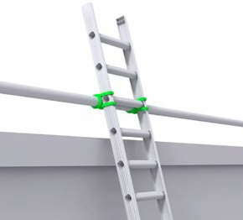
    - where they will not be pushed over by other hazards such as doors or windows, ie secure the doors (not fire exits) and windows where possible;
    - where the general public are prevented from using it, walking underneath it or being at risk because they are too near (use barriers, cones or, as a last resort, a person standing guard at the base);
    - where it has been secured.

What are the options for securing ladders?
The options are as follows:
Figure 6 Correct – ladder tied at top
II stiles (correct for working on, but not for gaining access to a
working platform/roof etc)

    - tie the ladder to a suitable point, making sure both stiles are tied, see Figures 6, 7 and 8;
    - where this is not practical, secure with an effective ladder stability device;
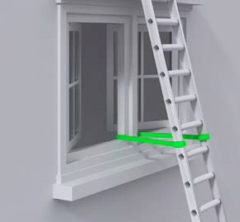
    - if this is not possible, then securely wedge the ladder, eg wedge the stiles against a wall;
    - if you can’t achieve any of these options, foot the ladder. Footing is the last resort. Avoid it, where ‘reasonably practicable’, by using other access equipment.

What about ladders used for access?
In general:

    - ladders used to access another level should be tied (see Figure 9) and extend at least 1 m above the landing point to provide a secure handhold. At ladder access points, a self-closing gate is recommended;
    - stepladders should not be used to access another level, unless they have been specifically designed for this.
II
Figure 7 Correct – tying part way
down

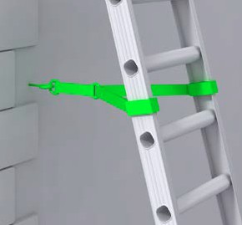
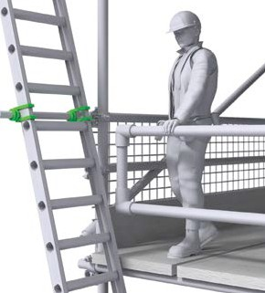
II
Figure 8 Correct – tying near
the base
Figure 9 Correct – access ladders
II should be tied and extend at least 1 m above the landing point to
provide a secure handhold

What about the condition of the equipment?
Employers need to make sure that any ladder or stepladder is both suitable for the work task and in a safe condition before use. As a guide, only use ladders or stepladders that:

- have no visible defects. They should have a pre-use check each working day;
- have an up-to-date record of the detailed visual inspections carried out regularly by a competent person. These should be done in accordance with the manufacturer’s instructions. Ladders that are part of a scaffold system still have to be inspected every seven days as part of the scaffold inspection requirements;
- are suitable for the intended use, ie are strong and robust enough for the job. HSE recommends British Standard (BS) Class 1 ‘Industrial’ or BS EN 131 ladders for use at work (see ‘Further reading’);
- have been maintained and stored in accordance with the manufacturer’s instructions.

A detailed visual inspection is similar to ‘pre-use’ checks’, in that it is used to spot defects. It can be done in-house by a competent person (pre-use checks should be part of a user’s training) and detailed visual inspections should be recorded.

When doing an inspection, look for:

- twisted, bent or dented stiles;
- cracked, worn, bent or loose rungs;
- missing or damaged tie rods;
- cracked or damaged welded joints, loose rivets or damaged stays.

Make pre-use checks and inspect ladder stability devices and other accessories in accordance with the manufacturer’s instructions.

Further reading
Working at height safely: A brief guide Leaflet INDG401(rev2) HSE Books 2014 www.hse.gov.uk/pubns/indg401.htm

Work at height web pages on the HSE website: www.hse.gov.uk/work-at-height/index.htm

You can access the Work at height Access equipment Information Toolkit (WAIT) at www.hse.gov.uk/work-at-height/wait/index

British Standards provide more information on current product standards (see ‘Further information’), eg:

BS 1129 Specification for portable timber ladders, steps, trestles and lightweight stagings British Standards Institution

BS 2037 Specification for portable aluminium ladders, steps, trestles and lightweight stagings British Standards Institution

BS EN 131 Ladders (Specification for terms, types, functional sizes; Specification for requirements, testing, marking; User instructions; Single or multiple hinge-joint ladders) British Standards Institution

Further information
For information about health and safety, or to report inconsistencies or inaccuracies in this guidance, visit www.hse.gov.uk. You can view HSE guidance online and order priced publications from the website. HSE priced publications are also available from bookshops.

British Standards can be obtained in PDF or hard copy formats from
BSI: http://shop.bsigroup.com or by contacting BSI Customer Services for hard copies only Tel: 0845 086 9001 email: cservices@bsigroup.com.

This guidance is issued by the Health and Safety Executive. Following the guidance is not compulsory, unless specifically stated, and you are free to take other action. But if you do follow the guidance you will normally be doing enough to comply with the law. Health and safety inspectors seek to secure compliance with the law and may refer to this guidance.

This leaflet is available at www.hse.gov.uk/pubns/indg455.htm.

© Crown copyright If you wish to reuse this information visit www.hse.gov.uk/copyright.htm for details. First published 01/14.

