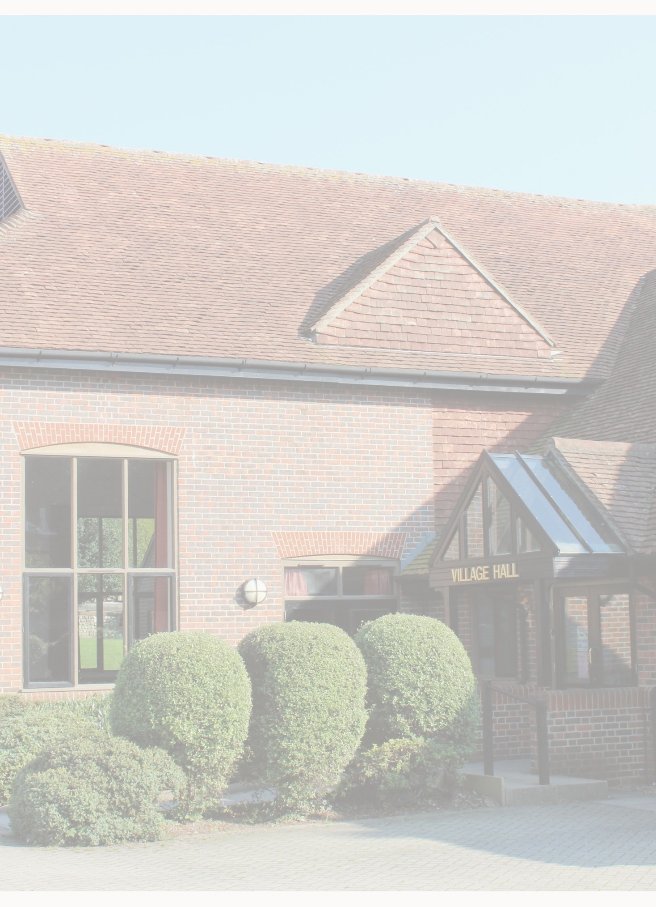

East Dean & Friston Village Hall

Fire Risk Assessment

Updated May 2026

Contents
Introduction | Page | 2
Fire hazards | Page | 2
People at risk | Page | 3
Evaluate, remove, reduce, protect from risk | Page | 4
Record, plan, inform, instruct and train | Page | 6
Review | Page | 6
Plans showing general fire safety measures | Appendix | 1
Review | Appendix | 2
Emergency evacuation capacity calculation | Appendix | 3

/Users/billhallett/Dropbox/EDFVH/Manual/Healt h & Safety/02 Fire Risk Assessment/01 Final/20170508 Fire Risk Assessment; merge part
01.docx
Page 2 Printed: 07/01/2016 14:24

Introduction
- This Fire Risk Assessment has been prepared to comply with the Regulatory Reform (Fire Safety) Order 2005.

- For the purposes of carrying out the Fire Risk Assessment the ‘responsible person’ is the Trustees of the East Dean and Friston Village Hall Trust who from time to time appoint one or more ‘competent’ persons to undertake the risk assessment.

- This Fire Risk Assessment has been carried out having regard to the Government guidance on Fire Safety Risk Assessment in Small and Medium Places of Assembly.

The guide describes five steps that should be taken when carrying out a Fire Risk Assessment:

- Identify fire hazards
- Identify people at risk
- Evaluate, remove, reduce and protect from risk
- Record, plan, inform, instruct and train
- Review

This Fire Risk Assessment follows this structure and has been carried out for each of the principal areas of useable space in the village hall, namely:

- Main Entrance and Foyer
- East Dean Hall; the Main Hall; including the Stage
- Under stage
- Friston Hall; the Small Hall
- Kitchen
- Male Toilet
- Female Toilet
- Disabled Toilet
- Cleaners’ Cupboard
- Electrical Cupboard
- Store Room including the two ‘Mezzanine’ storage areas
- Committee Room
- Loft Storage over Kitchen and Small Hall
- Boiler Room

- For each of these areas an assessment has been carried out of sources of ignition, fuel and oxygen, fire detection, fire fighting and precautionary equipment, escape routes, emergency lighting, signs and notices.

- The findings of this assessment are contained the Review in Appendix 2 and the key points discussed in the following paragraphs.

Fire Hazards: Sources of Ignition, Fuel and Oxygen

/Users/billhallett/Dropbox/EDFVH/Manual/Healt h & Safety/02 Fire Risk Assessment/01 Final/20170508 Fire Risk Assessment; merge part
01.docx
Page 3 Printed: 07/01/2016 14:24

- The main sources of ignition are the various items of electrical and gas equipment located in the Kitchen eg commercial gas hob and oven, dishwasher, microwave and refrigerator.

- Gas fired boilers and associated controls are located in an externally accessed Boiler Room.

- Elsewhere, the main sources of ignition are electric sockets and lighting located throughout all areas.

- There is audio equipment installed on the stage; and overhead projectors in both halls.

- The principal sources of fuel are concentrated in the loft storage over the Kitchen and Small Hall.

- Elsewhere, the main sources of fuel are the upholstered seating, stage curtains and various other curtains at each of the main windows as well as the wooden stage itself.

- The main source of oxygen is the natural airflow through doors, windows and other openings. This natural airflow is sometimes supplemented by mechanical means when the extract system is used to the Main Hall and through wall local extract fans are used in other locations.

People at Risk

People who use the hall and may be at risk if there is a fire include:

- Employees

- Hirers

- The Village Hall Trustees

- Local organisations

- Contractors

- Cleaners

- Visitors

- Children

- The elderly

- People with disabilities (mobility, hearing or vision impairment)

/Users/billhallett/Dropbox/EDFVH/Manual/Healt h & Safety/02 Fire Risk Assessment/01 Final/20170508 Fire Risk Assessment; merge part
01.docx
Page 4 Printed: 07/01/2016 14:24

- These people may or may not be familiar with the Hall layout.

Evaluate, remove, reduce and protect from risk

The risk of fire occurring

- It is considered that the risk of fire occurring is relatively low. The main sources of ignition comprise electrical equipment located in the Kitchen and gas boilers in the Boiler Room. Combustible materials are kept away from these sources and all equipment and boilers are regularly serviced and maintained in a good state of repair. The Boiler Room can only be accessed externally and is of a brick/block construction.

- Elsewhere, electric sockets and lighting are well maintained

The risk to people

- An evaluation has been carried out of the actual risk to people identified in Step 2 in the event a fire did start and spread from those areas with the main sources of ignition.

- Apart from the Loft Storage Areas, all other rooms are all at ground floor level and are open to the various escape routes available.

- The loft storage area over the Small Hall and Kitchen is a relatively confined space and the only escape routes are via the trap door access ladder into the Kitchen or by ladder from an access door in a bulkhead which leads into the Main Hall. Escape would then by via one of the main escape routes. If anyone is in that Loft Storage Area, at least, one of these access ladders will be in place.

Removal/reduction of the hazards

- The identified potential hazards comprise the range of electrical equipment contained in the Kitchen which is an essential part of the facilities available to the users of the Village Hall. Removal would not be in the best interests of the Village Hall or its users and the potential hazards are reduced as far as possible through regular maintenance, inspection and servicing.

- Similarly, the boilers located in the externally accessed Boiler Room are essential for the comfort and well-being of users of the hall. Their potential hazards are minimised through regular servicing. The Boiler Room is of a brick/block construction which should contain or significantly delay the spread of fire.

- No flammable paint and varnishes are stored in the in the Loft Storage Area (over the Kitchen and Small Hall) or elsewhere in within the building.

/Users/billhallett/Dropbox/EDFVH/Manual/Healt h & Safety/02 Fire Risk Assessment/01 Final/20170508 Fire Risk Assessment; merge part
01.docx
Page 5 Printed: 07/01/2016 14:24

- The Village Hall operates a ‘No Smoking’ policy in all areas of the building.

- Elsewhere flammable materials are limited to curtains, tables and seating, and generally are kept away from potential hazards. Similarly, mats and various sports and leisure equipment used by local groups are kept secure within the Store Room off the Main Hall where potential fire risks are very low.

Removal/reduction of the risks to people

- The fire risk to people has been reduced to as low as reasonably practical by ensuring that adequate fire precautions are in place to warn people in the event of fire and to allow them to escape safely.

- A fire alarm system is in place incorporating fire/smoke/heat detectors and alarm sounders throughout the building. Manually operated ‘break glass’ points which are located in the Main Entrance/Foyer, the Main Hall, the Kitchen and in the main corridor escape route. Locations of these are shown on a plan in Appendix 1 of this Assessment.

- Fire extinguishers for particular types of fire are situated in the Main Entrance/Foyer, Main Hall, Small Hall, Kitchen, Committee Room, the Stage and in the Loft as detailed on the plans in Appendix 1. These are regularly inspected and the Certificate of Inspection is retained in the Hall’s Operating Manual. There are two fire blankets located in the Kitchen.

- There are five main escape routes available at ground floor level and are readily accessible from all parts of the building. All are independent of each other with emergency escape lighting. The emergency lighting is tested every week and the battery packs are tested every six months. The main escape routes are:

Via the Main Entrance
Via two external fire escape doors in the Main Hall Via an external fire escape door in the Small Hall Via an external fire escape door in the Kitchen

In addition, two further escape routes are available via external doors from the elevated stage via the WC Lobby and from the Store Room.

- Escape routes are all unencumbered and are shown on the plan in Appendix 1. All external fire escape doors lead to the outside areas that provide open space for safe and easy clearance of the hall.

- Escape routes and exits together with the locations of fire fighting equipment are indicated by appropriate signs throughout the building.

- Notices indicating the location of fire doors and fire extinguishers are situated in a variety of positions around the building. Each fire extinguisher has operating instructions clearly displayed. Locations of fire extinguishers are shown on the plan in Appendix 1.

/Users/billhallett/Dropbox/EDFVH/Manual/Healt h & Safety/02 Fire Risk Assessment/01 Final/20170508 Fire Risk Assessment; merge part
01.docx
Page 6 Printed: 07/01/2016 14:24

Installation, testing and maintenance

- All fire prevention and fire fighting equipment is maintained in effective working order through regular checks, periodic servicing and maintenance. Sources of risk are also checked on a regular basis.

- Weekly checks are made of water heaters, refrigerators, emergency lighting, fire doors, lights, dishwasher, water boiler and the fire alarm.

- An annual check is made of the fire extinguishers and a certificate of inspection obtained. The electrical system is also checked on an annual basis and a safety certificate obtained. The gas boilers are serviced annually.

Conditions of Hire

- The conditions of hire of the Village Hall state that fire and other exits must not be obstructed. The conditions of hire are shown on the Village Hall web-site and are included in the Hall’s Operating Manual.

Record, Plan, Inform, Instruct and Train

Significant findings and action taken

- The main findings of the fire risk assessment including the actions taken to prevent fire occurring and to reduce the risk to people are contained in the preceding sections of this report.

- A plan showing the general fire safety measures is included in Appendix 1.

Emergency plan

- The Village Hall has a relatively simple layout with clear and well signed escape routes. As explained above, the conditions of hire state that fire and other exits must not be obstructed and that illuminated fire exit signs must be on for all public entertainment.

Information and instruction

- Copies of the Conditions of Hire are provided to hirers who are required to accept and adhere to them.

- Signs indicating the location of fire escape doors and fire extinguishers are posted at various prominent and visible points throughout the Village Hall.

- Fire safety advice is given to the hall employees, cleaners and contractors.

/Users/billhallett/Dropbox/EDFVH/Manual/Healt h & Safety/02 Fire Risk Assessment/01 Final/20170508 Fire Risk Assessment; merge part
01.docx
Page 7 Printed: 07/01/2016 14:24

Review

- This fire risk assessment has been carried out for the Village Hall following the introduction of the Regulatory Reform (Fire Safety) Order 2005. The assessment is kept under review particularly with regard to any potential new risks and the need to keep them under control and, also, to ensure that the fire precautions are still working effectively.

- A review of this Fire Risk Assessment is included in Appendix 2.

/Users/billhallett/Dropbox/EDFVH/Manual/Healt h & Safety/02 Fire Risk Assessment/01 Final/20170508 Fire Risk Assessment; merge part
01.docx
Page 8 Printed: 07/01/2016 14:24

Appendix 1

Plans showing the general fire safety measures Plan 1; Ground Floor Fire Alarm Zones Plan 2; Loft Fire Alarm Zones
Plan 3; Ground Floor Fire Escape Routes

Plan 4; Ground Floor Fire Extinguisher Location Plan 5; Loft Fire Extinguisher Location
Plan 6; Ground Floor Emergency Lighting, etc Plan 7; Loft Emergency Lighting, etc

/Users/billhallett/Dropbox/EDFVH/Manual/Healt h & Safety/02 Fire Risk Assessment/01 Final/20170508 Fire Risk Assessment; merge part
01.docx
Page 9 Printed: 07/01/2016 14:24


Boiler
Ladies Toilet
Disabled Entrance Toilet Lobby
Male Toilet
Elec
Main Hall
Zone 8
Store
Foyer
Cleaners
C C C Cupboard
Small Hall
Committee Room
Kitchen
Below Stage (Zone 8)
Stage
Above Stage (Zone 7)
WC
(Zone 8)
high level
Roof void at
Zone 2
Zone 1
Zone 8
Zone 6
Zone 4
Zone 5
Zone 3
Zone 7
East Dean & Friston Village Hall

Plan 1
Diagrammatic Ground Floor Planshowing Fire Alarm Zones

Not to scale

East Dean & Friston Village Hall

Diagrammatic Loft Floor Plan showing Fire Alarm Zones

Not to scale
Zone 1
Zone 3
Zone 5
Zone 7
Zone 2
Zone 4
Zone 6
Zone 8


Up
Freestanding steps down to Main Hall secured at head

Loft ladder from trap door down to Kitchen
Doors in bulkhead onto Main Hall

Denotes Final Fire Escape Door


Boiler
Female Toilet
Disabled Toilet
Entrance Lobby
Main Hall
Male Toilet
Elec
Store
Foyer
1500.00
Cleaners
C C C Cupboard
Small Hall
Committee Room
Kitchen
Stage
WC
East Dean & Friston Village Hall

Plan 3
Diagrammatic Floor Plan showing final Fire Escapes
Not to scale


Water
Foam
Boiler
Disabled Toilet
Entrance Lobby
Main Hall
Powder
Female Toilet
Male Toilet
Elec
Store
Foyer
Water CO2
Foam
Cleaners
C C C Cupboard
Fire blanket
Water
Foam
Small Hall
Committee Room
Kitchen
Stage
Fire blanket
WC
CO2
East Dean & Friston Village Hall

Plan 4
Diagrammatic Floor Plan showing Fire Extinguisher & Fire Blanket locations
Not to scale

East Dean & Friston Village Hall

Plan 5
Diagrammatic Loft Floor Plan showing fire extinguishers

Not to scale

Up
Freestanding steps down to Main Hall secured at head

Foam C02
Loft ladder from trap door down to Kitchen
Doors in bulkhead onto Main Hall


Emergency illuminated Fire exit sign over door

H
Fire Alarm Panel
Emergency illuminated Fire exit sign over door
H

Break Glass Fire Alarm Point
Emergency Light
Emergency illuminated Fire exit sign over door

H
Boiler
Ladies Toilet
Disabled Toilet
Entrance Lobby
H
Male Toilet
Elec
Main Hall
Emergency illuminated Fire exit sign over door
Store
H
Foyer
C
C
C
Cleaners Cupboard
Emergency illuminated Fire exit sign over door
Emergency illuminated Fire exit sign over door
Small Hall
Kitchen
Committee Room
Emergency illuminated Fire exit sign over door
Stage
Emergency illuminated
H Fire exit sign over door
WC
Emergency illuminated Fire exit sign over door
East Dean & Friston Village Hall

Plan 6
Diagrammatic Floor Plan
showing Emergency Lighting, Fire Alarm Points, etc

Not to scale

East Dean & Friston Village Hall

Plan 7
Diagrammatic Loft Floor Plan showing emergency lighting

Not to scale

Up
Freestanding steps down to Main Hall secured at head

Emergency Light
Emergency Light
Loft ladder from trap door down to Kitchen
Doors in bulkhead onto Main Hall

East Dean & Friston Village Hall Fire Risk Assessment

Appendix 2

Review of this Fire Risk Assessment

/Users/billhallett/Dropbox/edfvh/Manual/Health & Safety/02 Fire Risk Assessment/01 Final/20170322 Fire Risk Assessment; merge part
02.docx
Page 1 of 1 Printed: 07/01/2016 14:24

Location | Sources of ignition, fuel and oxygen | Fire detection, fire fighting and  precautionary equipment | Escape routes | Emergency lighting, signs and notices
Main entrance and foyer | Electric sockets and lighting. Computer workstation.  Wi---fi router. Pay telephone.  Security alarm sounder. Security alarm sensor. Fire alarm control box. Carpet. | See plans in Appendix 1 | See plans in Appendix 1 | See plans in Appendix 1  Adequate and appropriate signage throughout.
East Dean Hall including Stage | Electric sockets and lighting.  Permanently fixed Stage lighting and production equipment (Players) (stage).  Mechanical ventilation and controls.  Audio equipment including wall mounted speakers. Overhead Projector.  Overhead microphone. Security alarm sensors.  Upholstered seating and curtains. | See plans in Appendix 1 | See plans in Appendix 1 | See plans in Appendix 1  Adequate and appropriate signage throughout.
Friston Hall; includes Cupboard nrs 1, 2 & 3 | Electric sockets and lighting. Wall mounted audio speakers.  Xpelair through wall ventilation fan & controls. Upholstered seating and curtains.  Overhead projector. Security alarm sensors.  Hessian covered acoustic ceiling panels. | See plans in Appendix 1 | See plans in Appendix 1 | See plans in Appendix 1  Adequate and appropriate signage throughout.

Location | Sources of ignition, fuel and oxygen | Fire detection, fire fighting and  precautionary equipment | Escape routes | Emergency lighting, signs and notices
Kitchen | Electric sockets and lighting. Gas hob & oven.  Gas supply unit.  Hob extract canopy and duct. Dishwasher.  Extract fans. Insectocutor.  Free standing hot cupboards; 2 nr. Counter top boilers; 2 nr.  Kettles and other small appliances. Microwave.  Refrigerator. | See plans in Appendix 1 | See plans in Appendix 1 | See plans in Appendix 1  Adequate and appropriate signage throughout.
Disabled toilet. | Lighting.  Extract fan and controls. | See plans in Appendix 1 | See plans in Appendix 1 | See plans in Appendix 1  Adequate and appropriate signage throughout.
Male toilet | Lighting.  Extract fan and controls. Curtains. | See plans in Appendix 1 | See plans in Appendix 1 | See plans in Appendix 1  Adequate and appropriate signage throughout.
Female Toilet | Lighting.  Extract fan and controls. Curtains. | See plans in Appendix 1 | See plans in Appendix 1 | See plans in Appendix 1  Adequate and appropriate signage throughout.
Store Room includes two mezzanine storage areas | Electric sockets and lighting.  Xpelair through wall ventilation fan & controls. Art display units (mezzanine loft area).  Sundry timber items, etc.  Cables in steel electric trunking to walls. Upholstered seating.  Curtains.  Stage extension fittings. Tables and racks.  Easels, etc. Trestles. | See plans in Appendix 1 | See plans in Appendix 1 | See plans in Appendix 1  Adequate and appropriate signage throughout.

Location | Sources of ignition, fuel and oxygen | Fire detection, fire fighting and  precautionary equipment | Escape routes | Emergency lighting, signs and notices
Committee Room | Electric sockets and lighting.  Xpelair through wall ventilation fan & controls. Refrigerator.  Freezer.  Security alarm sensor. Timber cabinets.  Curtains. Trestles. | See plans in Appendix 1 | See plans in Appendix 1 | See plans in Appendix 1  Adequate and appropriate signage throughout.
Toilet Lobby off Committee Room | Lighting. | See plans in Appendix 1 | See plans in Appendix 1 | See plans in Appendix 1  Adequate and appropriate signage throughout.
Toilet off Committee Room | Lighting.  Xpelair through wall ventilation fan & controls. | None. | See plans in Appendix 1 | See plans in Appendix 1  Adequate and appropriate signage throughout.
Boiler Room | Electric sockets and lighting. Boilers.  Incoming gas supply. Electrical controls, etc | See plans in Appendix 1 | See plans in Appendix 1 | See plans in Appendix 1  Adequate and appropriate signage throughout.
Electrical Cupboard | Lighting. Distribution board.  Electrical controls, timers, etc | See plans in Appendix 1 | See plans in Appendix 1 | See plans in Appendix 1  Adequate and appropriate signage throughout.
Cleaners’ Cupboard | Lighting.  Table clothes | See plans in Appendix 1 | See plans in Appendix 1 | See plans in Appendix 1  Adequate and appropriate signage throughout.
Loft Storage | Electric sockets and lighting. Electrical controls, etc | See plans in Appendix 1 | See plans in Appendix 1 | See plans in Appendix 1  Adequate and appropriate signage throughout.

Appendix 3

Emergency Evacuation Capacity calculation

/Users/billhallett/Dropbox/edfvh/Manual/Health & Safety/02 Fire Risk Assessment/01 Final/20170322 Fire Risk Assessment; merge part
03.docx
Page 1 of 2 Printed: 07/01/2016 14:24

Check against fire escape criteria: | Main Hall | Small Hall
FE doors; single | 0 | 1
FE doors; double | 3 | 1
In event of fire, doors assumed out of use | 1 (double) | 1 (double)
Operable doors | 2 (double) | 1 (single)

Evacuation time for traditional built building | 2.5 | minutes
Evacuation capacity per single door | 40 | people per minute
Evacuation capacity per double door | 80 | people per minute
Evacuation capacity in 2.5 minutes | Main Hall  400 people |  | Small Hall  100 people

Notes: This calculation is purely to assess the numbers in respect of emergency evacuation. Other factors will dictate safe capacities for Hall usage which will be less than the numbers shown above.

This calculation assumes all occupants will be able bodied. Management measures to be put in place in the event of any disabled occupants.

For the purpose of this calculation the escape routes from the Main Hall through the Store and the Committee Room have been ignored.

/Users/billhallett/Dropbox/edfvh/Manual/Health & Safety/02 Fire Risk Assessment/01 Final/20170322 Fire Risk Assessment; merge part
03.docx
Page 2 of 2 Printed: 07/01/2016 14:24

