Washington Behavioral Health Peer Support Services | - Member and Provider Information
  What are Peer Support Services?  Peer Support Services are community support services that provide help to people with behavioral health conditions, such as substance use or mental health conditions. A Certified Peer Support Specialist is someone who has also lived with a behavioral health condition. They use their own experiences and training to help others who are living with similar conditions reach their health goals. Peer Support Services can be available at any time during a person’s care.  - Additional Support  - If you need additional support or have trouble finding Peer Support Services in your area, please contact your insurance provider’s Case Management Program.  - Community Health Plan of Washington  - Phone: 206-418-7004 or Fax: 206-652-7073 Email: CareMgmtReferrals@chpw.org  Coordinated Care Apple Health Care Management Department  1-877-644-4613 (TTY: 711)  Send a secure email to caremanagement@coordinatedcarehealth.com  Coordinated Care Apple Health Core Connections Health Care Coordination (Foster Care)  1-844-354-9876  Send secure email to AHCCTeam@coordinatedcarehealth.com  - Molina Healthcare  - Phone: 800-869-7175 ext. 142618  Provider Questions Email: MHWCMReferrals@MolinaHealthCare.Com  - UnitedHealthcare  - Member Services: 877-542-8997 TTY 711  - Provider Questions Email: wa_behavioralhealthreferrals@uhc.com  - Wellpoint  - Member and Provider Questions Email: WABHReferrals@wellpoint.com  - Member services: 1-833-731-2167  - King County  Provider & Client Services line at 206-263-8997 or 1-800-790-8049        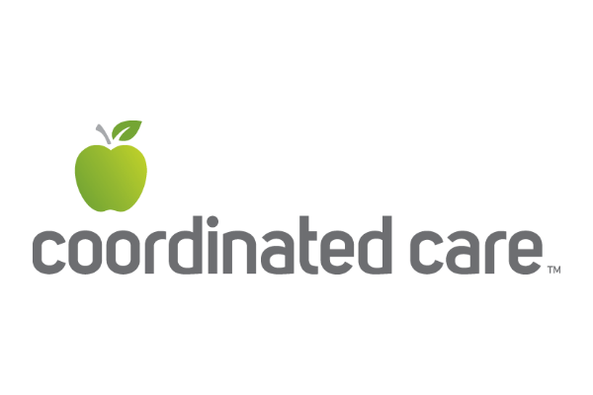  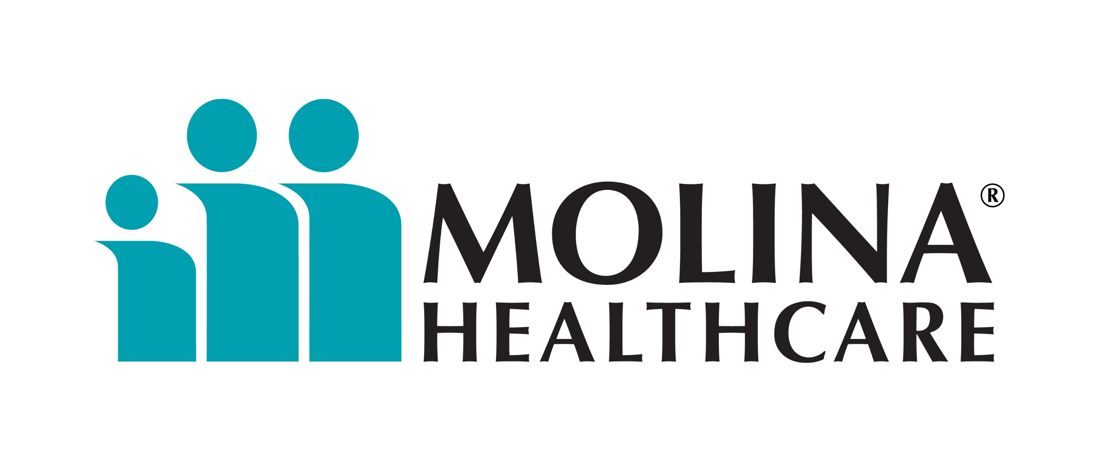 | Peer Support Services may include:  - Helping people, families, and caregivers find their way through the healthcare system to access clinical and community services.  - Working together with a person’s care team, case workers, and providers to make sure they get the help they need.  - Sharing helpful tools, skills, supports, and resources that can help people reach their health goals.  - Helping people feel hopeful, confident, and motivated during their care journey.  Peer Support Resources  A Common Voice, the Center of Parent Excellence (C.O.P.E.)- Peer Support Services for parents and caregivers: https://www.acommonvoice.org/  Behavioral Health Agencies Directory- list of licensed providers offering Peer Support Services in WA: https://doh.wa.gov/sites/default/files/2022-02/606019-BHADirectory.pdf  Clubhouse International- Peer-Led Support and Resources: https://clubhouse-intl.org/  Dads MOVE- Family-Centered Peer Services and Education: https://www.dadsmovewa.org/  Health Care Authority Peer Support and counseling- overview of Peer Support Services in WA: https://www.hca.wa.gov/free-or-low-cost-health-care/i-need-behavioral-health-support/peer-support-and-counseling#how-do-i-find  NAMI Peer Led Connection and Family Led Support Groups: https://www.namiwa.org/support-groups  Peer Washington- connect to Peer Support Services in WA: https://www.peerwa.org/services  Recovery Café- Peer Support and Community Building: https://recoverycafe.org/  Teen Link- teen Peer Support Services help line: https://www.teenlink.org/  Warm Line- Peer Support Services help line: https://www.crisisconnections.org/wa-warm-line/

