Think like a Writer

Build a noun phrase:

- Choose a thought provoking image from the internet, this could be a famous painting, a picture from the news or an historical photo.

- Choose five brick colours that will represent the different parts of the sentence:
Determiners e.g. the, those, yours, some
Noun e.g. car, Tom, cat
Adjectives e.g. smooth, tiny, smelly
Prepositional phrase e.g. above the cliff, next to the chair
Adverbial phrase e.g. by the wooden gate, next

- Ask the children to write five noun phrases about the picture you are using.
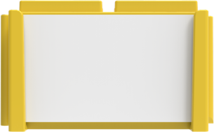
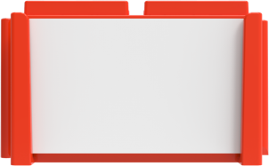
(Noun)
(Determiner)
rainbow
A
The
man

- Now add an adjective to each of the noun phrases.
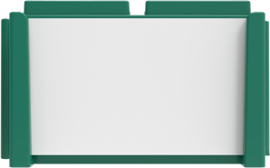
(Noun)
(adjective)
The
(Determiner)

man
towering

rainbow
A
beautiful

- Now add a prepositional phrase.
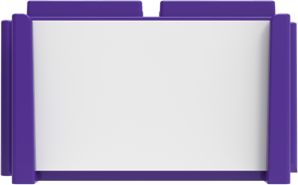
Prep-
phrase
(adjective)
towering
beautiful
(Noun)
(Determiner)
rainbow
A
man
The

with a kind face.

with bright colours

- Finally, extend the creations with an adverbial phrase.

Prep-
phrase
Adverbial
phrase
The
man
A
rainbow
(Determiner)
(Noun)
beautiful
towering
(adjective)
with bright colours

with a kind face.
in the shop

in the sky

Extension Activity

- How can you turn the phrase into a sentence?

