Site details
Site Name | Site Address | Post code | High risk building reference | Project Name
 |  |  | HRBxxxxxxxxx

Duty Holders
Duty holder | Name | email | telephone number | Company
Client
Individual Principal Designer
Individual Principal Contractor
Principal Accountable Person

Objective of change control plan
Schedule 1, The Building (Higher-Risk Buildings Procedures) (England) Regulations 2023 notes a Change Control Plan must set out the strategies, policies and procedures the client has adopted to ensure any controlled change takes place in accordance with regulation 18 (change control), and to log each controlled change in accordance with regulation 19 (change control: record-keeping) explaining -
(a) How proposed changes will be identified and to whom they must be reported;
(b) How the impacts of proposed changes are identified and considered;
(c) In relation to proposed changes, the decision-making procedures adopted for agreeing a change including whose advice is to be sought;
(d) How changes are recorded and by when;
(e) The procedure to identify which changes require notification to the regulator and which changes require a change control application;
(f) How the effectiveness of the change control plan will be reviewed by duty-holders periodically.

The Change Control Plan sets out how [Contractor] will manage the change control process through engagement with other duty-holders, contractors and designers. It sets out how changes will be assessed for their impact, how they will be recorded, and how the Building Safety Regulator will be notified of the changes which affect building works.

Legal Provisions
The Building (Higher-Risk Buildings Procedures) (England) Regulations 2023 and HRB SCHEDULE 1, Paragraph 2
The Building (Higher-Risk Buildings Procedures) (England) Regulations 2023 – Regulation 2
The Higher-Risk Buildings (Descriptions and Supplementary Provisions) Regulations 2023 (defines a HRB and separate sections of the building).
The Building Safety Act 2022
Building Regulations 2010 (as amended).
Construction (Design and Management) Regulations 2015 (CDM 2015).
Work at Height Regulations 2005.
Lifting Operations and Lifting Equipment Regulations 1998 (LOLER).
Health and Safety at Work Act 1974.

Change Control Plan
The Dutyholders must analyse the effect of change on the original Gateway 2 and Gateway 3 approval applications before the changes are implemented. Changes that affect the building works must be recorded by a change control form, and by revisions to documents and drawings which will collectively show the change for approval. Such accepted changes will subsequently be presented in the as built drawings and documents for inclusion in the 'Golden Thread', alongside a change log record.
Reg.18(1) controlled changes can be any one of the following:
(a) a change to any current plans of any work or proposed work or the carrying out of work otherwise than in accordance with the current plans;
(b) a change to any stage of HRB work, including adding or removing a stage;
(c) a change to any strategies, policies or procedures described in any current agreed document.

There are three district categories of “Controlled Change”

Types of Controlled Change

Major change
A major change undermines the basis by which building control approval was granted and an application MUST be made to the Building Safety Regulator BEFORE it can be commenced. Examples of major change are listed.
• a change which is a material change of use to any part of a proposed higher-risk building;
• a change to the number of storeys in a proposed higher-risk building (including adding or removing a mezzanine or gallery floor)
• a change to the structural design or structural loading of the building;
• a change to the number or width of the staircases or a change to the length of any other escape route or the number or width of any escape route (including evacuation lift) within the proposed building;
• a change to the external wall of a proposed higher-risk building including a wall tie, wall restraint fixing or support system in the wall;
• a change to any part of the active fire safety measures or passive fire safety measures referred to in the fire and emergency file;
• a change to the layout or dimensions of the common parts of the building;
• a change of any construction product or building element to be used, such that its replacement is of a lower classification under the reaction to fire classification (within the meaning in regulation 2(6) of the 2010 Regulations(2));
• a change to any assumptions made in the design as set out in the Building Regulations compliance statement;
• a change which would propose early occupation of any part of the proposed higher-risk building before all the work is completed.

Notifiable change

A notifiable change potentially has an impact on compliance. The Building Safety Regulator must be notified.
A notifiable change can be started once the Building Safety Regulator has been notified.
A Notifiable change within the scope of this specific project could include:
• a change to the construction control plan;
• a change to the change control plan;• a change to the layout of a room;
• a change to the number or dimensions of any openings in any wall, ceiling or other building element for any pipe, duct or cable;
• a change to the wall tie, wall restraint fixing or support system in any wall or proposed wall (excluding an external wall);
• a change of any construction product or building element to be used in or on a proposed higher-risk building (or to be used as part of works) where its replacement is of the same or higher classification under the reaction to fire classification (within the meaning in regulation 2(6) of the 2010 Regulations);
• any other change to the fire and emergency file or the fire safety compliance information;
• a change specified by the regulator as a notifiable change by notice given in accordance with regulation 25 (change control: regulator power to specify notifiable • changes and major changes);
• a change to the partial completion strategy or a change to a staged work statement or a subsequent stages statement (as defined in regulation 4(3)

Recordable change

A change that has no effect on the Building Regulation Application or impact on compliance.

[Contractor] Change Control Process.
All site changes, deviations from those specified in the detailed design must be reported to the PICW to log within the [Contractor] IMS-FRM-240B Project Change Control form. (A Blank Copy is inserted into Appendix A)
All change requests MUST be logged and approved before the change is carried out.
The flow chart below presents the change management flow required for building regulations management. All contractors and personnel working on site will be inducted and this process detailed to all to ensure compliance.
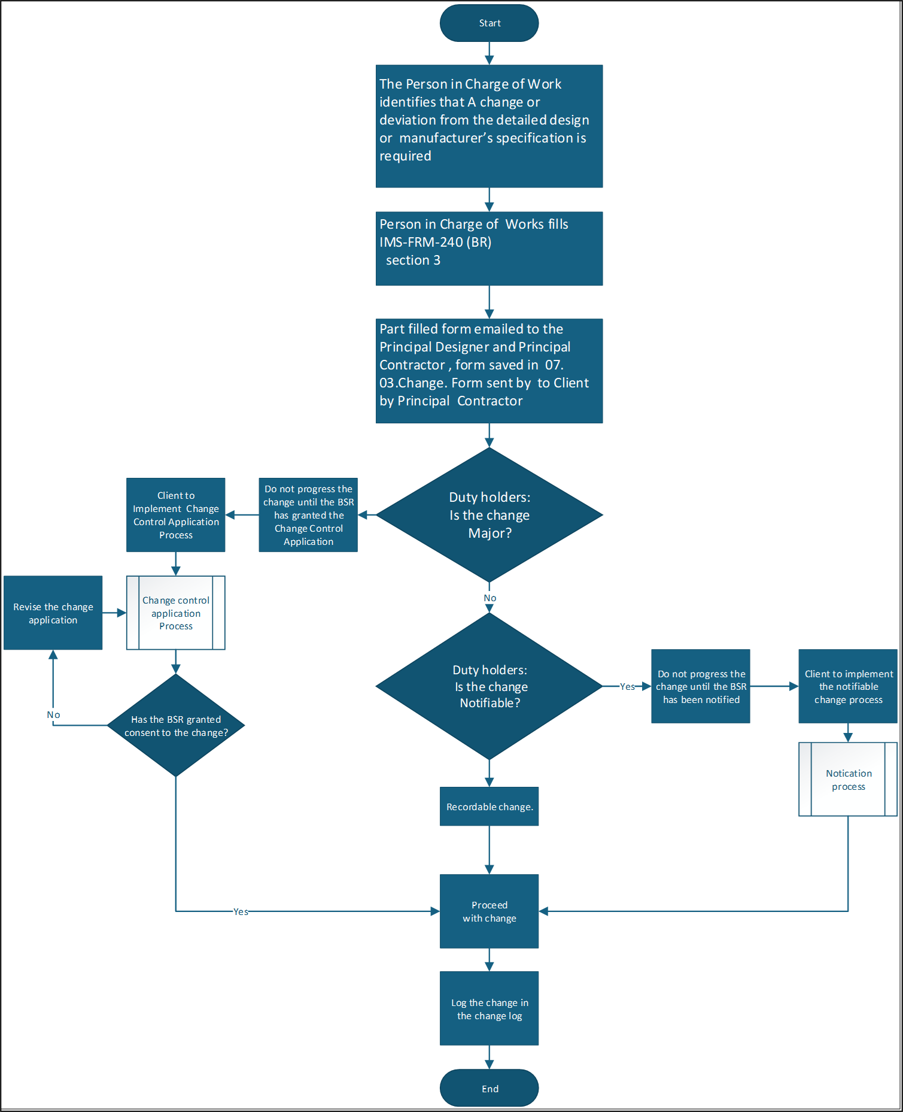

Change Control Application

Major change
Where the controlled change is a major change, the client must make an application for building control approval in respect of the change (a “change control application”) to the Building Safety Regulator in accordance with Reg.21 (change control applications). A major change must not be carried out, and the work to which it relates must not start, until the change control application is granted; a record is made of the controlled change in the Change Control Log; and a revised version of any agreed document(s) affected by the change is produced.
Requirements:
A major change application must be in writing, signed by the client, and must include -
(a) the name, address, telephone number and (if available) email address of the client,
(b) the name, address, telephone number and (if available) email address of the principal contractor (or sole contractor) and the principal designer (or sole or lead designer),
(c) a statement that the application is made under this regulation, and
(d) a description of the proposed controlled change.
The application must be accompanied by -
(a) an explanation of the reasons why the change has been proposed,
(b) a list of the name and occupation of each person, if any, whose advice was sought in relation to the proposed change and a summary of any advice provided,
(c) where the change is to the number of flats or residential rooms, plans showing the number of flats or residential rooms it is proposed the higher-risk building will contain,
(d) an assessment of the agreed documents affected by the proposed change,
(e) a compliance explanation in relation to the proposed change, and
(f) where the application is made by someone on behalf of the client, a statement signed by the client confirming they agree to the application being made and that the information contained in the application is correct,
b) and the application must be accompanied by the revised version of the agreed document(s).
For information, the Building Safety Regulator must determine a valid major change application within 6 weeks beginning with the date the application is received or within such longer period as at any time the regulator and the applicant agrees in writing.

Notifiable change
Where the controlled change is a notifiable change, the client must notify the regulator in accordance with Reg.20 (change control: notification requirements). A notifiable change must not be carried out, and the work to which it relates must not start, until the notification to the Building Safety Regulator has occurred; a record is made of the controlled change in the Change Control Log; and a revised version of any agreed document(s) affected by the change is produced.
Requirements:
A notifiable change must be in writing, signed by the client, and must include -
a) a description of the proposed controlled change,
b) an explanation of the reasons why the change has been proposed,
c) a list of the name and occupation of each person, if any, whose advice was sought in relation to the proposed change and a summary of any advice provided,
d) an assessment of the agreed documents affected by the proposed change,
e) a compliance explanation in relation to the proposed change, and
f) where the notification is made by someone on behalf of the client, a statement signed by the client confirming they agree to the notification being given and that the information contained in the application is correct, and the notice must be accompanied by the revised version of the agreed document(s)
The Building Safety Regulator may, by notice in writing, require the person giving the notification to provide further information in relation to the proposed controlled change. This is to be provided within 10 working days of receipt of the notice.

Recordable change
Recordable changes do not require notification / application to the Building Safety Regulator, but must be recorded on the Change Control Log (see appendix A)

APPENDIX A

