Site details
Site Name | Site Address | Post code | High risk building reference
 |  |  | HRBxxxxxxxx

Duty Holders
Duty holder | Name | email | telephone number | Company
Client
Individual Principal Designer
Individual Principal Contractor
Principal Accountable Person

Designers
Role | Name | Phone | email | Company
Designer
Structural Designer
Electrical Designer

Objective of this Building Regulations Compliance Statement

This statement and its appendix documents the approach taken to make sure Building Regulations are met and that the proposed building work, once built, will meet building regulations,
Drawings and plans have been produced to present the proposal to install a new telecommunications cell on the building’s roof. The new cell will provide 4G and 5G coverage and additional capacity for two mobile network operator’s , [MNO Name] and [MONO Name]. This site share arrangement reduces the requirement for other cells on other buildings in the area.
The scope presented in the design includes building works as defined in Building Regulations 2010. There are alterations proposed that are material to functional requirements of approved documents A, B, C, and P and hence categorised as ‘A’ . Other functional requirements of approved documents E, H, L, R and 7 are also applicable. The alterations are described in the Building Regulations Compliance Statement provided in Appendix A.
More detailed assessments of the how the planned work will meet the relevant functional requirement of each applicable approved document is provided in the same document, and where necessary further detail is supplied to explain why measures have been chosen in preference to others to meet the functional requirement. The application and compliance to British and BS EN standards and design codes is further assessed under each applicable Approved Document.

Legal Provisions
The Building (Higher-Risk Buildings Procedures) (England) Regulations 2023 and HRB SCHEDULE 1, Paragraph 2
The Building (Higher-Risk Buildings Procedures) (England) Regulations 2023 – Regulation 2
The Higher-Risk Buildings (Descriptions and Supplementary Provisions) Regulations 2023 (defines a HRB and separate sections of the building).
The Building Safety Act 2022
Building Regulations 2010 (as amended).
Construction (Design and Management) Regulations 2015 (CDM 2015).
Work at Height Regulations 2005.
Lifting Operations and Lifting Equipment Regulations 1998 (LOLER).
Health and Safety at Work Act 1974.

The Site
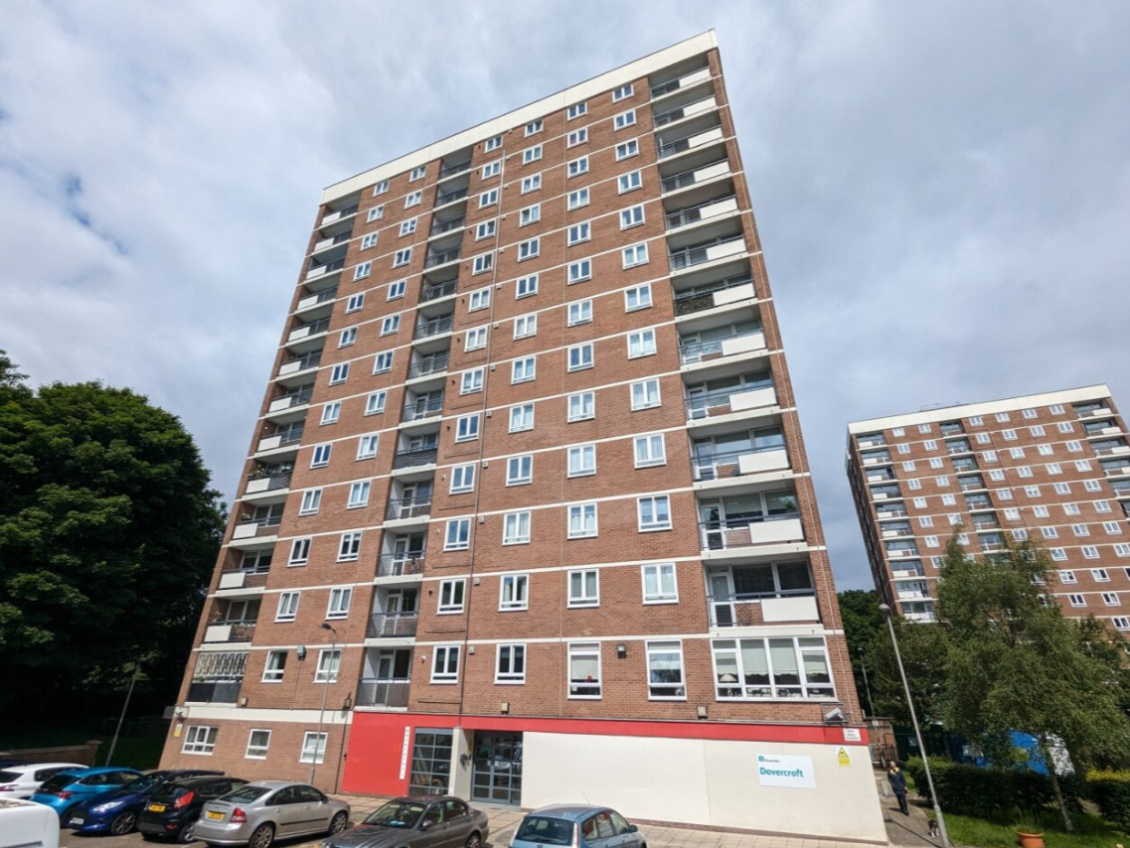 | 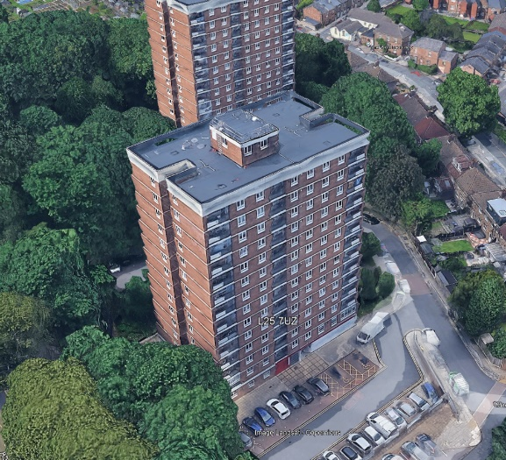
South Elevation | Bird’s Eye view courtesy of Google Earth

The Building is registered on the .Gov Higher Risk Building register as follows.
HRBxxxxxxxxxxx
Building Name
Address
Number of floors above ground | 14
Height from ground level to the top floor, not the roof. | 34 metres
Number of residential units | 79
When was the building completed [Building Name] was completed between 2001-2006.
The [AP/PAP Name] is responsible for the building's safety (accountable persons).
The [AP/PAP Name] is responsible for:
- the routes that residents can walk through, like corridors, staircases and fire doors
- facilities that residents share, like laundry rooms or bin rooms
- maintaining plant and equipment - this includes lifts, firefighting equipment and any other machinery in the building
The [AP/PAP Name] is the principal accountable person They're also responsible for telling residents how to contact them, make complaints or ask questions. This is part of their residents engagement strategy. They are based at [AP/PAP Name/address].

Overview of the Design

Further details are provided in appendix A.
A cell site is to be installed on the xx m above ground level roof. It will consist of three fixed antenna frames, positioned in the building corners to provide coverage to the North East, South East and North West of the surrounding area. These are to be supported on steel pedestals which have been designed to carry load to the reinforced concrete roof, which is covered with a warm roof designed and supplied by Langley Limited.
Two steel grillages will be similarly mounted on pedestals and positioned adjacent to the parapet edges, near the mid-span points of the long edges of the rooftop. These grillage will also be pedestal mounted and will support each operator’s cabinets.
Power supply will be obtained from the landlord supply, requiring new equipment to be installed in the Switch Room, and a submain cable to be run from the Switch Room to the [MNO name] cabinet grillage via a redundant gas main riser, requiring multiple penetrations through walls and floors slabs. Firestopping measures are described in the compliance statement . Fibre transmission is currently subject to a separate application submitted by [Fibre provider name], but provision has been made in this application to lay fibre-optic cable in parallel with the submain cable to the roof.
The original design was produced in 2024 by [Contractor] for [MNO name] under a different programme. The design was transferred to [Contractor] to progress the ‘site share’ proposal under the client’s programme. The design has been extensively revised, principally in order to meet the site share scope, but also to meet the functional requirements of approved documents A, B, C.

Designer Competencies.
The Client has authorised [Contractor Name] to act as Principal Designer and Principal Contractor following their assessment of its organisational competency of [Contractor Name] in both of these duty holder roles.
[Contractor Name] has also Designer responsibilities and has employed the following individuals designers to fulfil the duties below.

Designer | Name | Competency assessment summary
Designer | Joe Bloggs | Knowledge: Civil Engineering 2:1 University of West Scotland 2018  Experience 2019 to 2023 Design Manager , Ruff Consultants Limited rooftop cell design focusing on Notice to Quit sites  2023 to date : Site Designer 50% focus on rooftop sites including 10 higher risk buildings  Skills : CAD, structural CAD, and design.  Concrete construction understanding through previous employment (Stephenson SSC site supervisor).  Behaviours  Engagement in the design exhibited through proposed revisions to pedestal design to meet the, improvements in the presentation of firestopping details.
Structural Designer | Joanne Bloggs | Knowledge: MSc Structural Engineering 2013 BSc Civil Engineering/Structural Engineering with Distinction ; University of València (UPV) 2011  Experience 10 years of accumulated Telecommunications related structural engineering knowledge including rooftop design. Application of BS EN codes .  Skills Eurocodes, MS Tower , Autocad, Steel design Reinforced and prestressed concrete , MATLab  Behaviours : demonstrates critical design and safe by design key behaviours.
Electrical Designer | T Sparks | Knowledge NVQ Level 3 Electrical Engineering, Tameside College 2016  NICIEC 18th Edition Safe Contractor Competency  Experience : 14 years of electrician and electrical design experience  Skills: Electrician skills and Electrical design, telecommunications design.  Behaviours : Critical design, safe by design.

Appendix A

TELECOMS-[Insert Building Name] BUILDING REGULATIONS COMPLIANCE STATEMENT APPENDIX A details the applicable functional requirements and how the design will meet the these requirements. Note that the entries in this Building Regulations Compliance Statement are further used to define the testing, certification, completion image, and inspection requirements listed on the construction control plan Appendix A, which in turn defines the reporting requirements of Golden Thread Arrangements.

