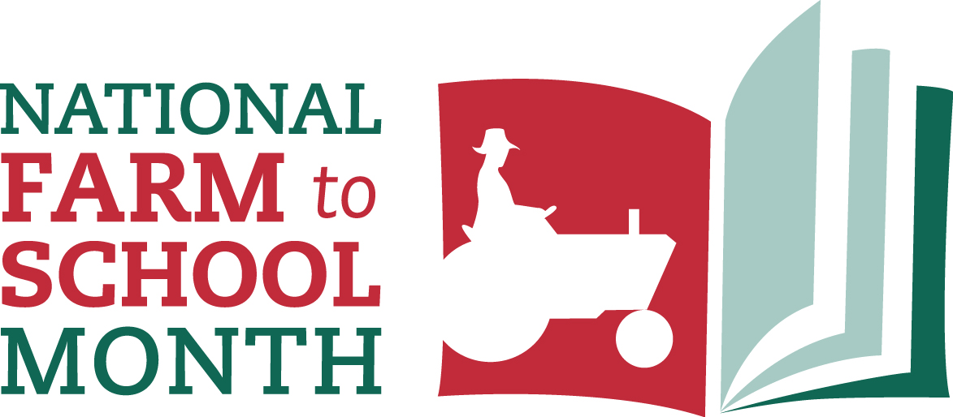

**2018 Sharing Toolkit**

www.farmtoschool.org/month

Introduction

**October is National Farm to School Month**, a time to recognize and celebrate the importance of farm to school programs as a means to improve child nutrition, support local economies and educate children about the origins of food. The **National Farm to School Network (NFSN), along with countless partners,** advocated for the creation of National Farm to School Month by Congress in 2010. NFSN now organizes the annual celebration in partnership with hundreds of groups and organizations across the country.

Everyone can get involved and celebrate National Farm to School Month! At the National Farm to School Network, we encourage everyone to use National Farm to School Month as an opportunity to find small ways to *get informed*, *be inspired* and *take action* to grow farm to school in communities across the country. Whether you’re hosting a taste test in the cafeteria, harvesting school garden produce, visiting a farmers market, reading a food-related book, or making a new farm to school connection, no action is too small! Check out our ***new*** [Farm to School Month Celebration Toolkit](http://www.farmtoschool.org/resources-main/national-farm-to-school-month-celebration-toolkit) for 60+ action ideas you can try this month. We’re excited to see the countless ways in which people celebrate – be sure to share with us by posting on social media with the hashtags #F2SMonth and/or #farmtoschool!

NFSN has developed this sharing toolkit to help communities, schools, early care and education sites and other organizations promote National Farm to School Month, share ways that people can get involved, and raise general awareness about the value of connecting students with local food. We have a variety of National Farm to School Month [resources](http://www.farmtoschool.org/resources) on our website – including logos, customizable posters, fact sheets, bookmarks, postcards, coloring pages – and a [shop](http://www.farmtoschool.org/store) where you will find merchandise – such as t-shirts, aprons, magnets and stickers – that make great gifts and giveaways.

Here’s how you can connect with us and the National Farm to School Month campaign:

* Our website:[farmtoschool.org](http://www.farmtoschool.org)
* Campaign hashtags: **#F2SMonth** and **#farmtoschool**
* Follow us on Twitter at **@FarmtoSchool**
* Follow us on Facebook by searching for “**National Farm to School Network**”
* Follow us on Instagram at **@FarmtoSchool**

This toolkit contains:

* Suggested social media posts – page 3
* Shareable graphics – page 5
* Sample text for newsletters & blogs – page 6
* Customizable press releases – page 7
* Media pitch suggestions – page 8
* Additional resources – page 9

Social Media

When you post about National Farm to School Month, use the hashtags **#farmtoschool** and **#F2SMonth**. Keep us in the loop about how your community is celebrating by tagging us in your social media posts. Follow us on Twitter and Instagram at **@FarmtoSchool** and on Facebook at **National Farm to School Network.**

**Get Involved & Celebrate**

October is National #FarmtoSchool Month – a time to get inspired, be informed & take action for farm to school in your community. Find ways to get involved & celebrate this month at farmtoschool.org

This October, take one small step for #farmtoschool and inspire others to do the same! Find activity ideas, resources and inspiration for celebrating National #F2SMonth at farmtoschool.org

Looking for resources to celebrate National Farm to School Month? @FarmtoSchool has free posters, bookmarks, stickers & more! farmtoschool.org #F2SMonth

New to #farmtoschool? Check out the National Farm to School Network’s free resource library for everything you need to get started: farmtoschool.org #F2SMonth

Everyone can celebrate National #FarmtoSchool Month! Find easy action ideas & tips for getting started at farmtoschool.org #F2SMonth

**Sign the “Take Action” Pledge**

Everyone can celebrate National Farm to School Month! Tell @FarmtoSchool how you’re supporting #farmtoschool in your community & you could win prizes for your school! farmtoschool.org/pledge #F2SMonth

Celebrate National Farm to School Month by pledging to take one small step to help grow farm to school in our community! Sign the pledge and find small steps you can take at farmtoschool.org/pledge.

October is National Farm to School Month! Celebrate by pledging to take action to support healthy kids and family farms in your community. Add your name, and you’ll be entered to win a package of farm to school prizes for your school or ECE site**!** farmtoschool.org/pledge

**Why Farm to School?**

Farm to school is connecting millions of kids to fresh, healthy food and supporting local agriculture across the country. During National #FarmtoSchool Month, find out how you can keep this movement growing**:** farmtoschool.org #F2SMonth

Farm to school is: kids cooking, gardens growing, farmers thriving. Help us celebrate the movers and shakers who make it all happen! Visit farmtoschool.org #F2SMonth

#Farmtoschool opens new markets to local farmers & helps build vibrant communities by strengthening the local economy. Learn more about the benefits of farm to school at farmtoschool.org #F2SMonth

Growing school gardens exposes children to local food early in life, encouraging healthier diets, hands-on learning, and vibrant communities! Join us in celebrating #farmtoschool this month by visiting farmtoschool.org #F2SMonth

#Farmtoschool connects kids to fresh food & supports local farmers. That's worth celebrating! Join in to celebrate #F2SMonth at farmtoschool.org

#Farmtoschool empowers kids to make informed food choices. That’s why we’re celebrating #F2SMonth! Tell us why you’re celebrating. Get involved at farmtoschool.org

**Share Your Celebrations**

We celebrate #F2SMonth by [insert activity]! Learn more about National Farm to School Month & get involved at farmtoschool.org

We’re trying new things for National #FarmtoSchool Month! Today, we challenged ourselves to [insert activity here]. #F2SMonth

We celebrate National Farm to School Month by [insert activity featured in photo]. Let us know how you celebrate in the comments below, and join us at farmtoschool.org to learn more ways that YOU can celebrate!

Shareable Graphics

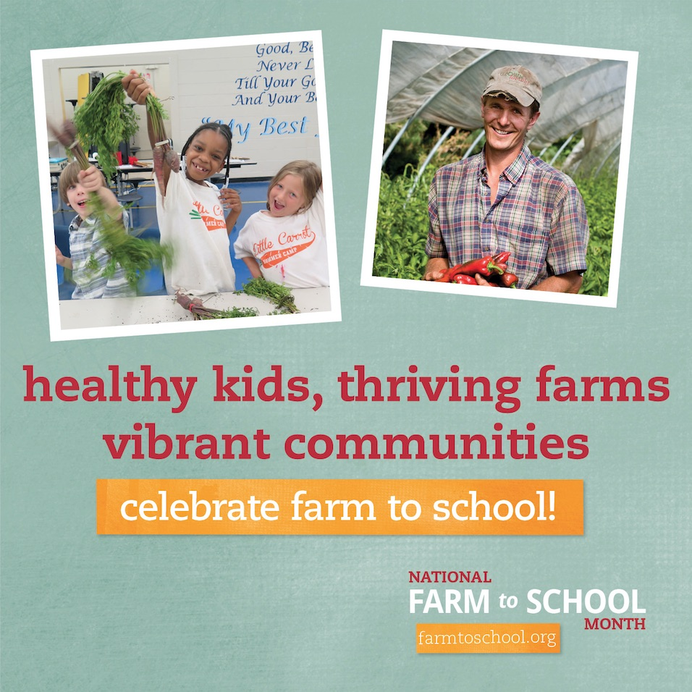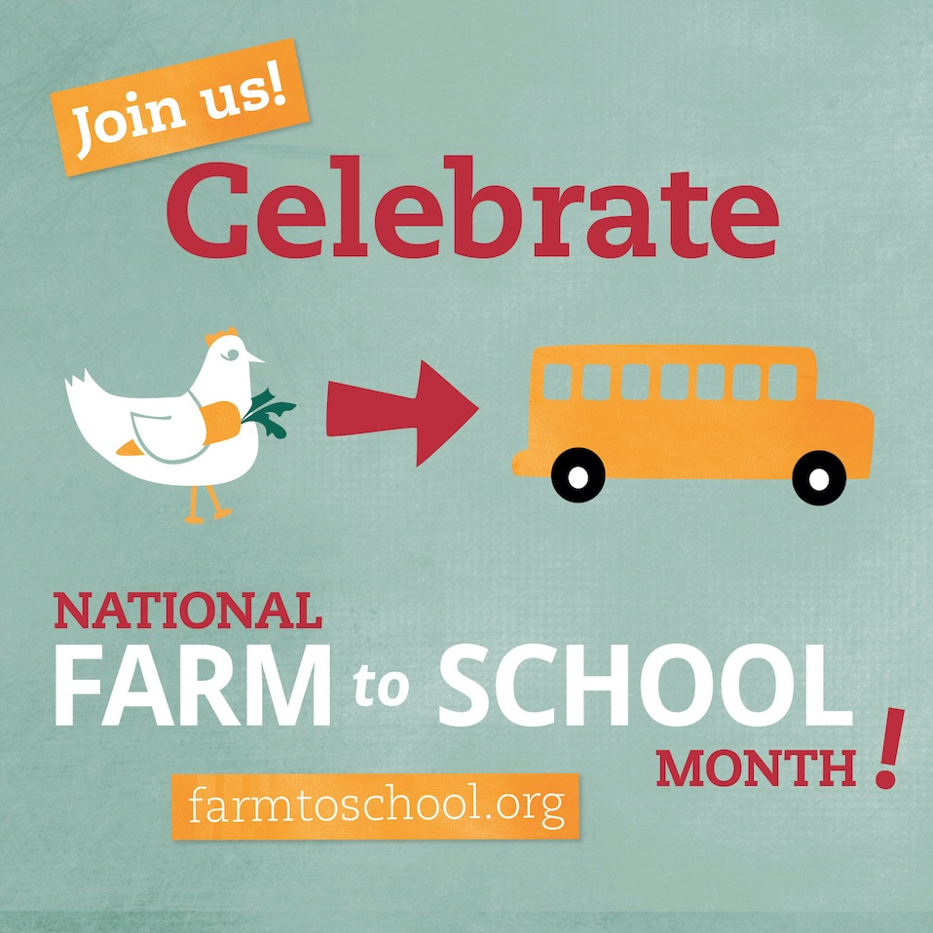Download full-sized graphics from this Dropbox folder: <https://goo.gl/2ycM7b>

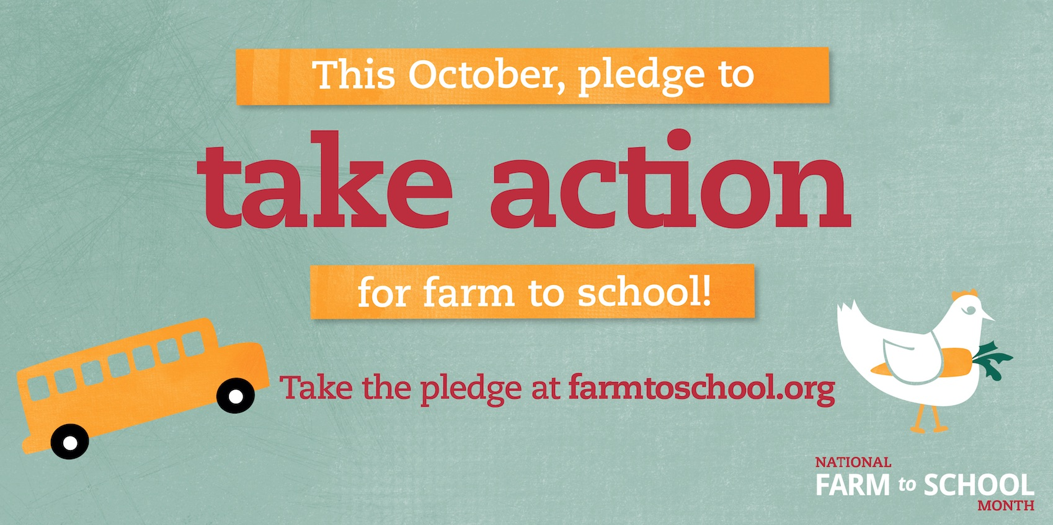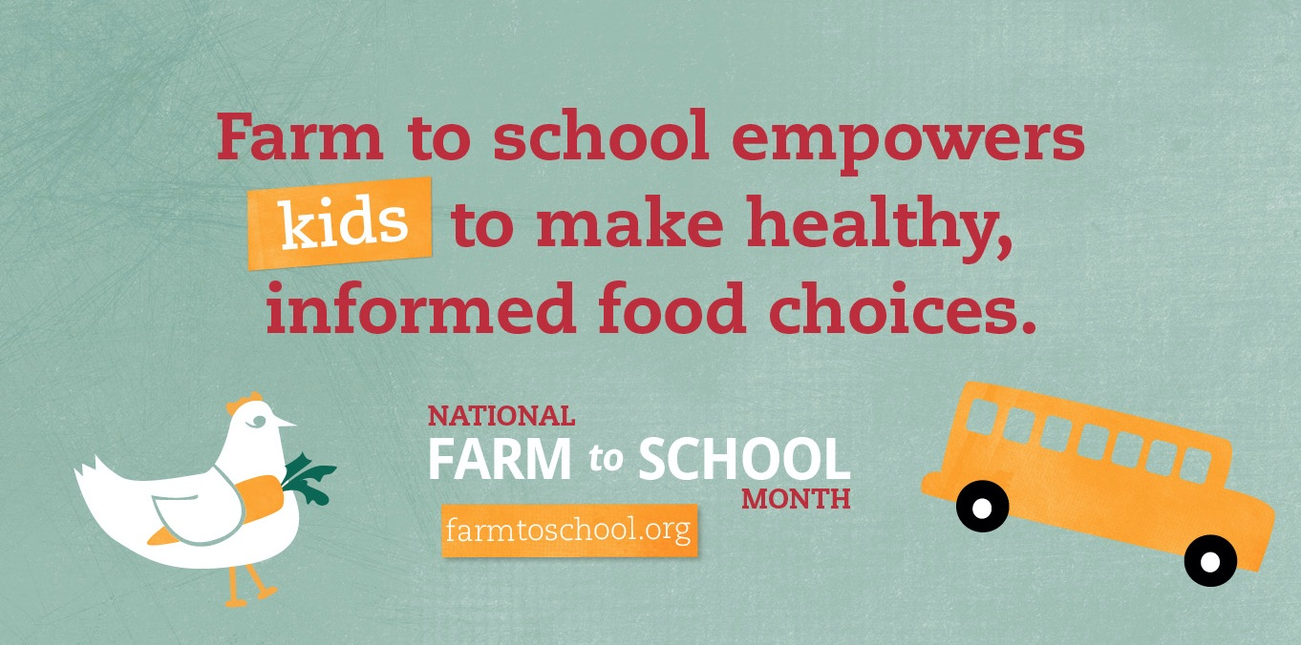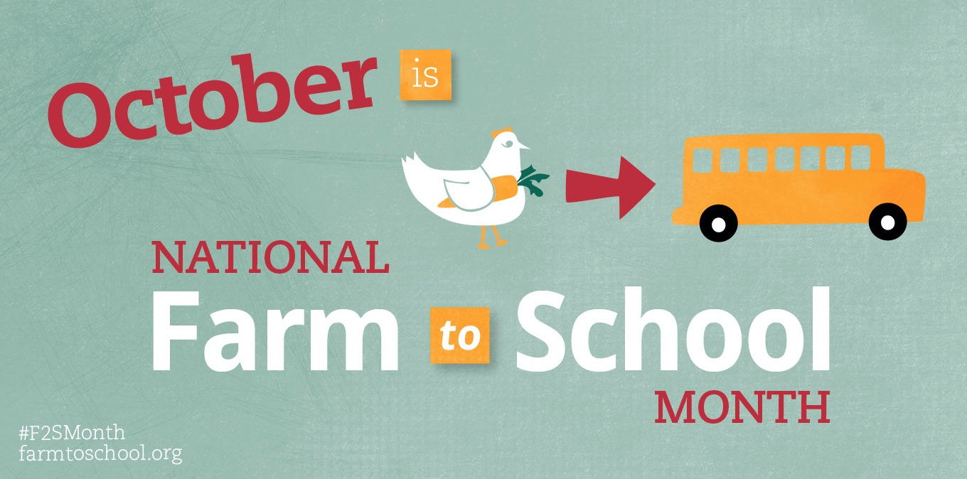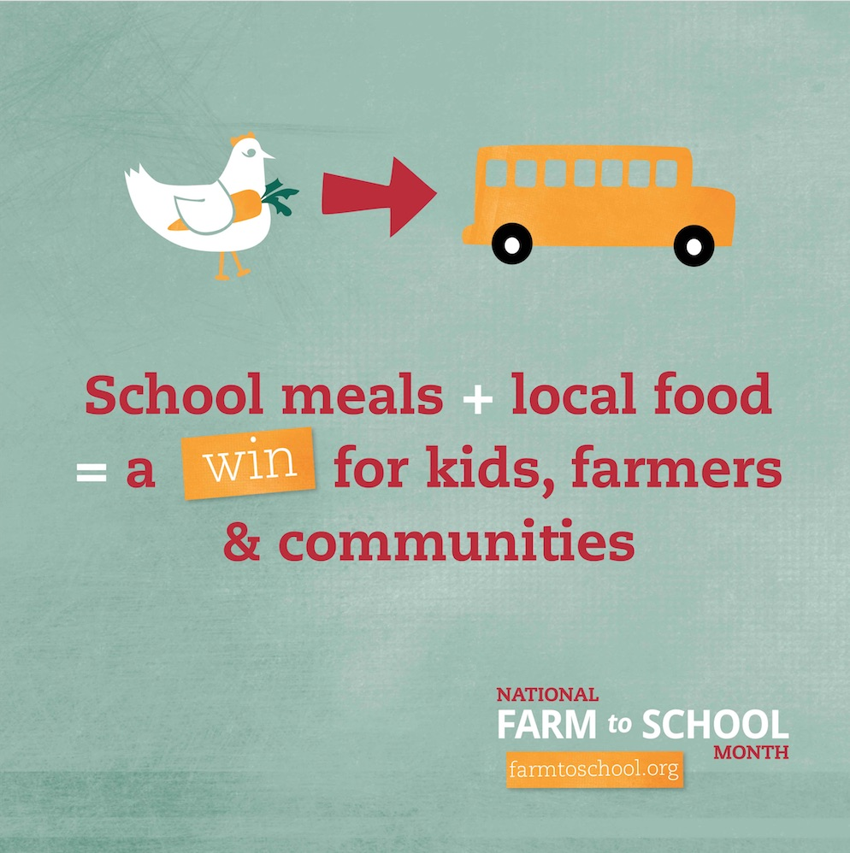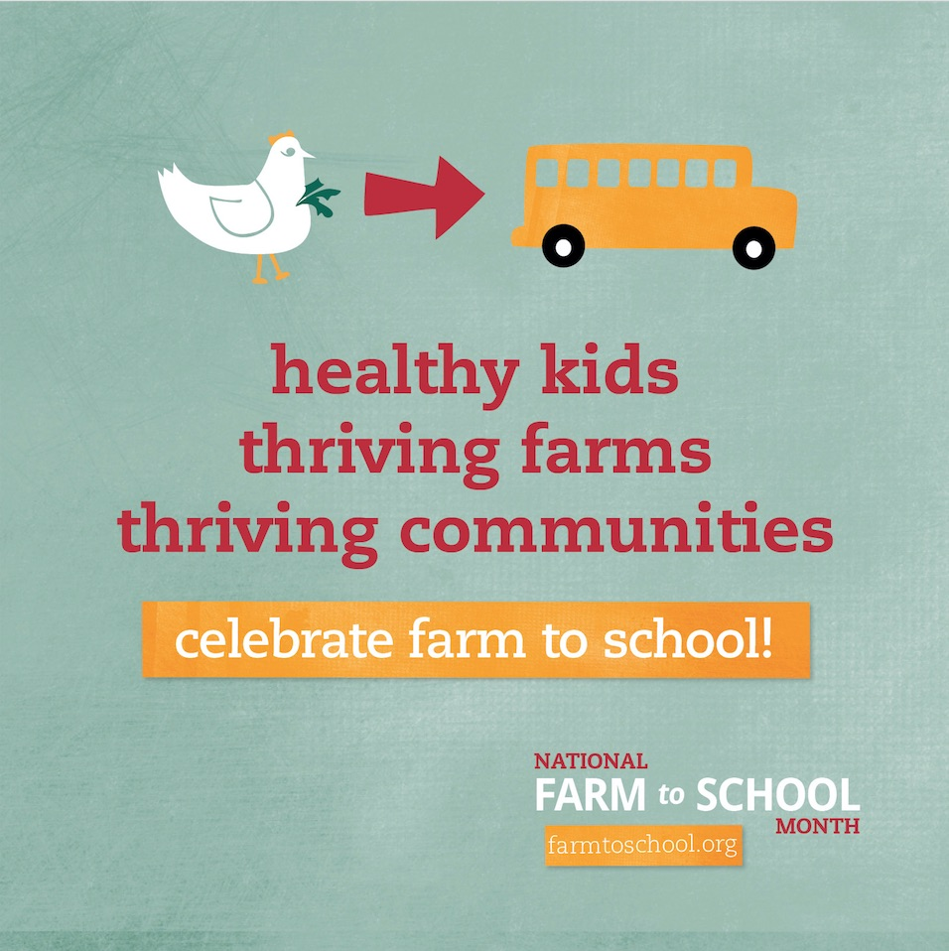

Sample text for newsletters and blogs

**Short version**

**Celebrate National Farm to School Month in October**

October is National Farm to School Month, a time to celebrate connections happening all over the country between schools, food and local food! Farm to school enriches the connections communities have with fresh, healthy food and local food producers by changing food purchasing and education practices at schools and early care and education settings. Farm to school is reaching millions of students in all 50 states, Washington, D.C. and U.S. territories. This October, get involved, be inspired and take action to advance farm to school in your community and across the country. Learn more about National Farm to School Month, find ways to get involved, and sign the *Take Action* pledge to win a package of farm to school prizes by visiting the National Farm to School Network’s website at farmtoschool.org.

**Longer version**

**Celebrate National Farm to School Month in October**

October is National Farm to School Month, a time to celebrate connections happening all over the country between schools, food, and local farmers!

Farm to school enriches the connections communities have with fresh, healthy food and local food producers by changing food purchasing and education practices at schools and early care and education settings. With farm to school, students gain access to healthy, local foods as well as education opportunities such as school gardens, cooking lessons and farm field trips.

Over the past decade, the farm to school movement has boomed across the United States, reaching millions of students in all 50 states, Washington, D.C., and U.S. territories. Farm to school is an important tool in the fight against childhood obesity and food insecurity. In addition to improving child health, schools create new markets for local and regional farmers and contribute to vibrant communities when they buy locally: a win-win-win scenario!

[Insert information about local Farm to School programs or statistics]

Whether you are a food service professional, a farmer, a teacher or a food-loving family, there are plenty of ways to celebrate and get involved in National Farm to School Month! Find free resources – including posters, stickers, coloring pages, and suggested activities – and a calendar of events happening across the country on the National Farm to School Network’s website at farmtoschool.org.

Sample press release – general purpose

For Immediate Release—[MONTH, DAY, 2018]

[ LOGO ]

**[ACTIVITY] celebrates fresh, healthy foods with kids at [YOUR SCHOOL] on [DAY]**

[ACTIVITY] spotlights local success of thriving national farm to school movement

[ACTIVITY] will happen at [YOUR SCHOOL] on [DAY] as part of National Farm to School Month celebrations taking place across the country. In 2010, Congress declared October National Farm to School Month, recognizing the important role farm to school plays in promoting well-being among children and strong local economies.

[“QUOTE ABOUT CONNECTING KIDS WITH PEOPLE WHO GROW THEIR FOOD OR OTHER BENEFITS OF FARM TO SCHOOL,” said FOOD SERVICE DIRECTOR / PRINCIPAL / OTHER.]

[PARAGRAPH WITH SUCCINCT DETAILS ABOUT LOCAL PROGRAM: FARMS AND SCHOOLS PARTICIPATING, TYPES OF LOCAL FOOD IN SCHOOLS, DATE/TIME OF CELEBRATORY EVENT, INVOLVED ORGANIZATIONS]

Over the past decade, the farm to school movement has exploded across the United States, reaching millions of students in all 50 states, Washington, D.C., and the U.S. territories. From school gardens and farm field trips to local food on cafeteria trays, farm to school practices help children learn about where food comes from and make healthier choices while also creating new markets for local and regional farmers.

“Farm to school enriches the connections between communities, local farmers, and schools,” said Anupama Joshi, Executive Director of the National Farm to School Network. “In addition to building healthy nutrition habits for children and encouraging hands-on learning, farm to school benefits farmers and local communities by stimulating the local economy.”

National Farm to School Network has representatives in every state to help connect schools with local farmers. For more information about farm to school in [YOUR STATE], contact [NAME] at [EMAIL] or [PHONE]. Learn more about the farm to school movement at farmtoschool.org.

# # #

Media contact:

[NAME]

[EMAIL]

[PHONE]

Media pitches

Press releases are a great way to share your story, but media professionals receive dozens of press releases every week, so it might take a little extra effort to get the attention of an editor or reporter. Having a great pitch or angle always helps make your story more unique and allows the editor to better visualize the final product. It also helps ensure that the story they tell is the one you want them to tell.

**Here are some suggested pitches for Farm to School Month activities:**

* Follow the food: Invite news crews to follow your local foods from the farm or the producer all the way to the cafeteria.
* Cooking demo: If you have a local TV talk program, suggest having your food service director highlight some of the farm to school dishes your kids are eating by preparing them on the show.
* Schedule a field trip to a dairy farm, farmers market, fishery or any of the sites that are part of your farm to school program and invite the news media.
* Kids views: Invite news – radio / TV / print – to talk to kids about where their food comes from. Kids can be unpredictable, but they could be balanced out by interviews with school nutrition directors, teachers, the principal, etc.
* Invite an elected official to school lunch (and invite the media!). Members of Congress will be on recess in their home states during October. This is a great time to build support for farm to school among key decision-makers AND get the media to cover it.
* Op-ed: Have a local teacher or school nutrition director write about the changes s/he has seen in the classroom/cafeteria since the farm to school program started.

**Here are a few tips to keep in mind:**

* If you don’t have a media list already, do an online search to find the news media, reporters, or bloggers who have covered local food, schools, the environment, agriculture, food and food-related businesses in your area.
* Email your press release to your media list. Emphasize the local angle in your headline.
* Emphasize the fact that your story will be very visual and include nice action, especially if you are dealing with a television station.
* Explain why the story is timely—emphasis that this is National Farm to School Month and mention any recent farm to school reports or statistics from your state that demonstrate the local relevancy. A great resource for local statistics is the USDA Farm to School Census website: <https://farmtoschoolcensus.fns.usda.gov/>
* Keep in mind that children will need permission slips before being photographed for a story. It might be necessary to set up a small photo-op with students who have the proper forms.

Additional Materials & Resources

The National Farm to School Network has many free materials and resources available to support the celebration of National Farm to School Month in your community, including:

[**National Farm to School Month Celebration Toolkit**](http://www.farmtoschool.org/resources-main/national-farm-to-school-month-celebration-toolkit) - This *new* resource includes background information, activity ideas, communications tools, and a list of resources for implementing Farm to School Month celebrations in your community.

[**About National Farm to School Month Fact Sheet**](http://www.farmtoschool.org/resources-main/about-national-farm-to-school-month-fact-sheet) - This two-page fact sheet provides a general overview of National Farm to School Month, and is a great resource to send home to families, display in the cafeteria, or have available at Farm to School Month events.

[**Posters**](http://www.farmtoschool.org/resources-main/farm-to-school-month-posters) - Posters are available in two standard print sizes (11 x 8.5 and 11 x 17) and include a blank space to add local event information. Use these posters in your cafeteria, classroom, on your farm.

[**Stickers**](http://www.farmtoschool.org/resources-main/farm-to-school-month-sticker) - Get kids excited to try new foods with the incentive of a sticker! Several designs are available, including *I Ate A Local Food Today* and *I Tried A New Food*.

[**Bookmark**](http://www.farmtoschool.org/resources-main/farm-to-school-month-bookmark) - Can be customized by adding information about local Farm to School Month events to the backside.

[**Coloring Pages**](http://www.farmtoschool.org/resources-main/farm-to-school-month-coloring-pages) - Encourage creativity and artistic expression with two coloring page templates.

[**“Save the Date” Postcards**](http://www.farmtoschool.org/resources-main/farm-to-school-month-save-the-date-postcard) - Includes simple activity ideas and a URL link for finding more resources and materials.

[**Sample Farm to School Champion Award & Invitation**](http://www.farmtoschool.org/resources-main/sample-award-and-invitation-for-farm-to-school-month) - Inviting public officials and distinguished guests to your Farm to School Month events will help raise the profile of the event while honoring those who have helped move farm to school forward in your community.

[**Sample Farm to School Month Government Resolutions**](http://www.farmtoschool.org/resources-main/sample-farm-to-school-month-government-resolutions) - In addition to the national declaration that was passed in 2010, many states have passed resolutions declaring October Farm to School Month. Use these examples to encourage your state government to recognize October as Farm to School Month.

[**Legislator to the Lunchroom**](http://www.farmtoschool.org/resources-main/legislators-to-the-lunchroom-guide) **/** [**Site Visit Guides**](http://www.farmtoschool.org/resources-main/child-nutrition-site-visit-guide) - Inviting Members of Congress, as well as state and local elected officials, to visit school cafeterias, gardens and food-related educational programs help them understand the value and impact of farm to school first hand. These resources offer step-by-step guidance for organizing a visit.

*Looking for more resources, materials or activity ideas? Our resource database is home to hundreds of farm to school resources and includes searchable tags for Farm to School Month, as well as topics like farm to early care and education, school gardens, and procurement. Explore more at* [*farmtoschool.org/resources*](http://www.farmtoschool.org/resources)*.*

Thank you!

We are grateful for your efforts in helping spread the word about National Farm to Month far and wide! **Questions?** Please contact Anna Mullen, NFSN Communications Manager, at [anna@farmtoschool.org](mailto:anna@farmtoschool.org).

*We extend special thanks to our 2018 National Farm to School Month Sponsors & Supporters:*

CoBank, Newman's Own Foundation, Organic Valley, US Highbush Blueberry Council

Captain Planet Foundation, Farm Credit, FarmLogix, Highmowing Organic Seeds