

Company Name

New Vendor Set-up Letter

Welcome New Vendor!
As part of Company Name’s new vendor set-up process, we ask that you complete and submit the following information:
W9– Company Name is required to have a signed legal document on file to support and document the tax information of vendors that it makes payments to. The required document is the IRS form W-9. The W-9 captures required information for tax reporting.
- This includes (1) name, (2) business name, (3) type of entity, (3) exempt status, (4) address, (5) taxpayer identification number, and (6) signature.

ACH Authorization – Company Name can remit payment electronically via ACH/Direct Deposit. If you would prefer this method of payment, please complete the attached authorization agreement for direct deposits. This form is optional.

Invoices must be mailed or emailed to the address below.

Company Name

Attn: xxxxxx

Adress 1

Adress 2
email@email.com

Company Name

AUTHORIZATION AGREEMENT FOR DIRECT DEPOSITS (optional)

Please print and complete ALL the information below.

Name: ____________________________________________________________

Address: ____________________________________________________________

City, State, Zip: ____________________________________________________________

Email Address: ____________________________________________________________

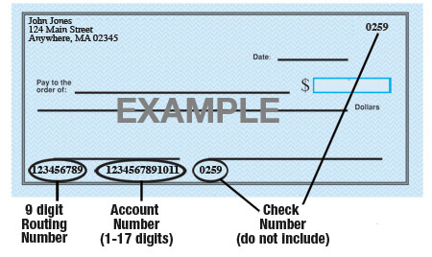

Name of Bank: ____________________________________________________________

Account #: ____________________________________________________________

9-Digit Routing #: ____________________________________________________________

Type of Account: Checking Savings (select one)

Approvals/Authorization: I certify that the information on this form is correct and I hereby authorize Company Name to electronically deposit payments to the bank account designated above. I understand that this authorization will remain in full force and effect until Entity Name has received written notification requesting a change or cancellation.

Name: _______________________________ Title: _________________________________

Signature: _______________________________ Date: ________________________________

