TCBC Worship Guide
Sunday, November 16, 2025, 9:30 am

Welcome and Opening Prayer – Pastor Barr

Call to Worship – Psalm 98:1-4, 9 – Oh, sing to the Lord a new song! For He has done marvelous things; His right hand and His holy arm have gained Him the victory. The Lord has made known His salvation; His righteousness He has revealed in the sight of the nations. He has remembered His mercy and His faithfulness to the house of Israel; All the ends of the earth have seen the salvation of our God. Shout joyfully to the Lord, all the earth; Break forth in song, rejoice, and sing praises. For He is coming to judge the earth. With righteousness He shall judge the world, And the peoples with equity.

We praise the Lord and trust in His care for He gives us the victory:
Psalm 118– “O Praise the Lord, for He Is Good”

Scripture – 1 Corinthians 15:50-58 – Jim Talbert

We humbly confess our sin and rest in Christ Who took our shame:
# 289 – “Hallelujah! What a Savior”

Choir – “My Refuge”

We find assurance in Christ our refuge and long for His return:
“He Will Hold Me Fast”

Prayer – Pastor Probus
Message – Pastor Barr

We remember Christ’s sacrifice for us:
“According to Thy Gracious Word”

Lord’s Supper
Bread – Pastor Probus
Cup – Allan Brace

Scripture Reading
I Thessalonians 4:13-18 – Pastor Barr

We respond with a call to prepare for Christ’s return:
# 291 – “Christ Is Coming”

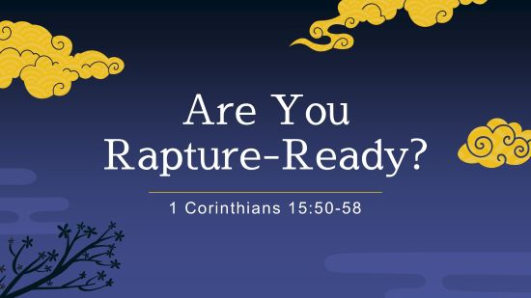

- Verse 50: Paul’s message to all Christians (brethren)
- Verses 51-52: Paul’s mystery for all Christians
- Verses 53-57: Paul’s comfort for Christians
- Verse 58: Paul’s challenge to Christians
We need to prepare for the Rapture by developing a steadfast trust in the Lord through faithful service to Him.

