TCBC Worship Guide
Sunday, November 30, 2025, 9:30 am

Welcome and Opening Prayer – Pastor Probus

Call to Worship – Psalm 122:1-2, 8-9 – I was glad when they said to me, “Let us go into the house of the Lord.” Our feet have been standing Within your gates, O Jerusalem! For the sake of my brethren and companions, I will now say, “Peace be within you.” Because of the house of the Lord our God I will seek your good.

We call all creation to come and worship Christ the King:
# 193 – “Angels, from the Realms of Glory”

Choir – “Doxology”

# 208 – “Ring the Bells”

Scripture – Isaiah 2

We humbly confess our need to wait upon Christ our Rock:
Psalm 62 – “Wait, My Soul”

We find assurance in the Hope of all the earth, Christ the King:
“Come, Thou Long-Expected Jesus”

Prayer – Pastor Barr

Message – Pastor Barr

We respond with a prayer to build our lives on Christ our Rock:
“O Lord, My Rock and My Redeemer”

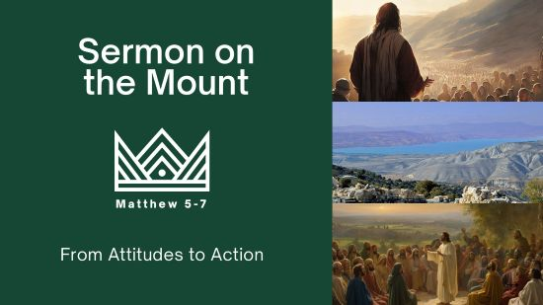
Repenting Because We Love the King
Matthew 7:24-8:22

- Q. What does it look like to build your life on the solid rock? 7:24-27
- A1. You ask Jesus to wash away that which you cannot clean. 8:1-4
- A2. You trust that Jesus will deliver on His promises. 8:5-13
- A3. You entrust the sicknesses of your body and soul to Jesus’ care. 8:14-17
- A4. You immediately and permanently commit to following Jesus. 8:18-22
We must build our lives on Jesus’ words by trusting in Him to heal us and lead us.

