TCBC Worship Guide
Sunday, December 07, 2025, 9:30 am

Welcome and Opening Prayer – Allan Brace

Call to Worship – Psalm 72:1-2, 17-19 – Give the king Your judgments, O God, And Your righteousness to the king’s Son. He will judge Your people with righteousness, And Your poor with justice. His name shall endure forever; His name shall continue as long as the sun. And men shall be blessed in Him; All nations shall call Him blessed. Blessed be the Lord God, the God of Israel, Who only does wondrous things! And blessed be His glorious name forever! And let the whole earth be filled with His glory.
Amen and Amen.

We give all glory to Christ the King:
# 194 – “Joy to the World”

# 199– “Hark! The Herald Angels Sing”

Scripture – Isaiah 11

We humbly confess our need for Christ the Light of Life:
“How Dark the Night”

Choir – “The Longing”.

We find assurance in the life, death, and resurrection of Christ:
# 227– “Who Is He in Yonder Stall”

Prayer – Pastor Probus

Message – Pastor Barr

We respond by singing with anticipation of Christ’s return:
# 229 – “O Come, O Come, Emmanuel”

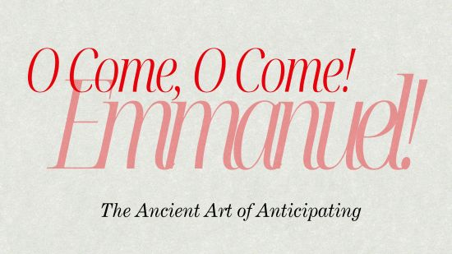
Psalm 74:1-23

- The Roots of O Come, O Come, Emmanuel come from deep in the Old Testament.
- Psalm 74: What is it like to wait for our Messiah to come?
Christians still anticipate Jesus’ Coming.

