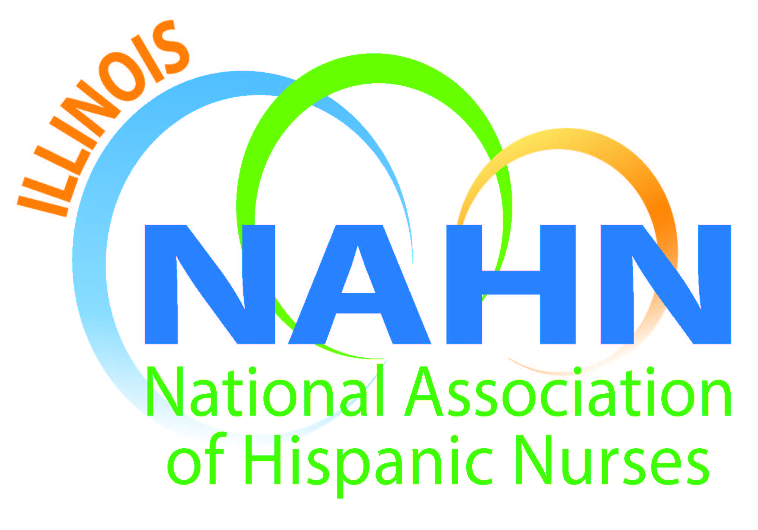

Meeting Minutes
Held at University of Phoenix
203 North LaSalle, Chicago, IL
August 18, 2016

- Meeting called to order at 6:15 pm by President Susana Gonzalez.
  - Mission read.
  - Acknowledgement of our host University of Phoenix. Robert Gabriel PhD, MBA Campus Director and Laura Beal MBA Community Development Specialist - Midwest College of Health Professions.
- Agenda Topics:
  - The scholarship amount for this year is $12,000 and we encourage you to apply. The application is on our website.
  - Treasurer, Gloria Barrera report: Beginning balance $42893.40. Kensington Rooftop raised funds ending balance $43130.84.
  - Muevete healthy eating program took place at Aspira and was a wonderful success. The issue of obesity in childhood in the Hispanic community is an important issue.
  - Dan CPR instructor has a bunch of events: Fosco Park Monday the 29th from 2 to 5:30, seeking a Nurse Guest Speaker to the Back of the Yards High School to speak to students on the 2nd or 24th of September. It’s a 2-hour event. October 1st at the Mexican Fine Arts Museum a health expo will be held. It’s called Amate Ahora. We are seeking a nephrologist as a speaker if anyone knows one that would be interested to participate. Villapalooza the 5th annual event in Little Village, we are going to host the first aid booth. It will be on the 27th of August from 11 to 10:00 pm. Pilsen Community Neighbors Council, September 16th we have tickets to the Chicago Fire if you are interested in going.
  - October 20th: the tentative venue is Puerto Rican Alliance Museum for our Scholarship Gala.
  - November 3 and 4 to the Feria Mujer Latina at Malcolm X
  - Dan Fraczkowski, President ANA-Illinois SNAI and General Assembly information:
    - The nurse practice act is sun setting, what that means is that every 10 years the Illinois legislature comes together to review and revise the Nurse Practice Act that governs all of nursing in Illinois. We have formed a coalition with all the organizations of the nursing community to make the changes that we want to see. For example, having education recognized across the board by having all the nursing programs accredited. That would mean that courses and credits can transfer between programs. We will be introducing a bill in the Fall. We have an advocacy portal to get information on the legislative pieces on the ANA website. On the side of the portal you can see that over 30 organizations in Illinois participated. Another example is the language of discipline and enforcement; we are looking to have language that is not ageist. I am also on the board of the Student Nursing Association, SNAI. They meet 9 months out of the year. October 1st and 2nd, the Student Conference will take place. Sometimes the schools can get funding to send the students. 40 under 40, tell your friends. We have space for 150 people, so register to attend early. Free webinar on Leadership and Nurses on Boards September 15th 12 to 1pm the webinar is free of charge. It is called Leap into Leadership Webinar. We were able to get the authority to have the Nurses Saves Lives license plate. So those of us that registered will be receiving information on getting that.
  - Resurrection University will have a scholarship to donate to a student of their own program during our scholarship gala. University of Phoenix is also interested in awarding a scholarship.
  - Diana Ortega and Vanessa put together a slide show of the NAHN conference. Remember that the next conference is July 18 through 21, 2017 in Phoenix, Arizona. The event will be at the Biltmore Hotel.
  - The Chicago Health Guide was presented at the conference. It was a collaboration between several nursing organizations in Chicago. It is presented free of charge to the community and contains healthcare resources.
  - October 6th the Black Nurses Association invited us to a policy conference that will include politicians that are running for office in November.
- Meeting adjourned by Susana Gonzalez at 7:45 pm.

