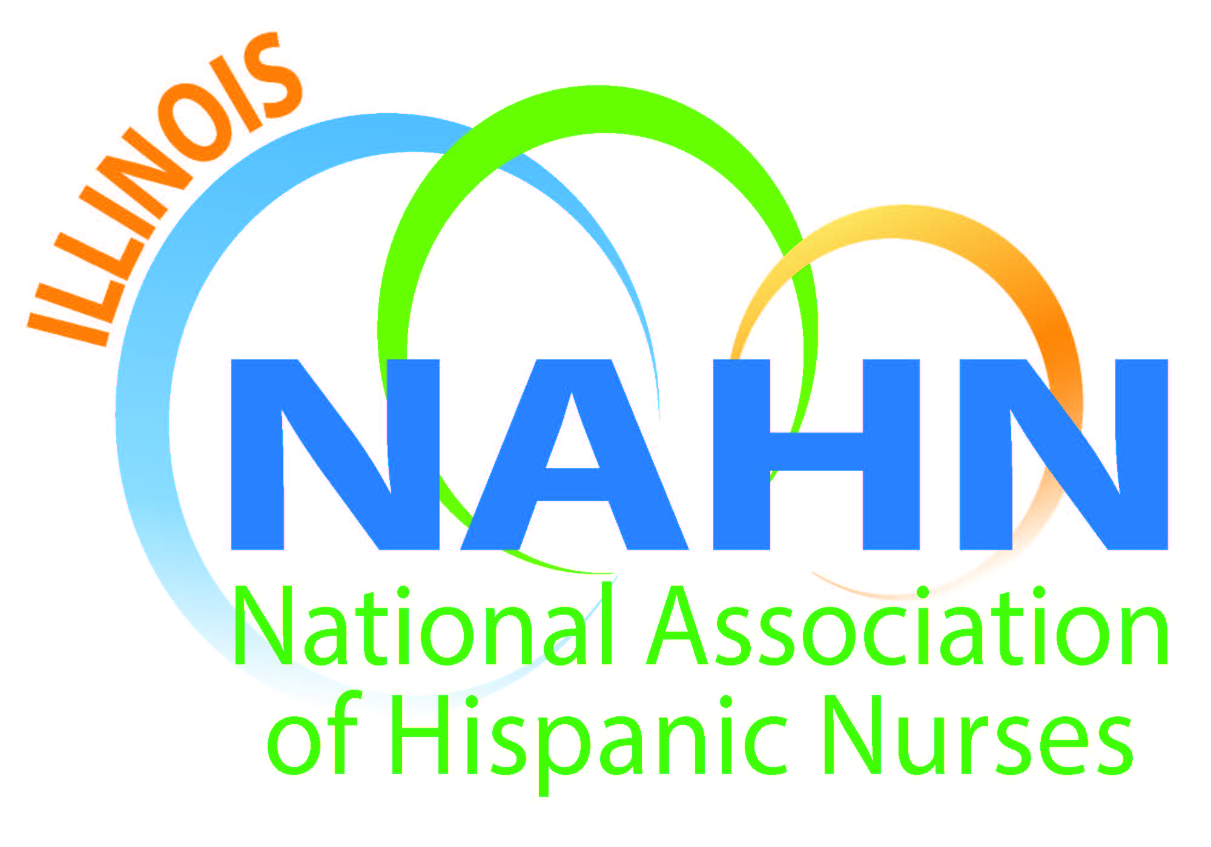

Meeting Minutes
Held at Depaul University
2350 N Kenmore, Rosati Room, Library
June 23, 2016

- Meeting called to order at 6:15 pm by President Susana Gonzalez.
  - Mission read.
  - Acknowledgement of our host DePaul University, Liz Florez, PhD.
- Agenda Topics:
  - Treasurer update Gloria Barrera, May ending balance $43,011.96.
  - Secretary Elect Irene Mendez to start office when Liz Florez takes presidency. Wanda Monterrubio, our current secretary will mentor her.
  - Anabel Guzman ACA will be presenting at the conference.
  - ANA-Illinois: Please sign up for the Nurses’ License Plate. At this point we are 16 plates away from being able to get a license plate dedicated to nursing. The plate will say “Nurses Save Lives”. The funds will go to the Illinois Nurses Foundation.
  - Evelyn Gomez, Mentorship program at Instituto Progreso Latino will be looking for new mentors soon.
  - Vive tu Vida Health Fair Illinois NAHN presence
  - Muevete program was held at the school and was successful with the leadership of Nancy Garcia. This is the NAHN program that we have been participating in for a couple of years. 47 7th graders took part in the activity.
  - One Million Degrees coaching is for mentoring junior college students. The program is reaching out to IHNA NAHN members to become coaches for junior college students looking to get into the health sciences field. One Million Degrees is offering to come to our location to do a specific training for our members in order to become a coach. It is a formal program that takes several hours of time investment.
  - Open scholarship of Illinois NAHN will open after the conference in July. This year we are committing $12,000 to be distributed to nursing students that are active members. There is an application process with an essay and other criteria. We do expect that the winners of scholarship awards will take leadership roles in the association. https://onemilliondegrees.tfaforms.net/296153
  - The next meeting is being preempted by the NAHN conference downtown. Our next regular meeting will be in August.
  - The ANA Illinois website has a link to nominate nurses for the 40 under 40 award.
  - Liz Florez and Irene Mendez are both running for the AHA in the Chicago Marathon and are looking for donations to their page to help in the fundraising effort. The web link is http//runwithheartchicago.kintera.org/metrochicago/lizann
  - Review of the NAHN conference schedule.
  - Illinois NAHN is hosting a networking night that is a fundraising event at the Kensington Rooftop Lounge. 6:30pm to 12:00am. Light appetizers and drinks will be served. The event is sponsored by Froedert Medical Center from Milwaukee, Wisconsin.
  - We will be packing meals as a group at the conference as our community service project.
- Meeting adjourned by Susana Gonzalez at 7:45 pm.

