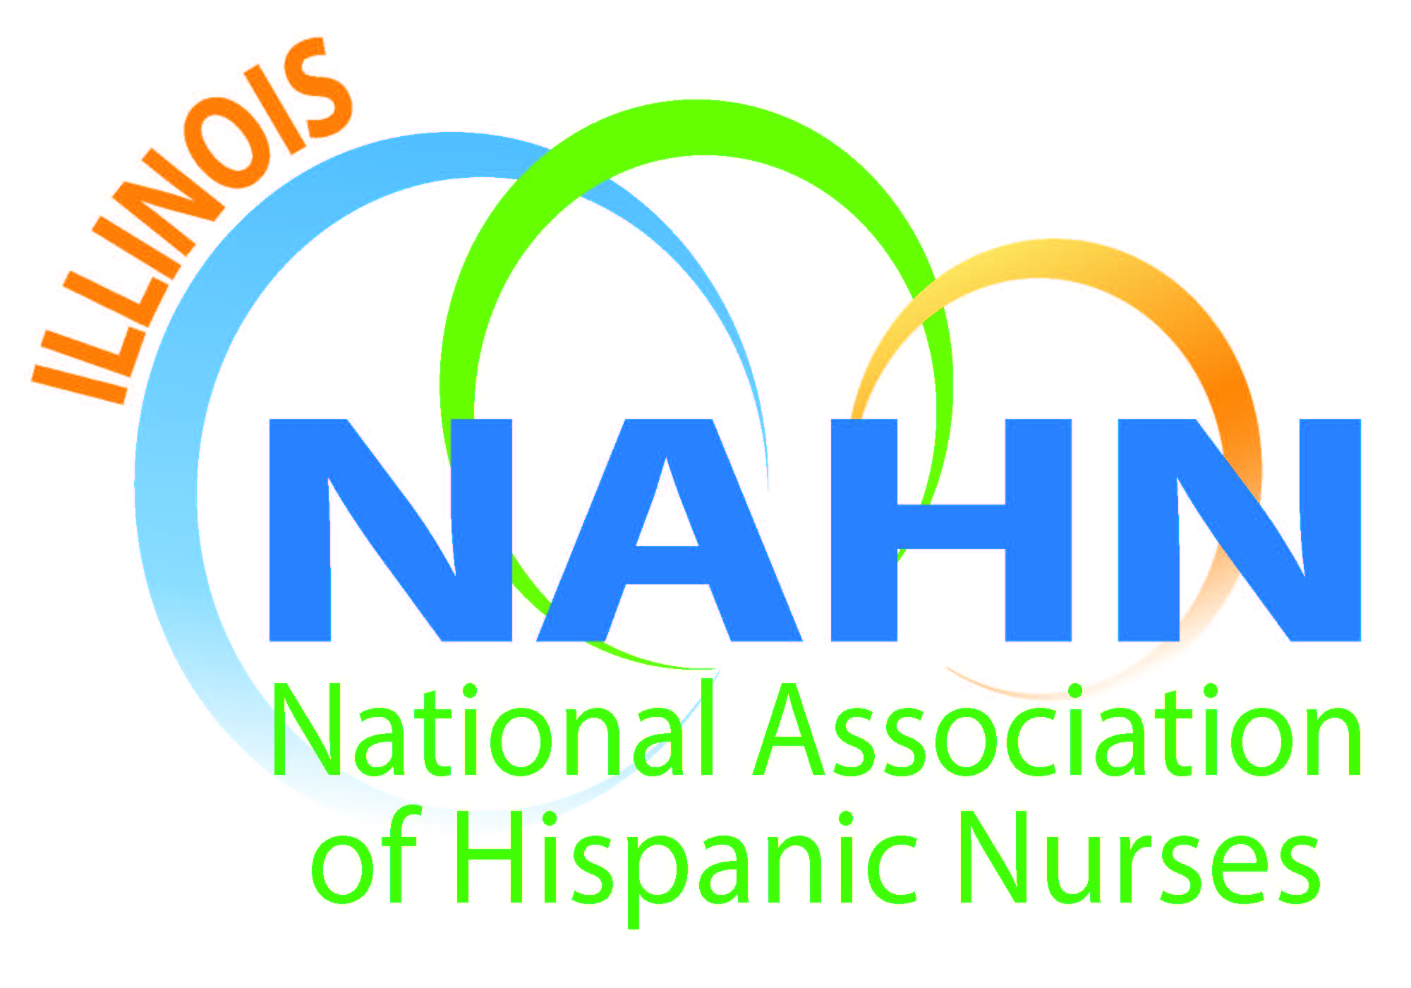

Meeting Minutes
Held at Resurrection University Chicago Campus
May 19th, 2016

- Meeting called to order at 6:00 pm by President Susana Gonzalez.
  - Mission read.
  - Acknowledgement of our host Resurrection University, Jerri Bingham, Director of Marketing and Communication and Therese Scanlan, EdD, Interim President ResU.

- Agenda Topics:
  - Dan Franczkowski. announced that our members get a tuition discount through ANA at University of St. Francis and Olivet. Dan. is president of ANA Illinois. Dan is also promoting the exclusive nurse license plates. The button to a link is on our website to sign up just under the ANA logo on our front page. Only 1500 license plates will be issued. Dan also is promoting the 40 under 40 to recognize the leadership of people under 40 years of age that are transforming nursing today. We are looking for nominations for people that are under 40 at the time of the event. The information is on the ANA website if you click on our ANA logo on the front page of the website.
  - First announcement of name change to NAHN Illinois: National Association of Hispanic Nurses Illinois along with new T shirts and branding items. Right now there are 44 chapters in NAHN and we are changing our logo to be in compliance with National and all the other chapters.
  - The President of Resurrection has shared information about a new scholarship for BSN and MSN, one scholarship each academic year. The winner will be announced at our scholarship ceremony in October of this year. The scholarship is renewable contingent upon academic status for the life of the program as long as the criteria is met. The scholarship will be announced on our website.
  - Our commitment this year is to give $12,000 in scholarship funds through our organization National Association of Hispanic Nurses of Illinois, NAHN Illinois!

- Evelyn Gomez is looking for members to be on the committee to mentor students in the LEAD program at Instituto Progreso Latino. This is the Sweitzer grant mentorship program that has been a great success. This is part of our mission to mentor the next generation. Please contact Evelyn to find out how to participate.

- ASPIRA Inc. is a group of schools. This is where we are promoting a mentorship program. It is a Saturday program that we have committed to and we are continuing with this partnership and would like other members to participate with us as well. Please contact Susana for information on how to participate.

- ACA update from Anabelle and Susana. Still doing outreach. Anabelle will present at the NAHN conference with the PI at the July Conference.

- MUEVETE USA is going on its third year with our organization led by our treasurer, Nancy Garcia. It is a spinoff of the First Lady’s program. It is for ages 6 through 12 and we use five lesson plans. We are going to do it with ASPIRA. It will take place on June 10th. We have the materials and freebies like an actual snack, soccer balls, and things like that to give to the children. We teach the children how to choose foods to eat based on the choosemyplate.gov guidelines.

We are looking for volunteers for Saturday June 10th to help lead the five stations that are required and to administer the pre and posttests that are a requirement of our grant from NAHN. We are getting funds from NAHN to complete with a minimum of 100 children, which will be posted to our scholarship funds that we are gifting this year. Please touch base with Nancy for further information. Nancy is also a part of the Rethink Your Drink campaign which is also being solicited for donations to our event. This campaign is linked to reducing the sugar in our beverages.

- Save the Date:
  - May 24th Tuesday ASPIRA college career day.
  - McKinley Park Vive Tu Vida Health Fair Saturday June 4th there will be blood pressure screenings that we can do at the fair.
  - October 20th Scholarship Awards Night location to be determined in lieu of a meeting. The Resurrection scholar will be announced on that evening as well as the winners of our own scholarship. Our goal is $12,000 this year.
  - Latina Web is another health fair that is coming with the theme Empowerment Beauty and business on October 15th. It will be held at the new facilities at Malcolm X College of Health Sciences.

- The next monthly meeting will be at DePaul.

- July is our conference at the Hyatt Regency Downtown and it is very important for all of us to show a presence at this once in a lifetime event. The festivities begin Tuesday in the evening as a ribbon cutting ceremony July 12th through the 15th. Be there by 7am for the conference on Wednesday. The Gala dinner on Friday night is included in the ticket for the conference. The Gala dinner alone is $150. We are planning to wear red to this event. Prices go up in price tomorrow $50, so pay it now to get the better price. If you do it in a group of at least 3, you get $100 discount per person. We are sending two students free of charge to the convention. Thursday we are thinking of doing an event in one of the clubs in conjunction with our sister chapter in Wisconsin. We don’t have details yet. It will be in the style of a networking event. We are looking for the cheapest venue so that it will be a nominal charge.

- The next convention will be held in Phoenix, Arizona, in July in 2017.

- Debra Johnson from United Health Group Talent Acquisition spoke on techniques that can help you find a job. Indeed, Career Builder, Monster, LinkedIn are good sources to post your information. There is an Illinois RN position open right now in the North Suburbs on the client side, Libertyville, Waukegan, Mundelein are the areas that the person would serve. Three years of clinical experience, presentation skills, fluency in Spanish are requirements. Tips on resume building were shared. Key words, measureable results, put in requirements of the position first. Use different resumes for different positions. Include your cover page as the first page of your resume. For more information, feel free to contact Debra at: Debra_johnson1@uhg.com (952) 202-0041.

- Michaela McGill Manager and Volunteer Programs Coordinator of One Million Degrees.org spoke on the Community College Project. This is a 10-year-old, non-profit organization to motivate low income students to finish degrees and to empower them in life as well. Many people begin their higher education experience in community college either as high school entrants or adult entrants. We offer scholarships and stipends and enrichment grants that can cover costs like attending conferences or whatever they need in order to be successful. We have professionals that work as mentors as well as peer support leaders. We have a once a month workshops on financial literacy and various subjects including etiquette dinners, attire workshops. 58% are African American and 26% are Hispanics. We currently have 440 scholars. 25% of our students support dependents. 56% are first generation college students. 71% of our students complete their degree. Our retention rate is 83%. We need more mentors for our program and would welcome your participation with our students. We have 330 coaches in different careers. For more information and to sign up, contact Michaela at mmcgill@onemilliondegrees.org.

- Meeting adjourned at 8:15 pm

