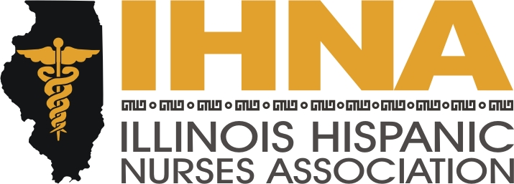

IHNA Meeting Minutes
Held at Chamberlain College of Nursing Chicago Campus
January 21st, 2016

- Meeting called to order at 6:00 pm by President Elect Elizabeth Florez, PhD.
  - Acknowledgement of our host Chamberlain College of Nursing.

- Agenda Topics:
  - February Go Red Event tickets, raffle items, volunteer opportunities.
  - Fil Guipoco from AHA offering no cost information and promotional materials for February Heart Health month suitable for presentations with a high blood pressure algorithm. Information about CPR-in-School program with IHNA liaison. Campaign for healthier vending, reducing sugar-sweetened beverages and substituting water instead.
  - Dan Fraczkowski, ANA Illinois President, information on the Nurse Practice Act coming up for renewal. Information about the Student Nurse Association of Illinois conference in Normal on March 19th and ANA student political action day in Springfield on April 12th.

- Updates:
  - Register for the NAHN conference online.
  - Remember to purchase Nurse License plates
  - NAHN scholarship and Illinois Nurse Foundation Scholarships are open.
  - IHNA was on Univision with Susana Gonzalez and Eva Ramos.
  - Griselda Perez is the Muevete USA liaison.
  - Evelyn Gomez is the LEAD liaison.
  - Anabelle Guzman is the ACA Liaison. They will have a presentation at Westlake on Saturday from noon to six p.m.
  - Alex Acevedo is running for 2nd District State Representative and is also a graduate of Chamberlain. There are volunteer opportunities to support our fellow nurse by canvassing.

- Meeting adjourned by Elizabeth Florez, PhD., President-Elect, at 7:30 pm.

