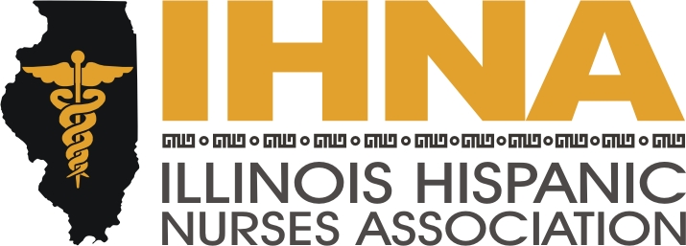

IHNA Meeting Minutes
Instituto Progreso Latino
Chicago, Il
June 18th, 2015

I. Meeting called to order at 6:00 pm by President Susana Gonzalez.
Acknowledgement of host Henrietta Barcelo, Healthcare Industry Liaison, Office of the President/CEO
II. Recap and upcoming: Susana Gonzalez.
- Nancy Garcia led a successful Muevete USA for IHNA at Vive tu Vida on June 6th at McKinley Park. There were over 100 participants with free giveaways including bicycles for the registrants.
- In the June issue of the Nursing Voice, Lupe Hernandez is presented as winner of the AHA community service award. We are very proud of all the hard work Lupe and our team put in to receive this award. Please contact Liz Florez, PhD, our IHNA-AHA liaison coordinator and new President-elect to find out all the activities that IHNA does with AHA
III ACA Wanda Monterrubio: Great news! NAHN has given us $5,000 for the program that Wanda led on ACA outreach. With these funds we are sponsoring the July conference trip for several members that assisted Wanda in this initiative. Because of the fine work we did along with 10 other sister chapters, NAHN has been renewed for the grant to the tune of $250,000.
IV. Calendar Website Feature:
Please check our new website feature of the calendar located under the “In the Spotlight” tab. This is a location you can easily see what we are up to and plan your activity participation accordingly. This is in addition to our regular Facebook updates. It is also easily accessed on our smart phones.
V. We have a new solicitation letter for members as well as a welcome kit and a reminder letter to give to members who are due to expire. In addition, the new ambassador program will be in place in order to further our mission of mentoring the new generation of healthcare leaders at nursing schools. Our new list of Ambassadors are Diane Ortega at Chamberlain, Andrea Fitzsimmons at Dominican University, Angel Hernandez and Miriam Vera at Resurrection University, Lydia Falbo at Moraine Valley, and Patty Ramirez at IDPL.
VI. Scholarship award ceremony. Susana Gonzalez. Our committee consists of Luz Mariani, Griselda Perez, Marisca Sanchez and Denise Massey. We are soliciting leads to help us find the perfect venue.
VII. Our next meeting will be preempted by the National Conference in California. The August meeting will be held at Resurrection University on August 20th. Meeting adjourned by Susana Gonzalez at 8:00 pm.

