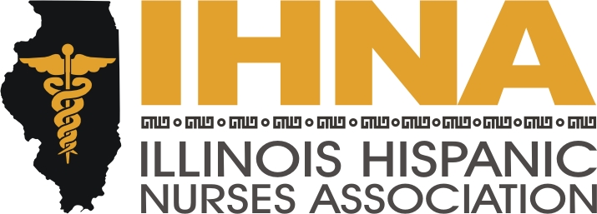

IHNA Meeting Minutes
Held at Humboldt Vocational Center
1645 N California, Chicago, Il
May 21, 2015

I. Meeting called to order at 6:00 pm by President Susana Gonzalez
a. Acknowledgement of our host, Humboldt Park Vocational Center and Director Ines Montero.
II. Recap and upcoming: Susana Gonzalez.
- Recap of Cinco de Mayo event with Hispanic professional associations at Joe’s on Weed Street. This is a fundraiser to add to our scholarship fund. It is a new collaboration with the National Society of Hispanic MBAs, Hispanic Association of Lawyers, Association of Latino Professionals and Society of Hispanic Professional Engineers.
- May 5th IHNA-AARP lobby day in Springfield, members advocated for AARP Care Act and March of Dimes initiatives.
III. AHA. Liz Florez, PhD.
We are soliciting members to participate in the AHA Go Red for Women Expo on the 29th of May as part of our liaison with the AHA. It is an all-day event starting at 8:30 am and will be held in the Great Hall of Union Station. We are also soliciting a Speaker Bureau presenter to present AHA Powerpoint information in Blue Island. Also we are promoting the Red Dress Dash July 29th from 5:30 to 7:30 at Daley Plaza. This is an opportunity to support the AHA Go Red for Women by wearing a red dress and going on a short jog downtown. Please contact Liz Florez, PhD, our IHNA-AHA liaison coordinator and new President-elect for assignments.
IV. ACA. Wanda Monterrubio.
We have done several health fairs recently in Berwyn and Cicero. Up to this point we have done outreach to slightly over 250 members of the community to meet our obligation to our NAHN-OMH grant and look forward to receiving $2,500 to aid in building our scholarship reserve.
V. The annual Vive tu Vida health fair, will be held on June 6th and we will be presenting the Muevete Campaign and Zumbando en el Barrio with Nancy Garcia in collaboration with AARP. We reach out to families and children teaching healthy habits. She will be coordinating stations on reading food labels, health snack options, developing a balanced meal and lifestyle changes. We are soliciting volunteers to help man the stations. For more information, please contact Nancy Garcia, our Treasurer. Volunteers can help set up at 8:30 am.
VI. Calendar Website Feature: Wanda Monterrubio.
Please check our new website feature of the calendar located under the “In the Spotlight” tab. This is a location you can easily see what we are up to and plan your activity participation accordingly. This is in addition to our regular Facebook updates. It is also easily accessed on our smart phones.
VII. Bylaws and elections: Susana Gonzalez.
Our bylaws have been approved and we have the new roster:
Susana Gonzalez for President 2015-2017
Wanda Monterrubio for Secretary 2015-2017
Nancy Garcia for Treasurer 2015-2016
Treasurer elect, Gloria Barrera 2016-2018
President elect, Liz Florez 2017-2019
VIII. Treasurer report: Nancy Garcia.
We have $33,946.40 in the bank. We will be donating $10,000 to our scholarship fund to be awarded in October. In addition, our organization is sponsoring three students, Diana Ortega, Annabelle Guzman, and Danny Montes to attend the national convention in Anaheim, California, a $500 fee per person, as well as provide airfare and hotel accommodation. For volunteering with the ACA initiative, Bradley Feliciano and Yuni Moreno will receive paid memberships to our own organization.
IX. Recruitment: Patty Ramirez.
We have a new solicitation letter for members as well as a welcome kit and a reminder letter to give to members who are due to expire. In addition, the new ambassador program will be in place in order to further our mission of mentoring the new generation of healthcare leaders at nursing schools. Our new list of Ambassadors are Diane Ortega at Chamberlain, Andrea Fitzsimmons at Dominican University, Angel Hernandez and Miriam Vera at Resurrection University, Lydia Falbo at Moraine Valley, and Patty Ramirez at IDPL.
X. Scholarship award ceremony. Susana Gonzalez.
Scholarship award recipients will be asked to coordinate the scholarship award ceremony in October of this year.
XI. Evelyn Gomez, recipient of a Sweitzer Grant, is soliciting members to mentor high school students at IDPL in order to create a broader base of Hispanics in healthcare careers. At this point she is starting with 25 students and is looking to match them one to one with 25 mentors.
XII. Meeting adjourned by Susana Gonzalez at 8:00 pm.

