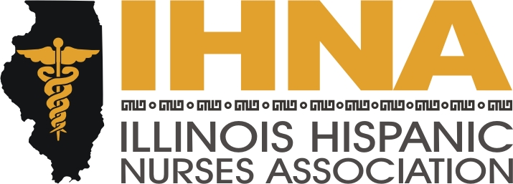

IHNA Meeting Minutes
Held at Chamberlain School of Nursing,
1225 Swift Road, Addison, Illinois
April 16, 2015

I. Meeting called to order at 6:00 pm by President Susana Gonzalez
a. Acknowledgement of our host, Chamberlain School of Nursing Associate Dean of Academic Operations, Debi Savage and our IHNA-Chamberlain Ambassador, Diana Ortega.
II. Reminders:
- Project Embrace May 1st, annual program to donate formal dresses to help girls with HS prom.
- Cinco de Mayo on May 1st at Joe’s on Weed Street. This is a fundraiser to add to our scholarship fund. It is a new collaboration with the National Society of Hispanic MBAs, Hispanic Association of Lawyers, Association of Latino Professionals and Society of Hispanic Professional Engineers.
- May 5th IHNA-AARP lobby day in Springfield, members are invited to attend an advocacy day to represent issues related to the Care Act. Our lodging will be provided by AARP and is at the Hampton Inn in Springfield. This is a two day event in keeping with our mission of healthcare advocacy to make our presence known at our State’s capitol.
- We are soliciting members to participate in the AHA Go Red for Women Expo on the 29th of May as part of our liaison with the AHA. It is an all day event starting at 8:30 am and will be held in the Great Hall of Union Station. Please contact Liz Florez, PhD, our IHNA-AHA liaison coordinator for assignments.
- The annual McKinley Park Health and Lifestyle Fair will be held on June 6th and we will be presenting the Muevete Campaign with Nancy Garcia. This is a collaboration with our national NAHN wherein we reach out to families and children teaching healthy habits. She will be coordinating stations on reading food labels, health snack options, developing a balanced meal and lifestyle changes. We are soliciting volunteers to help man the stations. For more information, please contact Nancy Garcia, our Treasurer.
- Please check our new website feature of the calendar located under the “In the Spotlight” tab. This is a location you can easily see what we are up to and plan your activity participation accordingly. This is in addition to our regular Facebook updates.
III. Bylaws and elections:
Our bylaws have been approved and we are nominating:
Susana Gonzalez for President 2015-2017
Wanda Monterrubio for Secretary 2015-2017
Nancy Garcia for Treasurer 2015-2016
Treasurer elect, Gloria Barrera 2016-2018
President elect, Liz Florez 2017-2019
V. Ambassadors:
In order to further our mission of mentoring the new generation of healthcare leaders, we have implemented our Ambassador program where our members pass on ideas, information and recruit members at their educational institutions. Our new list of Ambassadors is Diane Ortega at Chamberlain, Andrea Fitzsimmons at Dominican University, Angel Hernandez and Miriam Vera at Resurrection University, Lydia Falbo at Moraine Valley, Patty Ramirez and Ines Montero at IDPL.

VI. Meeting adjourned by Susana Gonzalez, President, at 8:00 pm.

