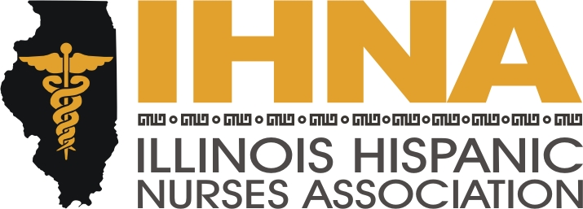

IHNA Meeting Minutes
Career Information Fair at Instituto Progresso Latino
2520 South Western Avenue, Chicago, Illinois
December 18th, 2014

I. Career Information Fair begun at 6:00 pm by President Susana Gonzalez
a. Acknowledgement of our host, Instituto Progreso Latino and Claudia Regalado.
II. Professional Nursing Careers Represented:
APN, Men in Nursing, Women’s Health and Obstetrics, Emergency and ICU, Home Health Care, Pediatrics.

Thank you all for your participation. Our next meeting will be held at Resurrection
University on January 18th, 2015. See you at the first meeting of the new year!

