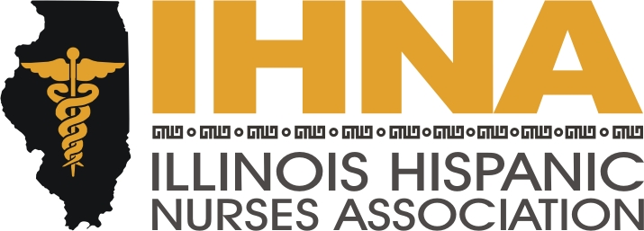

IHNA Meeting Minutes
Held at Dominican University,
7900 West Division Street, River Forest, Illinois
November 19th, 2014

I. Meeting called to order at 6:00 pm by President Susana Gonzalez
a. Acknowledgement of our host, Dominican University, and our member Andrea Fitzsimmons, MSN-RN, past president of IHNA and clinical coordinator of nursing at Dominican.
II. Agenda Topics and Reminders:
a. IHNA partnership with AHA on Chicago Little Hats for Big Hearts. We will meet up to learn how to crochet red baby hats at the Lyons Library, 4209 Joliet Ave., Lyons, IL, 60534 on Monday November 24th at 7pm. Our contact there is Cassandra Ozouf, ozoufc@lyonslibrary.org. Her number is 708-447-3577x302. The hats will be distributed in February to newborns at several hospitals. Our goal is 500. Please attend.
b. AHA Go Red Multicultural Scholarship fund comprises 16 separate $2,500.00 scholarships. The deadline is December 31st. We would like our members to apply. For more information on how to apply, please email Dr. Florez: Contact Liz Florez at eflorez1@depaul.edu.
c. December 18th is Career Fair Day from 6pm to 8pm in partnership with Instituto Progresso Latino located at 2520 S Western Avenue. We are hosting our next monthly meeting at this event.
d. Tuesday, November 25th just two days before Thanksgiving is a tradition we have of going to San Lucas Church on North Avenue in Humboldt Park to assist in giving flu shots. Please remember to spend a couple hours here if you can. There will be an opportunity to present our ACA curricula at this event.
e. IHNA was represented by Susana Gonzalez on a Healthcare Panel in partnership with Hispanic Pro at Vertigo Sky Lounge on November 19th.
f. Upcoming tomorrow, Susana Gonzalez will be a panelist at the Latino Legislative Caucus on Healthcare Education to discuss opportunities for access to training.
g. Deadline for Abstracts to NAHN is December 1st for the 2015 Conference in California.
III. The Illinois Alliance to Prevent Obesity is presenting the Rethink Your Drink Campaign.
Nancy Garcia, our treasurer, is our lead on this initiative, which is supported by the American Academy of Pediatrics. The program is part of the Healthy Eating and Active Living (HEAL) Act, which is a bill that funds obesity prevention and treatment by taxing sugar-sweetened beverages. We can support this initiative by making a pledge to stop or reduce our consumption of sugar-sweetened beverages, and telling other people about the program.
IV. Our next meeting will be held at the Instituto Progresso Latino for the Career Fair. See
You there!
V. Meeting adjourned by Susana Gonzalez, President, at 8:00 pm.

