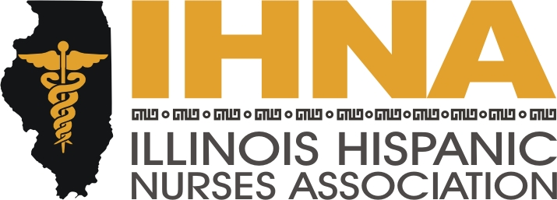

IHNA Meeting Minutes
Held at West Suburban Hospital, Oak Park, Illinois
October 16th, 2014

- Meeting called to order at 6:00 pm by President Susana Gonzalez
  - Acknowledgement of location, West Suburban Hospital, and our host, Denise Massey, our recent IHNA scholarship recipient.

- Agenda Topics:
  - AHA is asking IHNA for partnership on Chicago Little Hats for Big Hearts. We will meet up to learn how to crochet red baby hats at the Lyons Library, 4209 Joliet Ave., Lyons, IL, 60534 on Monday Oct 27th and November 24th at 7pm. Our contact there is Cassandra Ozouf, ozoufc@lyonslibrary.org. Her number is 708-447-3577x302. The hats will be distributed in February to newborns at several hospitals. Our goal is 500. Please atten
  - AHA Go Red Multicultural Scholarship fund comprises 16 separate $2,5000 scholarships. The deadline is December 31st. We would like our members to apply. For more information on how to apply, please email Dr. Florez: Contact Liz Florez at eflorez1@depaul.edu..
  - December 20th is Career Fair Day. This is a collaboration with member Melissa Hernandez from UIC. We will discuss more details as it comes closer.
  - Tuesday before Thanksgiving is a tradition we have of going to San Lucas on North Avenue in Humboldt Park and assist in giving flu shots. Please remember to spend a couple hours here if you can.

- IHNA-ACA collaboration with NAHN where chapters make presentations on the Affordable Care Act to the community. We are participating. The Chair is Wanda Monterrubio, who had the program last year with AARP. At the end of this month we are going to Arizona for a session meeting and will come back with official information and a program to present for the November meeting. Members that reach a goal presentation can receive a free registration for the annual conference which will be held next year in California. Contact Wanda Monterrubio at wanda.monterrubio@gmail.com.

- Presentation by March of Dimes, Ana Blankenberger. Specific Latino initiatives to address health disparities are preventing preterm birth, infant mortality and birth defects. On November 6th at the UIC College of Medicine there will be a presentation on this topic that is free by Diana Ramos from 12:30 until 2:00 pm. There also will be a reception at Art revolution on Ashland and Lake at 6:30 pm.

- A new initiative is Rethink Your Drink to be presented next month by our Treasurer Nancy Garcia. This is targeting obesity in children.

- Meeting adjourned by Susana Gonzalez, President, at 8:00 pm.

