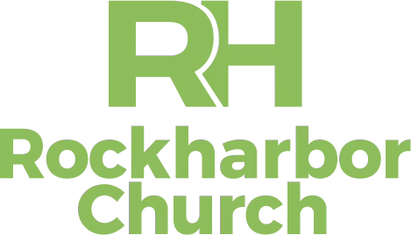
JOB DESCRIPTION
Position Title: IT and Software Training Coordinator
Ministry Department: Operations
Reports To: Business Administration Director
Status: Full Time, Exempt (Some weeknights)
Created: July 2026

Primary Purpose
The IT & Software Training Coordinator provides day-to-day administration, support, maintenance, and staff training. They are the primary point of contact for resolving technical issues, ensuring staff have reliable, secure technology. Directs and leads software adoption, documentation, onboarding, ongoing training, and technical support. Responsibilities include troubleshooting, configuring systems, managing service tickets, and maintaining equipment.

Position Requirements
- High School Diploma. Associates or bachelor’s degree in IT, Education, HR or a related field, preferred.
- Minimum 2 years direct IT support experience.
- Extensive macOS and Apple hardware knowledge; as well as Microsoft 365 administration.
- Professional experience with digital security including Ubiquiti Network, Protect, Access, and Identity
- Expertise working with Dropbox, Planning Center, UKG, Contio, and CCB is a plus.
- Excellent communication, customer service and documentation skills.
- Ability to explain technical concepts to non-technical users.
- Strong organizational, time management skills, and desire/ability to love and lead others.
- Ability to be teachable, seeking out coaching and learning for growth and development.
- Ability to promote a positive attitude and working environment, with the desire to have fun, be positive and flexible.

Position Responsibilities
- Primary point of contact for resolving technical issues. computers, printers, mobile devices and conference room technology.
- Oversee and service networking, WiFi, cameras and access control.
- Manages IT inventory, warranties and documentation associated with tracking an asset from purchase to disposal.
- Maintain and update Visix displays
- Create and maintain technical records such as user manuals and troubleshooting guides.
- Administer Microsoft 365, email, SharePoint, OneDrive and licensing. Including Dropbox, Visix, Contio. and future software.
- Manage user accounts, permissions, onboarding and offboarding for staff and volunteers.
- Implement all new employee technology onboarding meetings.
- Develop Standard Operations Procedures (SOP’s), guides and training videos.
- Provide ongoing education for approved software including any Ai introduced.
- Research AI tools and recommend practical improvements.
- Support MFA, backups, updates and endpoint security.
- Maintain documentation and disaster recovery procedures.
- Provide support for weekend services and all major events.
- Recommend and coordinate vendors and technology purchases.
- Assist with ensuring standardized technology for future campuses.
Personal and Spiritual Requirements
- Has a growing relationship with Jesus, and a commitment to spending daily time with Him.
- Commitment to spiritual, personal and professional growth
- Models’ standards and expectations of Rockharbor Church leadership, including, but not limited to:
  - Upholding Rockharbor’s Core Values and mission
  - Regular attendance at Rockharbor Church services
  - Regular participation in an RH Group
  - Partnership through tithing and serving
  - Abstaining from smoking, vaping and illegal substances
  - Models’ discretion and positivity in use of social media
  - Setting of appropriate boundaries to protect character and integrity.

Rockharbor Church exists to love and lead one another to be devoted followers of Jesus. We encourage each member of our staff team to live this mission through their personal lives and in their work. We value striving for excellence and working together as a team. We believe God has gifted everyone with specific and unique gifts and talents, which He brings together to reach our community and world with the love and message of Jesus!

