

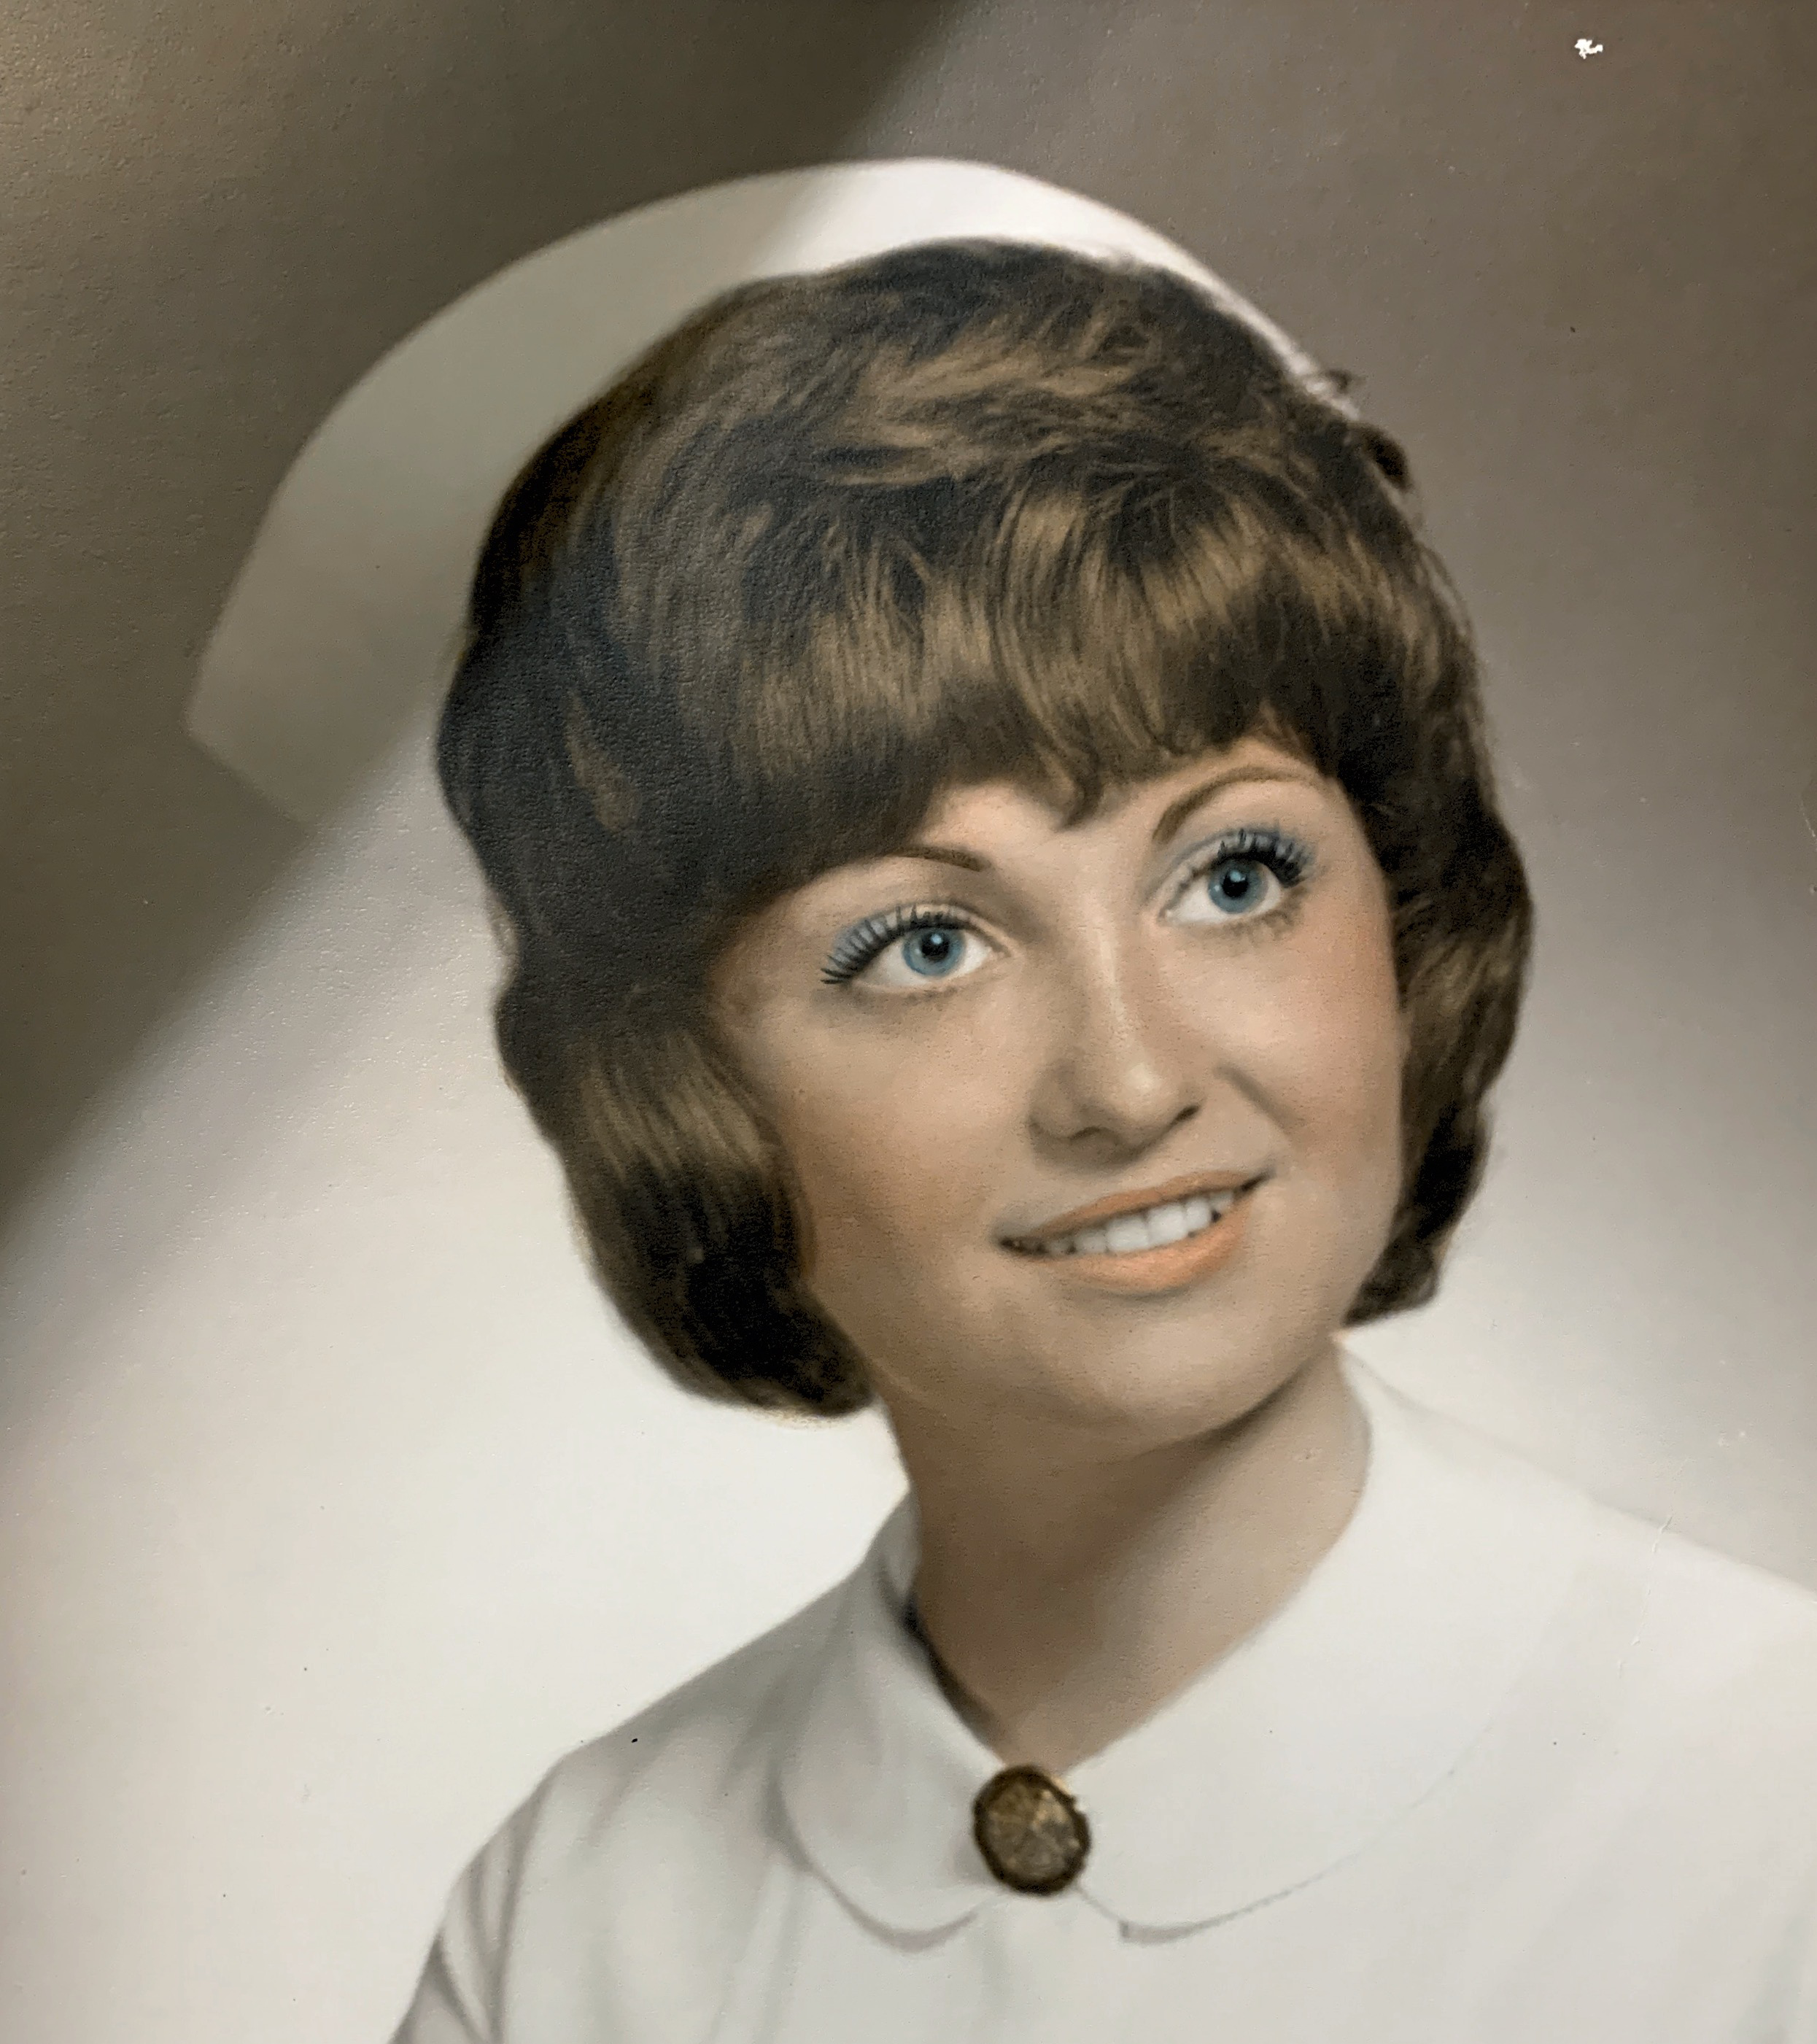




Barbara Fallon Memorial Nursing Scholarship Application
Spring 2026
(Application MUST be typed or computer generated)

Last Name: First Name: Middle Initial:

Address:

City/Zip Code: Phone Number:

High School: Email Address:

Date of Birth:

Parent(s)/Guardian(s) Name:

Parent(s)/Guardian(s) Occupation(s):

Place(s) of Employment:

Do you live with your parent(s)/guardian(s)? How many children in your family?

Ages of each child:

Please list school activities, honors, hobbies, clubs/organizations, talents and community activities. Also, include information about leadership roles you may have had (additional sheets may be used):

Does attending college depend on outside help?

Name of School/College you plan to attend:

School/College Major or Field of Study:

Attach an essay explaining your goals pertaining to the nursing profession and why you are in need of this scholarship.

Please note: Academic information will automatically be pulled for each applicant.
The application, essay, and reference letter MUST be returned to your guidance office NO LATER than March 2nd, 2026. If you have any questions, please call Tiffani King at (352) 726-1931 x4369.

Barbara Fallon Memorial Nursing Scholarship

Procedures:

- All applications must be typed or computer-generated and complete.

- Applications MUST be received NO LATER than March 2nd, 2026. All applications must be returned to your guidance office.
- Recipients will be announced at the high school academic awards programs.

- The number of recipients and the monetary amount awarded will be based on the number of applicants.

- The monetary award will be given to the student on the night of high school academic awards program.

Criteria Checklist:

_____1. The applicant must be a Citrus County resident of at least one year.

_____2. The applicant must be seeking a career in the nursing profession.

_____3. The applicant must be a graduating senior or currently enrolled in college or nursing program.

_____4. The applicant’s transcript will automatically be pulled. All of the transcript’s academic information will be taken into consideration.

_____5. It is preferred that the applicant demonstrate leadership in extracurricular activities and contribute to the community and/or work and/or have volunteer experience.

_____6. One (1) reference letter is required:
- Reference may come from a teacher, coach, advisor, school counselor, school administrator, employer, clergy, a person with whom the student has done volunteer or community work, or any other adult who is aware of the student's goals and skills.
- Reference may NOT be a family member.

_____7. Essay: Each applicant must write an essay explaining your goals pertaining to the nursing profession and why you are in need of this scholarship.

