Cavanaugh Seminole Scholarship
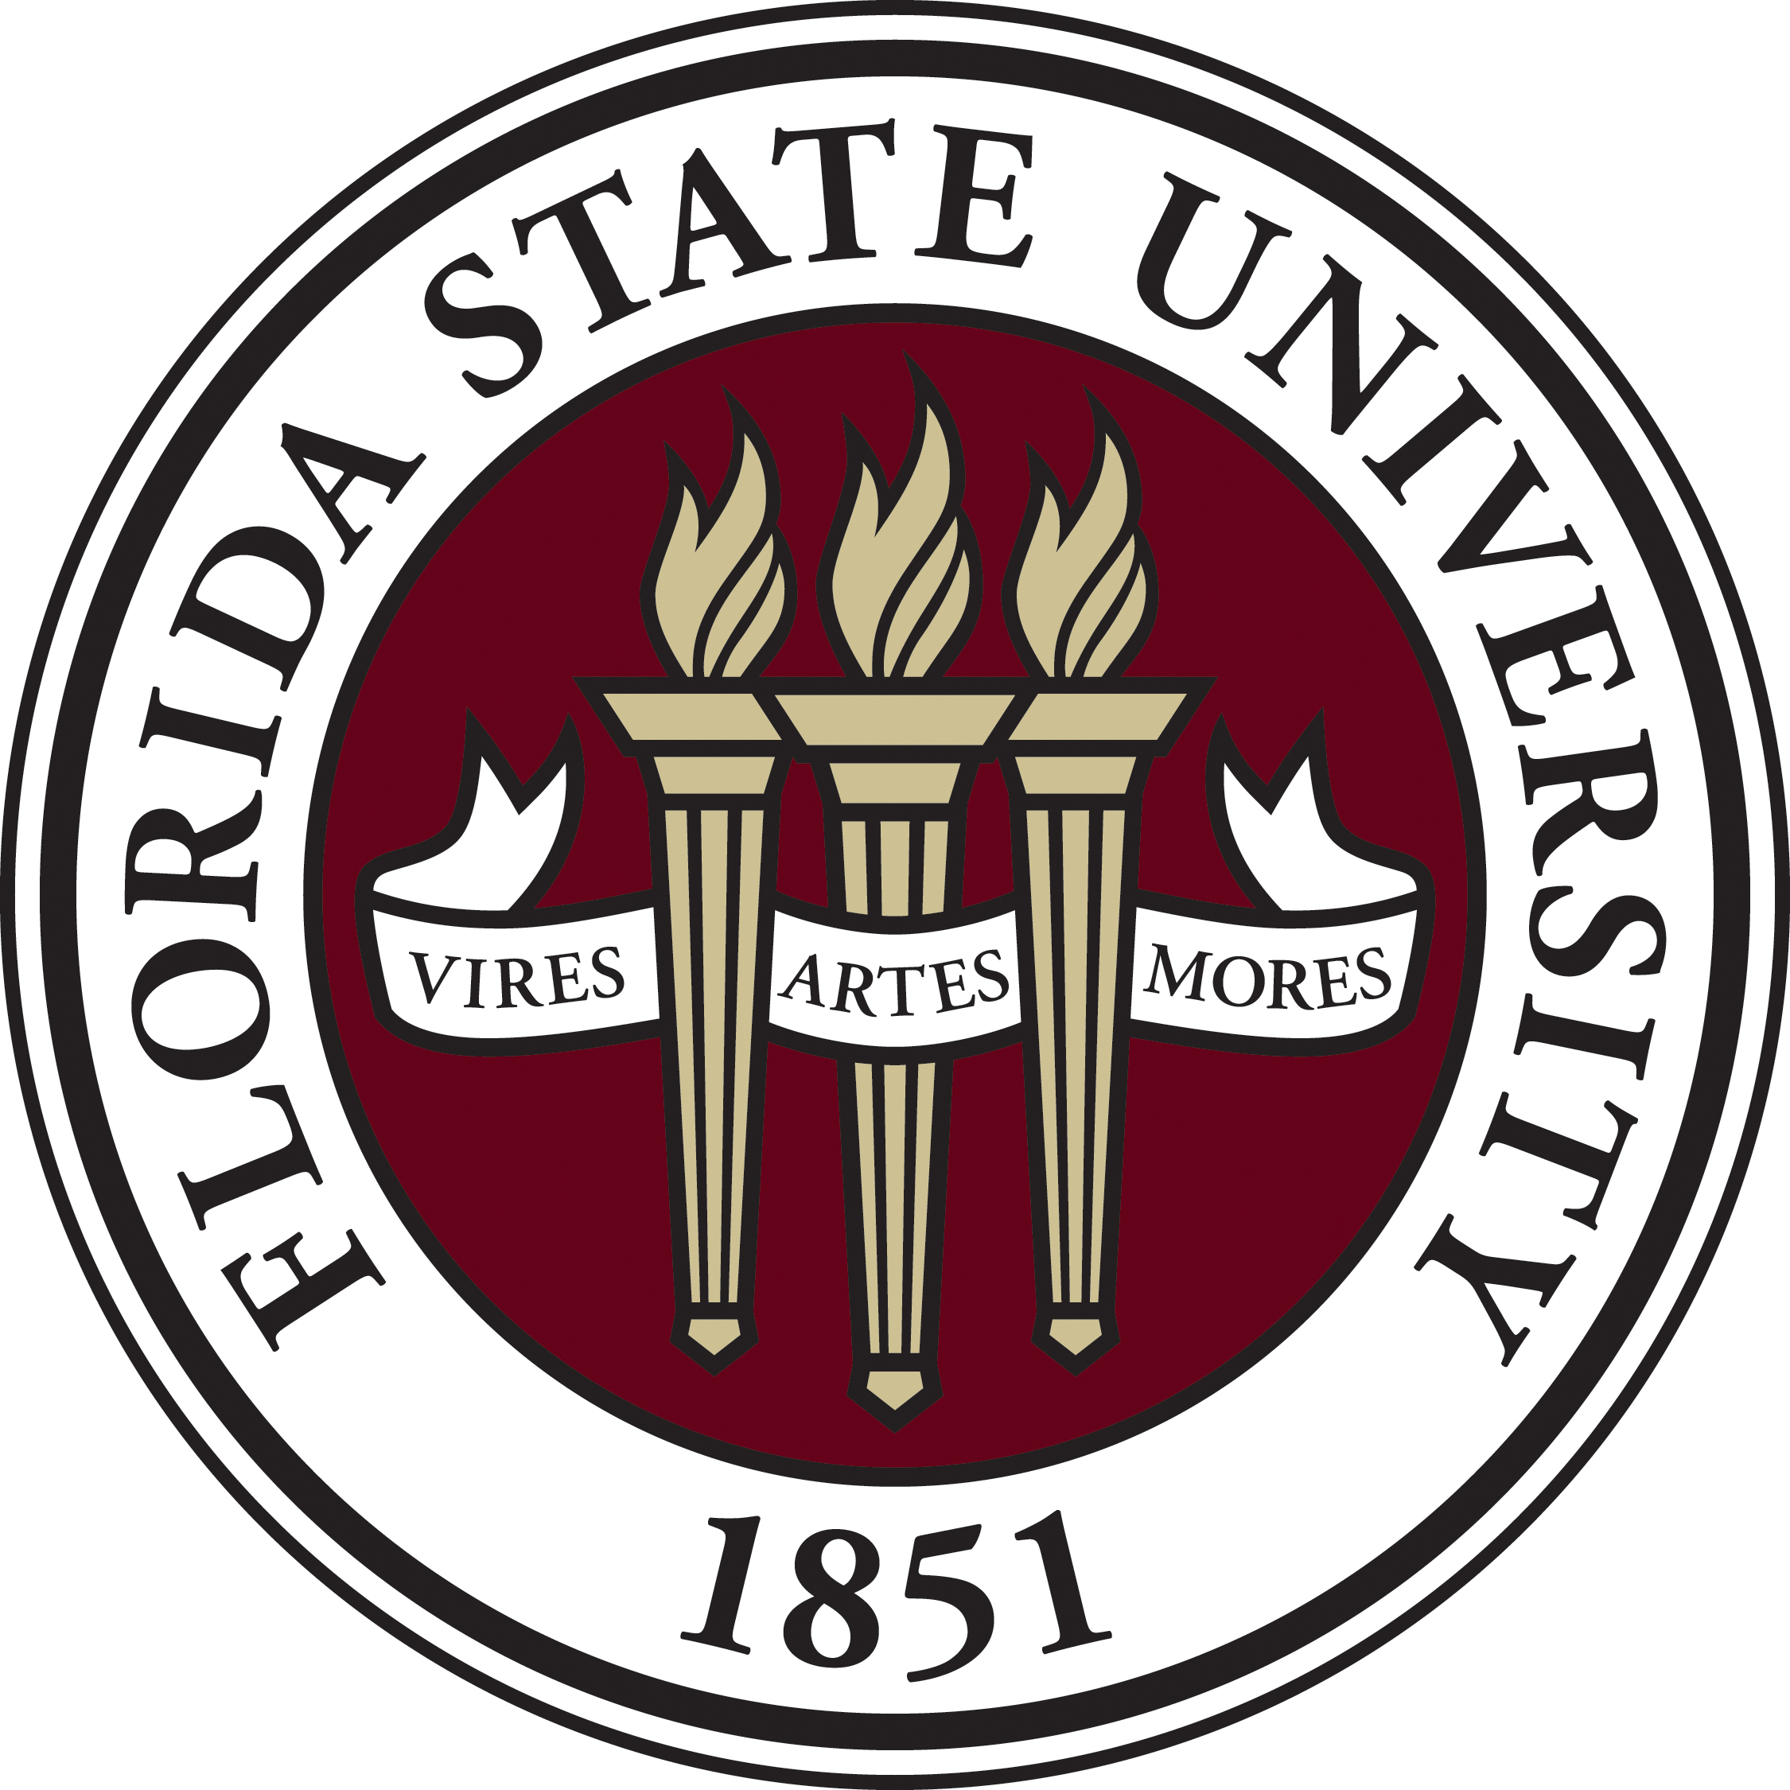

Eligibility
- Will graduate from a public high school in Citrus County.
- Will be attending Florida State University in Tallahassee in the following year.

Information
Scholarship award amount: $1000
Number of scholarships awarded: 1 per year.
You will need to request the scholarship money be sent to the FSU Financial Aid Office as soon as you get your FSU ID card and your schedule for the fall semester.

Background
John and Ellen Cavanaugh owned a musical string manufacturing company in Florida for over four decades. Both were very involved in community affairs and philanthropy. Although they did not attend Florida State University, all three of their children would graduate as Seminoles. Between their own children, in-laws, and grandchildren over 10 degrees were earned by the Cavanaugh Family and descendants from Florida State University.

Procedures and Submission
- All applications must be typed or computer-generated and complete (expand as needed).
- The application, a resume or curriculum vitae (cv), and any other materials must be returned by March 31, 2026, to your guidance counselor or mailed to:

Citrus County Education Foundation Scholarship Committee
Attention: Tiffani King
PO Box 2004
Inverness, FL 34451

PERSONAL INFORMATION
ITEM | INFORMATION
APPLICANT’S NAME
PARENTS/GUARDIANS
HOME ADDRESS
PHONE
EMAIL
WEIGHTED GPA
UNWEIGHTED GPA
SAT/ACT SCORES (SUPERSCORED)
AP/IB/AICE EXAMS PASSED & SCORES | EXAM |  |  | SCORE | EXAM |  | SCORE
AP/IB/AICE EXAMS TAKEN THIS MAY
DUAL ENROLLMENT CLASSES IN WHICH YOU EARNED AN “A”
CHECK ANY OF THE FOLLOWING THAT DESCRIBE YOU |  | DESCRIPTION
CHECK ANY OF THE FOLLOWING THAT DESCRIBE YOU |  | ALREADY HAVE EARNED AN IB, AICE OR AP CAPSTONE DIPLOMA
 |  | CANDIDATE FOR AN IB, AICE, OR AP CAPSTONE DIPLOME (JULY NOTIFICATION)
 |  | WILL EARN AN AA/AS DEGREE AT THE SAME TIME AS GRADUATING HIGH SCHOOL
 |  | SELECTED TO FMEA ALL-STATE BAND, CHORUS, OR ORCHESTRA
GIVE DETAILS OF WHAT YEAR(S) AND ENSEMBLE | YEAR(s)  ENSEMBLE
 |  | COMPETED AT STATE FINALS CHAMPIONSHIP TOURNAMENT AS AN INDIVIDUAL (NOT RELAY OR TEAM).
GIVE DETAILS OF WHAT YEAR(S) AND SPORT | YEAR(s) or  SPORT or

FSU INFORMATION
ITEM | INFORMATION
WHAT WILL YOUR MAJOR(S) BE:
LIST ANY MINORS IF APPLICABLE

MARK WITH A CHECK OR WITH AN “X” YES OR NO TO THE FOLLOWING: | YES | NO
WILL YOU BE LIVING ON CAMPUS (DORM) IN YOUR 1ST YEAR AT FSU?
WILL YOU BE ATTENDING SUMMER SCHOOL THIS SUMMER (2026) AT FSU?
WERE YOU ACCEPTED TO THE HONORS COLLEGE AT FSU?
WERE YOU ACCEPTED AS PART OF THE CARES PROGRAM AT FSU?
ARE YOU THE FIRST FAMILY MEMBER TO ATTEND FSU?
(IF NO, WHO ATTENDED?)
WHO ARE SOME OF THE ALUMNI THAT HELPED GUIDE YOU INTO CHOOSING FSU?

PLEASE ATTACH THE FOLLOWING:
A) In a short essay (500-1000 words), tell why you chose FSU and how FSU will help you in obtaining your life goals.
B) VIRES, ARTES, MORES (Strength, Skill, and Character)
Florida State University has three institutional core values— Vires, Artes, Mores. In another short essay (400-750 words), briefly tell what you have done while in high school (both inside and outside of the classroom) to demonstrate why you will be a good representative for FSU.
C) Please attach a resume or a curriculum vitae (cv) with this application.

TYPE NAME & DATE BELOW:
Signature: | Date:
☐ I understand that checking (MARK WITH AN X), this box constitutes a legal signature confirming that I acknowledge and warrant the truthfulness of the information provided in this document.

