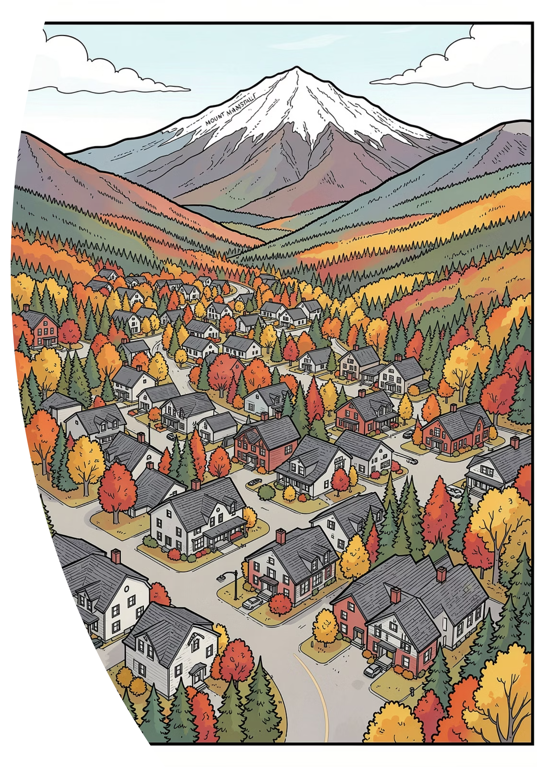



Economic Impacts
of Short-Term Rentals Stowe, Vermont

Report
Table of Contents

Table of Contents
Definitions 6
Acknowledgements 7
Chapter 1: Introduction 8
The Pros and Cons of STRs 9
The benefits 10
The costs 10
The Study’s Objectives 11
Chapter 2: Baseline: 12
Short-Term Rentals in Stowe 12
Housing Supply and Homesteads 12
Inventory of Short-Term Rentals in Stowe 13
Has the introduction of STRs decreased the supply of long-term affordable Housing in Stowe? 15
Homesteads and STRs 20
Homestead Filing Requirements in Vermont 23
Does the Decrease in Homesteads mean a decrease in Residences? 24
Estimation of Stowe Residents in Non-homestead Properties 25
Chapter 3: Statewide Comparative 26
Analysis of STRs in Vermont 26
Homesteads Declarations and STRs 26
Statewide comparison of STR Activity Across Vermont 27
Chapter 4: The Economics of 29
Short-Term Rentals in Stowe 29
Homestead vs. Non-homestead Short Term Rental Activity 29
Are Hotels and STRs Economic Substitutes? 31
STRs and Commercial Hotels: Occupancy Rates 32
What is the impact that STRs Investors have on real estate values in Stowe? 34
STR Ownership Types 34
STR Nights Booked 36
Nightly Rates of STRs 38
STR RevPAR: Revenue Potential and Commercial Value 38
Estimated Yield Rates and Capitalization Rates from STR properties 40
Demand for STRs in Stowe 44
Targeting STR Investor Activity in Stowe 45
Multi-STR owner Investors 46
Investor STR Owners in Stowe and their Returns 47
Single STR Owner Investor 48
Summary of Investor STRs 49
Are investor STRs taking housing away from long-term rentals or ownership for Workforce Housing? 50
Chapter 5: Social and Environmental 51
Impacts of STRs in Stowe 51
STR energy use 51
Water Use 53
Transportation Impacts 55
Emergency Services 56
Chapter 6: Economic Contribution Analysis 57
Appendix 1: § 5410. Declaration of homestead 59

Table of Tables
Table 1 Stowe Housing Inventory (source2025 Grand List) 12
Table 2 Housing Units in Stowe 2025 (source 2025 Grand List) 12
Table 3 STR Registrations and Active Listings (source Town Managers Office) 14
Table 4 STR inventory in Stowe (source Town Managers Office) 15
Table 5: Assessed Value of STRs for SF homes and Condos (source, 2025 Grand List) 16
Table 6: Stowe Housing Needs Assessment, Affordability Thresholds. (Source: Community Scales) 16
Table 7: Affordability Calculations for Workforce Housing (source Crane Associates) 17
Table 8 Affordable STR Condos by number of bedrooms (Source, Town Managers Office) 18
Table 9 Revenue of Condo STR units at <$500,000 asset valuation 19
Table 10 Gross Revenue from Long-term rental vs STRs 19
Table 11: Homesteads and STRs (source, 2025 Grand List) 20
Table 12 Homestead Filings, Stowe 2012 to 2025 (source, Town Manager’s Office) 21
Table 13 : Estimation of Non-homestead Stowe residents (source 2025 Grand List) 24
Table 14: Registered voters and votes cast in non-homestead parcels (source Town Managers Office) 25
Table 15 Estimate of Non-Homestead Residents in Stowe 25
Table 16 STR Intensity Levels Across Vermont Towns (source Crane Associates, VHFA and US Census) 27
Table 17 Homestead vs Non-Homestead STRs 29
Table 18 Revenue and Nights booked 30
Table 19 STR nights booked 30
Table 20: summary of nights booked May to Dec 2025 30
Table 21 Occupancy Rates of STRs in Stowe using two methods 33
Table 22 Average Occupancy Rates of Stowe Area Association Member Hotels (source Stowe Area Association) 33
Table 23 STRs by Property Valuation and Type 35
Table 24 STR Revenue by Property Valuation and Type 35
Table 25 STR efficiency of revenue generation 36
Table 26 Revenue per Nights Booked 37
Table 27 Nights booked per year by Ownership Type 37
Table 28 Nightly rates and revenue by asset class 38
Table 29 RevPAR of Stowe STRs ranked by Assessed Value using Hotel Occupancy Rates 39
Table 30 RevPAR by Ownership Segment 40
Table 31 Gross Yields per Asset Class 41
Table 32 Benchmark cap rates. 2025 42
Table 33 Cap rate benchmarks for hotels 42
Table 34 STR Cap Rates by Asset Class 43
Table 35 STR Cap Rates by Ownership Type 44
Table 36 Market Demand for STRs 45
Table 37 STRs per Owner 46
Table 38 multi-Owner STRs by type 46
Table 39 Active multi-STR Owners and Level of Activity 47
Table 40 ROI and CAP Rates for Investor STR Owners 48
Table 41 One STR owners by Gross Revenue 48
Table 42 One-Owner STRs with cap rates above 5% 49
Table 43 Summary of Investor STR owners and Units 49
Table 44 Investor STRs by Assessed Value 50
Table 45 Energy Consumption, STR vs Full-Time Residence in Stowe 51
Table 46 Summary Comparison of Energy Use 52
Table 47 Water consumption in STRs vs Full-Time Homes 54
Table 48 Total Water usage comparison 54
Table 49 Trip Generation Assumptions for STRs 55
Table 50 Trip Generation Calculations for STRs in Stowe 55
Table 51 Vehicle Usage from Stowe STRs 55
Table 52 Incident rates/property by property type 56
Table 53: Probability of active STRs requesting EMS services versus All Other Property 56
Table 54 Lamoille County Visitor Spending Profile 57
Table 55: Economic Contribution of STR-related spending in Stowe 58

Table of Figures

Figure 1 Inventory of STRs by select months (source Town Managers’ Office) 13
Figure 2 Registered STRs and Percent Active by Unit Type 14
Figure 3 Homestead Filings in Stowe 2012-2025 22
Figure 4: Homestead Filings and Airbnb Activity 22
Figure 5 Economic Substitutes between STRs and Hotels 31
Figure 6 Distinctions between STRs and Hotels 31
Figure 7 LLCs STRs 35
Figure 8 Benchmark cap rate for hotels 2005 to 2025 42

