CEDaCI
Circular Economy for Data Centre Industry
Transnational Co-Creation Workshop

Summary of Key Findings
Date: 05/10/2022
Address: Virtual
Time: 09:00 – 12:00 UK Time
Working Group Country
Transnational Session

ACRONYMS
CDCC | Circular Data Centre Compass
DMT | Decision Making Tool
UX | User Experience
UI | User Interface

Name | Organisation
Deborah Andrews | LSBU
Kristina Kerwin | LSBU
Kate Calloway | LSBU
Nil Atmaca | LSBU
Dominika Ptach | LSBU
Astrid Wynne | Techbuyer
Julie Chenadec | GITA
Naeem Adibi | WeLOOP
Mohan Gandhi | STG Advisors
Ben Lisham | LSBU
Hanna Jung | Closing the Loop
Joseph Smith | Iceotope
Jesper K. Lessen | Kimbrer
Mark Dansie | OCP
Rasmus Vilain | Kimbrer
Ajay Jamodka | Tracelinq
Iegor Trieshchov | Aliter
Arnaud Bourlier | Ablogix
Harry Martin | SDIA

Summary
This co-creation workshop was combined with the Technical Assistance session delivered on October 5, 2022. The break-out rooms in three eco-design, product life extension (refurbishment) and recycling served for this purpose. After having completed the delivery, the break out room leads raised questions to map their views on the Circular Data Centre Compass (CDCC)

Topics of Discussion

- Break –out room eco-design :
The participants received the training about how to use the eco-design evaluator of the CDCC and responded to the questions of LSBU team:

Their main comments of the CDCC eco-design evaluator were as follows:
- Overall, it is useful to have everything in one place.
- Feedback from me: no recent improvements had been implemented.
- Repeated questions in the section relating to Resources Tracking and Tracing – it’s the questions about the availability of locally sourced and imported parts. The two questions appear twice – this will affect the total score.
- Adding explanatory information to questions for the security sections and firmware/software updates (other sections as well) – again should have been added long ago, the security one was specifically added during the last co-creation workshop – I have notes in my spreadsheet.
- Adding geographical location options to the design of the server i.e. how the server design will be affected by the area of its intended use (we do cover that with resources tracing and tracking part – encouraging to source locally, and also in compare part of CDCC).

- Break-out room product life extension/refurbishment :

The participants received first the training about the key aspects of product life extension and compare section of the CDCC.

Their main comments about the compare section were as follows:
- User friendly tool
- The compass should include most common servers and more data is needed to make the tool complete and attractive to the Data Centre Industry
- Memory and storage option for some models are missing. These data should be completed.

- Break-out room recycling :

The participants received the training about the CRM recycling processes developed by TND. The following comments and inputs were collected.

- PCB is a critical and valuable part for Closing the Loop
- The representative of the Closing the Loop will get in touch with TND to discuss the collaboration opportunities.
- The compass is considered good and useful tool

Co-creation survey
7 questions were raised to collect the inputs of the participants and to initiate a discussion.

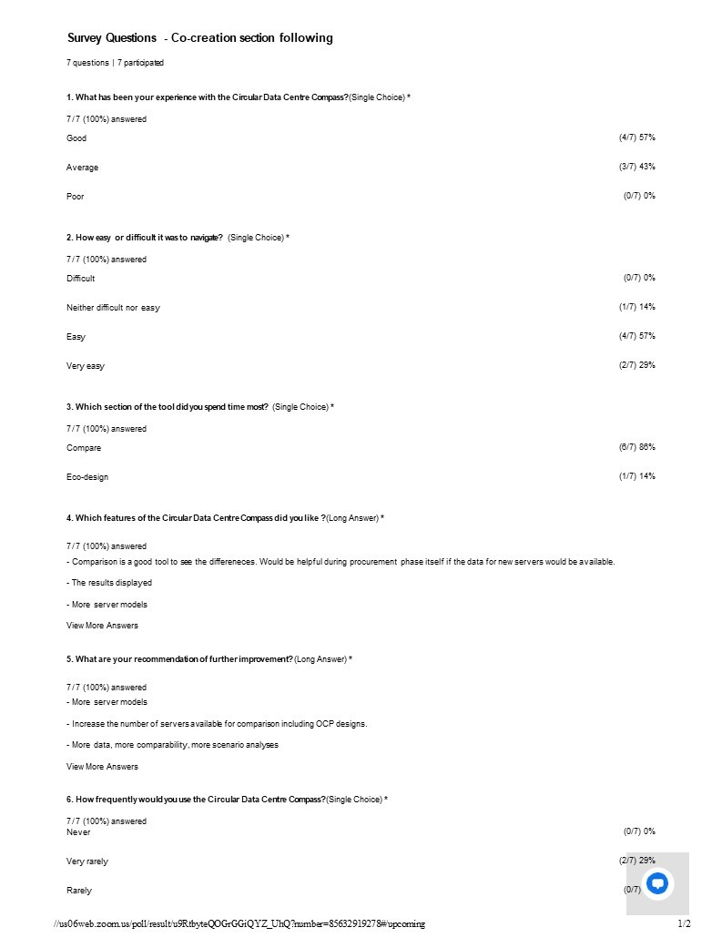

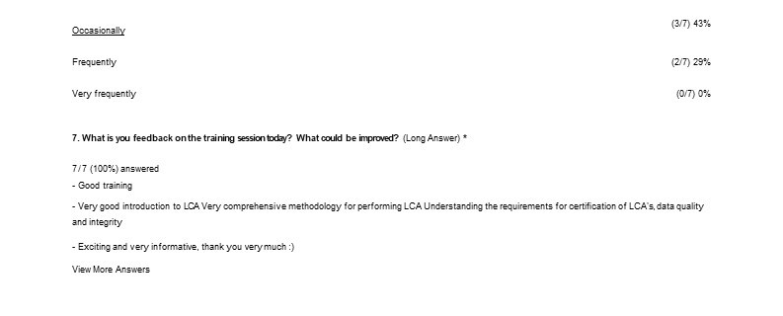

Summary and wrap up: The main comments and feedbacks collected from the audience highlighted the necessity to include more and recently used equipment. The CEDaCI team highlighted that the new servers will be gradually uploaded onto the compass when the characterisation of each model and its components are completed.

