Eastbourne unLtd Chamber of Commerce
Annual General Meeting

27th May 2026
6.00pm to 8.00pm

Montague Farm Hankham

Meeting Called by The Board of Directors
Attendees Members, Directors and Invited Guests

6.00pm to 7.00pm | Welcome  Notice convening the AGM  Apologies for Absence  Minutes of AGM  Adopt Annual Accounts  President’s Report  Election of President, Vice Presidents and Treasurer for 2025/26  Election of Members of the Board for 2026/27 including Member nominations  Confirm Auditors  Any other business  Formal AGM closes | President  President  Chamber Chief Executive  President  Price & Co Auditor  President  President  President  Treasurer  President  President

7.00pm | Martin Hole  Landowner, Farmer and Conservation  Montague Farm | Farm and nature tour
7.30pm | Members evening  Drinks and canapés | All
8.30pm | Close

Directors seeking re-election

Neville Beckhurst representing accountancy and Russell Colbran of Colbran & Wingrove representing construction.

Neville Beckhurst


neville.beckhurst@eastbournechamber.co.uk
01323 641144

Neville is interested in helping businesses across a wide range of areas and has years of experience to draw on.
He has extensive knowledge in dealing with the sale and purchase of private companies and the minimisation of tax liabilities. This includes preparing clients for a sale through tailored strategic and profit planning.
He has been involved with the Chamber for a considerable period of time, including the preparation of their accounts when he was training to be a Chartered Accountant. His interests include supporting local businesses and environment.
Away from the office he is a visitor at Twickenham watching the rugby having been a former player at Eastbourne Rugby Club.

Russell Colbran
Colbran & Wingrove



info@eastbournechamber.co.uk
01323 729025

Russell is managing director of the town’s longest established building contractors, Colbran & Wingrove. The business was started in 1967 by his father Terry. Russell joined in 1996 and subsequently took over the business with his wife Judy.
He loves every aspect of building and delivering an excellent service and is proud of the company’s continued growth with the help of his “brilliant” team. Seeing the passion and care they bring to every project is another work highlight.
A family man with two sons, Russell enjoys walking on the South Downs and running with a local club. He is also a keen golfer and forever striving to improve his golf handicap.
Having been an active member of the Chamber for many years, Russell joined the Board as a Director in 2017, and is pleased to be involved in supporting new and established businesses in Eastbourne and East Sussex.
‍

President Elect

Luke Shevels
Home & Castle Sussex



luke@hcsussex.co.uk
01323 481922

Luke has worked in the property sector for over 15 years, with the majority of this in Estate Agency. You can find him at local agency, Home + Castle, where he prides himself going above and beyond for his clients.
He is an Eastbourne native which means he has a lot of local knowledge. When not working he is often busy renovating a property or taking time out to explore the country.
As a Chamber Director Luke leads on the Future Leaders group and associated events. Previously he has chaired other local charity and school boards.

Sta
Treasurer Elect
Katy Veevers
Dominic Hill Chartered Accountants



katy@dominichill.co.uk
01323 649509

Katy started her career in finance at a local bookkeeping firm in 2008 and had two different accounting roles before moving to Dominic Hill Chartered Accountants in 2017.
Now an associate director and fully qualified ACCA accountant, Katy’s role within the business is varied.
Katy has a team of 3 accounts staff and 2 managers who she assists with workflow and technical queries for a portfolio of nearly 500 clients. In addition to this, she oversees 7 bookkeepers and is the training provider for everyone under her watchful eye.
One of Katy’s favourite roles is being the first point of contact for new clients and particularly enjoys messy or difficult situations which she can help resolve.
Outside of the workplace Katy lives with her husband Martyn who is a director of another local firm, Gallery Furniture Systems and has a 19 year old son, Tristan.
Katy is excited to be part of the Chamber board and looking forward to continuing the great work of adding back to the Eastbourne community.

‍
as

Directors seeking election as
Vice Presidents

Nicky Fisher, Reeta Minhas-Judd and Shoes Simes

Nicky Fisher
Herron Fisher Insolvency Practitioners
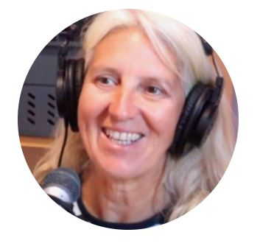
nicky.fisher@herronfisher.co.uk
01323 723643

Nicky Fisher was born and bred in Eastbourne and originally trained as an Accountant before qualifying as an Insolvency Practitioner in 1998 with a local firm. She later commuted to London and Croydon for a few years before setting up Herron Fisher in 2006. The firm now employs eight people and has offices in Eastbourne and Croydon.
Nicky has been an active member of the Chamber since 2006 and is a great supporter of the town. When she has a spare minute, she loves to play golf and tennis and spend time with her two grand-daughters. She is also a Past President of R3, the trade body for Insolvency Practitioners and is a much valued Past President of the Chamber.‍
(Photograph with thanks to Nick Bryant of Brilliant Businesses.)

Reeta Minhas-Judd
RMJ Wellbeing

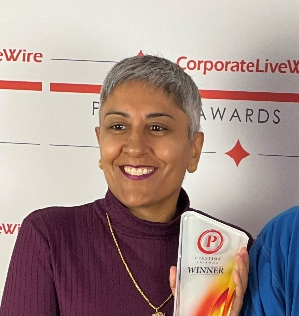

reeta@rmjwellbeing.com
020 8150 7176

Reeta Minhas-Judd is a qualified and award winning NLP Wellbeing Therapist who has been practicing for the past six years. Very passionate about mental health, Reeta is already helping several Chamber Members to manage their businesses and deal with anxiety in the current climate.
Reeta was bullied throughout her secondary education, and until the past few years had never properly dealt with the impact it had on her own mental health. She created RMJ Wellbeing to help those who want to leave their past in the past and not have it define them in the present and potentially into the future.
“I run therapy and coaching in Eastbourne and London and give 'Wellbeing Within The Workplace' talks to local businesses to support them with their team's mental health and to develop a more positive mindset. I also host 'Mind & Body Retreats; at the Grand Hotel in Eastbourne.
Since joining the Chamber in December 2021, I have made Eastbourne my second home and spend part of my week working on the Sunshine Coast, where I have engaged with several new clients and made some wonderful new friendships.
Reeta wants everybody to live their best life and so she offers complimentary therapy and coaching sessions to anybody who reaches out. These sessions are delivered in person, walk & talk, online and also over the telephone.
Good mental health is more vital than ever, particularly after the pandemic and in the current cost of living crisis. It therefore makes sense to include a mental health specialist on the Chamber board.

And…

Shoes Simes
Owner of The Eagle, the Dew Drop Inn, the Rainbow and The Glass House

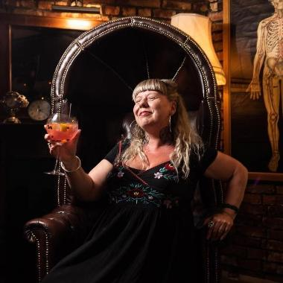

info@eatsleepdrink.co.uk
01323 417799

Shoes Simes has been resident in Eastbourne since 1975 and studied Business & Finance at ECAT College.
After a successful career in retail she moved into hospitality management where she applied her eye for detail and enthusiasm for business. In just 6 years Shoes turned around 8 failing businesses and went on to purchase the Dew Drop in 2007 followed by the Eagle in 2009. During the pandemic Shoes bought and refurbished the Rainbow public house and restaurant.
Shoes took on the Pavilion Cafe and Gardens on the seafront in 2024. Having become very rundown, Shoes invested over £500,000 to turn this into a first-class cafe, bar and restaurant.
Her latest project is to open a café bar in the railway station complex – watch out for La Cantina, coming soon.
Shoes is also Chair of Your Eastbourne BID Limited and is passionate about Eastbourne.

New nominations for directorships

Vicky Regan
Loch Associates



Victoria Regan is an experienced employment law solicitor and Partner with over 20 years’ experience. She originally commenced her legal training in Eastbourne and is delighted to have recently returned to work in Eastbourne - which is her hometown.
Victoria, or “Vicky” as commonly known, advises employers and employees on all aspects of employment law and represents clients in the employment tribunal, employment appeal tribunal and the Supreme Court. Recognised for her expertise, Victoria has been annually ranked in Chambers and Partners 2025 and recognised as a ‘Leading Partner’ by The Legal 500 UK 2025.
She regularly delivers webinars and seminars at regional and industry events, providing employment law updates and guidance on topical issues such as mental health & wellbeing, AI, menopause and fertility, restrictive covenants and most latterly on the Employment Rights Act 2025.
In her free time, Victoria enjoys walking her dog around Pevensey Castle and finding new places to eat and drink!

Jack Haffenden

Cramp & Mullaney

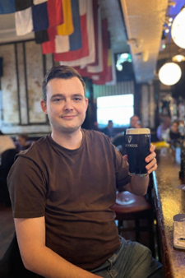

I am a conveyancing solicitor at Cramp and Mullaney and have been here since 2014. I qualified in 2018 and became an equity partner in 2021.
I head up our property department and deal with all aspects of both residential and commercial property matters, however, we are a full service firm of solicitors, which means I have access to colleagues who can provide advice on virtually all issues that arise for the people of Eastbourne.
I have two young children, Lilah, who is 5 (but thinks she is 15) and Finley who is nearly 2. In my spare time, I enjoy spending time with my family and taking them on days out and holidays. However, as you can see from the photo, sometimes we need a break away from the children also! When I can find the time, I also enjoy playing golf and padel.
I would like to become more involved with the Chamber as I feel that I have a lot to offer and it is also a good opportunity for me to meet other local businesses and hopefully contribute to these being as successful as possible!”

Ben Garcia

Brighton & Hove Buses and Metrobus



Ben Garcia is Business Development Manager for Brighton & Hove Buses and Metrobus, with responsibility for commercial growth, partnership development and community engagement across the network, including key services in Eastbourne such as the Coaster, Regency 28, Route 54 and Eastbourne Sightseeing.
With a career spanning several regions and operators - including Transdev Blazefield in North Yorkshire and Lancashire, Warrington’s Own Buses in Cheshire, and Go South West in Devon and Cornwall - Ben Garcia brings extensive experience in stakeholder engagement, collaborative working and delivering transport initiatives that support local economies and vibrant town centres.
He works closely with business chambers, Business Improvement Districts, local authorities and community organisations, building partnerships that strengthen connectivity and support economic growth.
Alongside his professional role, Ben Garcia serves as a Trustee of Possability People, a Sussex-based disability charity. This governance experience has strengthened his strategic oversight skills and deepened his commitment to inclusive community development.
Passionate about the role transport plays in enabling access to employment, education, healthcare and social opportunity, Ben Garcia is committed to supporting Eastbourne’s continued growth as a regional economic and visitor centre. He is keen to contribute his commercial insight, partnership experience and strategic perspective to support the Chamber and the wider business community.

Joel Fielder

Switchplane, Chalk and Digifest



Joel Fielder co-founded Switchplane in 2003 alongside his brother Tom and has led the business ever since with a strong commercial focus and a pragmatic, delivery-led approach. He holds a 2:1 in Music and Sound Recording from the Tonmeister course at the University of Surrey, a background that developed his systems thinking and attention to detail early in his career.
As a Managing Director at Switchplane, Joel brings hands-on experience across software engineering, project delivery, finance, and marketing communications, enabling him to balance technical understanding with commercial decision-making.
He currently sits on the board of Team East Sussex representing tech and digital businesses, as well as Eastbourne, across the wider region. Joel was Highly Commended as Young Entrepreneur of the Year at the 2012 Eastbourne Business Awards and has been an active BNI member since 2007, also serving as President.
Outside of work, he is an accomplished flute player and lives in Eastbourne with his wife Jen and their two children.

Bryce Murphy

Sussex Audiology

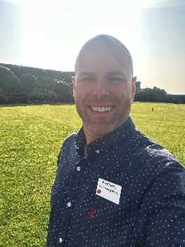
Bryce Murphy is an experienced business leader with a strong commitment to Eastbourne’s economic growth and community wellbeing. He works as Operations Director at Sussex Audiology Centre, where he is responsible for operational strategy, service delivery, and supporting sustainable growth within the healthcare sector. Alongside this, he is Managing Director of Clarity Sound Solutions, providing specialist hearing and communication solutions to individuals and organisations.
Beyond his professional roles, Bryce is deeply committed to giving back to the local community. He is Chair of the Eastbourne Healthcare Network, helping to connect healthcare providers, charities, and local organisations to improve collaboration and outcomes for local residents. He also organises the Eastbourne Later Life Fair, an event focused on supporting older members of the community by bringing together trusted local services, advice, and resources.
He is an active participant in community events across the town and proud to support local initiatives, including acting as a sponsor of Eastbourne Carnival. He lives in Eastbourne and cares deeply about the town and its future. It is his genuine desire to help make Eastbourne a great place to live and work, with a thriving business environment and a strong, connected community.

Danni Drew

Howden Insurance



Danielle Drew began her training at Elmhurst Ballet School and Laine Theatre Arts, building the discipline and resilience that have shaped her career. She went on to manage pubs and restaurants, gaining hands-on experience in people management, customer service, and the realities faced by local businesses.
She later took on a leadership role at OneFamily finance company in a 60-person call centre, where she earned a company Value Award for her commitment to team support and service excellence. Danielle then moved into insurance, working as a broker before joining Howden Insurance Eastbourne in September 2024. The branch has since won two community awards for its support of local charities and businesses.
A proud and active Chamber of Commerce member, Danielle is a strong advocate for the Chamber and its members. She is passionate about strengthening Eastbourne’s business community and ensuring every organisation feels seen, supported, and valued.

