[Instructions. Use this example to design your own syllabus related to classroom PBIS. Replace green bracketed text with your own content and adjust to match your local context. Review resources in reading list and check out other pre-service resources on www.pbis.org.]

Classroom Positive Behavioral Interventions and Supports (PBIS)

Supporting and Responding to Students’ Social, Emotional, and Behavioral Needs in Tier 1
[Add Course Details]

Instructor Name | Communications | Learning Management System (LMS)
[Add] | [Add] | [Add]

Overview
In this course, we build knowledge and skill fluency with evidence-based, culturally relevant, proactive, and positive behavioral intervention and support (PBIS) practices. With PBIS—a multi-tiered system of support (MTSS) framework for promoting students’ social, emotional, and behavioral growth—as the foundation for this course, we describe (a) the theoretical and empirical support for PBIS, (b) the essential elements of PBIS and MTSS, and (c) practices appropriate to each tier. We emphasize universal (Tier 1) classroom practices that provide a robust foundation of support for all learners, and we describe how to further target or individualize these practices to meet the needs of students who benefit from targeted (Tier 2) or intensive (Tier 3) support.

Instructors present course content through readings, lectures, small group discussion (in class and online), and practice activities; evaluate student performance; and provide feedback that enables students to meet course objectives. Students engage in these activities and demonstrate their understanding and mastery of the course content. By meeting the course objectives below, beginning educators will demonstrate knowledge and skills that are essential to “create and contribute to safe, respectful, and productive learning environments…through the use of effective routines and procedures and use a range of preventive and responsive practices to support social, emotional, and educational well-being” (Council for Exceptional Children [CEC], 2020, p. 3).

Learning Objectives
As a result of actively participating in this course and meeting/exceeding expectations on course assignments, each student is expected to meet the following objectives.

Learning Objective 1
Demonstrate an understanding of the essential elements of PBIS, as evidenced by earning at least 85% of points possible on quizzes throughout the semester.

Learning Objective 2
Develop resources to facilitate classroom PBIS implementation in your current and future classrooms by successfully completing and earning at least 85% of points on the following assignments.

2.1. Select, define, and provide examples of classroom expectations within routines by developing a classroom teaching (expectations within routines) matrix for your current (or future) classroom (Assignment 1).

2.2. Develop a social skills lesson plan to explicitly teach one expectation within one routine (Assignment 2).

2.3. Develop and describe a classroom acknowledgement system (Assignment 3).

2.4. Demonstrate an understanding of how to individualize PBIS practices for a student requiring intensive support by developing a competing pathway model and suggesting individualized practices (Assignment 4).

2.5. Apply classroom PBIS practices (prompts, OTRs, and specific praise) by implementing, monitoring, and self-analyzing practices in your classroom (Application Activities 1-3).

Initial Preparation Standards
By meeting the above course objectives, this course addresses the Council for Exceptional Children’s (CEC) Initial Preparation Standard 6: Supporting Social, Emotional, and Behavioral Growth: “Candidates create and contribute to safe, respectful, and productive learning environments for individuals with exceptionalities through the use of effective routines and procedures and use a range of preventive and responsive practices to support social, emotional and educational well-being. They follow ethical and legal guidelines and work collaboratively with families and other professionals to conduct behavioral assessments for intervention and program development” (CEC, 2020, p.3).
- 6.1. “Candidates use effective routines and procedures to create safe, caring, respectful, and productive learning environments for individuals with exceptionalities (CEC, 2020, p.3).”
- 6.2. “Candidates use a range of preventive and responsive practices documented as effective to support individuals’ social, emotional, and educational well-being (CEC, 2020, p.3).”
- 6.3. “Candidates systematically use data from a variety of sources to identify the purpose or function served by problem behavior to plan, implement, and evaluate behavioral interventions and social skills programs, including generalization to other environments (CEC, 2020, p.3).”

Accommodations
Our goal is to create a safe and productive environment where all students can engage, learn, and grow as educators. If you require adaptations or accommodations, please let us know as soon as possible. Information on the procedures for documentation and/or services can be obtained by contacting:

[Insert university center for students with disabilities]

Our goal is to take care of ourselves and others. To learn more about university services and supports for wellbeing and mental health, contact:

[Insert statement, policy, and university resource center for mental health]

Also note these important resources:
Add relevant university office or support | Add relevant university office or support | Add relevant university office or support | Add relevant university office or support

Expectations or Norms
Respect
- We use respectful language and behavior during all class activities. Potentially controversial topics or issues may be discussed in an open and professional manner. Any student who feels uncomfortable or has concerns in the context of class discussion or other class activities should talk with the class instructors.
- When discussing people with disabilities, you may use either person-first or identity first language. Person-first language mentions the person before considering or describing any other features of their abilities (e.g., student with a disability). This language communicates respect and acknowledges that ability is one of many characteristics of a human being. However, some individuals with disabilities prefer identity-first language, which leads with disability as a key part of their identity (e.g., Deaf student, autistic individual). Please read the Association of University Centers on Disabilities statement about person-first and identity-first language (https://www.aucd.org/template/page.cfm?id=605).
- Maintain a positive learning environment. Please turn off, silence, and/or mute cell phones, messaging and social media apps, and other potential sources of distraction.

Responsibility
- Regular attendance and active participation (on video, when possible, during remote classes) are expected.
- Students are accountable for reading and understanding the information presented in the assigned materials before coming to class. This advance preparation is essential to understand and participate fully in discussions.
- All written assignments must be typed and prepared according to formatting and guidelines posted on [Course Learning Management System (LMS)] for each assignment and/or the APA Publication Manual. Products that do not conform to the preparation guidelines may be returned for immediate revision, due back the following class meeting.
- Submit original work and maintain academic integrity. If academic misconduct occurs, the student will receive a zero on that assignment and may be subjected to additional university sanctions (e.g., failing the course). See [add university policy on academic integrity].
- All assignments must be submitted on time via [Course LMS] (i.e., at or before class starts on the due date). Obtain prior permission for any exception. Any returned assignments are due back the next class.
- [Add university policies on incompletes and any other relevant policies related to responsible participation.]
- Grades will be assigned in accordance with the scale presented below. Each student's percentage scores will be computed based on the total points earned out of 100 points possible in the term.
A | 93 to 100% of the total points | C | 73 to 76% of the total points
A- | 90 to 92% of the total points | C- | 70 to 72% of the total points
B+ | 87 to 89% of the total points | D+ | 67 to 69% of the total points
B | 83 to 86% of the total points | D | 63 to 66% of the total points
B- | 80 to 82% of the total points | D- | 60 to 62% of the total points
C+ | 77 to 79% of the total points | F | Less than 60% of the total points

Safety
- If class cancellation (e.g., instructor emergency, inclement weather) is required, an instructor will inform students as soon as the cancellation is known. To the greatest extent possible, an instructor will send emails and/or notify the department about cancellations. All of us should use good judgment and keep personal safety and the safety of others the foremost concern in the event of inclement weather, illness, or other natural events that may interfere with class attendance.
- Communicate any safety concerns related to your participation in class.
[Add other required university policies related to safety]

Readings

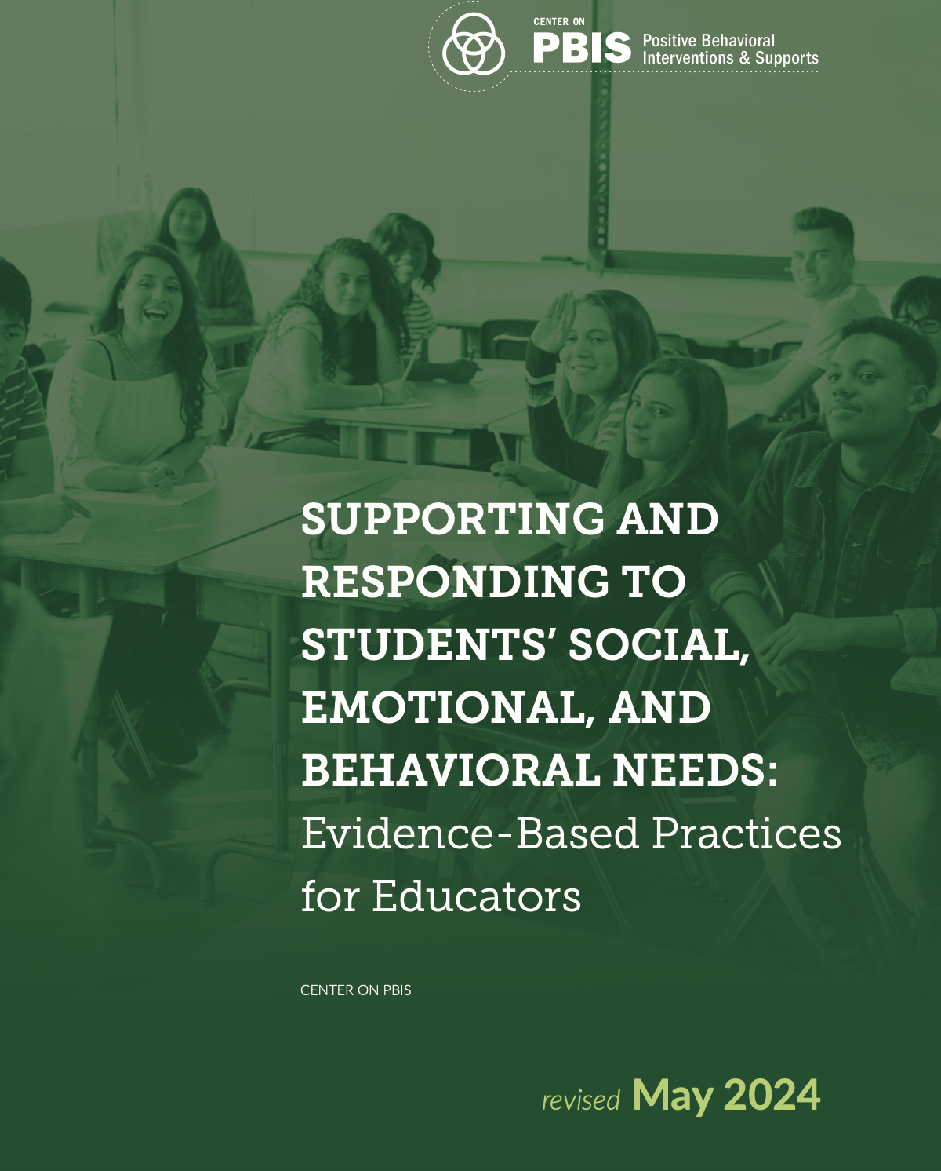 | Center on PBIS. (2024). Supporting and responding to student’s social, emotional, and behavioral needs: Evidence-based practices for educators (Version 2.0). Center on PBIS, University of Oregon. https://www.pbis.org/resource/supporting-and-responding-to-behavior-evidence-based-classroom-strategies-for-teachers
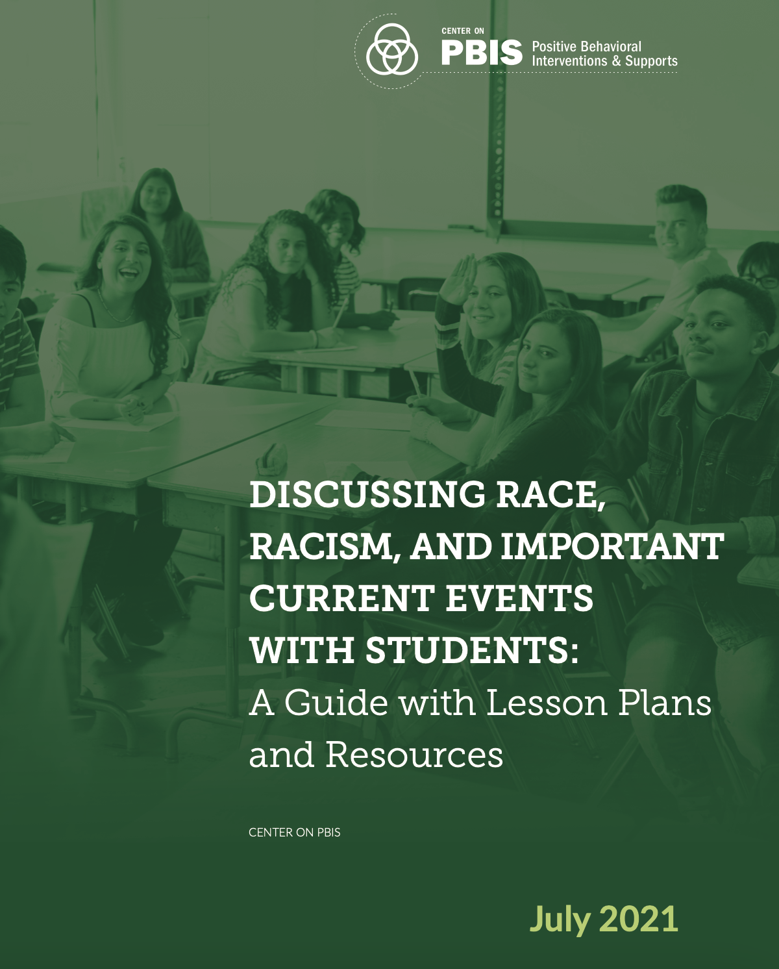 | Center on PBIS (2021). Discussing race, racism, and important current events with students: A guide with lesson plans and resources. Center on PBIS, University of Oregon. https://www.pbis.org/resource/discussing-race-racism-and-important-current-events-with-students-a-guide-with-lesson-plans-and-resources
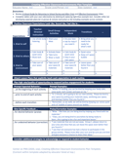 | Center on PBIS. (2020). Creating effective classroom environments plan template. Center on PBIS, University of Oregon. https://www.pbis.org/resource/creating-effective-classroom-environments-plan-template
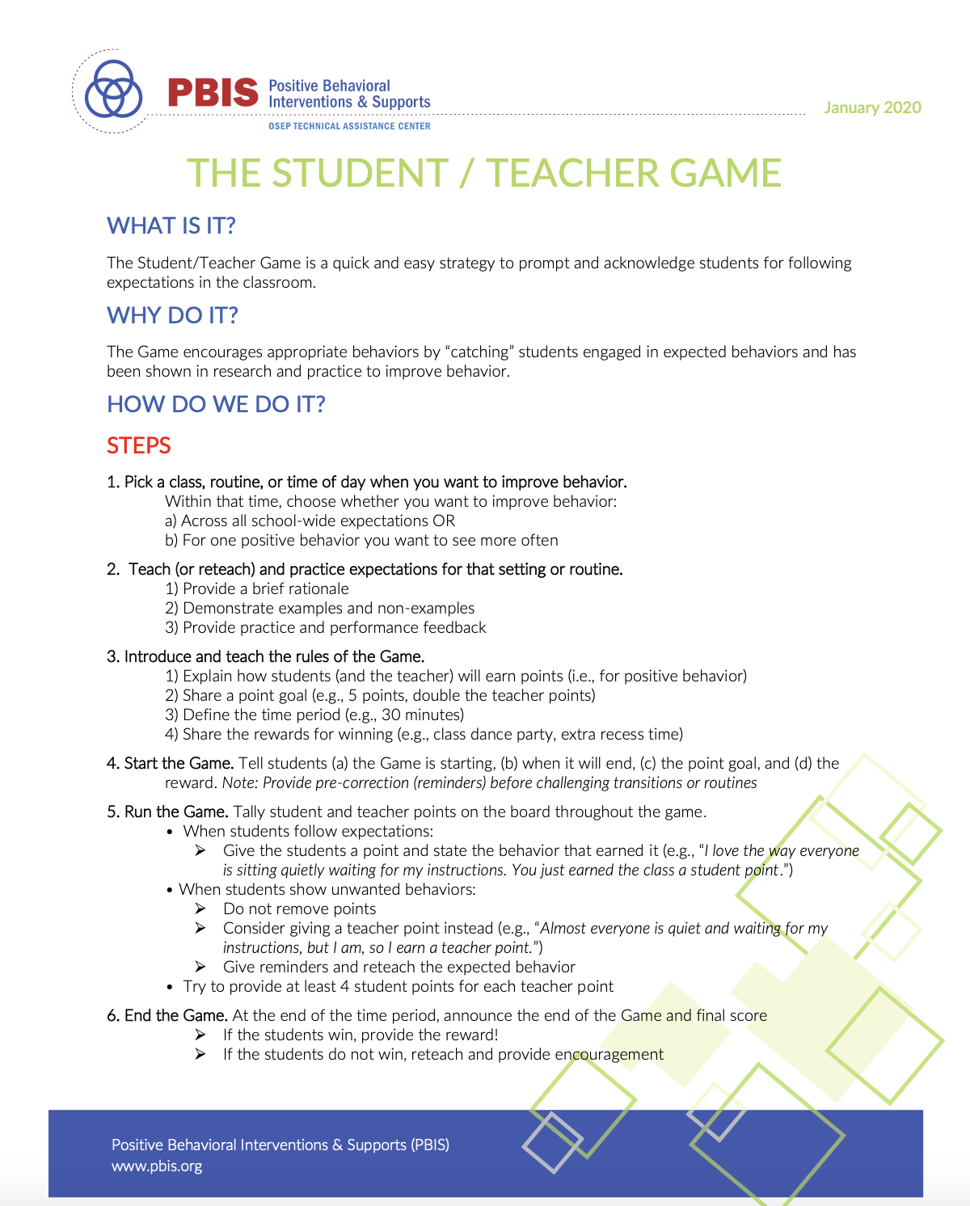 | Center on PBIS. (2020). The student/teacher game. Center on PBIS, University of Oregon. https://www.pbis.org/resource/the-student-teacher-game
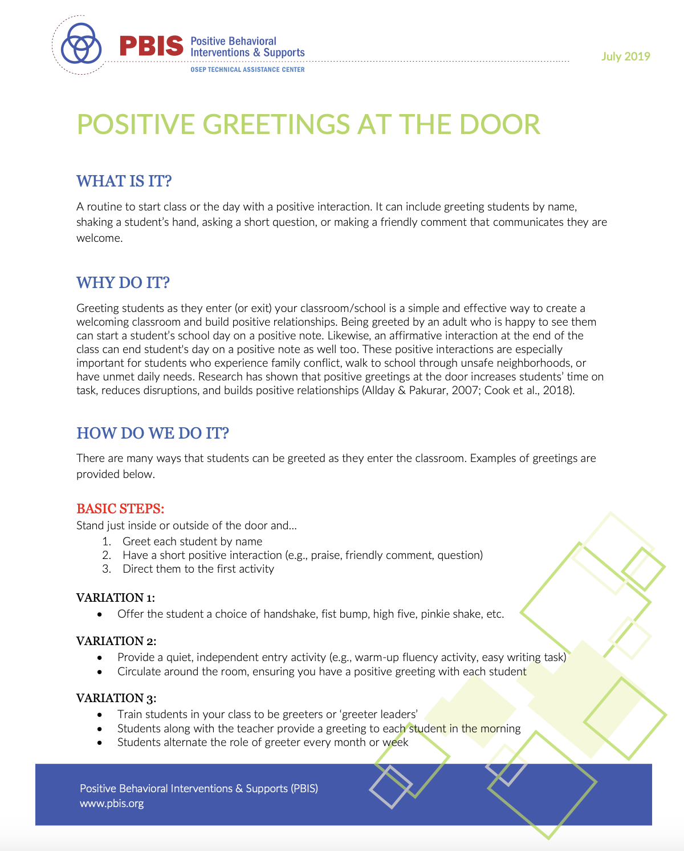 | Center on PBIS. (2019). Positive greetings at the door. PBIS strategy handout. Center on PBIS, University of Oregon. https://www.pbis.org/resource/positive-greetings-at-the-door
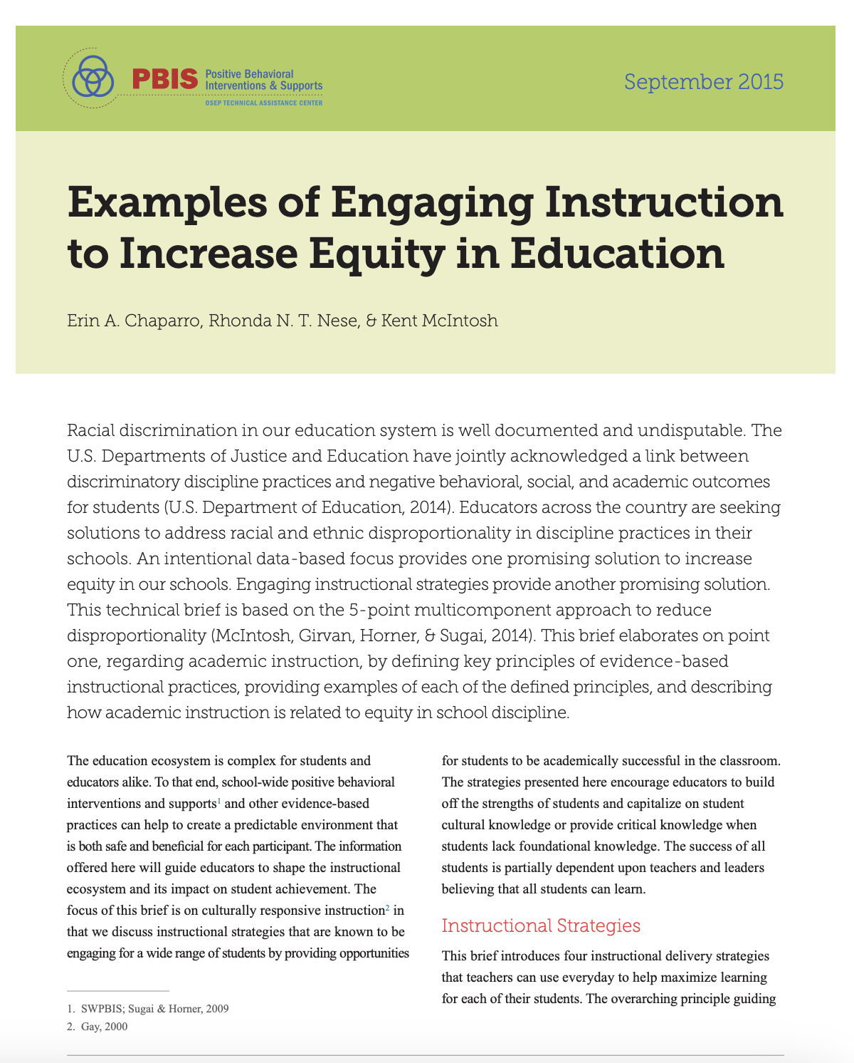 | Chaparro, E. A., Nese, R. N. T., & McIntosh, K. (2015). Examples of engaging instruction to increase equity in education. Center on PBIS, University of Oregon. https://www.pbis.org/resource/examples-of-engaging-instruction-to-increase-equity-in-education
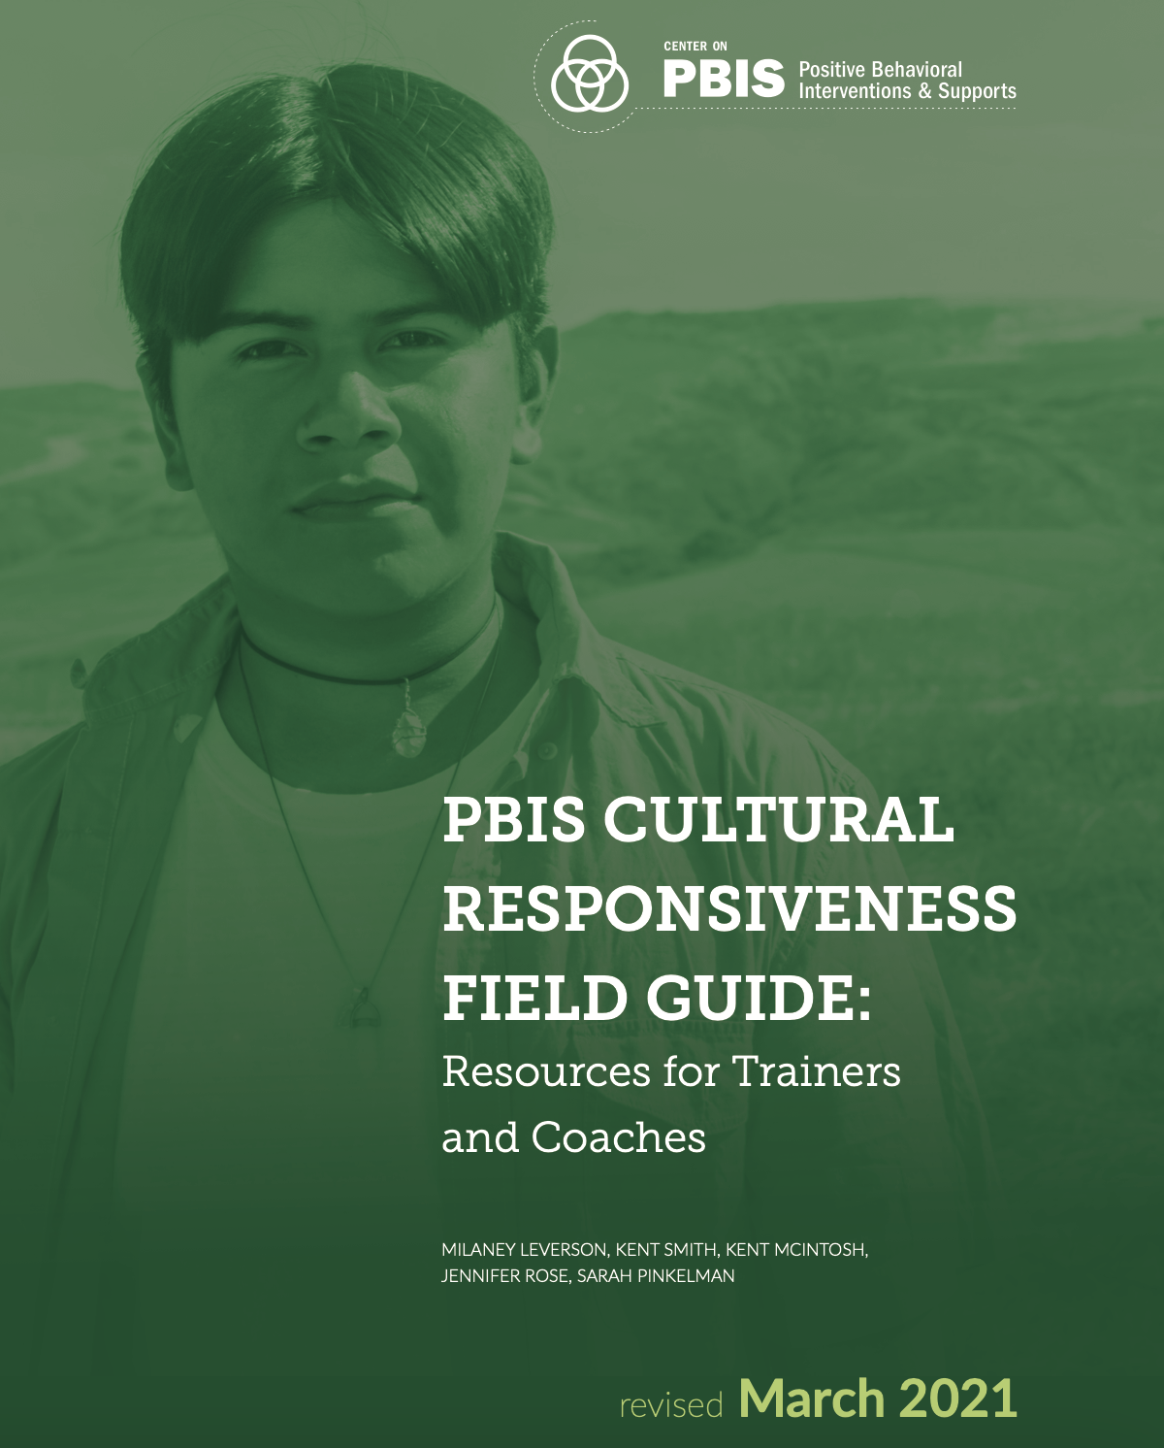 | Leverson, M., Smith, K., McIntosh, K., Rose, J., & Pinkelman, S. (2021). PBIS cultural responsiveness field guide: Resources for trainers and coaches. Center on PBIS, University of Oregon. https://www.pbis.org/resource/pbis-cultural-responsiveness-field-guide-resources-for-trainers-and-coaches
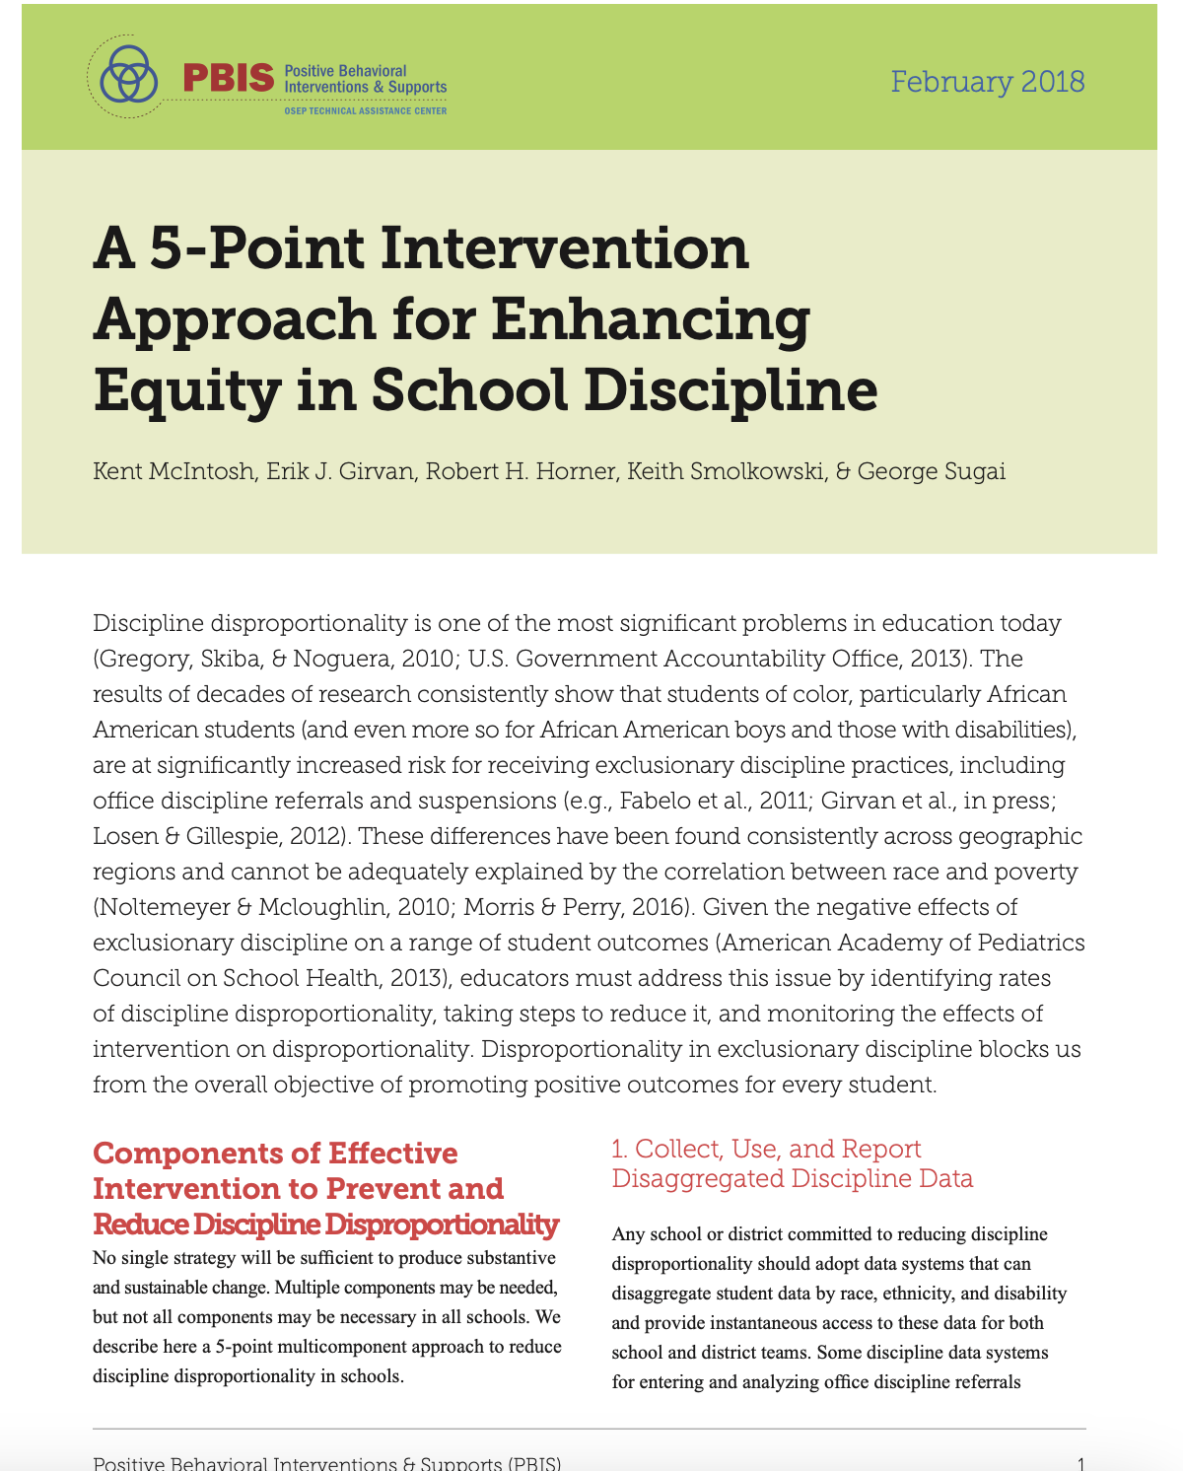 | McIntosh, K., Girvan, E. J., Horner, R. H., Smolkowski, K., & Sugai, G. (2018). A 5-point intervention approach for enhancing equity in school discipline. Center on PBIS, University of Oregon. https://www.pbis.org/resource/a-5-point-intervention-approach-for-enhancing-equity-in-school-discipline
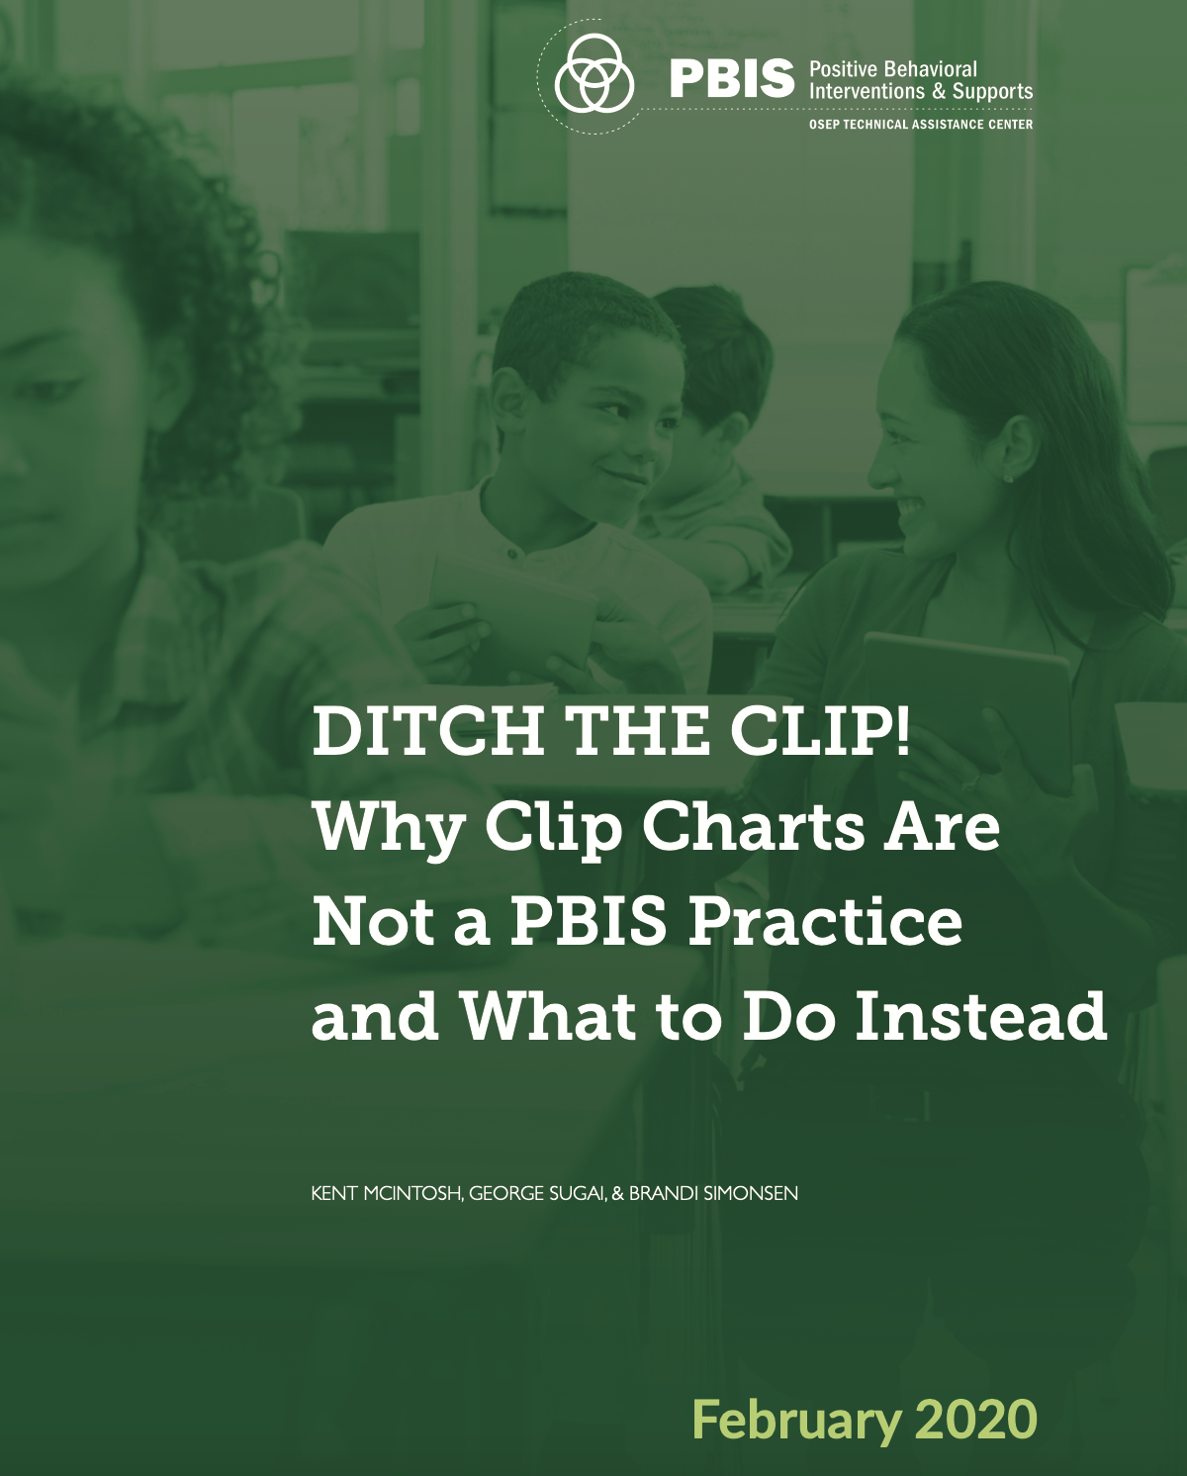 | McIntosh, K., Sugai, G., & Simonsen, B. (2020). Ditch the clip! Why clip charts are not a pbis practice and what to do instead. Center on PBIS, University of Oregon. https://www.pbis.org/resource/ditch-the-clip-why-clip-charts-are-not-a-pbis-practice-and-what-to-do-instead
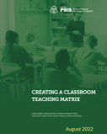 | Robbie, K., Santiago-Rosario, M., Yanek, K., Kern, L., Meyer, B., Morris, K., & Simonsen, B. (2022). Creating a classroom teaching matrix. Center on PBIS, University of Oregon. https://www.pbis.org/resource/creating-a-classroom-teaching-matrix
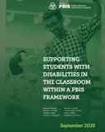 | Simonsen, B., Putnam, R., Yanek, K., Evanovich, L., Shaw, S. Shuttleton, C. Morris, K., & Mitchell, B. (2020). Supporting students with disabilities within a PBIS framework. Center on PBIS, University of Oregon. https://www.pbis.org/resource/supporting-students-with-disabilities-in-the-classroom-within-a-pbis-framework
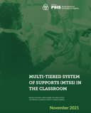 | Simonsen, B., Robbie, K., Meyer, K., Freeman, J., Everett, S., & Feinberg A. (2021). Multi-tiered system of supports (MTSS) in the classroom. Center on PBIS, University of Oregon. https://www.pbis.org/resource/multi-tiered-system-of-supports-mtss-in-the-classroom
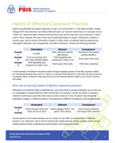 | Simonsen, B., Yanek, K., Sugai, G., & Borgmeier, C., (2020). Habits of effective classroom practice. Center on PBIS, University of Oregon. https://www.pbis.org/resource/habits-of-effective-classroom-practice
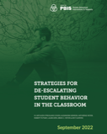 | Strickland-Cohen, M. K., Newson, A., Meyer, K., Putnam, R., Kern, L., Meyer, B. C., & Flammini, A. (2022). Strategies for de-escalating student behavior in the classroom. Center on PBIS, University of Oregon. https://www.pbis.org/resource/strategies-for-de-escalating-student-behavior-in-the-classroom
Assessments

Assignments (4 assignments @ 15 points each = 60 points)
Please use the templates posted online for each assignment and submit via [course LMS].

- Assignment 1: Classroom Teaching Matrix (15 points)
Identify and describe a classroom setting (either your current or future classroom). Choose 3-5 positively stated expectations or norms, identify 5-7 routines, and then identify 2-3 positively stated examples of social, emotional, and behavior skills that are consistent with each norm within each of the routines. (Note, in real life, you would develop a matrix collaboratively with your students, with feedback their from families.)

- Assignment 2: Social Skills Lesson Plan (15 points)
Based on the matrix you completed for Assignment 2, chose one expectation and one routine (i.e., 1 box on matrix). Develop a lesson plan to teach that social skill (i.e., rule) in that setting. Use the provided format or create your own with the same components.

- Assignment 3: Classroom Recognition Plan (15 points)
Identify and describe a classroom setting (either your current classroom or the type of classroom in which you hope to teach). Using the information presented in class, design a classroom recognition plan (e.g., student-teacher game, token economy, group contingency) to increase the likelihood of contextually appropriate behaviors or skills (i.e., skills consistent with matrix) in that setting. Clearly state how you’re addressing each step in developing the system (listed in the scoring criteria) and discuss the pros and cons of your plan.

- Assignment 4: Competing Pathway and Strategies (15 points)
Choose one of the scenarios given or write your own scenario about a student you know well. Complete the provided competing pathway for the scenario and describe potential intervention strategies on the accompanying form.

Application Activities (3 total activities @ 5 points each = 15 points)
For each application activity, select a 20 min period when you are leading instructional activities (whole or small group) in your clinic placement or classroom. For each application activity, you will focus on a key classroom PBIS practice: (1) prompts, (2) OTRs, and (3) specific praise. You may either video record or ask someone else (e.g., your cooperating teacher) to observe you. (If you video record yourself, you will watch it and take data on your use of the target practice. If someone else observes you, they will take data on your use of the target practice.) Complete a self-analysis reflection of your own application of the targeted skill. Upload your self-reflection with either your video recording or your observer’s signature to [course LMS]. (Note: Uploaded videos will ONLY be viewed by course staff and will be destroyed at the end of the semester.)

Quizzes (5 quizzes @ 5 points each = 25 points)

Quizzes will be designed to assess the student’s learning of course content. Each quiz will cover the material from the previous readings and lectures—quizzes are not cumulative. Quizzes will be administered via [Course LMS].

Assignment Rubrics

Assignment 1: Classroom Teaching Matrix (15 points)
Category | Exceeds Expectations | Meets Expectations | Below Expectations
Setting Description | 3 points  All relevant features of the setting are clearly defined | 1-2 points  Some features of the setting are clearly defined | 0-1 points  Setting is not identified or clearly defined
Positive Expectations | 3 points  3-5 positively stated, mutually exclusive, and contextually relevant expectations or norms | 1-2 points  3-5 positively stated expectations | 0-1 points  < 3 positively stated expectations
Predictable Routines | 3 points  5-7 mutually exclusive, contextually appropriate, and predictable routines | 1-2 points  5-7 predictable routines | 0-1 points  < 5 predictable routines
Examples of Skills | 3 points  2-3 positively stated, mutually exclusive, and contextually appropriate examples for each expectations/routines box | 1-2 points  2-3 positively stated examples for each expectations/routines box | 0-1 points  < 2 positively stated examples for one or more expectations/routines box
Professional appearance, etc. | 3 points  Matrix is typed, appropriately formatted, and includes correct grammar and spelling | 1-2 points  Matrix is typed and appropriately formatted, but has minor grammar and/or spelling errors | 0-1 points  Matrix is not typed, not appropriately formatted, and/or contains significant errors that limit readability
Total points: | Points: 14-15 | Points 12-13 | Points: 0-11
Comments:

Assignment 2: Social Skills Lesson Plan (15 points)
Category | Exceeds Expectations | Meets Expectations | Below Expectations
Lesson Focus | 3 points  Lesson focus clearly identifies the expectation, routine, and a complete operational definition with relevant examples and non-examples | 1-2 points  Lesson focus clearly identifies the expectation, routine, and a basic operational definition | 0-1 points  Lesson focus is missing or unclear
Objective and Materials | 3 points  Lesson objective is clearly stated including context and criteria for mastery, and appropriate materials are clearly identified | 1-2 points  Lesson objective is clearly stated and some materials are identified | 0-1 points  Lesson objective and materials are missing or unclear
Positive and Negative Teaching Examples | 3 points  > 3 relevant positive and  > 3 relevant negative examples of the expectations are clearly described and illustrate minimal differences | 1-2 points  > 3 relevant positive and  > 3 relevant negative examples of the expectations are clearly described, but do not illustrate minimal differences | 0-1 points  < 3 relevant positive and  < 3 relevant negative examples are identified and/or not clearly described
Lesson Activities (Model, Lead, Test) | 3 points  Lesson includes clear model-lead-test activities in relevant context | 1-2 points  Lesson includes model-lead-test activities | 0-1 points  Lesson does not include model, lead, and/or test activities
Follow-Up Activities (Prompt, Reinforce, Correct, Monitor, Evaluate) | 3 points  Activities include clearly defined and contextually appropriate plans to prompt, reinforce, correct, monitor, and evaluate | 1-2 points  Activities include plans to prompt, reinforce, correct, monitor, and evaluate | 0-1 points  Activities do not include plans to prompt, reinforce, correct, monitor, and/or evaluate
Total points: | Points: 14-15 | Points 12-13 | Points: 0-11
Comments:

Assignment 3: Classroom Recognition Plan (15 points)
Category | Exceeds Expectations | Meets Expectations | Below Expectations
Recognition Approach | 3 points  Type of recognition approach is clearly identified, appropriate for target behaviors/skills and context, and type of planned positive/negative reinforcement is described | 1-2 points  Type of recognition approach is clearly identified | 0-1 points  Type of recognition approach is not clearly identified
Target Behaviors/Skills and How to Teach | 3 points  Target behaviors/skills are operationally defined and plan for teaching includes a clear and contextually appropriate model-lead-test activities to teach behaviors/skills | 1-2 points  Target behaviors/skills are mostly operationally defined and plan for teaching includes model-lead-test activities to teach behaviors/skills | 0-1 points  Target behaviors/skills are not operationally defined and/or model-lead-test activities to teach behaviors/skills are missing, unclear, or not appropriate
Reinforcers or Recognition Strategies and How to Teach | 3 points  Contextually appropriate reinforcers are clearly described and plan for teaching includes clear and contextually appropriate model-lead-test activities to teach recognition plan | 1-2 points  Reinforcers are described and plan for teaching includes model-lead-test activities to teach recognition plan | 0-1 points  Reinforcers are not described and/or model-lead-test activities to teach the recognition plan are missing, unclear, or not appropriate
How to Monitor and Decisions Rules to Change/Fade | 3 points  Plans for monitoring the plan are clearly described, feasible, and contextually appropriate; decision rules are clear and contextually appropriate | 1-2 points  Plans for monitoring the plan are described; decision rules are included | 0-1 points  Plans for monitoring the plan and decision rules are missing or unclear
Pros/Cons of Recognition Plan | 3 points  Both pros and cons of plan are discussed, including how it may be adjusted to improve contextual fit if needed | 1-2 points  Both pros and cons of plan are discussed | 0-1 points  Pros and/or cons of plan are not discussed or are unclear
Total points: | Points: 14-15 | Points 12-13 | Points: 0-11
Comments:

Assignment 4: Competing Pathway and Strategies (15 points)
Category | Exceeds Expectations | Meets Expectations | Below Expectations
Testable Hypothesis  (SE-A-B-C) | 3 points  Testable hypothesis clearly describes relevant setting events, antecedents, contextually inappropriate behaviors (CIBs), and maintaining consequences (function), based on scenario | 1-2 points  Testable hypothesis clearly describes possible setting events, antecedents, CIBs, and maintaining consequences (function) | 0-1 points  Testable hypothesis does not clearly identify possible setting events, antecedents, CIBs, and/or maintaining consequences (function)
Replacement and Desired Behaviors | 3 points  Competing pathway clearly identifies a functionally equivalent replacement behavior (short term goal) and desired behavior (long-term goal) that are contextually appropriate | 1-2 points  Competing pathway identifies a functionally equivalent replacement behavior (short term goal) and desired behavior (long-term goal) | 0-1 points  Competing pathway does not identify a functionally equivalent replacement behavior and/or desired behavior
Antecedent (Prevention) Strategies | 3 points  Contextually appropriate and functionally relevant antecedent strategies are identified to prevent CIBs and promote replacement and desired behaviors | 1-2 points  Antecedent strategies are identified to prevent CIBs and promote replacement and desired behaviors | 0-1 points  Antecedent strategies are not identified and/or would not prevent CIBs or promote replacement and desired behaviors
Behavior (Teaching) Strategies | 3 points  Contextually appropriate and functionally relevant teaching strategies are identified to explicitly (model-lead-test) teach replacement behaviors and shape toward desired behaviors | 1-2 points  Teaching strategies are identified to explicitly teach replacement behaviors and shape toward desired behaviors | 0-1 points  Teaching strategies are not identified to teach replacement behaviors and/or shape toward desired behaviors
Consequence (Reinforcement and Response) Strategies | 3 points  Contextually appropriate and functionally relevant consequence strategies are identified to (a) reinforce replacement and desired behaviors and (b) prevent reinforcement for CIBs | 1-2 points  Consequence strategies are identified to (a) reinforce replacement and desired behaviors and (b) prevent reinforcement for CIBs | 0-1 points  Consequence strategies are not identified to (a) reinforce replacement and desired behaviors and/or (b) prevent reinforcement for CIBs
Total points: | Points: 14-15 | Points 12-13 | Points: 0-11
Comments:

Application Activity 1: Prompts (5 points)
Category | Exceeds Expectations | Meets Expectations | Below Expectations
Operational Definition | 1 point  Complete and concise operational definition of practice, based on course content | ½ point  Partial definition, accurate but incomplete | 0 points  Definition is not completed or is inaccurate
Data collection (on 20 mins of direct instruction) | 2 points  Response includes data collection (e.g., tally of practice) for 20 mins of instruction | 1 point  Response includes some data collection but not complete or 20 min | 0 points  Data are not included
Reflection on Practice | 2 points  Thoughtful and complete reflection that accurately references class material | 1 point  Reflection that references class material, and may contain some errors | 0 points  Reflection missing or incomplete/unclear
Total points: | Points: 5 | Points 4 | Points: 0-3
Comments:

Application Activity 2: OTRs (5 points)
Category | Exceeds Expectations | Meets Expectations | Below Expectations
Operational Definition | 1 point  Complete and concise operational definition of practice, based on course content | ½ point  Partial definition, accurate but incomplete | 0 points  Definition is not completed or is inaccurate
Data collection (on 20 mins of direct instruction) | 2 points  Response includes data collection (e.g., tally of practice) for 20 mins of instruction | 1 point  Response includes some data collection but not complete or 20 min | 0 points  Data are not included
Reflection on Practice | 2 points  Thoughtful and complete reflection that accurately references class material | 1 point  Reflection that references class material, and may contain some errors | 0 points  Reflection missing or incomplete/unclear
Total points: | Points: 5 | Points 4 | Points: 0-3
Comments:

Application Activity 3: Specific Praise (5 points)
Category | Exceeds Expectations | Meets Expectations | Below Expectations
Operational Definition | 1 point  Complete and concise operational definition of practice, based on course content | ½ point  Partial definition, accurate but incomplete | 0 points  Definition is not completed or is inaccurate
Data collection (on 20 mins of direct instruction) | 2 points  Response includes data collection (e.g., tally of practice) for 20 mins of instruction | 1 point  Response includes some data collection but not complete or 20 min | 0 points  Data are not included
Reflection on Practice | 2 points  Thoughtful and complete reflection that accurately references class material | 1 point  Reflection that references class material, and may contain some errors | 0 points  Reflection missing or incomplete/unclear
Total points: | Points: 5 | Points 4 | Points: 0-3
Comments:

Course Schedule
Date | Topic, Big Idea, and Practice Focus | Assessments | Readings & Resources
Class 1  [date] | Introduction & Overview  Essential Elements of PBIS  Practice focus: Greeting at Door | Getting to Know You Survey | www.pbis.org  Center on PBIS (2019)
Class 2  [date] | Basic Concepts of Behavior 1  ABCs and Function of Behavior  Practice focus: Neutralizing Routines | Quiz 1 | McIntosh et al. (2018)
Class 3  [date] | Basic Concepts of Behavior 2  Behavioral Principles in Learning  Practice focus: Focus on Your Learning | - | Center on PBIS (2024)  (Intro pp. 1-9)
Class 4  [date] | Measurement  Defining, Measuring, & Graphing  Practice focus: Counting Behavior | Quiz 2 | Simonsen et al. (2021)  (Table 1)
Class 5  [date] | Antecedent Strategies in Tier 1  Welcoming & Predictable Spaces  Practice focus: Prompts | Quiz 3 | Center on PBIS (2024)  (Table 1)  Simonsen et al. (2020)
Class 6  [date] | Positive Expectations in Tier 1  Define and Teach Expectations  Practice focus: Effective Environments | Application Activity 1 Due | Center on PBIS (2020)  Leverson et al. (2021)  Robbie et al. (2022)
Class 7  [date] | Instructional Strategies in Tier 1 Actively Engage Students in Learning  Practice focus: OTRs | Assignment 1 Due | Center on PBIS (2021)  Chaparro et al. (2015)
Class 8  [date] | Acknowledgement Strategies in Tier 1  á Contextually Appropriate Behavior  Practice focus: Specific Praise | Quiz 4 | Center on PBIS (2024)  (Table 2)  Center on PBIS (2020)
Class 9  [date] | Response Strategies in Tier 1  â Contextually Inappropriate Behavior Practice focus: De-Escalation | Application Activity 2 Due | McIntosh et al., (2020)  Strickland-Cohen et al. (2022)
Class 10  [date] | Building Habits of Effective Practice  Applying ABCs to Support Yourself!  Practice focus: Self-Management | Assignment 2 Due | Simonsen et al. (2020)
Class 11  [date] | Data-Based Decision Making  Using Fidelity and Outcome Data Practice focus: CMOT | Application Activity 3 Due | Center on PBIS (2024)  (Tables 3 & 4)
Class 12  [date] | Introduction to Tier 2  Function-informed Tier 2 support  Practice focus: Testable Hypothesis | Quiz 5 | Simonsen et al. (2021)  (Table 2)
Class 13  [date] | Introduction to Tier 3  Individualized support (FBA and BIP)  Practice focus: Competing Pathway | Assignment 3 Due | Simonsen et al. (2021)  (Table 3)
Class 14  [date] | Review  All the above | Assignment 4 Due | Center on PBIS (2024)  (Self-Assess & Plan)

Council for Exceptional Children (CEC). (2020). Initial Practice-Based Professional Preparation Standards for Special Educators. CEC.
Add hyperlink to student code of conduct
Add hyperlink to policy related to student discrimination, harassment, etc.

