[Instructions. Use this example to design your own syllabus related to advanced classroom PBIS. Replace green bracketed text with your own content and adjust to match your local context. Review resources in reading list and check out other pre-service resources on www.pbis.org.]

Advanced Classroom Positive Behavioral Interventions and Supports (PBIS)
Implementing Targeted (Tier 2) and Individualized (Tier 3) PBIS in the Classroom
[Add Course Details]

Instructor Name | Communications | Learning Management System (LMS)
[Add] | [Add] | [Add]

Overview
In this course, we build knowledge and skill fluency with evidence-based and culturally relevant targeted (Tier 2) and intensive (Tier 3) positive behavioral interventions and supports (PBIS) in the classroom. With PBIS as the foundation for this course, we (a) describe the essential elements, (b) briefly review universal (Tier 1) classroom practices that provide a robust foundation of support for all learners, and (c) emphasize how to further target and individualize these practices to meet the needs of students who benefit from targeted (Tier 2) or intensive (Tier 3) support. Instructors present course content through readings, lectures, small group discussion (in class and online), and practice activities; evaluate student performance; and provide feedback that enables students to meet course objectives. Students engage in these activities and demonstrate understanding and mastery of the course content.

Learning Objectives
As a result of actively participating in this course and meeting/exceeding expectations on course assignments, each student is expected to meet the following objectives.

Learning Objective 1
Effectively describe the critical features of a multi-tiered system of support (MTSS) framework, like PBIS, to support students’ social, emotional, and behavioral growth in your (future) classroom as evidenced by earning at least 80% of points possible on Quiz 1. (Aligned with CEC Standard 6.2.)

Learning Objective 2
Demonstrate tier 2 (targeted) support (a) knowledge by earning at least 80% of points possible on Quiz 2 and (b) application to your (hypothetical) classroom by earning at least 80% of points possible on Assignment 1. (Aligned with CEC Standards 6.2 and 6.3.)

Learning Objective 3
Demonstrate tier 3 (intensive) support (a) knowledge by earning at least 80% of points possible on Quizzes 3-5 and (b) application to your (hypothetical) classroom by earning at least 80% of points possible on Assignments 2 and 3. (Aligned with CEC Standards 6.2 and 6.3.)

Accommodations
We aim to create a safe and productive environment where all students can engage, learn, and grow as educators. If you require adaptations or accommodations, please let us know as soon as possible. Information on the procedures for documentation and/or services can be obtained by contacting: [Insert center for students with disabilities]

Our goal is to take care of ourselves and others. To learn more about university services and supports for wellbeing and mental health, contact: [Insert statement, policy, and university resource center for mental health]

Also note these important resources:
Add contact for university office for equity | Add contact for academic writing center | Add contact for substance abuse office | Add contact for Dean of Students

Expectations or Norms
Respect
- We use respectful language and behavior during all class activities. Potentially controversial topics or issues may be discussed in an open and professional manner. Any student who feels uncomfortable or has concerns in the context of class discussion or other class activities should talk with the class instructors.
- When discussing people with disabilities, you may use either person-first or identity first language. Person-first language mentions the person before considering or describing any other features of their abilities (e.g., student with a disability). This language communicates respect and acknowledges that ability is one of many characteristics of a human being. However, some individuals with disabilities prefer identity-first language, which leads with disability as a key part of their identity (e.g., Deaf student, autistic individual). Please read the Association of University Centers on Disabilities statement about person-first and identity-first language (https://www.aucd.org/template/page.cfm?id=605).
- Maintain a positive learning environment. Please turn off, silence, and/or mute cell phones, messaging and social media apps, and other potential sources of distraction.

Responsibility
- Regular attendance and active participation (on video, when possible, during remote classes) are expected.
- Students are accountable for reading and understanding the information presented in the assigned materials before coming to class. This advance preparation is essential to understand and participate fully in discussions.
- All written assignments must be typed and prepared according to formatting and guidelines posted on [Course Learning Management System (LMS)] for each assignment and/or the APA Publication Manual. Products that do not conform to the preparation guidelines may be returned for immediate revision, due back the following class meeting.
- Submit original work and maintain academic integrity. If academic misconduct occurs, the student will receive a zero on that assignment and may be subjected to additional university sanctions (e.g., failing the course). See [add university policy on academic integrity].
- All assignments must be submitted on time via [Course LMS] (i.e., at or before class starts on the due date). Obtain prior permission for any exception. Any returned assignments are due back the next class.
- [Add university policies on incompletes and any other relevant policies related to responsible participation.]
- Grades will be assigned in accordance with the scale presented below. Each student's percentage scores will be computed based on the total points earned out of 100 points possible in the term.
A | 93 to 100% of the total points | C | 73 to 76% of the total points
A- | 90 to 92% of the total points | C- | 70 to 72% of the total points
B+ | 87 to 89% of the total points | D+ | 67 to 69% of the total points
B | 83 to 86% of the total points | D | 63 to 66% of the total points
B- | 80 to 82% of the total points | D- | 60 to 62% of the total points
C+ | 77 to 79% of the total points | F | Less than 60% of the total points

Safety
- If class cancellation (e.g., instructor emergency, inclement weather) is required, an instructor will inform students as soon as the cancellation is known. To the greatest extent possible, an instructor will send emails and/or notify the EPSY department about cancellations. All of us should use good judgment and keep personal safety and the safety of others the foremost concern in the event of inclement weather, illness, or other natural events that may interfere with class attendance.
- Communicate any safety concerns related to your participation in class.
[Add other required university policies related to safety]

Readings

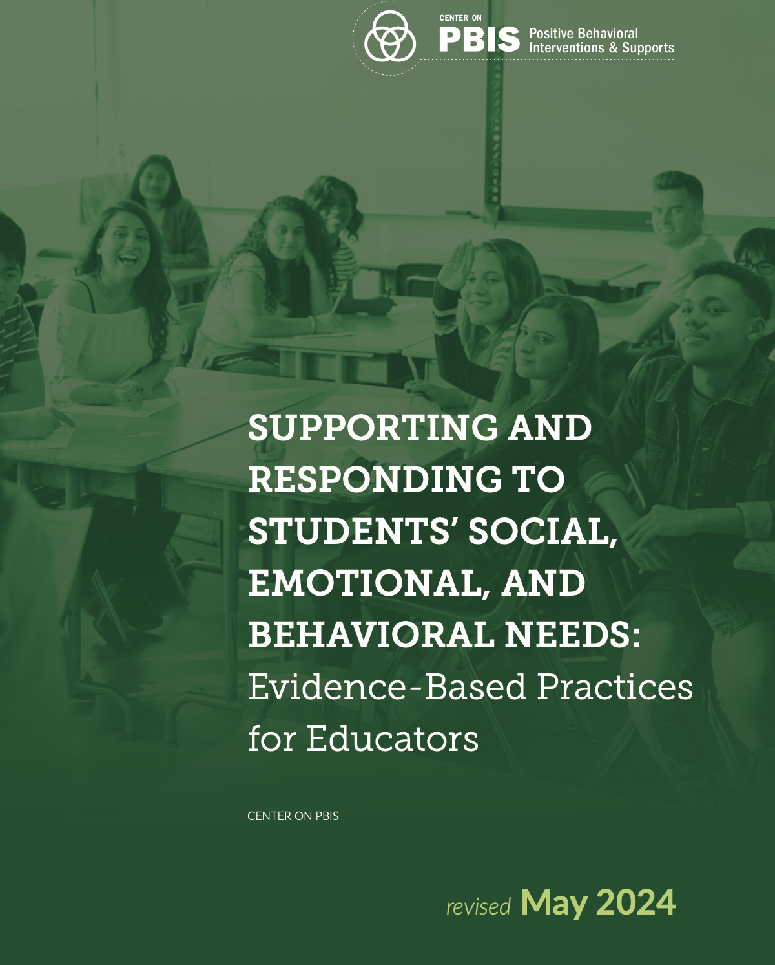 | Center on PBIS. (2025a, April). Supporting and responding to student’s social, emotional, and behavioral needs: Evidence-based practices for educators (Version 2.0). Center on PBIS, University of Oregon. https://www.pbis.org/resource/supporting-and-responding-to-behavior-evidence-based-classroom-strategies-for-teachers
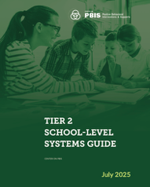 | Center on PBIS. (2025b, July). Tier 2 School-Level Systems Guide. Center on PBIS, University of Oregon. https://www.pbis.org/resource/tier-2-school-level-systems-guide
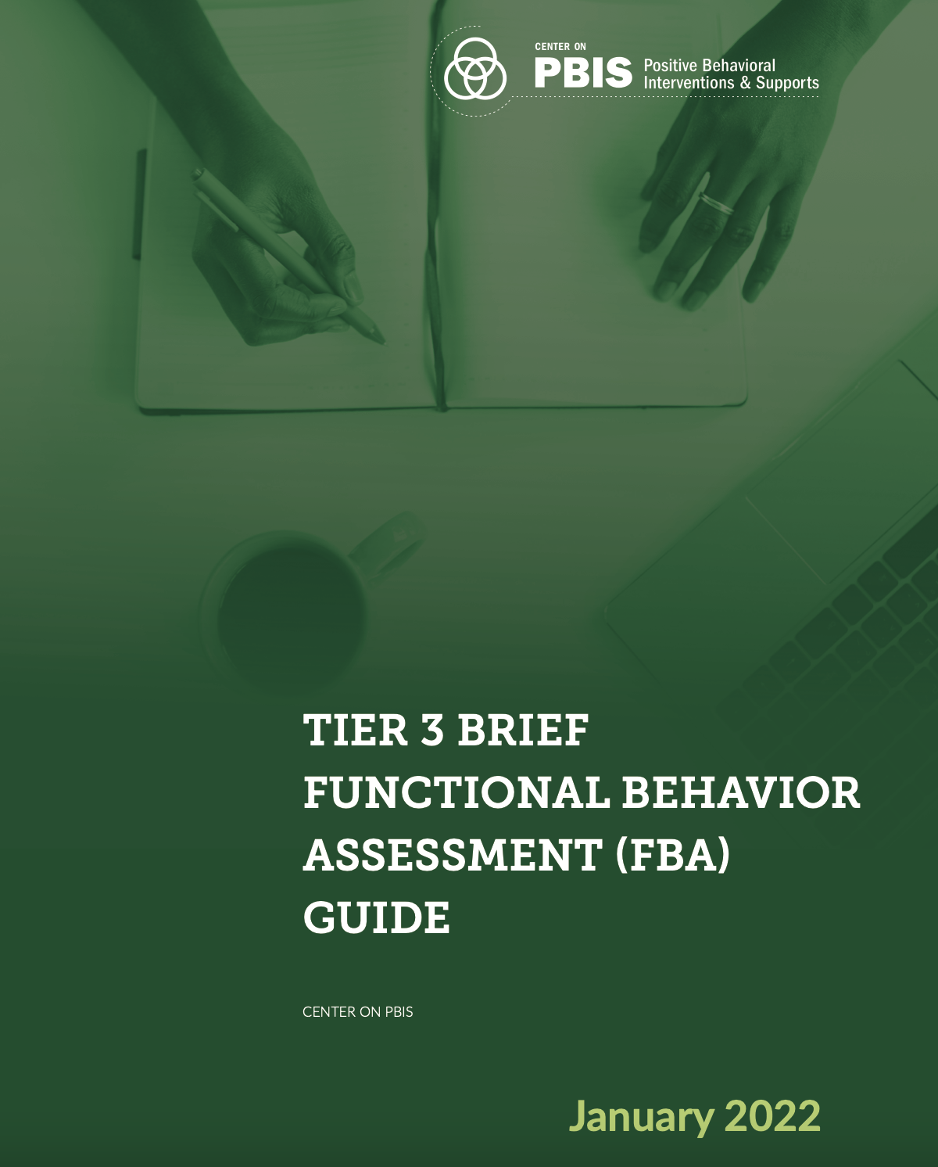 | Center on PBIS. (2022a). Tier 3 Brief Functional Behavior Assessment (FBA) Guide. Center on PBIS, University of Oregon. https://www.pbis.org/resource/tier-3-brief-functional-behavior-assessment-fba-guide
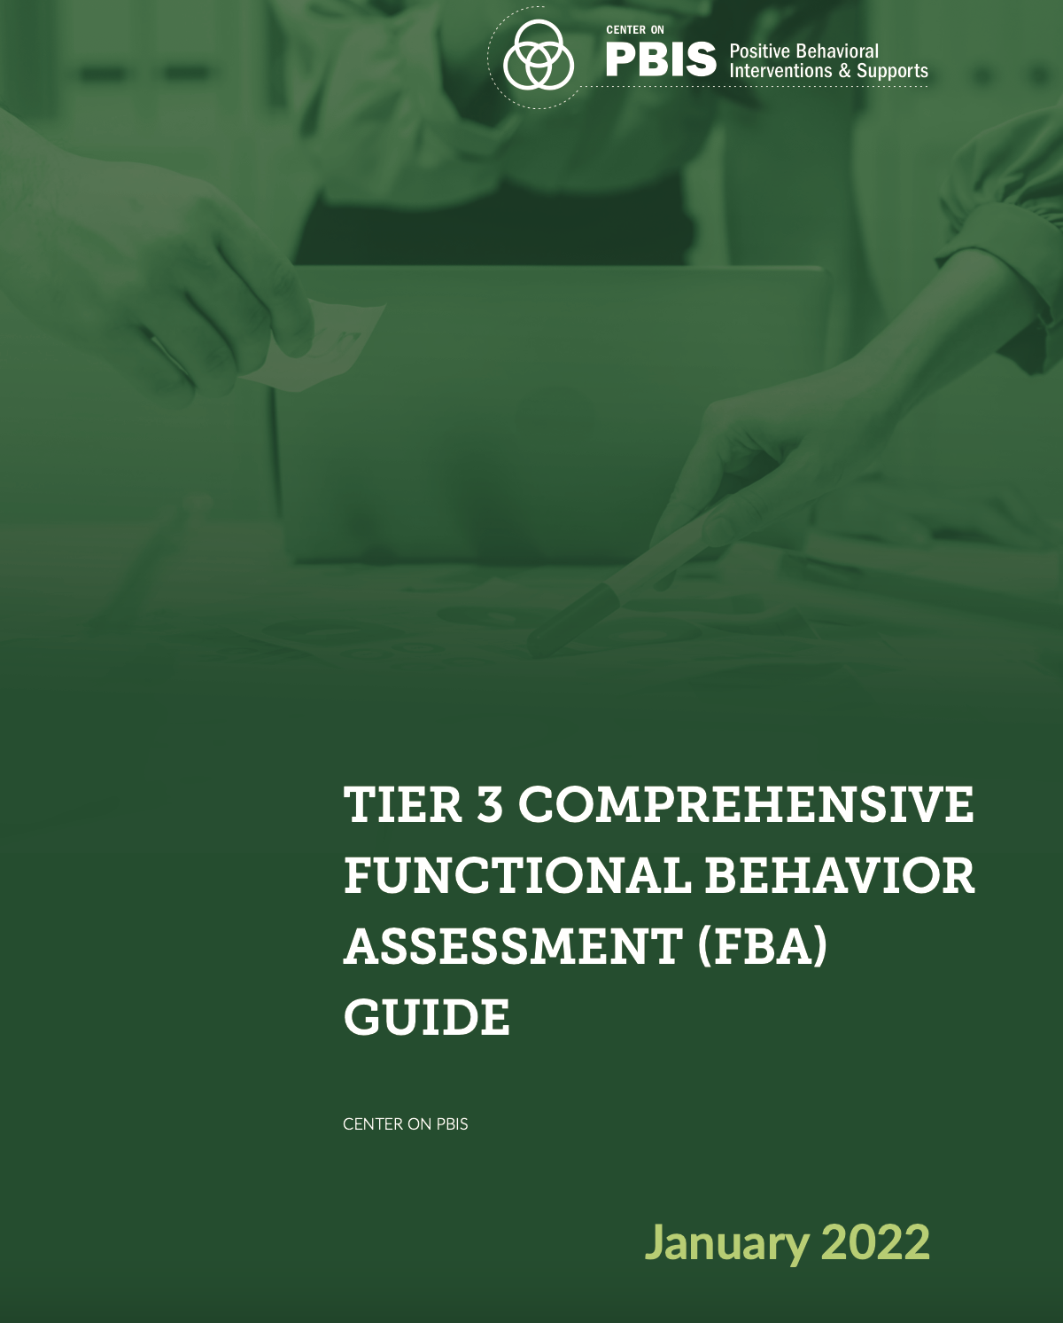 | Center on PBIS. (2022b). Tier 3 Comprehensive Functional Behavior Assessment (FBA) Guide. Center on PBIS, University of Oregon. https://www.pbis.org/resource/tier-3-comprehensive-functional-behavior-assessment-fba-guide
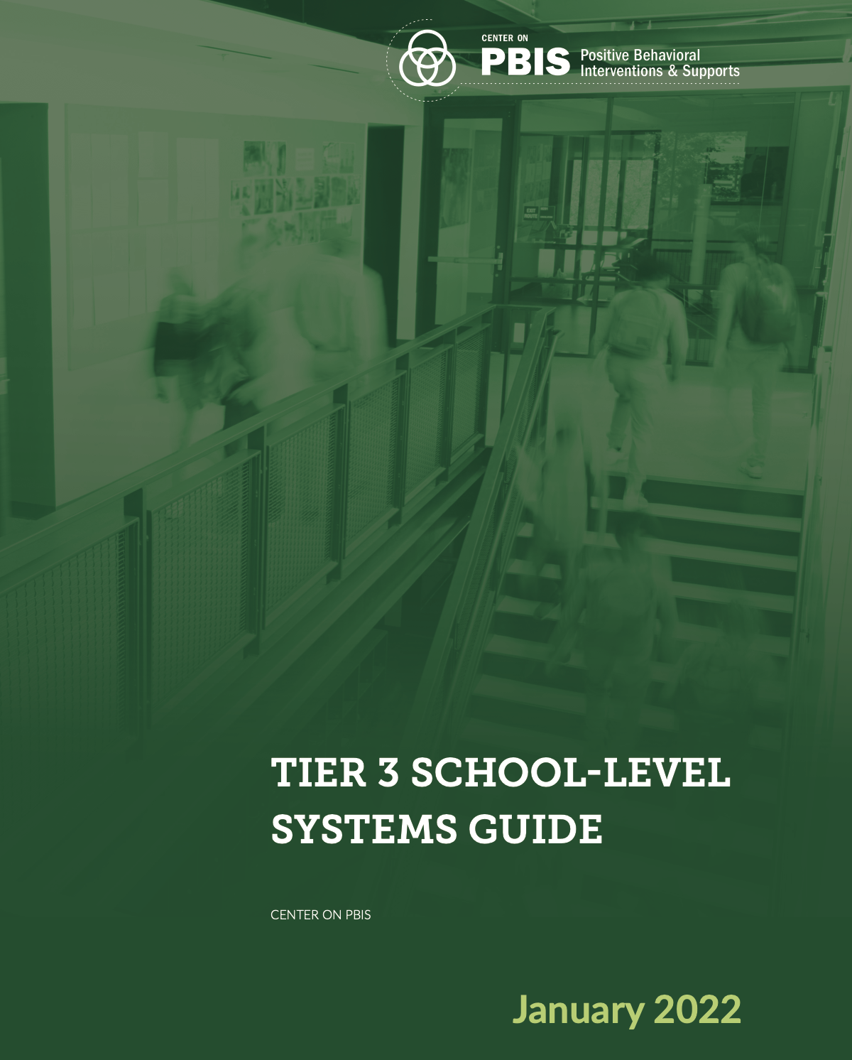 | Center on PBIS. (2022c). Tier 3 school-level systems guide. Center on PBIS, University of Oregon. https://www.pbis.org/resource/tier-3-school-level-systems-guide
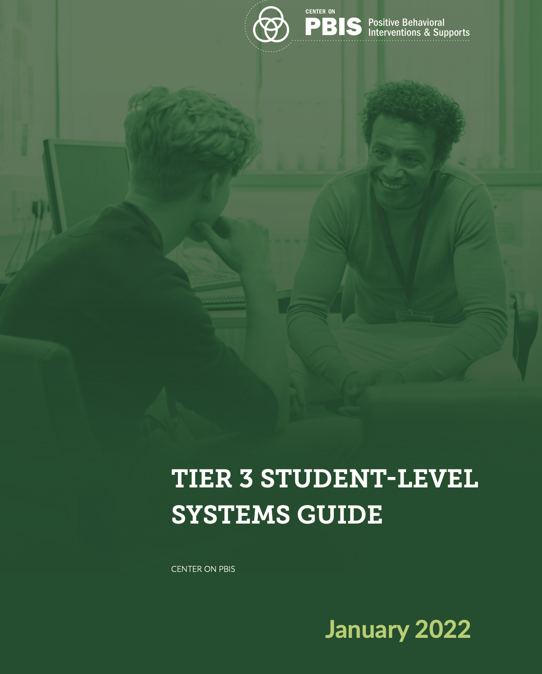 | Center on PBIS. (2022d). Tier 3 student-level systems guide. Center on PBIS, University of Oregon. https://www.pbis.org/resource/tier-3-student-level-systems-guide
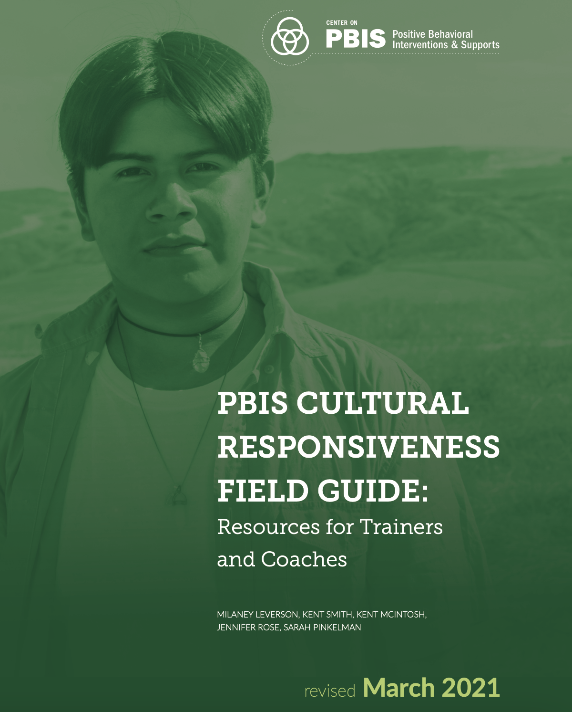 | Leverson, M., Smith, K., McIntosh, K., Rose, J., & Pinkelman, S. (2021). PBIS cultural responsiveness field guide: Resources for trainers and coaches. Center on PBIS, University of Oregon. https://www.pbis.org/resource/pbis-cultural-responsiveness-field-guide-resources-for-trainers-and-coaches
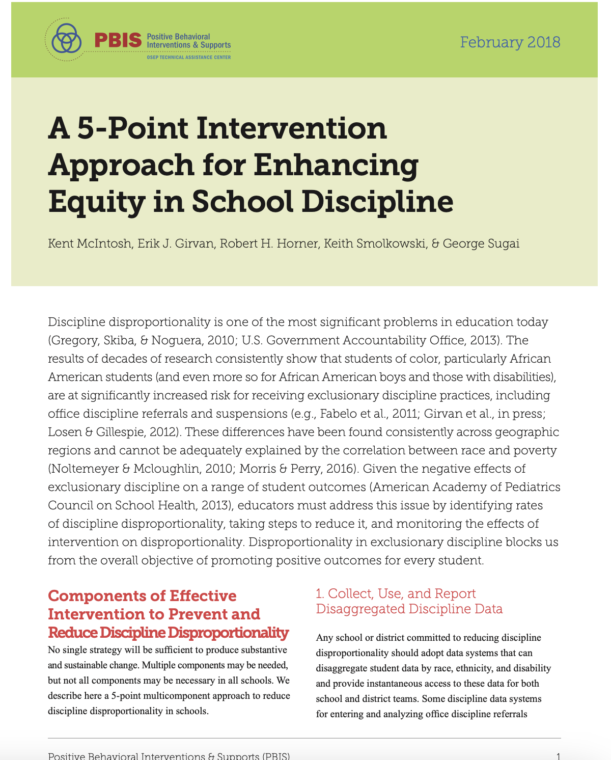 | McIntosh, K., Girvan, E. J., Horner, R. H., Smolkowski, K., & Sugai, G. (2018). A 5-point intervention approach for enhancing equity in school discipline. Center on PBIS, University of Oregon. https://www.pbis.org/resource/a-5-point-intervention-approach-for-enhancing-equity-in-school-discipline
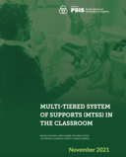 | Simonsen, B., Robbie, K., Meyer, K., Freeman, J., Everett, S., & Feinberg A. (2021). Multi-tiered system of supports (MTSS) in the classroom. Center on PBIS, University of Oregon. https://www.pbis.org/resource/multi-tiered-system-of-supports-mtss-in-the-classroom
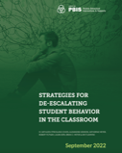 | Strickland-Cohen, M. K., Newson, A., Meyer, K., Putnam, R., Kern, L., Meyer, B. C., & Flammini, A. (2022). Strategies for de-escalating student behavior in the classroom. Center on PBIS, University of Oregon. https://www.pbis.org/resource/strategies-for-de-escalating-student-behavior-in-the-classroom
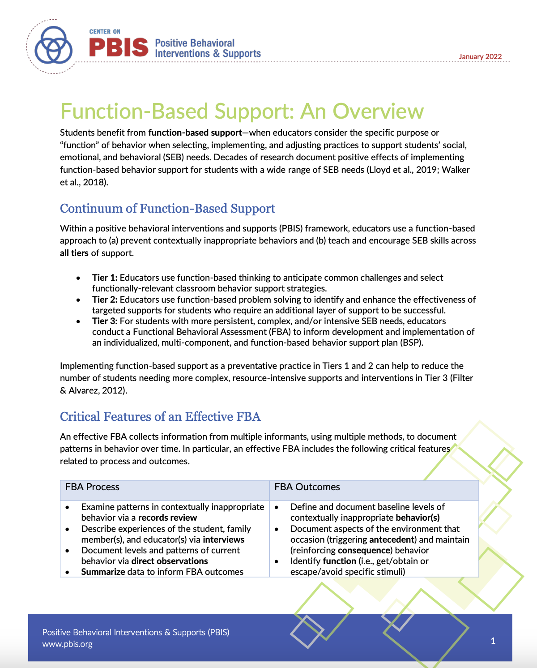 | Strickland-Cohen, M. K., & Simonsen, B. (January, 2022). Function-Based Support. Center on PBIS, University of Oregon. https://www.pbis.org/resource/function-based-support-an-overview

Assessments

Assignments (3 assignments for a total of 50 points)
Note: All assignments are posted on [course LMS] and should be submitted in the provided format (unless otherwise specified). Please review rubrics and handouts for specific expectations and details for each assignment.

- Assignment 1: Check-In/Check-Out (CICO) in Classroom (20 pts)
Draft a CICO plan for a hypothetical classroom. Describe the process of implementation and products needed in to implement CICO in your classroom. (See rubric for details.)

- Assignment 2: Competing Pathway and Strategies (10 pts)
Complete the provided competing pathway for a hypothetical student, and briefly describe potential antecedent, behavior, and consequence strategies. (See rubric for details.)

- Assignment 3: Lesson Plan to Teach Replacement and Desired Behavior (20 pts)
Develop a lesson plan to teach replacement and desired behaviors, based on competing pathway for your hypothetical student. (See rubric for details.)

Quizzes (5 quizzes @ 10 points each = 50 points)
Quizzes assess students’ understanding of course content. Each quiz will cover the material from the previous classes—quizzes are not cumulative. The questions will be based on both the readings and lectures.

Assignment Rubrics

Assignment 1: CICO in Classroom (20 Points)
Category | Emerging  (0 points per row) | Target  (1 point per row) | Exemplary  (2 points per row)
Process for Implementation (Addresses CEC Standard 6.2)
Goals of CICO in classroom | - Goals are missing or unclear | - Goals identified for students who participate in CICO, but not observable and measurable | - Goals are clear, observable, and measurable for students who participate in CICO
Expectations and SEB skills | - Expectations/SEB skills are missing or unclear | - Expectations/SEB skills supported in CICO are identified but not operationally defined | - Expectations/SEB skills supported in CICO are operationally defined
Family/student orientation | - Process to orient family member(s) and student to CICO is missing or unclear | - Process to orient family member(s) and student to CICO is present, but lacks detail | - Process to orient family member(s) and student to CICO is clear and complete
Daily routine | - Description of daily routine is missing or unclear | - Description of daily routine includes most critical features | - Description of daily routine includes all critical features adapted to “your” classroom
Weekly routine | - Description of weekly routine is missing or unclear | - Description of weekly routine includes most critical features | - Description of weekly routine includes all critical features adapted to “your” classroom
Monthly routine | - Description of monthly routine is missing or unclear | - Description of monthly routine includes most critical features | - Description of monthly routine includes all critical features adapted to “your” classroom
Data system | - Description of data system is missing or unclear | - Described data system would be somewhat feasible and useful for data-based decision making | - Described data system would be feasible and useful for data-based decision making
Suggestions for modifications based on data | - Suggestions for modifications are missing or unclear | - Suggestions for modifying are not fully described and/or inappropriate for context | - Suggestions for modifying are clearly described and appropriate for context
Products (Addresses CEC Standard 6.2)
CICO card | - CICO card is missing or contains very few critical elements | - CICO card contains most critical elements | - CICO card contains all critical elements
Spreadsheet | - Spreadsheet is missing or doesn’t function | - Spreadsheet partially set up to collect and graph data (with adjustments needed) | - Spreadsheet effectively set up to collect and graph data based on described data system
Total points | Points: 0-15 | Points 16-18 | Points: 18-20
Comments:
Assignment 2: Competing Pathway and Strategies (10 Points)
Category | Emerging  (0 points per row) |  | Target  (1 point per row) |  | Exemplary  (2 points per row)
Competing Pathway Model (Addresses CEC Standard 6.3)
4-term contingency | - Multiple elements (setting event, antecedent, behavior, consequence) missing or unclear | - Most elements (setting event, antecedent, behavior, consequence) clearly identified |  | - Setting event, antecedent, behavior, and consequence clearly identified
Replacement Behavior | - Replacement behavior is missing or not aligned with function | - Replacement behavior somewhat meets the same function, but may not be efficient or contextually relevant |  | - Replacement behavior would efficiently and effectively meet the same function in a contextually relevant way
Desired behavior & natural consequence | - Desired behavior and natural consequence are missing or unclear | - Desired behavior is not contextually relevant and/or natural consequence is unclear |  | - Desired behavior is contextually relevant and natural consequence is identified
Category | Emerging  (0 points per row) | Target  (1 point per row) |  | Exemplary  (2 points per row)
BSP Strategies (Addresses CEC Standard 6.2)
Setting event strategies | - Setting event strategies are missing, unclear, or irrelevant given competing pathway | - Setting event strategies are somewhat clear and/or relevant given competing pathway |  | - Setting event strategies are clear and relevant given competing pathway
Antecedent strategies | - Antecedent strategies are missing, unclear, or irrelevant given competing pathway | - Antecedent strategies are somewhat clear and/or relevant given competing pathway |  | - Antecedent strategies are clear and relevant given competing pathway
Teaching strategies | - Teaching strategies are missing, unclear, or irrelevant given competing pathway | - Teaching strategies are somewhat clear and/or relevant given competing pathway |  | - Teaching strategies are clear and relevant given competing pathway
Consequence strategies | - Consequence strategies are missing, unclear, or irrelevant given competing pathway | - Consequence strategies are somewhat clear and/or relevant given competing pathway |  | - Consequence strategies are clear and relevant given competing pathway
Total points: | Points: 0-7 | Points: 8-9 |  | Points: 10
Comments:

Assignment 3: Lesson Plan to Teach Replacement and Desired Behavior (20 Points)
Category | Emerging  (0 points per row) | Target  (1 point per row) | Exemplary  (2 points per row)
Lesson introduction (Addresses CEC Standard 6.3)
Lesson focus, objectives, & materials | - Lesson focus, objectives, & materials missing or unclear | - Lesson somewhat operationally defines the replacement &/or desired behavior; short (replacement) & long-term (desired) objectives are unclear or incomplete; or some, but not all, materials identified. | - Lesson clearly operationally defines the replacement & desired behaviors; short (replacement) & long-term (desired) objectives are clearly stated including context & criteria; & all appropriate materials clearly identified.
Examples (>3 positive & >3 negative) | - Fewer than 3 positive & 3 negative examples are provided | - 3 positive & 3 negative examples of replacement OR desired behaviors are provided | - 3 positive & 3 negative examples of the replacement & desired behaviors are provided
Lesson activities to teach replacement & desired behaviors (Addresses CEC Standard 6.2)
Model (demonstrate behaviors/skills) | - Model is missing or unclear | - Lesson activities clearly include modeling, guided practice, & independent practice | - Lesson activities clearly include modeling in appropriate context (where/when to use)
Lead (guided practice) | - Lead is missing or unclear | - Lesson activities include guided practice | - Lesson activities include guided practice in context
Test (content & application) | - Test is missing or unclear | - Lesson activities include an opportunity to test | - Lesson activities include test in context
Follow-up activities (Addresses CEC Standards 6.2 & 6.3)
Prompt (6.2) | - Plans to prompt replacement & desired behaviors are missing or unclear | - Plans to prompt replacement & desired behaviors are clear | - Plans to prompt replacement & desired behaviors are clear & contextually relevant
Reinforce (6.2) | - Plans to reinforce replacement & desired behaviors are missing or unclear | - Plans to reinforce replacement & desired behaviors are clear & functionally relevant | - Plans to reinforce replacement & desired behaviors are clear, functionally relevant, & contextually appropriate
Correct (6.2) | - Plans to correct replacement & desired behaviors are missing or unclear | - Plans to correct replacement & desired behaviors are clear & functionally relevant | - Plans to correct behaviors are clear, functionally relevant, & contextually appropriate
Shaping plan  (replacement to desired, 6.2) | - Shaping plan is missing or unclear | - Shaping plan somewhat describes shift in criterion & schedule of S^{R} | - Shaping plan clearly describes shift in criterion & schedule of S^{R}
Monitor & Evaluate (6.3) | - Plans to monitor & evaluate are missing or unclear | - Plans to monitor & evaluate are clear & appropriate | - Plans to monitor & evaluate are clear, appropriate, & doable
Total points: | Points: 0-15 | Points 16-18 | Points: 18-20
Comments:
Course Schedule

Date | Topic & Big Idea | Assessments | Readings & Resources
Class 1  [date] | Introduction & Overview  Basic Concepts | Getting to Know You Survey | Leverson et al. (2021)  McIntosh et al. (2018)
Class 2  [date] | Review of Classroom PBIS/MTSS  Tier 1 & Intro to Tier 2 |  | Center on PBIS (2025a)  Website: Intro to Tier 2
Class 3  [date] | Tier 2 Practices  Check-In/Check-Out & SS Groups | Quiz 1 (Review of PBIS/Tier 1) | Center on PBIS (2025b)  Simonsen et al. (2021)
Class 4  [date] | Tier 2 Data-Driven Decisions  Monitoring & Modifying Tier 2 Practices |  | Website: CICO SWIS
Class 5  [date] | Tier 3 Overview  Overview of Tier 3 | Quiz 2 (Tier 2) | Strickland-Cohen & Simonsen (2022)  Website: Intro to Tier 3
Class 6  [date] | Tier 3 Comprehensive Assessment  Functional Behavioral Assessment (FBA) | Assignment 1 due | Center on PBIS (2022a)  Center on PBIS (2022b)
Class 7  [date] | Tier 3 Conceptual Foundations  Advanced ABA/PBIS Concepts | Quiz 3 (FBA) | Center on PBIS (2022d)
Class 8  [date] | Tier 3 Practices Overview  Behavior Intervention/Support Plans |  | Center on PBIS (2022d)  (review pp. 14-17)
Class 9  [date] | Tier 3 Practices in Detail  SE-A-B-C Strategies & Self-Management | Quiz 4 (ABA and BIP/BSP) | Center on PBIS (2022d)  (review pp. 15-16)
Class 10  [date] | Tier 3 Crisis Response  De-Escalation and Crisis Plan | Assignment 2 due | Strickland-Cohen et al. (2022)
Class 11  [date] | Tier 3 Data Systems  Overview of Efficient Data Systems |  | Center on PBIS (2022c)  Website: I-SWIS
Class 12  [date] | Tier 3 Data-Driven Decisions  Monitoring & Modifying Tier 3 Practices |  | Center on PBIS (2022d) (review pp. 20-22)
Class 13  [date] | Tier 2 & 3 Systems in Context  Collaborating & Teaming in Tiers 2 & 3 | Quiz 5 (Tier 3 Data) | Center on PBIS (2022c)  (review pp. 5-7, 15-19)
Class 14  [date] | Review  All the above | Assignment 3 due

Add hyperlink to student code of conduct
Add hyperlink to policy related to student discrimination, harassment, etc.

