START WITH INTENTIONAL INPUTS

Considerations | Action Steps
Collaboratively Partner with Families and Students  Consider the following questions as you plan action steps:  - How will students and families co-design or inform implementation plans?  - What strengths, needs, and preferences will you gather from students and families?  - How will you maintain ongoing, two-way communication about implementation?  - How will you ensure family and student voices are equitably represented in decisions? |   
Ensure Implementation is Culturally Sustaining

Consider the following questions as you plan action steps:
- How will you affirm students’ cultural and linguistic identities in this practice?
- What community knowledge or values can be reflected in the implementation?
- How does the content or structure sustain, rather than replace, cultural ways of knowing?
- How will you reflect on and address any biases or assumptions within the practice?

Ensure Implementation is Inclusive and Safe for All  Consider the following questions as you plan action steps:  - How will the environment support physical, emotional, and intellectual safety for every student?  - What adaptations or differentiation will ensure full access and participation?  - How will you monitor for equity in who is benefiting from the practice?  - What structures will support belonging and respect for all identities? | 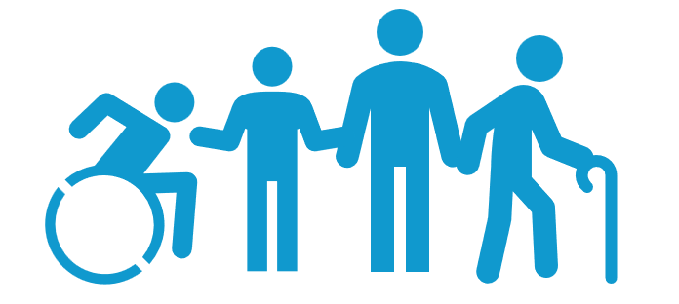

 | PLAN FOR PRACTICE IMPLEMENTATION AND MONITORING
Considerations |  | Action Steps
Estimate Your Current Practice Baseline  How consistently, inclusively, and equitably do you greet students using their preferred greeting throughout the week?  - Highly Consistent, Inclusive, and Equitable: I greet:  - All of my students (100%).  - At least five times per week.  - In ways that seek out and honor preferences of all, including those who may be less likely to voice needs.  - Moderately Consistent, Inclusive, and Equitable:  I greet:  - Most of my students (51–90%)  - Two to four times per week  - In ways that make intentional efforts to include diverse preferences, though some students’ voices may be underrepresented or inconsistently acknowledged.  - Occasionally Consistent, Inclusive, and Equitable:  I greet:  - Some of my students (20–50%)  - Once per week or less  - With intention to learn and honor preferences and needs, but I’m not yet consistent  - Rarely or Not Yet Equitable:  I greet:  - Fewer than 20% of my students  - Infrequently or not at all  - But have yet to intentionally consider preferences, needs, and building authentic connections with all  How often do you proactively prompt students to the first activity of the day or expected behaviors  - Frequently (3–5 times per morning routine): I consistently prompt students to begin the first activity and reinforce expected behaviors at key moments throughout the morning (e.g., during arrival, transitions, or settling in).  - Moderately (1–2 times per morning routine): I prompt students to begin the first activity and reinforce expected behaviors during specific moments of the morning (e.g., at arrival or before a major transition).  - Occasionally (Once per morning routine): I prompt students to begin the first activity or reinforce expected behaviors only when needed (e.g., after disruptions or delays). |  | I currently greet students using their preferred greeting ____ times per week.  I currently greet ___% of my students using their preferred greeting each day of the school week.  A group of students whose preferred greetings I inconsistently acknowledge, or whose preferences I have yet to learn, includes:  I currently prompt students proactively during arrival _____ per minute.
Set Initial Practice Rate Goal  Set an initial goal for how you plan to use this practice during an arrival routine?  - Make your goal ambitious but doable  - You can adjust after you have data  - If this is already a habit, focus on equitable implementation |  | I aim to greet students using their preferred greeting _____ times per week.  I aim to greet ___% of my students using their preferred greeting each day of the school week.  I aim to consistently acknowledge or learn more about preferences for the following students:  I aim to proactively prompt students during arrival _____ times per minute.
Plan for Increasing Practice

Identify how you will
- Prompt/remind yourself to use the practice
- Use other strategies (e.g., script practice into your lesson, practice to fluency)
- Prompt/remind yourself to self-monitor
Plan for Monitoring Practice

Identify how you will
- Self-monitor (e.g., tally, use golf counter, Be+ app)
- Review data over time to examine trends
- Adjust your goal based on the data to ensure equitable implementation

Plan Self-Reinforcement (Small Celebration)

Identify the celebration, or reinforcer, you will give yourself on days you meet your goal and when you will
- Review your practice data,
- Determine if you met your goal, and
- Reinforce yourself (i.e., how you celebrate).

CHECK: MONITOR, REFLECT, & ADJUST

Considerations | Action Steps
Think Back

Review your data and consider:
- What went well with implementation?
- What challenges are you experiencing?
Think Forward

Review your data and consider:
- How can you overcome those challenges?
- How can you continue to elevate your practice to promote inclusive and safe spaces?
Think Inward

Reflect on your experiences:
- What are conditions or experiences that may inhibit equitable and inclusive implementation?
- What are conditions or experiences that may support equitable and inclusive implementation?
Think Outward

Plan to enhance your practice:
- What specific adjustments can you make to enhance your implementation for all students?
- How will you promote equitable and inclusive implementation to support each student?
Note. Four Dimensions of Reflective Learning (Adapted from Barstable, 2009;
https://kbarnstable.wordpress.com/2009/12/15/22-questions-for-reflection/)

