PLAN WITH INTENTIONAL INPUTS

Considerations | Action Steps
Collaboratively Partner with Families and Students  Consider the following questions as you plan action steps:  - How will students and families co-design or inform implementation plans?  - What strengths, needs, and preferences will you gather from students and families?  - How will you maintain ongoing, two-way communication about implementation?  - How will you ensure family and student voices are equitably represented in decisions? |   - For example, use Praise Preference Assessment to gather student input  
Ensure Implementation is Culturally Sustaining  Consider the following questions as you plan action steps:  - How will you affirm students’ cultural and linguistic identities in this practice?  - What community knowledge or values can be reflected in the implementation?  - How does the content or structure sustain, rather than replace, cultural ways of knowing?  - How will you reflect on and address any biases or assumptions within the practice? | - For example, consider Getting to Know You Activities including this survey
Ensure Implementation is Inclusive and Safe for All  Consider the following questions as you plan action steps:  - How will the environment support physical, emotional, and intellectual safety for every student?  - What adaptations or differentiation will ensure full access and participation?  - How will you monitor for equity in who is benefiting from the practice?  - What structures will support belonging and respect for all identities? | 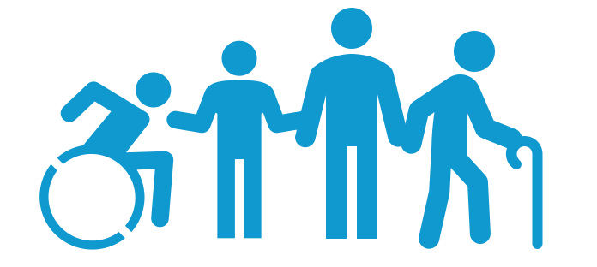

PLAN TO IMPLEMENT & MONITOR

Considerations | Action Steps
Estimate Your Current Practice Rate  How often do you think you use this practice per minute?  - Once every 1 min = 1.0  - Once every 2 min = 0.5  - Once every 5 min= 0.2 | I currently implement _____ practice (s) per min
Set Initial Practice Rate Goal  Set an initial goal for how often you plan to use this practice per minute?  - Make your goal ambitious but doable  - You can adjust after you have data  - If this is already a habit, focus on equitable implementation and Planned Praise | I aim to implement _____ practice(s) per min  AND/OR  I aim to increase planned praise for __ group of students to __ statements per min
Plan for Increasing Practice

Identify how you will
- Prompt/remind yourself to use the practice
- Use other strategies (e.g., script practice into your lesson, practice to fluency, use Planned Praise)
- Prompt/remind yourself to self-monitor
Plan for Monitoring Practice

Identify how you will
- Self-monitor (e.g., tally, golf counter, Be+ app)
- Select a brief (10-15 min) routine to self-monitor (e.g., Routine Assessment Worksheet)
- Review data over time to examine trends
- Adjust your goal based on the data to ensure equitable implementation

Plan Self-Reinforcement (Small Celebration)

Identify the celebration, or reinforcer, you will give yourself on days you meet your goal and when you will
- Review your practice data,
- Determine if you met your goal, and
- Reinforce yourself (i.e., how you celebrate).

CHECK

Considerations to Monitor, Reflect, & Adjust | Action Steps
Think Back

Review your data and consider:
- What went well with implementation?
- What challenges are you experiencing?
Think Forward

Review your data and consider:
- How can you overcome those challenges?
- How can you continue to elevate your practice to promote inclusive and safe spaces?
Think Inward

Reflect on your experiences:
- What are conditions or experiences that may inhibit equitable and inclusive implementation?
- What are conditions or experiences that may support equitable and inclusive implementation?
Think Outward

Plan to enhance your practice:
- What specific adjustments can you make to enhance your implementation for all students?
- How will you promote equitable and inclusive implementation to support each student?
Note. Four Dimensions of Reflective Learning (Adapted from Barstable, 2009;
https://kbarnstable.wordpress.com/2009/12/15/22-questions-for-reflection/)

