
SELF-ASSESSMENT TO PLAN FOR PRACTICE IMPLEMENTATION AND MONITORING (Developed by Ruthie Payno-Simmons 2025)

Directions
Estimate your current practice by rating how often you use each practice during the instructional cycle: Planning → Teaching → Actively Engaging Students → Supporting → Reflecting & Adjusting. Select the practices you most need to strengthen.
Frequency Options:
Frequently (F), Moderately (M), Occasionally (O)
- Frequently – I use this practice consistently across most phases (3–4 times per cycle).
- Moderately – I use this practice in at least one or two phases (1–2 times per cycle).
- Occasionally – I rarely use this, or only when needed.
RELEVANT LEARNING PRACTICE | Frequency (F/M/O) | Focus? (✔)
Connect content to students’ identities, interests, lived experiences
Link learning to real-life applications & career/transition goals
Build & prime background knowledge
ACTIVE PARTICIPATION PRACTICE | Frequency (F/M/O) | Focus? (✔)
Provide frequent & varied opportunities to respond (OTRs)
Implement a wide variety of engagement strategies
Provide performative feedback (real-time, actionable)
MEANINGFUL PARTICIPATION PRACTICE | Frequency (F/M/O) | Focus? (✔)
Build supportive, trusting relationships with students
Ensure students can influence aspects of their learning (voice, choice, shared power)
Use multiple instructional approaches

PLAN WITH INTENTIONAL INPUTS

Considerations | Action Steps
Collaboratively Partner with Families and Students  Consider the following questions as you plan action steps:  - How will students and families co-design or inform implementation plans?  - What strengths, needs, and preferences will you gather from students and families?  - How will you maintain ongoing, two-way communication about implementation?  - How will you ensure family and student voices are equitably represented in decisions? |   
Ensure Implementation is Culturally Sustaining

Consider the following questions as you plan action steps:
- How will you affirm students’ cultural and linguistic identities in this practice?
- What community knowledge or values can be reflected in the implementation?
- How does the content or structure sustain, rather than replace, cultural ways of knowing?
- How will you reflect on and address any biases or assumptions within the practice?

Ensure Implementation is Inclusive and Safe for All  Consider the following questions as you plan action steps:  - How will the environment support physical, emotional, and intellectual safety for every student?  - What adaptations or differentiation will ensure full access and participation?  - How will you monitor for equity in who is benefiting from the practice?  - What structures will support belonging and respect for all identities? | 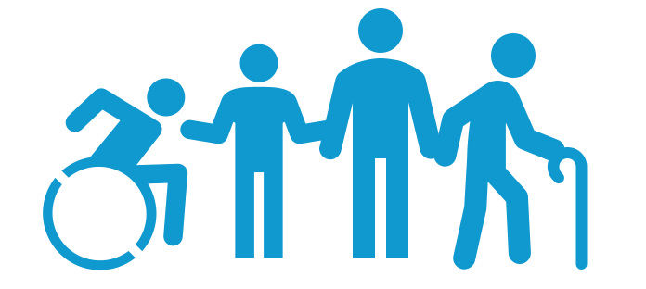

PLAN FOR PRACTICE IMPLEMENTATION AND MONITORING

Considerations | Action Steps
Reflect On Your Instructional Planning Practice  Are you using the following reflection prompts as you plan instruction?  - How will I ensure instruction connects to who my students are and what they care about?  - How will I deliver instruction in ways that are accessible, engaging, and inclusive?  - How will I ensure every student is actively involved in learning?  - How will I use student input and teacher and students' performance to guide next steps? | I currently reflect on #_____ these 4 prompts when planning instruction
Estimate Your Current Practice Rate For The Area(s) You Selected in the Self-Assessment Across the Instructional Cycle  How often do you use each practice when you are  2) Teaching, 3) Actively Engaging Students, and 4) Supporting students during instruction?  - Frequently – I use this practice consistently across most phases (3–4 times per cycle).  - Moderately – I use this in at least one or two phases (1–2 times per cycle).  - Occasionally – I rarely use this or only when needed. | I currently implement _____ practice (s) per phase and per cycle
Reflect on Assessing, Reflecting, and Adjusting Practice after delivering instruction and facilitating learning.  Are you using the following reflection prompts as you assess, reflect and adjust instruction?  - How did I ensure instruction connects to who my students are and what they care about?  - How did I deliver instruction in ways that are accessible, engaging, and inclusive?  - How did I ensure every student is actively involved in learning?  - How did I use student input and teacher and students' performance to guide next steps? | I currently reflect on #_____ these 4 prompts when assessing, reflecting, and adjusting after delivering instruction and facilitating learning
Set Initial Practice Rate Goal  Set an initial goal for how often you plan to use this practice per minute?  - Make your goal ambitious but doable  - You can adjust after you have data  - If this is already a habit, focus on equitable implementation | I aim to reflect on _____ of these 4 prompts when planning instruction  I aim to implement _____ practice(s) per phase and per cycle  I currently reflect on _____ of these 4 prompts when assessing, reflecting, and adjusting after delivering instruction and facilitating learning
Plan for Increasing Practice

Identify how you will
- Prompt/remind yourself to use the practice
- Use other strategies (e.g., script practice into your lesson, practice to fluency)
- Prompt/remind yourself to self-monitor
Plan for Monitoring Practice

Identify how you will
- Self-monitor (e.g., tally, use golf counter, Be+ app)
- Review data over time to examine trends
- Adjust your goal based on the data to ensure equitable implementation
Plan Self-Reinforcement (Small Celebration)

Identify the celebration, or reinforcer, you will give yourself on days you meet your goal and when you will
- Review your practice data,
- Determine if you met your goal, and
- Reinforce yourself (i.e., how you celebrate).

CHECK: MONITOR, REFLECT, & ADJUST

Considerations | Action Steps
Think Back

Review your data and consider:
- What went well with implementation?
- What challenges are you experiencing?
Think Forward

Review your data and consider:
- How can you overcome those challenges?
- How can you continue to elevate your practice to promote inclusive and safe spaces?
Think Inward

Reflect on your experiences:
- What are conditions or experiences that may inhibit equitable and inclusive implementation?
- What are conditions or experiences that may support equitable and inclusive implementation?
Think Outward

Plan to enhance your practice:
- What specific adjustments can you make to enhance your implementation for all students?
- How will you promote equitable and inclusive implementation to support each student?
Note. Four Dimensions of Reflective Learning (Adapted from Barstable, 2009;
https://kbarnstable.wordpress.com/2009/12/15/22-questions-for-reflection/)

