PLAN WITH INTENTIONAL INPUTS

Considerations | Action Steps
Collaboratively Partner with Families and Students  Consider the following questions as you plan action steps:  - How will students and families co-design or inform plans for data collection and use?  - What strengths, needs, and preferences will you gather from students and families?  - How will you maintain ongoing, two-way communication about data collection and use?  - How will you ensure family and student voices are equitably represented in decisions? |   
Ensure Implementation is Culturally Sustaining

Consider the following questions as you plan action steps:
- How will you affirm students’ cultural and linguistic identities in data collection and use?
- What community knowledge or values can be reflected in data collection and use?
- How does data collection and use sustain, rather than replace, cultural ways of knowing?
- How will you reflect on and address any biases or assumptions within data collection and use?

Ensure Implementation is Inclusive and Safe for All  Consider the following questions as you plan action steps:  - How will you collect and use data to ensure environment supports physical, emotional, and intellectual safety for every student?  - How will you collect and use data whether adaptations or differentiation ensure full access and participation?  - How will you monitor for equity in who is benefiting from the practice?  - How will you collect and use data on whether structures will support belonging and respect for all identities? | 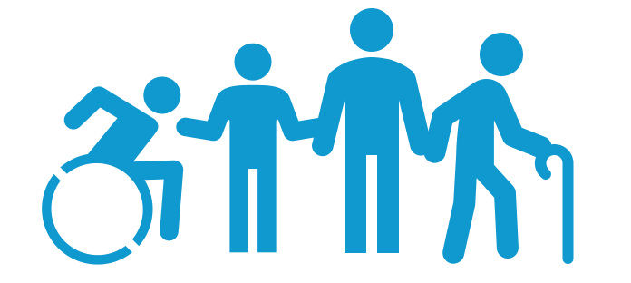

PLAN TO IMPLEMENT & MONITOR DATA COLLECTION AND USE STRATEGIES

Considerations | Action Steps
Assess Current (A) Data Tools and (B) Routines for Data Collection & Use for Decision Making.

Consider both:
- Fidelity of Implementation
- Outcomes of Implementation

Consider the following questions as you plan action steps:
- What are strengths of our current approach?
- What are limitations that need to be addressed to effectively engage in data-based decision making?
- What action steps can help ensure data collection and use are guided by intentional inputs?
Identify Gaps in Your Current (A) Data Tools and (B) Routines for Data-Based Decision Making

Consider the following questions as you plan action steps:
- What data are missing and need to be added?
- How do data routines need to be adjusted to incorporate these data?
Plan for Continuous Improvement via Data Collection & Use for Decision Making

Identify how you will
- Prompt/remind yourself to collect & use data
- Review your data—both aggregated and disaggregated fidelity and outcome data—to inform decisions (maintain or modify)
- Develop (a) specific goals and (b) an action plan to implement changes and restart the cycle
Plan Self-Reinforcement (Small Celebration)

Identify the celebration, or reinforcer, you will give yourself on days/weeks you meet your goal and when you will
- Review your fidelity and outcome data,
- Determine if you met your goal, and
- Reinforce yourself (i.e., how you celebrate).

CHECK

Considerations to Monitor, Reflect, & Adjust | Action Steps
Think Back

Review your data and consider:
- What went well with data collection and use?
- What challenges are you experiencing?
Think Forward

Review your data and consider:
- How can you overcome those challenges?
- How can you continue to elevate your data collection and use to promote inclusive and safe spaces?
Think Inward

Reflect on your experiences:
- What are conditions or experiences that may inhibit equitable and inclusive data collection and use?
- What are conditions or experiences that may support equitable and inclusive data collection and use?
Think Outward

Plan to enhance your practice:
- What specific adjustments can you make to enhance your data collection and use for all students?
- How will you promote equitable and inclusive data collection and use to support each student?
Note. Four Dimensions of Reflective Learning (Adapted from Barstable, 2009;
https://kbarnstable.wordpress.com/2009/12/15/22-questions-for-reflection/)

