**JENNIFER BOYUAN HAN （1996-）**

626-487-6394 | http://www.jenniferboyuanhan.com | jennifer.hanbca@gmail.com

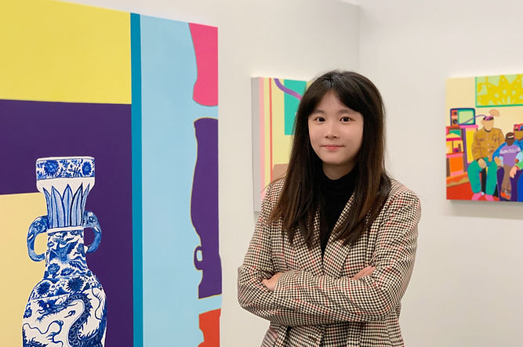

**Education:**

2018 ­- BFA Painting — California College of the Arts, San Francisco, CA

2026 ­- MFA Painting — California College of the Arts, San Francisco, CA

**Solo and Two-Person Exhibitions**:

2025 ­- Two-Person Exhibition, Nanjing Forestry University, “Chuang Zao Li De Guang

Pu”, Nanjing, China (with artist Augustus Kollie).

2023 ­- OneHouse Arts Studio Gallery, “A Select History of Humanbot”, Monterey Park,

CA. USA.

2023 ­- Xinqiao Art Museum, “Machinery in the Loop”, Shanghai, China

2023 ­- XSpace Gallery, “Growing Up With Cellphones”, Nanjing, China

2023 ­- Path & Cube Gallery, “Drowning”, Nanjing, China

2018 ­- Hubbell Street Gallery, “The Grid,” San Francisco, CA. USA.

**Selected Group Exhibitions**:

2025 – Huazhong Art Museum, “’Visual Nanny’ International Youth Contemporary Art

Exhibition”, Baoding, Hebei, China

2025 – Shang Art Museum, “How Carbon is Forgotten”, Hangzhou, China

2025 – Da Ci Tie Laboratory, Huazhong Art Museum, “The 4th Fantasy Tree Trend Art

Exhibition: Creating Tide Gravity Field”, Baoding, Hebei, China

2025 – Micki Meng Gallery, “San Francisco Art Fair”, Fort Mason Center, San Francisco,

CA. USA.

2025 ­- Institute of Contemporary Art, “For the Time Being”, San Francisco, CA. USA.

2024 ­- CCA Campus Gallery, “Meowzeum”, San Francisco, CA. USA.

2024 ­- NOWS, “Artogo” Art Festival, Nanjing, China.

2023 ­- Boomer Gallery, “What Is Art”, London, UK.

2023 ­- Rossocinabro Gallery, “Maximalism”, Rome, Italy.

2023 ­- Palazzo Albrizzi-Capello, “Secret Spaces - Boarders Art Fair 2023”, Venice, Italy.

2023 ­- XSpace Gallery, “Rabbit Gogogo”, Nanjing, China.

2022 ­- Path and Cube, “There Are Seven Paths in A Cube”, Nanjing, China.

2022 ­- XSpace Gallery, “Tiger On the Beat”, Nanjing, China.

2019 ­- Anken Avenue, “Heaven.Earth.Segregation”, Shanghai, China.

2019 ­- 161-151 Hubbell Street Galleries, “Alma Matter:Methods”, San Francisco, USA.

2019 ­- National Tour, Fox 2 Gallery, Dodge Painting Galleries & Hubbell Street Gallery

“Disegno 9: Contemporary Undergraduate Drawing,” Maryland, Kansas City &

San Francisco, CA, USA.

2019 ­- Trestle Gallery, “Small Works 2019” Online Exhibition, Brooklyn, NY, USA.

2019 ­- California College of the Arts, “Commencement Exhibition,” San Francisco, USA.

2018 ­- Olive Art Center, “The Interface Show,” Oakland, CA. USA.

2018 ­- California College of the Arts, “NASAD Exhibition,” San Francisco, CA, USA.

2018 ­- Olive Art Center, “All-College Honor Exhibition,” Oakland, CA. USA.

2018 ­- 161 Hubbell Street Gallery, “Paintings Among Laughter Somewhere,” San

Francisco, CA. USA.

2016 ­- California College of the Arts, “International Student Exhibition,” San Francisco,

CA. USA.

**Press and Writing**:

*Humble Pie*, Vol. 22, California College of the Arts, 2025. Featured artwork published in

literary and arts journal.

“Jennifer Boyuan Han: A Select History of Humanbot”, One House Arts Studio Gallery,

Nov 22, 2023, https://www.onehousearts.org/gallery/shows/jennifer-boyuan-han-

a-select-history-of-humanbot/

Wen, Tian, "'Machinery in the Loop' Jennifer Han’s Solo Exhibition", Xinqiao Art

Complex, Oct, 2023, <http://mingqiart.com/show.asp?id=883>

**Honors and Awards**:

2025 ­- *Silver Award*. “Visual Nanny” International Youth Contemporary Art Exhibition.

China.

2024 ­- *The Leo and Florence Helzel Endowed Scholarship Fund in Honor of David Kirshman*. California College of the Arts.

2019 ­- *The 10th New Star Art Award*. New Star Art Festival. China.

2018 ­- *All-College Honor.* California College of the Arts.

2018 ­- *Special Merit Award. “*All-Women” Art Exhibition, Light Space & Time Art Gallery.

2016 ­- *First Place Winner.* First Annual Pam June Naik Video Art Festival. Washington

D.C., USA

**Others**:

Member of the Asian American Women Artists Association, USA

Member of the Association of Chinese Young Artists, Nanjing, China