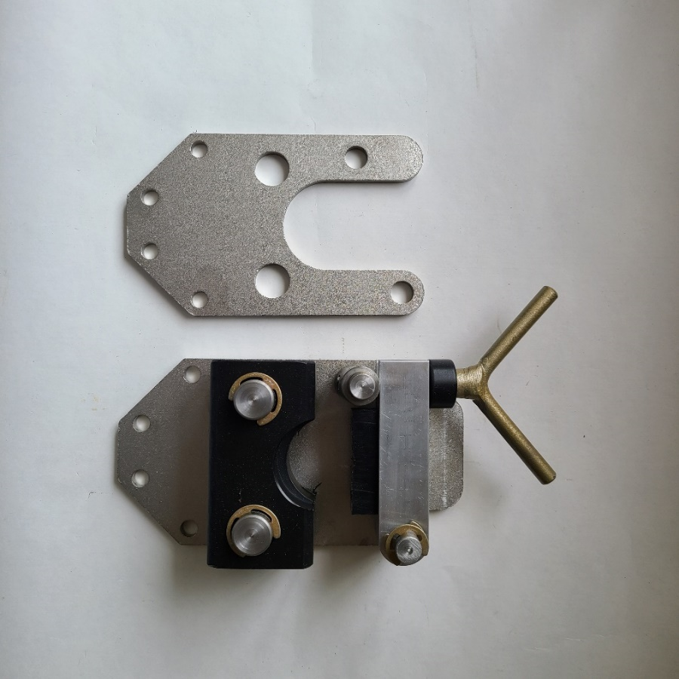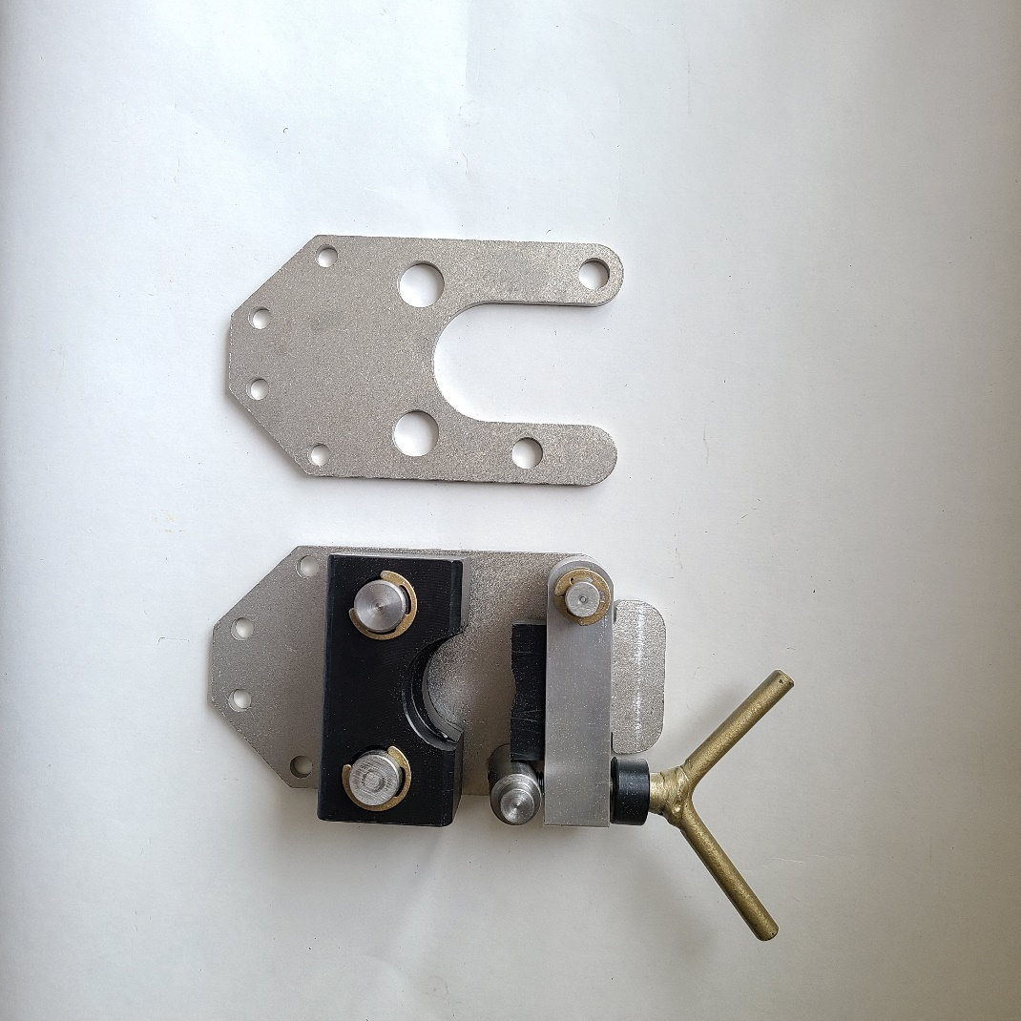

NOT PICTURED – TO HOLD HEADS ONTO FRAME:

DC-28 HHCS 5/16-18 X 3

DC-30 NYLON HEX NUT

EACH DECOILER FRAME GETS A **LEFT AND RIGHT** HEAD

DC-08 BRAKE PAD

DC-34 M6X30 SHCS

DC-12 BRAKE ARM

DC-16 SPACER

DC-32 E-CLIP ½”

DC-15 LOCKING PIN ½”

DC-13 LOCKING PIVOT

DC-17 HANDLE

DC-33 E-CLIP ¾”

DC-23 LOCKING PIN ¾”

DC-09 BEARING BLOCK

DC-11 INSIDE PLATE

DC-10 OUTSIDE PLATE