

Dr. Christine Cole DDS, MHS Dr. Elizabeth Miller DDS
Dr. Giles Horrocks DDS, MS

This is to introduce

Date: ________________

Patient Name: ______________________________________________________
Patient Number: ____________________________________________________
Referred By: ________________________________________________________

1 | 2 | 3 | 4 | 5 | 6 | 7 | 8 | 9 | 10 | 11 | 12 | 13 | 14 | 15 | 16
32 | 31 | 30 | 29 | 28 | 27 | 26 | 25 | 24 | 23 | 22 | 21 | 20 | 19 | 18 | 17

Please check all that apply:

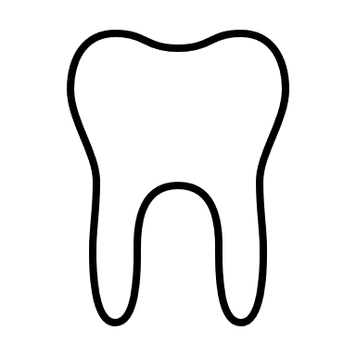Comprehensive Examination Limited Examination
Take 3D Scan 3D Scan taken Date: ___________
Take Radiograph Radiograph taken Date: ___________

Specific Concerns/Comments: _______________________________________________
__________________________________________________________________________
__________________________________________________________________________
__________________________________________________________________________
__________________________________________________________________________
__________________________________________________________________________
__________________________________________________________________________
__________________________________________________________________________
__________________________________________________________________________
__________________________________________________________________________
__________________________________________________________________________
__________________________________________________________________________

3400 Penrose Pl, Ste #103 Boulder, CO 80301 Office: 303.449.1301
www.boulderperiodontics.com images@boulderperiodontics.com

