Overcurrent Relaying

Conversion of Electromechanical (EM) setting to Digital setting

TOC = Time OverCurrent
IOC = Instantaneous OverCurrent

Electromechanical time overcurrent relays are set based on taps.
Digital time overcurrent relays are set based on 5A secondary or primary CT setting.

Electromechanical instantaneous overcurrent relays are set based on a dial setting (not time dial).
Digital instantaneous overcurrent relays are set based on 5A secondary or primary CT setting.

For example: Setting EM Digital (for 5A CTs)_____
TOC Pickup value Tap = 5 1 x CT or 1 x PU
Tap = 2 0.4 x CT or 0.4 x PU

IOC Pickup value 30A 6 x CT or 6 x PU
(dial setting)

Curve Shape Inverse (IAC51) IAC Inverse
Very Inv (IAC53) IAC Very Inv
Ext Inv (IAC77) IAC Ext Inv

Curve used Time Dial Multiplier
within family

Reset Timed Timed (linear) or Fast

Instantaneous Overcurrent (function 50)

- The instantaneous overcurrent protective element operates with no intentional time delay when the current has exceeded the relay setting
- There is a pickup setting. Pickup usually set at 25% higher than the maximum current seen by the relay for a three-phase fault at the end of the line.
- 50P – phase inst. overcurrent - typical pickup setting of 6-10 x CT rating
- 50N – neutral inst. overcurrent - typical pickup setting of of 6-10 x CT rating
(The phasor summation of phase currents Ia, Ib, Ic equals In)
- 50G – ground inst. overcurrent - typical pickup setting of of 6-10 x CT rating
(The electrical summation of phase currents Ia, Ib, Ic equals Ig)


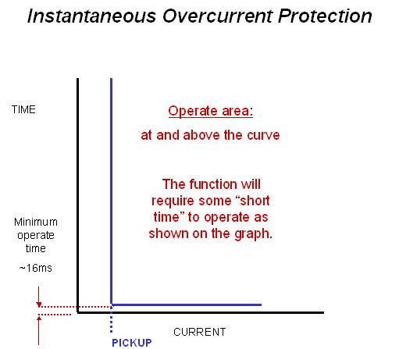

Time Overcurrent (function 51)

- Where it is desired to have more time delay before the element operates for the purpose of coordinating with other protective relays or devices, the time overcurrent protective element is used.
- The trip time varies inversely with current.
- Characteristic curves most commonly used are called “inverse”, ”very inverse,” and “extremely inverse.” The user must select the curve type. They are said to be a family of curves and selected by the time dial.
- There is a minimum pickup setting. The pickup setting should be chosen such that the protective device will be operating on the most inverse part of its time curve over the range of current for which must operate.
- 51P – phase time overcurrent – typical pickup setting of 1.0pu or 1 x CT rating
- 51N – neutral time overcurrent – typical pickup setting of 0.3pu or 0.3 x CT rating
(The phasor summation of phase currents Ia, Ib, Ic equals In)
- 51G – ground time overcurrent – typical pickup setting of 0.3pu or 0.3 x CT rating
(The electrical summation of phase currents Ia, Ib, Ic equals Ig)

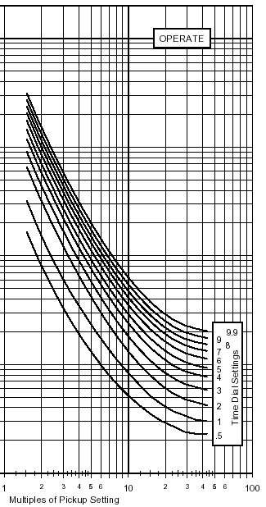

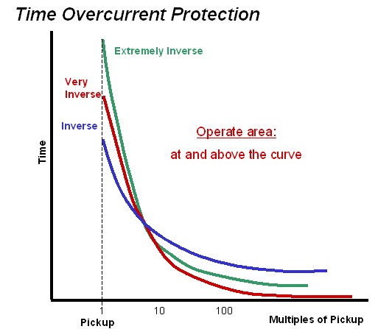
During the selection of the curve, the protection engineer will uses what is termed as a “ time multiplier” or “time dial” to effectively shift the curve up or down on the time axis

Reset of Time Overcurrent Element
There are (2) different types of resets within Time Overcurrent Protection:
- EM or Timed Delay Reset – this mimics the disc travel of an electromechanical relay moving back to the reset position.
  - If the disc has not yet completely traveled back to the reset position and the time overcurrent element picks up again, the trip time will be shorter.
  - If the current picks up and then dropouts many times, the disc will “ratchet” itself to the operate position.
  - Be careful when coordinating with upstream or downstream devices.

- Instantaneous Reset – once the time overcurrent element operates, it will reset immediately

CGW 10-08-06

