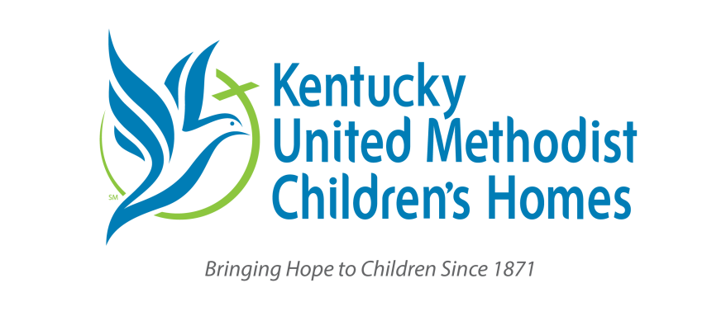

Thank you for sharing this update from us with your church! You are welcome to use our logo (above) in your bulletin or newsletter as well. Please contact Rebecca Merrill at info@kyumh.org if you have any questions about how to use this information.

An Update from the Kentucky United Methodist Children’s Homes
The next Offering of Hope is Sunday November 30, 2025.
- We want you to have a tangible story of the hope that you are providing young people through KyUMH. Feel free to share this story.
  - Hope is when a young person came us and ate their first meal with us. After eating, this young person told our direct care staff that this was the first time in their life that their belly had ever felt full. That is hope!
- Together we served 1,974 young people in 2024. We can grow and help more families thanks to your support.

- Here are the 5th Sunday dates for 2026:
  - March 29, 2026
  - May 31, 2026
  - August 30, 2026
  - November 29, 2026
- KyUMH is funded by your donations! There are several ways to give for 5th Sunday:
  - You can mail a check to PO Box 930, Nicholasville KY 40340
  - You can give on our secure online form via credit card or direct bank transfer at kyumh.org/donate

