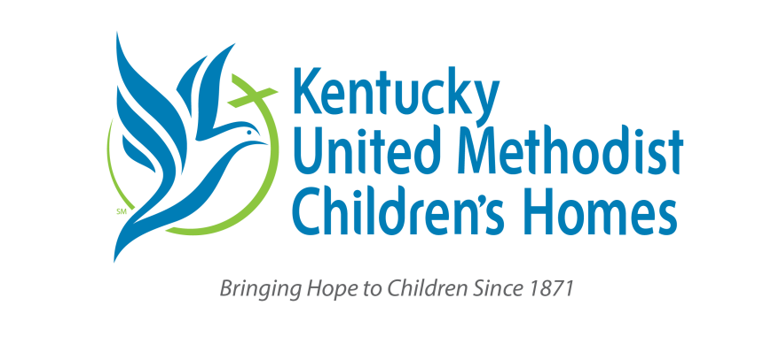

Thank you for sharing this update from us with your church! You are welcome to use our logo (above) in your bulletin or newsletter as well. Please contact Rebecca Merrill at info@kyumh.org if you have any questions about how to use this information.

An Update from the Kentucky United Methodist Children’s Homes
The next Offering of Hope is Sunday March 29, 2026.
- Together we served 2,486 young people in 2025. We can grow and help more families thanks to your support. This is a wonderful testament to the transformative power of Jesus. Please be sure to share this with your congregation!

- Here are the 5th Sunday dates for 2026:
  - March 29, 2026
  - May 31, 2026
  - August 30, 2026
  - November 29, 2026
- KyUMH is funded by your donations! There are several ways to give for 5th Sunday:
  - You can mail a check to PO Box 930, Nicholasville KY 40340
  - You can give on our secure online form via credit card or direct bank transfer at kyumh.org/donate

