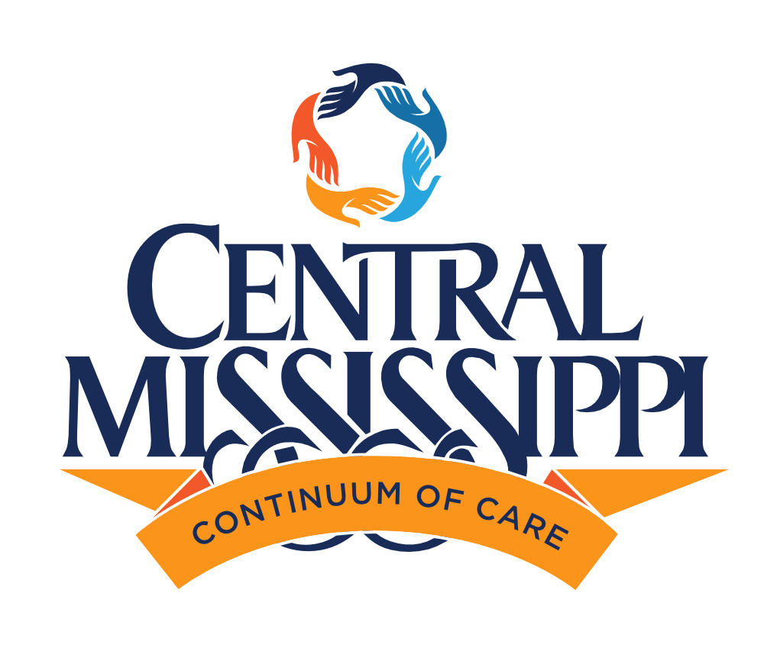
Dir. Planning 3rd Qtr Report
October 2025

The third quarter of Fiscal Year 2025 has been defined by continued resilience, steady performance, and forward progress amid ongoing uncertainty in the federal funding environment. Across Central Mississippi, member agencies have remained steadfast in advancing the CoC’s shared mission—to prevent and end homelessness through coordinated and data-informed systems.
Despite national fiscal pressures, the Central Mississippi CoC sustained strong program outcomes and continued to implement the strategies outlined in our Five-Year Strategic Plan. Planning funds were leveraged to support system evaluation, provider capacity building, and regional coordination with state and municipal partners.
Key highlights for Q3 FY2025 include:
- 4% overall reduction in homelessness since Q2, driven by expanded housing placements and prevention interventions.
- 92% of the housing retention rate among CoC-funded permanent supportive housing (PSH) programs.
- 15% increase in coordinated entry referrals to rapid rehousing and PSH combined.
- Strengthened partnerships with Mississippi Home Corporation, City of Jackson, and faith-based organizations to align efforts with state housing initiatives.
- Initiation of FY2026 Point-in-Time (PIT) Count planning, with volunteer recruitment and venue confirmation completed.
- Ongoing work to diversify funding and explore partnerships with healthcare and philanthropic sectors.
This quarter reaffirmed that the CoC’s collective capacity—rooted in data, collaboration, and shared accountability—is the foundation for progress, even as external funding challenges persist.
The national HUD landscape continues to be shaped by delayed federal appropriations and uncertainty surrounding FY2025 CoC Program funding levels. Continuing resolutions in Congress have extended temporary budgets, creating challenges for CoCs to forecast renewal awards and project start dates.
While HUD remains committed to the Continuum of Care Program, potential reallocations and competitive scoring shifts mean local performance metrics carry greater weight than ever. The Central Mississippi CoC has positioned itself well through consistent data quality, compliance readiness, and demonstrated community coordination.
While funding decisions remain pending, early communications from HUD Regional Leadership indicate continued support for CoCs demonstrating measurable outcomes, fiscal accountability, and system-level coordination—all of which the Central Mississippi CoC has strengthened this year.
Between July and September 2025, the CoC reported a 4% decrease in overall homelessness compared to the previous quarter, continuing a downward trend that began in late FY2024. Unsheltered homelessness decreased by 6%, largely due to enhanced outreach and diversion efforts.
System performance metrics for Q3 FY2025:
- Housing Placements: 138 individuals and families moved into permanent housing (up 12% from Q2).
- Rapid Rehousing Outcomes: 82% of participants exited permanent destinations.
- PSH Retention: 92% of households-maintained housing for six months or longer.
- Returns to Homelessness: Down 7% compared to Q3 FY2024.
- Average CES Referral Time: Reduced from 19 to 14 days—a 26% improvement.
These outcomes reflect a maturing system with stronger coordination, data-driven decision-making, and alignment among service providers.
The CoC’s Coordinated Entry System (CES) continued to demonstrate efficiency gains and improved client flow. Updated assessment tools and prioritization protocols, implemented in partnership with the CES Workgroup, allowed more accurate identification of high-need clients and fair distribution of housing resources.
The Homeless Management Information System (HMIS) achieved 97% data completeness for Universal Data Elements (UDEs).
The CoC’s Data and HMIS team conducted targeted training for agencies with data entry errors or performance gaps, resulting in measurable improvement across the system.
Recognizing ongoing uncertainty in federal funding, the CoC continued implementation of its Funding Diversification Plan, focusing on two primary strategies:
- Philanthropic Engagement: Outreach to local foundations and corporate partners, including healthcare entities exploring supportive housing investments.
- State Collaboration: Alignment with Mississippi Home Corporation’s Emergency Solutions Grant (ESG).
While these diversification efforts are in early stages, they represent critical steps toward financial stability beyond HUD’s annual competition cycle.
This quarter’s CoC Learning Series focused on:
- Best practices in trauma-informed engagement for outreach teams.
- Fiscal compliance and documentation standards for CoC-funded projects.
- Data quality clinics to support HMIS integrity.
Over 80 agency staff and volunteers participated, reflecting on a continued investment in workforce development and CoC compliance readiness.
Preparation for the 2026 Point-in-Time Count began this quarter, supported by CoC planning funds.
- Venue Secured: New Jerusalem Church will host the annual volunteer training and staging area.
- Volunteer Recruitment: Over 45 community members have registered, with outreach ongoing through partner agencies, universities, and local faith networks.
- Data and Mapping Preparations: HMIS and outreach teams have begun refining unsheltered count maps and coverage zones to improve accuracy.
The PIT Count continues to serve as both a data collection exercise and community engagement opportunity, raising awareness about homelessness and reinforcing the need for sustained resources.
State and federal developments affecting homelessness and housing policy this quarter include:
- The HUD FY2025 CoC Notice of Funding Opportunity (NOFO) is anticipated to be released in early Q4. The CoC’s Planning Office has initiated pre-competition readiness checks and project monitoring.
- The Mississippi Department of Mental Health expanded its Housing Initiative to include transitional housing stabilization grants, presenting a new partnership opportunity for CoC agencies.
- State legislators have expressed interest in expanding affordable housing tax credits, a potential tool for leveraging private investment in permanent supportive housing development.
The CoC’s advocacy team will continue monitoring these developments and coordinating messaging to ensure Central Mississippi’s needs remain represented at both state and federal levels.

As we transition into the final quarter of FY2025, the Central MS CoC will continue to strengthen its foundation through innovation, accountability, and collaboration. Key objectives include:
- CoC NOFO Preparation: Finalize project evaluations, compile performance narratives, and ensure full compliance ahead of submission.
- PIT Count Execution: Continue recruitment, training, and logistical planning to ensure a successful count in January.
- Funding Diversification Implementation: Formalize local partnership agreements and pursue state-level grant opportunities.
- Data and Performance Enhancement: Expand use of system performance dashboards to support real-time decision-making.
Our collective work this quarter underscores the CoC’s strength in unity. Together, we are demonstrating that effective collaboration, being anchored in data, compassion, and shared accountability—can sustain progress even in uncertain funding environments.
Through intentional planning, clear communication, and steadfast commitment, the Central Mississippi Continuum of Care continues to move forward—strong, prepared, and united.

