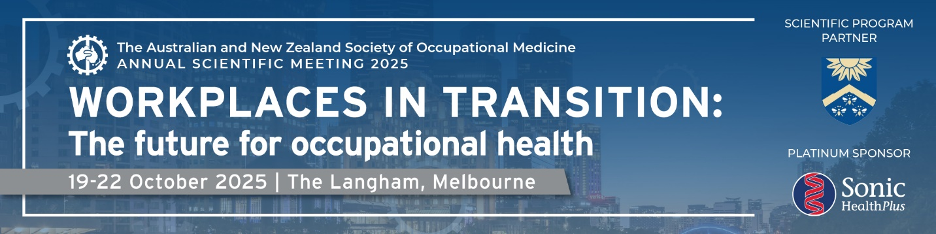

**Join us in Melbourne this coming October**

ANZSOM Australia looks forward to welcoming you to our Annual Scientific Meeting – a must for health professionals working in occupational medicine, including medical practitioners, nurses and allied health professionals.

This year’s theme, "**Workplaces in Transition: The future for occupational health**", explores evolving workplace practices, industry trends, and innovative solutions. The meeting will run over three full days, with the main program commencing on Monday 20th October. It features an impressive lineup of international and national speakers, as well as site visits and workshops, plus an exciting social program.

**Key topics include:**

* Psychosocial hazards: from prevention to work injury management
* Innovating occupational health: leveraging emerging technologies
* Navigating the new legal landscape - practical implications for respiratory testing and psychosocial hazard prevention
* Workplace frontiers: occupational health & safety in emerging industries
* Mental health and the workplace
* Occupational lung disease
* Health of healthcare workers
* PFAS guidelines around the world: Navigating differences & risk communication challenges
* The next pandemic: what we have learned from COVID about managing workplaces
* Ethics and behaviour in occupational medicine
* Clinical aspects of safety-critical work

**Call for contributed papers**

Do you have some research, a fresh idea or a case study that you would like to present? We invite you to share your insights at the ANZSOM ASM by submitting a paper for consideration. Accepted papers will be presented as 15-minute oral presentations in the Contributed papers section and considered for the prestigious David Goddard Best Paper Award. The deadline for submissions is the 11 August.

**Can't make it to Melbourne?**

Don't worry!  ASM2025 is a hybrid event, giving delegates the choice of attending in person or virtually from wherever they find themselves.

Virtual registration includes:

* ***Full access to all 3 days of the technical program*** - sessions will be broadcast live via our online conference portal where you'll be able to chat to your fellow virtual delegates and join in the discussion.
* ***On-demand access to recordings and learning material*** - all technical sessions will be recorded, with access for 6 months post-event.

For more information or to register, visit the Conference website at <http://www.anzsomasm2025.com.au/>.