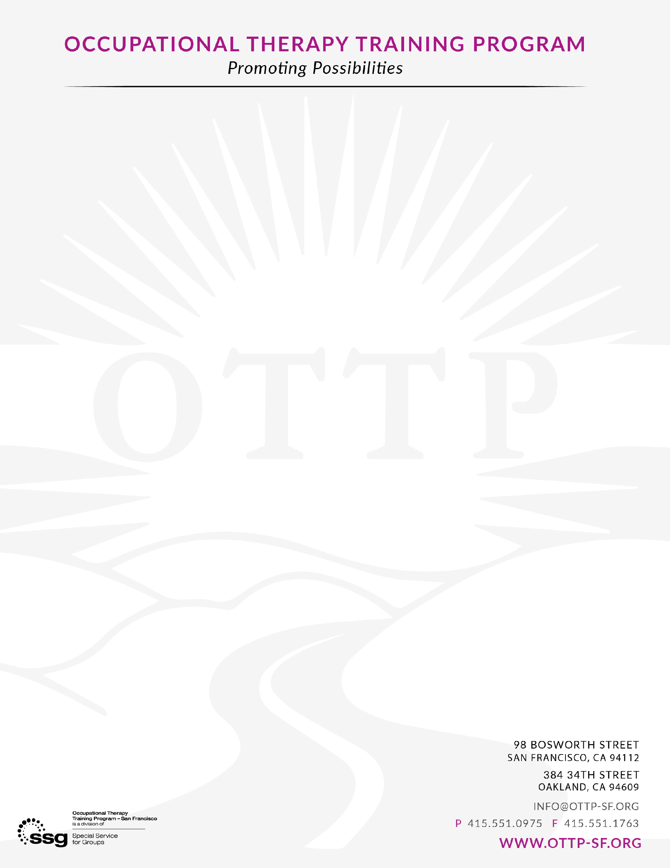OTTP Volunteer Application

**Name:**

**Pronouns:  
  
Language Capacity:**

**Contact Info (Phone & Email:**

**Questions:**

Why are you interested in volunteering at OTTP? (*Please indicate if you are applying to OT school and when)*

What days and times would you be available?

Are you interested in a one-time opportunity or looking to complete a certain number of hours?  
  
  
  
  
  
Choose five words to describe yourself:

Please submit completed application and resume to [fieldwork@ottp-sf.org](mailto:fieldwork@ottp-sf.org)