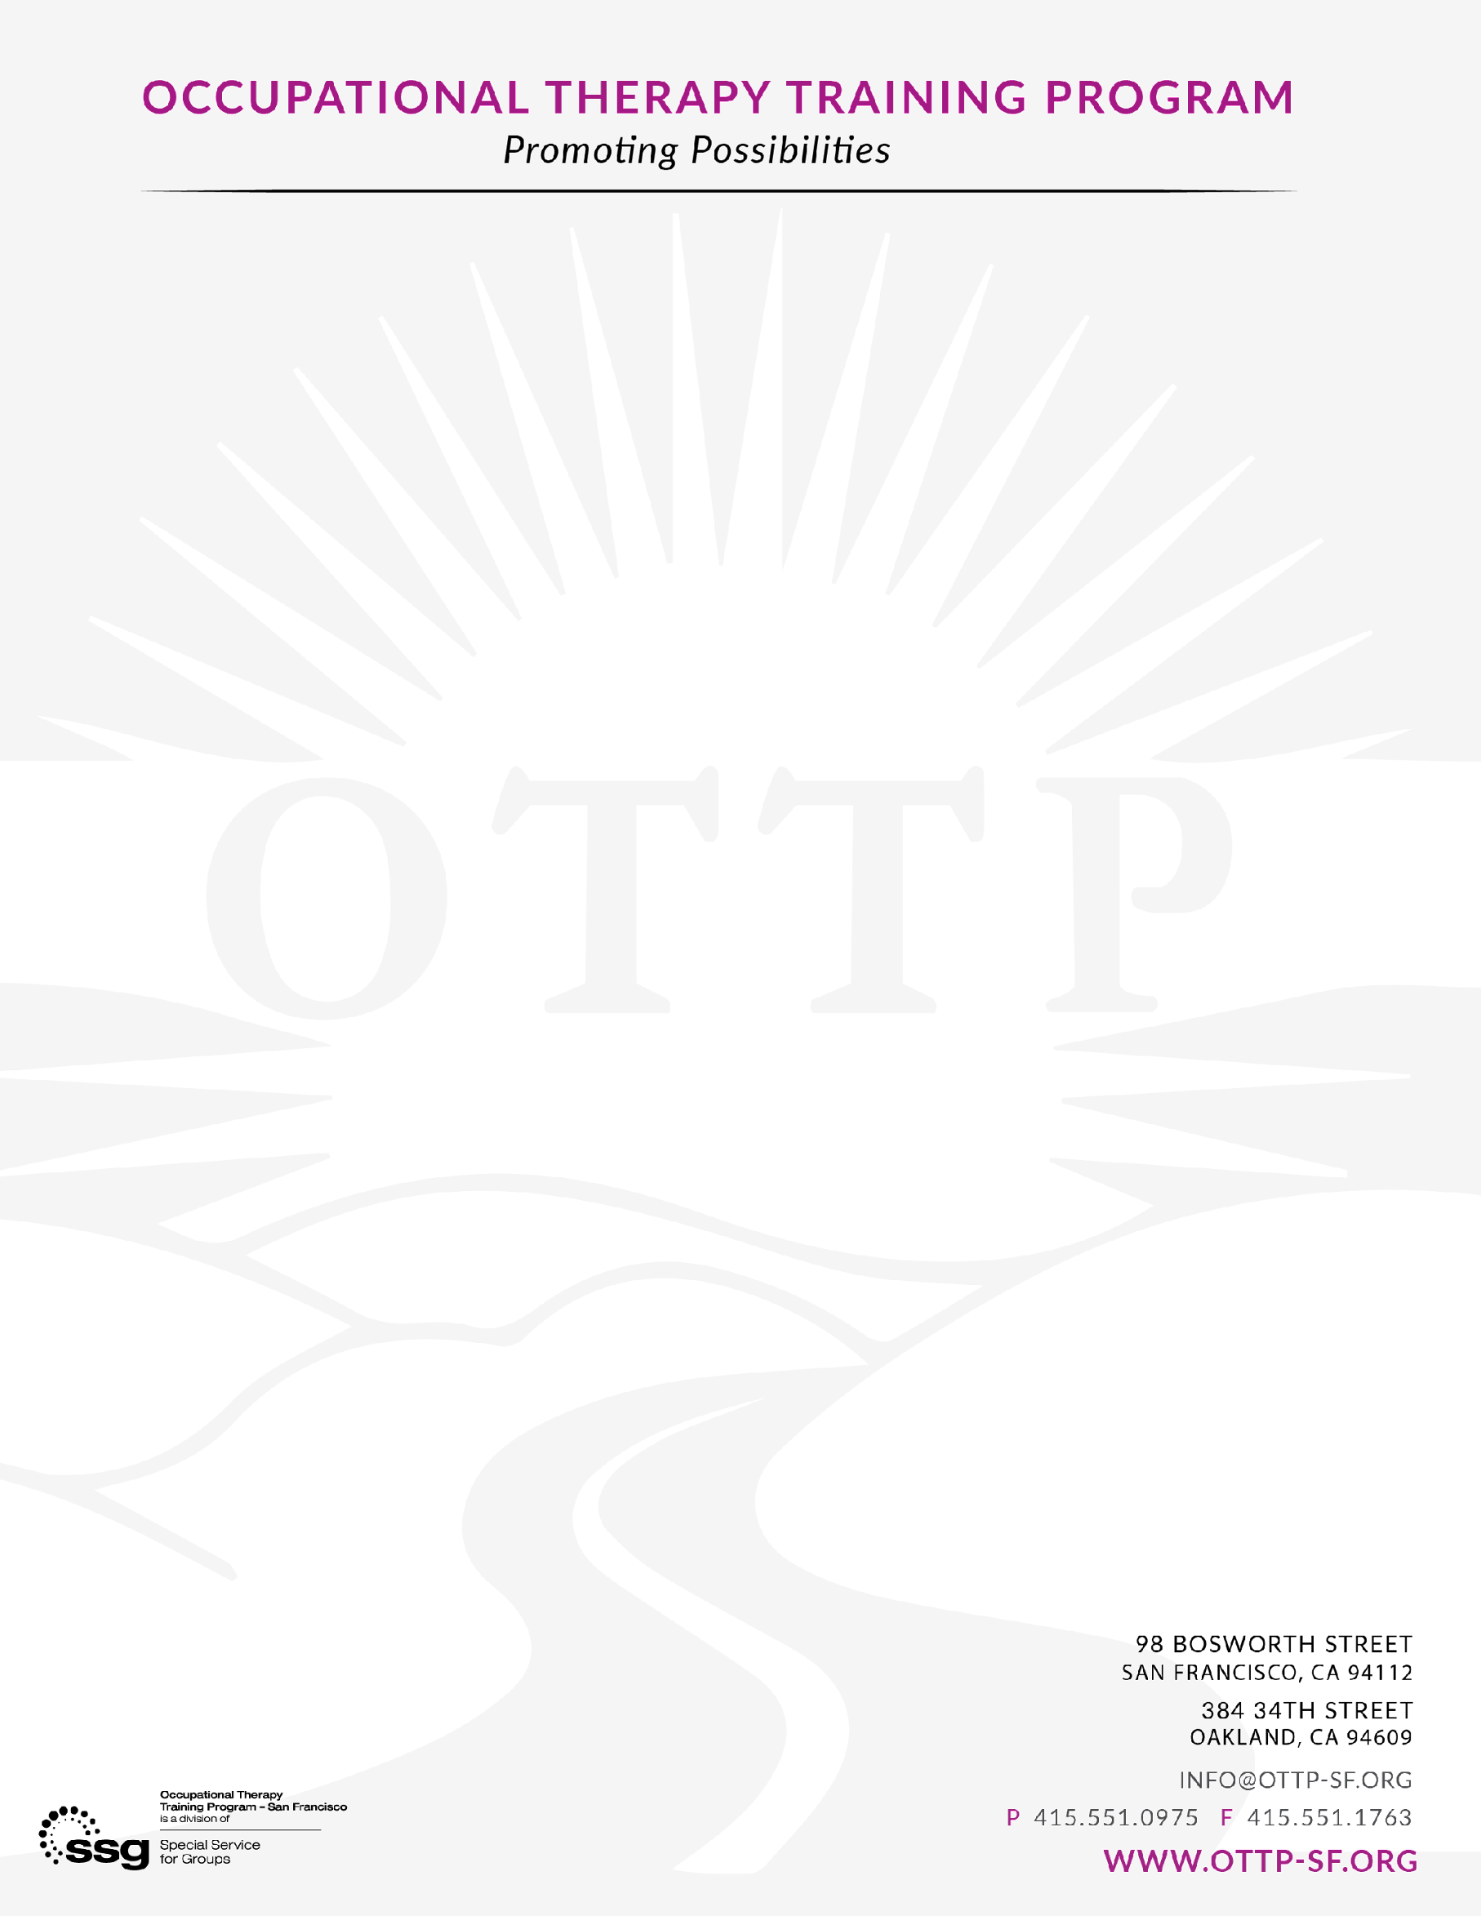
OTTP Volunteer Application
Name:
Pronouns:
Language Capacity:
Contact Info (Phone & Email:

Questions:
Why are you interested in volunteering at OTTP? (Please indicate if you are applying to OT school and when)

What days and times would you be available?

Are you interested in a one-time opportunity or looking to complete a certain number of hours?
Or please let us know if you are interested in just volunteering to give back and supporting us with non-clinical tasks, and we can connect you to our Development Team. Some examples of non-clinical tasks are assembling activity kits and organizing supplies.
Choose five words to describe yourself:

Please submit completed application and resume to fieldwork@ottp-sf.org

